AutoLearn AR: An AI- and AR-Assisted Mobile System for Automotive Practical Skill Training
[Author Name(s) To Be Added]
[Department, University Name]
[City, Country]
[email@example.edu]

Abstract—Automotive vocational education traditionally separates theoretical instruction from hands-on practice, leaving students to bridge that gap largely on their own while a single instructor supervises many learners at once. This paper presents AutoLearn AR, a mobile learning platform for Android that pairs a theoretical reference library with an AI- and augmented-reality-assisted practical training pipeline. The practical pipeline identifies an engine component from the live camera feed using an on-device TensorFlow Lite convolutional classifier, automatically matches the component to its corresponding maintenance task, provides step-by-step AR-guided instructions, and verifies each practical step in real time by comparing the camera-predicted action against an expected step label. A rule-based scoring model, together with elapsed-time tracking and a manual-continuation fallback that is explicitly flagged in the stored results, produces an automated, objective performance report with safety warnings and improvement suggestions at the end of each session. Unlike augmented-reality training systems built around dedicated headsets, AutoLearn AR runs entirely on a standard smartphone, which keeps the approach accessible for resource-constrained training environments. We describe the system architecture, the Kotlin/Jetpack Compose implementation, and the closed-loop teach-observe-evaluate-feedback design, and report preliminary internal testing of the working prototype on a defined air-filter maintenance task. We close by discussing current limitations and a planned controlled study to evaluate learning-outcome impact against conventional instruction.
Keywords—augmented reality; mobile learning; automotive education; on-device machine learning; computer vision; TensorFlow Lite; formative assessment; vocational training
I. INTRODUCTION
Practical, hands-on competence is the ultimate learning objective of automotive vocational education, yet most programs still teach it the way they did decades ago: theory in a classroom, practice in a workshop, and assessment by a single instructor who must divide attention across many students at once. This arrangement makes individualized, real-time feedback difficult to provide consistently, and it means a student can complete a practical exercise without ever being told precisely which action was performed incorrectly. The resulting theory-practice gap, combined with the subjectivity and limited scalability of manual observation, motivates the search for tools that can support a student through a procedure and assess that procedure objectively, without requiring a dedicated instructor to watch every step.
Two technological trends make this feasible today. First, augmented reality (AR) is increasingly used for procedural, step-by-step technical guidance in maintenance and industrial training, from tablet- and headset-based overlays on factory floors to sensor-driven systems that guide a technician through a repair sequence [1]. Second, consumer smartphones are now powerful enough to run convolutional neural networks on-device, which removes the need for the specialised, costly hardware — headsets, depth sensors, or a persistent cloud connection — that many AR training systems still assume. Recent work on cost-effective AR training makes this contrast explicit: mobile AR that runs on a smartphone or tablet a learner already owns is markedly more accessible than approaches built around dedicated head-mounted displays [2]. Separately, computer-vision-based automated assessment of human action quality has matured into an active research area in its own right, though it has concentrated mainly on sports and surgical skill scoring rather than structured, multi-step vocational procedures such as automotive maintenance [3].
This paper presents AutoLearn AR, an integrated mobile learning platform designed for automotive students that combines a centralized theoretical learning library with AI-based component identification, task-specific AR guidance, real-time practical action verification, and automated performance evaluation, in order to connect automotive theoretical knowledge and practical skill development within a single application running on the student's own phone. The recurring design theme throughout the system is a closed loop: Theory → Guided Practice → Real-Time Verification → Automated Assessment → Personalized Feedback.
The contribution of this paper is not any single algorithm in isolation — mobile learning, AR-guided instruction, and vision-based verification are each established ideas individually — but their integration into one coherent, smartphone-only workflow for automotive practical training, together with a working Android implementation. Concretely, we contribute: (i) a two-pillar mobile architecture that couples a theory library with an AI/AR-driven practical pipeline; (ii) an on-device, confidence-gated, real-time verification mechanism that distinguishes automatically-verified steps from manually-continued ones, preserving a richer signal for formative feedback than a simple pass/fail result; (iii) a lightweight, fully on-device rule-based scoring model that needs no cloud connectivity and remains transparent and auditable to students and instructors; and (iv) a working prototype demonstrated end-to-end on a real automotive maintenance task.
The remainder of this paper is organized as follows. Section II reviews related work in AR-based technical training, mobile and AI-assisted vocational learning, and automated action assessment. Section III describes the overall system architecture. Section IV details the implementation of each pipeline stage. Section V reports preliminary internal testing of the prototype. Section VI discusses strengths and limitations, and Section VII concludes with planned future work.
II. RELATED WORK
A. Augmented Reality for Maintenance and Technical Training
AR-guided maintenance has been explored using a range of sensing hardware. Warade et al. presented a Kinect-based system that overlays repair instructions on tractors and other vehicles, using skeletal tracking of twenty body joints to recognize a mechanic's gestures, verify that the correct tool is being used, and track completion of each maintenance step so that a supervisor can review stepwise progress remotely [1]. This closely mirrors the goal of AutoLearn AR's verification stage, but relies on dedicated Kinect depth-sensing hardware mounted in a fixed workshop location rather than a device the student carries with them. Industrial AR training research has likewise combined vision-based guidance with adaptive feedback mechanisms, including reinforcement-learning-driven training models for equipment operation, reflecting a broader move from static instructions toward systems that adapt to the trainee's demonstrated performance.
B. Mobile and AI-Assisted Vocational e-Learning
Mobile AR has also been applied directly to technical higher education. Neffati et al. describe a mobile e-learning tool that overlays augmented-reality content on coursebook material for technical higher education, evaluated with real learners in a lecture setting [4]. This line of work demonstrates that mobile-only AR content delivery is viable for technical subjects, but it targets conceptual/theoretical understanding rather than verifying a physical, hands-on procedure. On the recognition side, deploying a convolutional classifier for component identification on a smartphone is well established practice: TensorFlow Lite's on-device object-detection and classification tooling is designed explicitly for this kind of low-latency, no-cloud-dependency mobile inference [5], and prior work has specifically fine-tuned mobile object-detection models to recognize automotive parts for an AR overlay experience on Android [6], which is functionally close to AutoLearn AR's Component Identification stage.
C. Automated Skill and Action Quality Assessment
A separate body of computer-vision research, generally termed Action Quality Assessment (AQA), studies how to automatically quantify the quality of a human action from video rather than merely recognizing what the action is. Recent surveys catalogue well over two hundred AQA papers spanning sports scoring, surgical skill assessment, and rehabilitation monitoring, and identify interpretable, rule-grounded scoring as one of the fastest-growing directions in the field, moving away from opaque black-box regression toward assessment a learner or coach can actually understand [3], [7]. AutoLearn AR's evaluation stage sits in this same broad space — deriving an objective score and structured feedback from observed actions — but applies a deliberately simple, fully transparent scoring rule rather than a learned regression model, and targets a discrete, multi-step procedural task (automotive maintenance) rather than a continuous athletic or surgical performance.
D. Accessibility: Smartphone-Based vs. Headset-Based AR
A recurring theme across recent AR-training literature is the accessibility trade-off between headset-based and smartphone-based delivery. A feasibility study of AR-based cognitive training for older adults found that mobile AR running on a smartphone or tablet is a practical and markedly more accessible alternative to VR systems that require expensive dedicated headsets, while still achieving good usability and engagement [2]. AutoLearn AR follows the same design philosophy: every stage of the practical pipeline runs on the student's own Android phone, with no additional hardware, which matters for training environments — such as many vocational institutions — where issuing dedicated AR headsets to every student is not realistic.
Taken together, the reviewed work confirms that AR-guided maintenance, mobile technical e-learning, on-device automotive part recognition, and vision-based action assessment are each individually established. What remains comparatively unexplored is their integration into a single, smartphone-only pipeline purpose-built for automotive vocational students, one that combines identification, guidance, verification, and formative scoring end-to-end on a device the student already owns. That integration is the gap AutoLearn AR addresses.
III. SYSTEM ARCHITECTURE
AutoLearn AR is organized around two complementary environments, shown in Fig. 1: a Theory Library and a Practical Training pipeline, connected by a shared feedback loop back into further study.
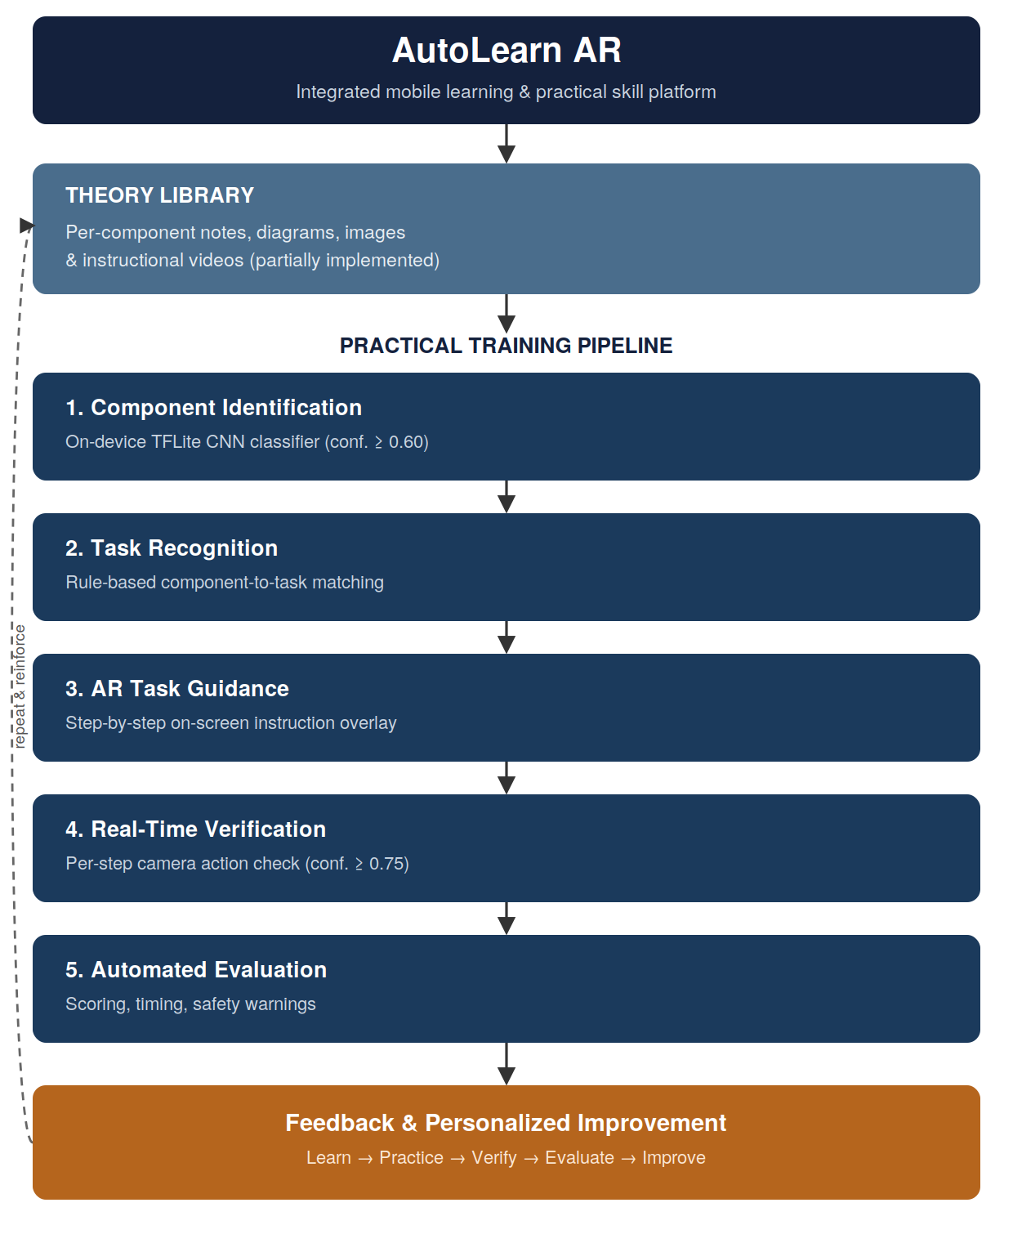
Fig. 1. AutoLearn AR system architecture: a theoretical library feeds a five-stage practical training pipeline, which reports back into continued learning.
The Theory Library is a centralized, per-component knowledge repository intended to hold notes, diagrams, images, and instructional videos for each covered automotive component, giving a student a place to build conceptual understanding before attempting a hands-on task. At the time of writing this Library is partially implemented; the content model and navigation are in place, but reference content does not yet cover every component addressed by the practical pipeline.
The Practical Training pipeline is the fully implemented half of the system and consists of five stages: (1) Component Identification, in which the student's camera identifies the automotive part in view; (2) Task Recognition, in which the identified component is matched to its associated maintenance task; (3) AR Guidance, in which the student receives step-by-step on-screen instructions for that task; (4) Real-Time Verification, in which the camera feed is continuously compared against the expected action for the current step; and (5) Automated Evaluation, in which a final score, timing information, and safety feedback are computed and presented. Section IV describes the implementation of each stage in detail. Consistent with the recommendation to avoid over-claiming prototype scope, we describe the pipeline at the level of the general design; the concrete example implemented and exercised in this paper is a four-step air-filter maintenance task, and the identification stage currently distinguishes a small, defined set of components (e.g., air filter, battery terminal) rather than the full space of automotive parts.
IV. IMPLEMENTATION
A. Platform and Tools
AutoLearn AR is implemented as a native Android application in Kotlin using Jetpack Compose for the UI layer and Navigation Compose to manage the screen graph. The practical pipeline is realized as a linear navigation flow: Home → Camera (component identification) → Component (reference information) → Task Recognition → Task (instructions) → AR Guidance → Verification → Evaluation, with the option to retry verification or return home from the final screen. On-device inference uses the TensorFlow Lite runtime, avoiding any dependency on network connectivity or a remote inference server during a training session.
B. Component Identification
A wrapper class loads a TensorFlow Lite convolutional classifier and exposes a single classification call to the rest of the app. Raw model output is normalized — lower-cased, and with hyphens and spaces converted to underscores — before being matched against the configured set of component identifiers (for example, air_filter or battery_terminal). A minimum confidence threshold of 0.60 is enforced: predictions below this threshold are treated as inconclusive and the student is prompted to try again rather than being routed to an incorrect task. This threshold, together with the label-normalization step, is intended to make the identification stage robust to minor variation in model output formatting while still gating on prediction confidence before committing the student to a downstream task.
C. Task Recognition
Rather than a second learned classifier, task recognition is implemented as a deterministic, rule-based lookup from a component identifier to its associated task record. This mirrors the system's original rule-based design intent for this stage and keeps the component-to-task relationship easy to inspect, extend, and debug as additional components and tasks are added, at the cost of requiring each new component to be explicitly associated with a task rather than having that association inferred automatically.
D. AR Guidance and Real-Time Verification
Once a task is identified, an AR guidance screen presents the required procedure to the student before the camera-verified portion of the exercise begins. The verification screen then takes over: it defines an ordered list of expected steps for the task (for the implemented air-filter example: air_filter_closed → air_filter_open → inspection → reinstall) and continuously evaluates incoming camera predictions against the current expected step. Fig. 2 summarizes this logic.
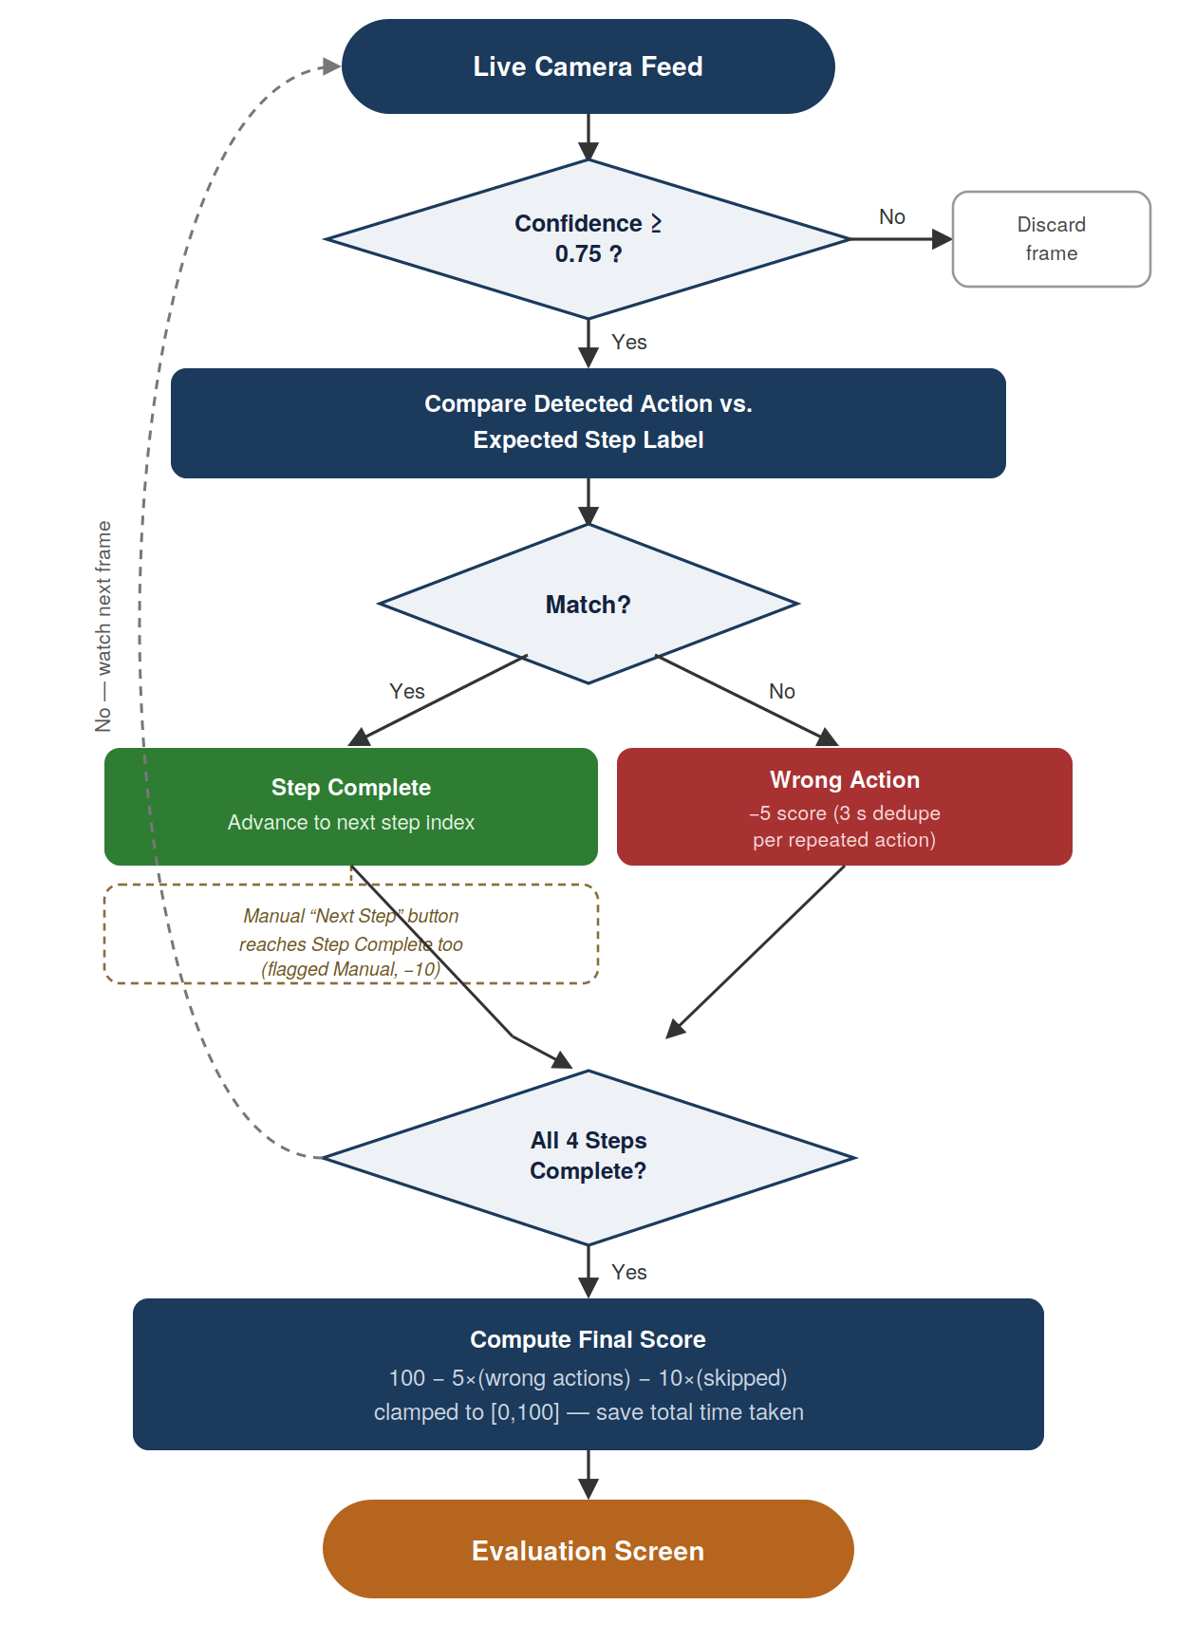
Fig. 2. Real-time verification and scoring logic executed on every camera frame once a session is started.
Each incoming frame is first gated on a 0.75 confidence threshold — deliberately higher than the 0.60 threshold used for component identification, since a false action match should be rarer than a false component match given the consequence of silently skipping a step. A frame that clears the threshold is compared to the expected label for the current step. A match marks that step complete and advances the step index. A mismatch is logged as a wrong action and reduces the running score by five points; to avoid a single held incorrect position being counted many times, repeated identical wrong actions are deduplicated within a three-second cooldown window before being counted again. If the camera cannot reliably recognize a given action — for example, due to occlusion or lighting — the interface also exposes a manual “Next Step” control that advances the step directly. Critically, a manually-advanced step is not indistinguishable from an automatically-verified one in the stored results: it is explicitly flagged as manual and incurs a larger ten-point penalty. This distinction, rather than silently treating both cases the same, preserves information about how much of a session was genuinely machine-verified versus operator-assisted, which downstream feedback can use to tell a student, for instance, that a particular step required assistance and may need further practice. Before verification can begin at all, a safety confirmation dialog requires the student to confirm that the engine has been switched off and has cooled down, tying the practical exercise to basic workshop safety practice from the outset.
E. Automated Evaluation
When every expected step has been completed, the system computes a final score starting from a baseline of 100 points, deducting 5 points per logged wrong action and 10 points per manually-advanced step, and clamping the result to the [0, 100] range. Session start and end timestamps are recorded to derive total time taken. The resulting evaluation report (summarized in Table I) is passed to an Evaluation screen together with per-component safety warnings, and the system classifies overall performance into a qualitative band — Excellent, Good, Needs Improvement, or Requires Further Practice — alongside targeted, rule-based suggestions such as reviewing steps that required manual continuation or reducing repeated incorrect actions. From the Evaluation screen the student may retry the verification stage or end the session, closing the Theory → Practice → Verify → Evaluate → Improve loop introduced in Section III.
TABLE I. EVALUATION REPORT FIELDS
Field | Description
Final Score | 0–100, from the rule-based scoring model
Time Taken | Elapsed session time (MM:SS)
Step Results | Per-step completion status
Wrong Actions | Count of logged incorrect actions
Manual Steps | Steps advanced via manual fallback
Safety Warnings | Per-component safety reminders
Recommendation | Qualitative band + improvement tips

V. PRELIMINARY TESTING
The prototype was informally exercised by the development team on the implemented air-filter maintenance workflow to confirm that each pipeline stage behaves as designed under normal indoor lighting: the classifier triggers correctly on the target component, the verification screen advances through the four defined sub-steps as the corresponding actions are performed in front of the camera, incorrect actions are logged and penalized as intended, the manual-continuation fallback is correctly distinguished from automatic verification in the stored results, and the final score, elapsed time, and report fields match the design described in Section IV-E.
This testing establishes functional correctness of the implemented pipeline — that each stage does what it was designed to do — rather than a statistically validated recognition accuracy figure or evidence of a learning-outcome effect. We report it as preliminary and developer-conducted; Section VII outlines the labeled-dataset accuracy evaluation and controlled user study needed to establish those two claims separately.
VI. DISCUSSION
A. Strengths
The system's central design strength is the closed loop it forms: rather than only presenting instructions, it teaches, observes, evaluates, and feeds back, which is a materially different proposition from a static instructional app. Running entirely on a standard smartphone — with no headset, external sensor, or cloud dependency — keeps the approach accessible for training environments where issuing dedicated AR hardware to every student is impractical, consistent with the accessibility argument for mobile AR discussed in Section II-D. Explicitly distinguishing automatically-verified steps from manually-continued ones preserves a richer, more honest signal than a simple completion flag, which is what allows the evaluation stage to move toward formative rather than purely summative feedback. Finally, using a transparent, rule-based scoring formula rather than a learned scoring model keeps the assessment auditable: a student or instructor can reconstruct exactly why a given score was produced, which is difficult to do with a black-box regression-based AQA model.
B. Limitations
Several limitations should be stated plainly rather than glossed over. The prototype currently covers a defined, limited set of components and one fully worked task — air-filter maintenance, with four verification steps — rather than the full space of automotive maintenance procedures; the architecture is designed to extend to additional components and tasks, but that extension has not yet been carried out or tested. The Theory Library is only partially implemented at the time of writing. As with any camera-based recognition system, both the identification and verification stages are sensitive to lighting, camera angle, and occlusion, and the fixed confidence thresholds used here (0.60 and 0.75) were set from development experience rather than a systematic accuracy sweep. Most importantly, the evaluation reported in Section V is internal, developer-conducted functional testing rather than a controlled study with student participants; no claim is made in this paper about learning-outcome improvement, recognition accuracy on a held-out dataset, or student usability, since none of these has been measured yet. Finally, the current system is single-device and offline by design, with no instructor-facing dashboard or cross-session analytics.
VII. CONCLUSION AND FUTURE WORK
We presented AutoLearn AR, a mobile learning platform that integrates a theoretical reference library with an AI- and AR-assisted practical training pipeline for automotive students, combining on-device component identification, automatic task recognition, AR-guided instruction, real-time camera-based step verification, and automated, transparent performance evaluation in a single smartphone application. The prototype is implemented end-to-end and has been functionally validated by the development team on a real air-filter maintenance task; it is deliberately scoped as a defined-coverage prototype rather than a claim of general automotive-procedure coverage.
Future work follows directly from the limitations in Section VI-B. We plan to: (1) extend component and task coverage beyond the current air-filter and battery-terminal examples; (2) complete Theory Library content across all covered components; (3) run a quantitative accuracy evaluation of the identification and verification classifiers against a labeled image dataset; (4) conduct a controlled comparative study, following a conventional-instruction-versus-AutoLearn-AR design with pre-/post-test practical performance measures and a usability/satisfaction questionnaire, to evaluate impact on learning outcomes rather than functional correctness alone; and (5) add an instructor-facing analytics view so a supervisor can review verified, manually-assisted, and flagged steps across students rather than only within a single session.
REFERENCES
[1] S. Warade et al., “Automated Training and Maintenance through Kinect,” arXiv:1207.2597, 2012.
[2] “Feasibility of Augmented Reality-Based Cognitive Training for Older Adults: The MarketMind AR Approach,” PMC. [Online]. Available: https://www.ncbi.nlm.nih.gov/pmc/articles/PMC11991451/
[3] H. Yin et al., “A Decade of Action Quality Assessment: Largest Systematic Survey of Trends, Challenges, and Future Directions,” Int. J. Comput. Vis., vol. 134, no. 2, 2026. [Online]. Available: https://arxiv.org/abs/2502.02817
[4] O. S. Neffati et al., “An educational tool for enhanced mobile e-Learning for technical higher education using mobile devices for augmented reality,” ScienceDirect. [Online]. Available: https://www.sciencedirect.com/science/article/abs/pii/S0141933121002027
[5] K. LeViet, “Easier object detection on mobile with TensorFlow Lite,” The TensorFlow Blog, Jun. 2021. [Online]. Available: https://blog.tensorflow.org/2021/06/easier-object-detection-on-mobile-with-tf-lite.html
[6] A. M. Sam, “Object Detection in TensorFlow Lite,” [Online]. Available: https://www.inspirisys.com/objectdetection_in_tensorflowdemo.pdf
[7] “A Comprehensive Survey of Action Quality Assessment: Method and Benchmark,” arXiv:2412.11149, 2024.

