Department of Computer Engineering
University of Peradeniya
CO527 Advanced Database Systems
Edirimanna Y.H.
E/20/089
- Troubleshooting Simple Queries Using EXPLAIN
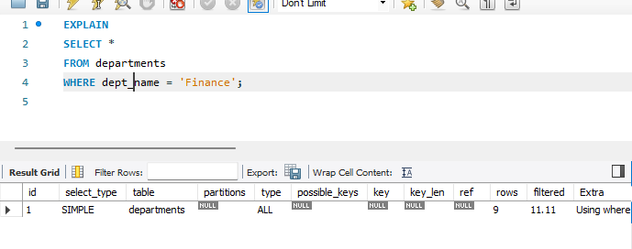
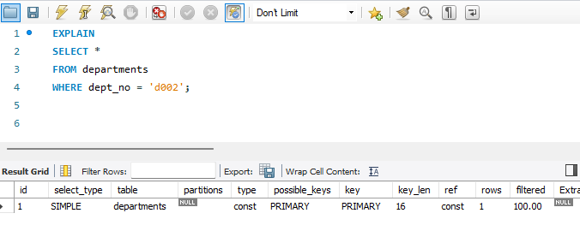
Query 1: dept_name = 'Finance'
- key = NULL → No index is used
- type = ALL → Full table scan
- rows → MySQL checks all rows in departments
- Reason: dept_name is not indexed
Interpretation: MySQL scans the entire department’s table to find matching records, which is inefficient and does not scale well for large datasets.
Query 2: dept_no = 'd002'
- key = PRIMARY → Primary key index is used
- type = const → Fastest possible access type
- rows = 1 → Only one row examined
- Reason: dept_no is the primary key
Interpretation: MySQL directly locates the required row using the primary key index, resulting in minimal row access and optimal performance.
- Join Query Analysis Using EXPLAIN
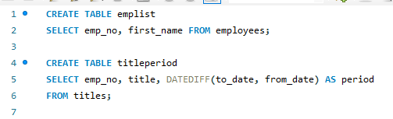
Initial Query
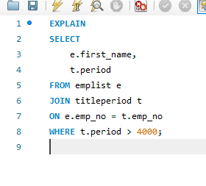
EXPLAIN Output Analysis
- Join type: ALL (full table scan on both tables)
- Rows examined: emplist_rows × titleperiod_rows
- MySQL uses a nested loop join
- Large number of row combinations must be checked
- No indexes available to speed up matching
Estimated Row Combinations
- emplist has 300,024 rows
- titleperiod has 443308 rows
Then MySQL may evaluate hundreds of millions of row combinations, leading to poor performance. his is why the query is extremely slow.
- Indexing for Optimization
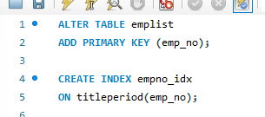
Before Indexing

After Indexing
The Improvement
Before Indexing | After Indexing
Full table scans | Index lookups
Huge row combinations | Drastically reduced
key = NULL | key = PRIMARY / idx_emp_no
Slow | Fast

Is it possible to optimize the query execution further?
Yes it is possible to optimize. We can use Composite Index for this. This allows efficient join and efficient filtering.

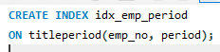

- Query Rewriting Techniques
FORCE INDEX

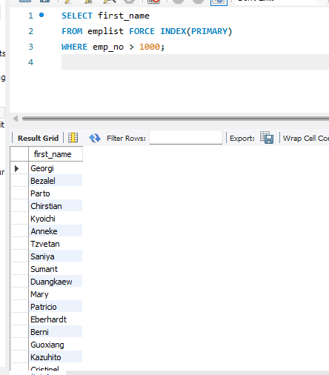

IGNORE INDEX
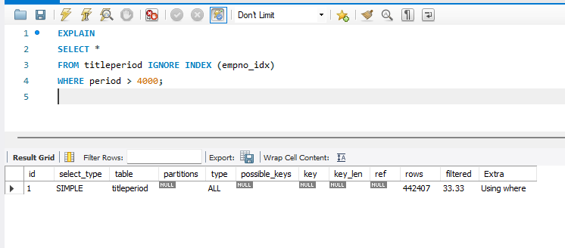

STRAIGHT_JOIN
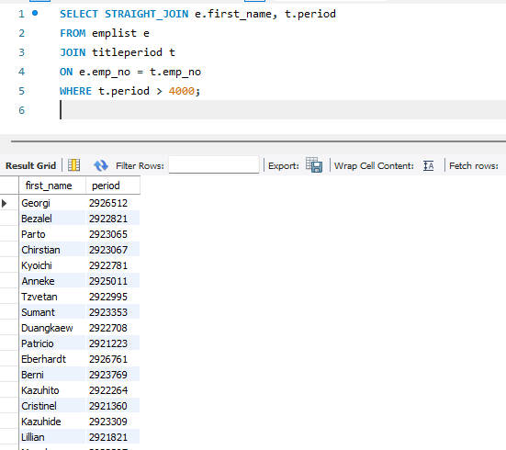
These techniques provide manual control when the optimizer’s choice is suboptimal.

