Department of Computer Engineering
University of Peradeniya
CO527 Advanced Database Systems
Edirimanna Y.H.
E/20/089
- Assuming no indexes are used, record the query execution time for retrieving all the employees by first name in ascending order.
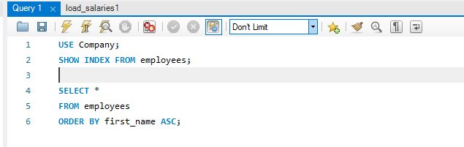

time

- Create an index called fname_index on the first_name of the employee table. Retrieve all the employees by first name and record the query execution time. Observe the performance improvement gained when accessing with index.
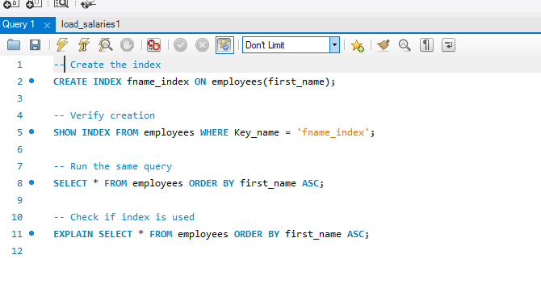
Time
Before time is 1.063msec
After indexing time is 0.625msec

- Which indexing technique has been used when creating the above index?

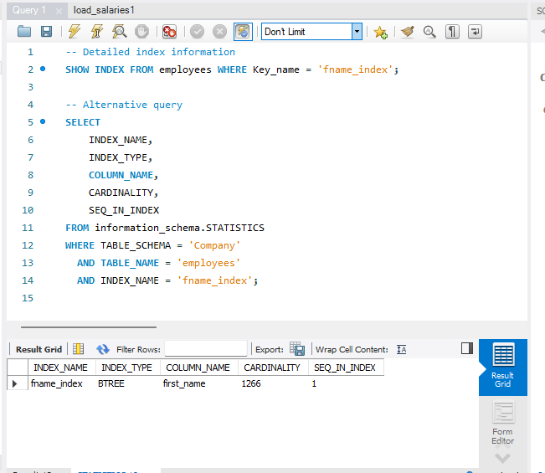
Type is B Tree indexing

- Create a unique index on emp_no, first_name and last_name of employees table. Retrieve all the employees by emp_no, first_name and last_name. Observe if there is any performance improvement with respect to question1. If not, explain any possible reason.
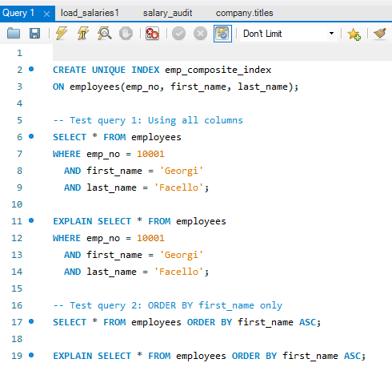
There may not be significant performance improvement compared to Question 1 because:
1. The primary key (emp_no) already has a clustered index
2. When ordering by first_name alone, the composite index (emp_no, first_name, last_name) may not be optimal since emp_no is the leading column
3. For the composite index to be effective, queries should use emp_no in WHERE
clause or ORDER BY should include emp_no as the first column

5. Take the following 3 queries.
A. select distinct emp_no from dept_manager where from_date>= ’1985-01-01’ and dept_no>= ’d005’;
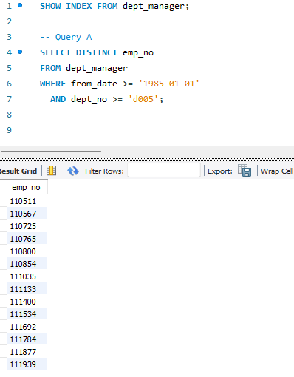
B. select distinct emp_no from dept_manager where from_date>= ’1996-01-03’ and dept_no>= ’d005’;
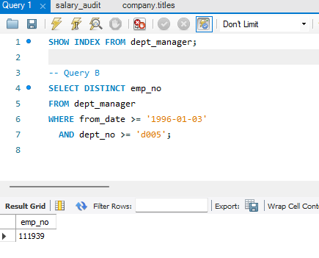
C. select distinct emp_no from dept_manager where from_date>= ’1985-01-01’ and dept_no<= ’d009’;
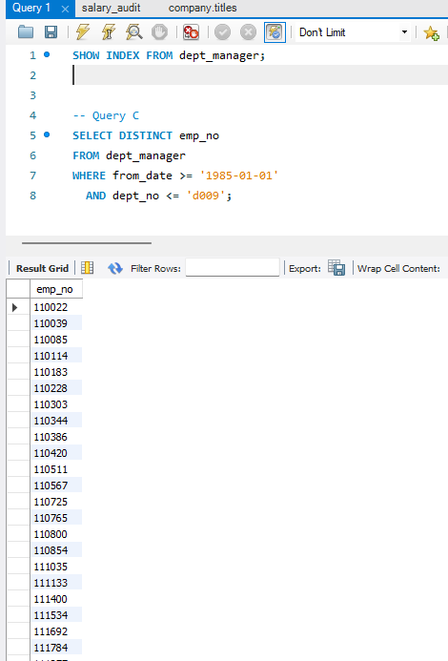

- Choose one single simple index(i.e index on one attribute) that is most likely to speed up all 3 queries giving reasons for your selection.
I chose from_date because:
1. It appears in all three queries with range conditions, from_date has higher cardinality (more distinct values) than dept_no ,Date ranges are more selective than dept_no ranges and MySQL can use this index to filter rows before applying dept_no condition
II. For each of the 3 queries, check if MySQL storage engine used that index. If not, give a short explanation why not. You can prefix your select queries with EXPLAIN EXTENDED or with EXPLAIN to display a query execution plan.

A
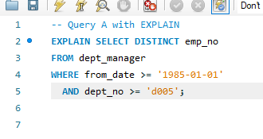
it shows "PRIMARY": Using the primary key instead.
Reason:
1. from_date = '1985-01-01' is VERY EARLY (near minimum date in table)
- This condition matches MOST rows in the table (low selectivity)
2. dept_no >= 'd005' eliminates departments d001-d004
- The PRIMARY KEY includes dept_no, making it useful for this filter
3. Since most rows match from_date condition, MySQL decides:
- Cost of idx_from_date: scan many index entries + lookup rows
- Cost of PRIMARY: direct scan with dept_no filtering built-in
- PRIMARY is more efficient because dept_no is part of the key
B
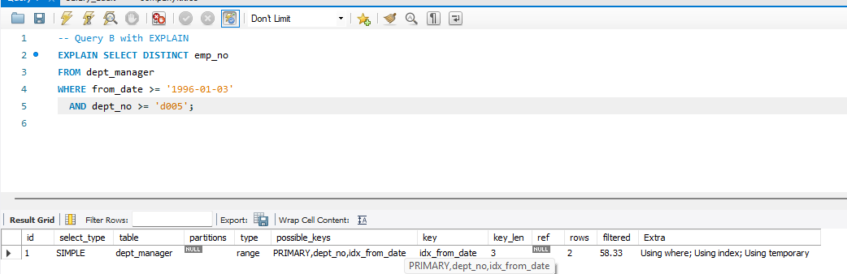
it shows "idx_from_date": The index is being used
1. from_date = '1996-01-03' is MUCH LATER (closer to maximum date)
- This condition is HIGHLY SELECTIVE (matches fewer rows)
- Most managers started before 1996, so this filters out many rows
2. The idx_from_date can quickly skip to 1996 entries
3. Since from_date filters out most rows efficiently:
- Cost of idx_from_date: scan few index entries + lookup few rows
- Cost of PRIMARY: must scan more entries to filter
- idx_from_date is more efficient due to high selectivity

C
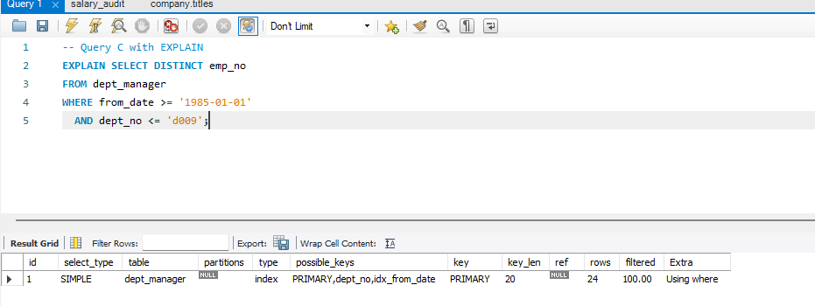
it shows "PRIMARY": Using the primary key instead.
1. from_date = '1985-01-01' matches MOST rows (low selectivity)
2. dept_no <= 'd009' matches ALL or MOST departments
- If there are only 9 departments (d001-d009), this matches everything
- Very low selectivity for dept_no condition
3. PRIMARY KEY scan is efficient because:
- Both conditions have low selectivity
- No advantage to using idx_from_date
- PRIMARY provides better data locality (clustered index)

6.nConsider the queries you wrote for questions 2 - 10 in PreLab assignment. Give with short explanations, which attributes on which relations should be used for creating indexes that could speed up your queries.
Query # | Query Description | Tables Involved | Recommended Index(es) | Column(s) | Reasoning
2 | Top 10 family names | employees | None | - | Requires full table scan for GROUP BY on all last_names. Index won't help when aggregating all distinct values.
3 | Number of Engineers per department | departments, dept_emp, titles | idx_title  idx_dept_emp_todate | title  to_date | • Filter titles containing 'Engineer'  • Filter current employees (to_date = '9999-01-01')
4 | Female managers who were senior engineers | employees, dept_manager, titles | idx_gender  idx_title | gender  title | • Equality filter on gender = 'F'  • Equality filter on title = 'Senior Engineer'
5 | Employees with salary > 115000 | employees, dept_emp, departments, titles, salaries | idx_salary  idx_salaries_todate  idx_dept_emp_todate | salary  to_date  to_date | • Range query on salary > 115000  • Filter current salaries  • Filter current employees
6 | Senior employees (>50 years, >10 years service) | employees | idx_birth_date  idx_hire_date | birth_date  hire_date | • Help with date range calculations  • Though TIMESTAMPDIFF function prevents direct index usage, indexes still assist with range scans
7 | Employees NOT in HR | employees, dept_emp, departments | idx_dept_name  idx_dept_emp_todate | dept_name  to_date | • Filter by department name  • Filter current employees
8 | Employees earning more than all Finance employees | employees, salaries, dept_emp, departments | idx_salary  idx_dept_emp_composite | salary  (dept_no, to_date) | • Salary comparison with MAX()  • Composite index for department filtering
9 | Employees earning more than company average | employees, salaries, dept_emp, departments | idx_salary_todate | (salary, to_date) | • Composite index for salary comparison  • Filter current salaries efficiently
10 | Salary difference: Senior Engineers vs All | salaries, titles | idx_title  idx_salaries_todate | title  to_date | • Filter by title = 'Senior Engineer'  • Filter current salaries for AVG calculation

7.Assume that most of the queries on a relation are insert/update/delete. What will happen to the query execution time if that relation has an index created?
If a relation has indexes and most queries are INSERT/UPDATE/DELETE operations, the query execution time will INCREASE
- With indexes: Fast SELECT, Slow INSERT/UPDATE/DELETE
- Without indexes: Slow SELECT, Fast INSERT/UPDATE/DELETE
- Ex –
- Table with 5 indexes: - 1 INSERT operation = 1 table write + 5 index updates = 6 total operations - Without indexes = 1 table write = 1 operation Result: 6x slower for writes
For write-heavy (OLTP) systems, minimize indexes and only create essential ones. For read-heavy (OLAP/reporting) systems, more indexes are acceptable as the read performance gain outweighs the write penalty.

