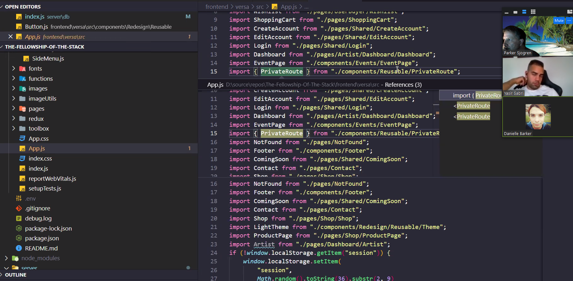

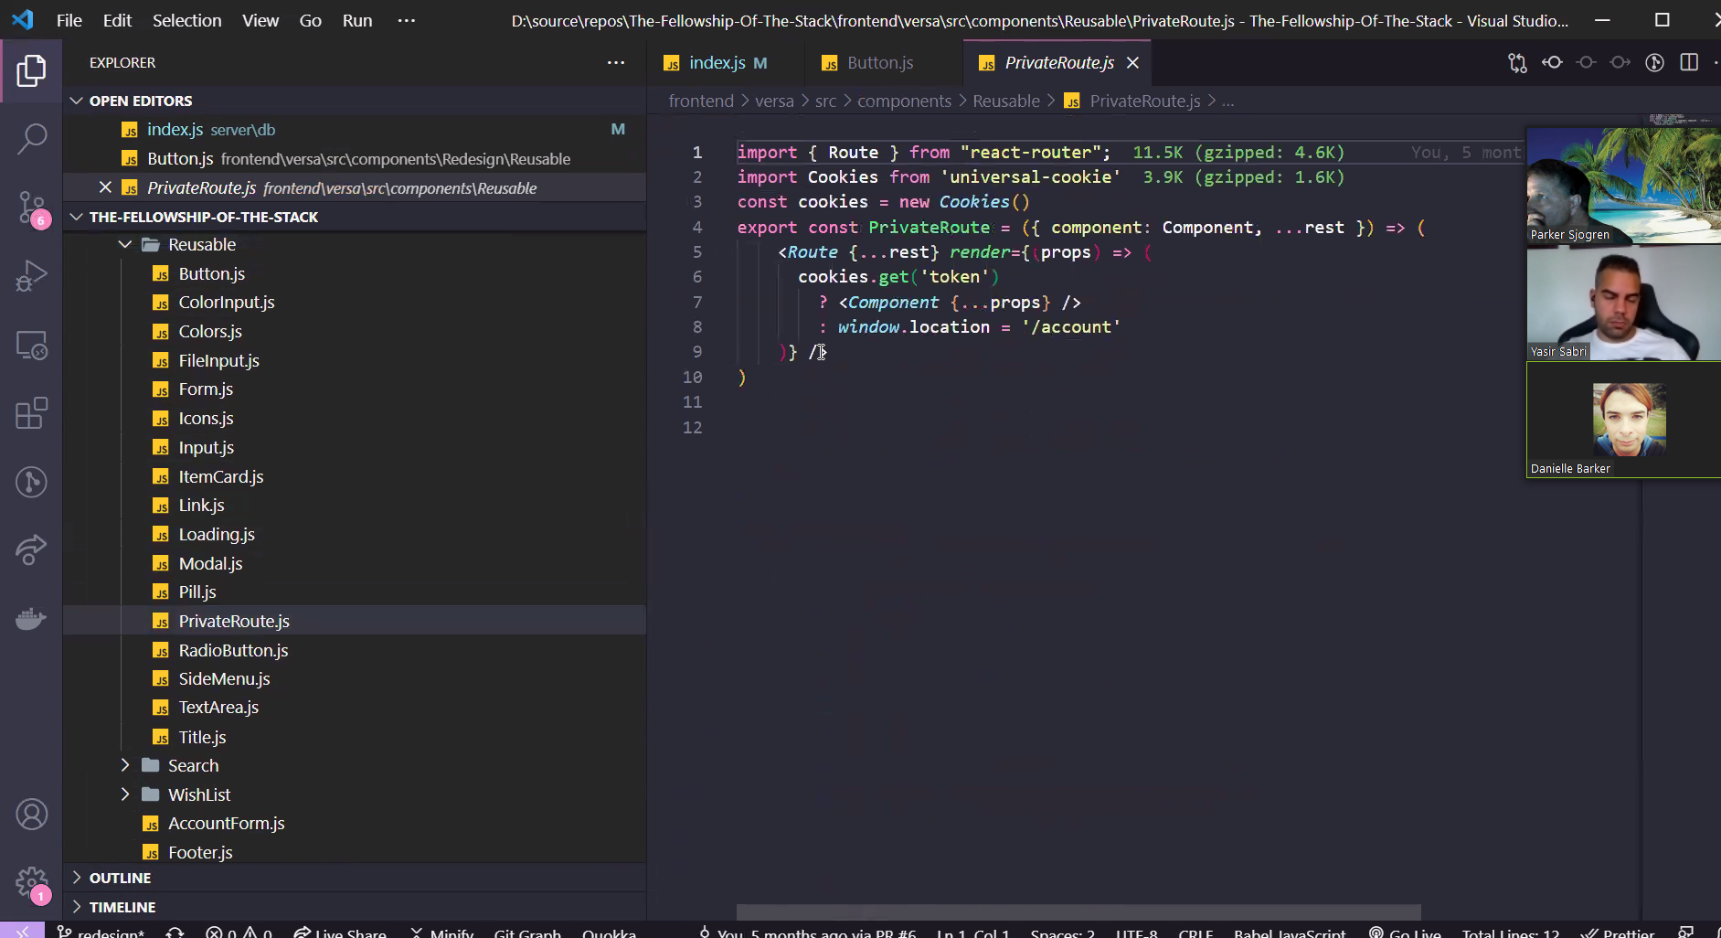

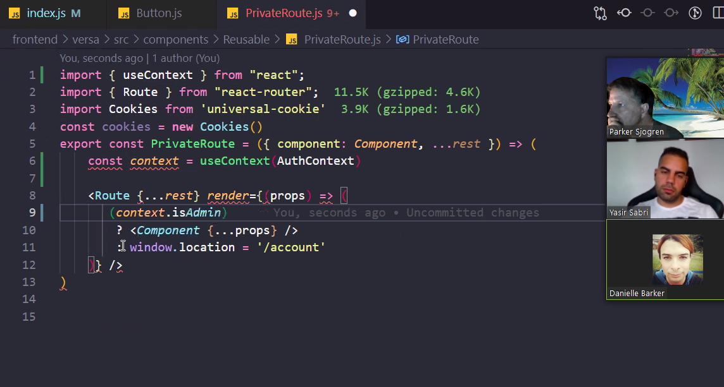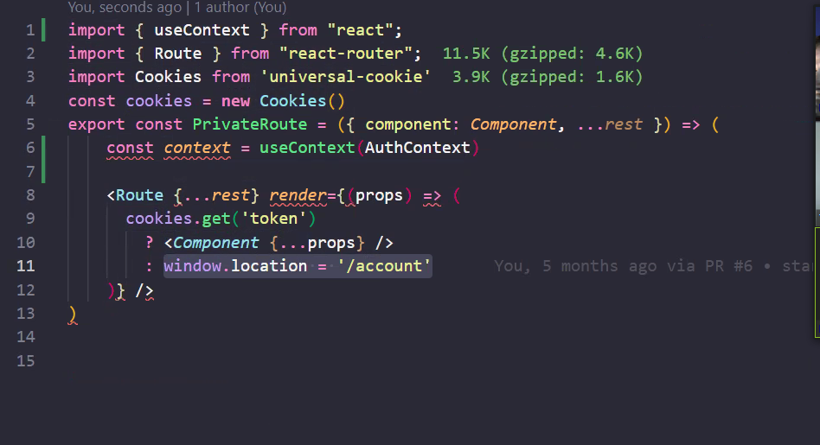

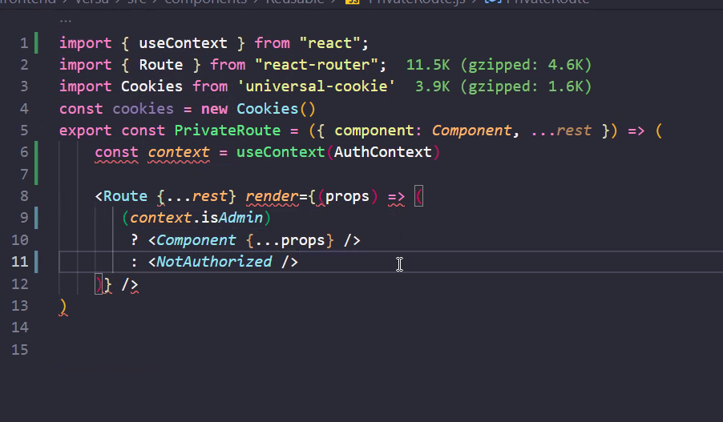

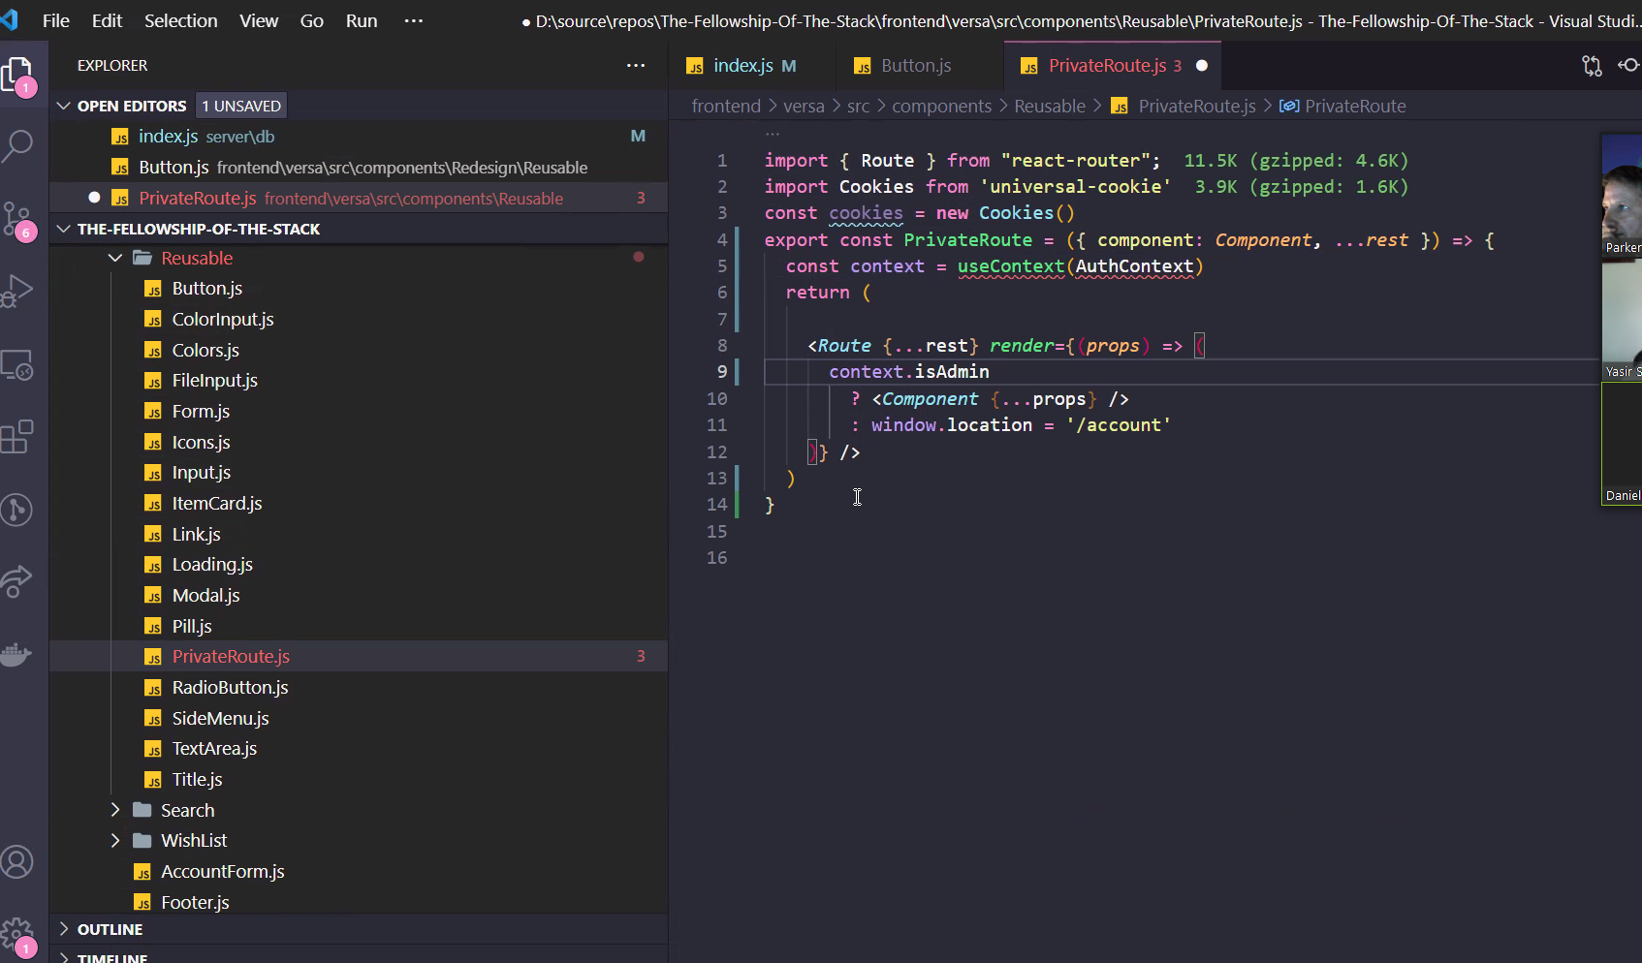

import { Route } from "react-router"; export const PrivateRoute = ({ component: Component, ...rest }) => { const context = useContext(AuthContext) return ( <Route {...rest} render={(props) => ( context.isAdmin ? <Component {...props} /> : window.location = '/account' )} /> ) }

import { Route } from "react-router"; export const PrivateRoute = ({ component: Component, ...rest }) => { const context = useContext(AuthContext) return ( <Route {...rest} render={(props) => ( context.isAdmin ? <Component {...props} /> : window.location = '/login' )} /> ) }

