|  |  |
| --- | --- |
| **4COSC001W: Software Development I – Coursework specification (2024/25)** | |
| Module leader | Guhanathan Poravi (P.Guganathan@westminster.ac.uk) |
| Weighting: | 50% |
| Qualifying mark: | 30% |
| Description: | Coursework |
| Learning Outcomes Covered in this Assignment: | The coursework rationale is:  LO1 Analyse specific problems and design their solutions by applying appropriate algorithmic techniques;  LO2 Apply programming concepts to implement solutions in the taught programming language;  LO3 Implement and manipulate simple data structures;  LO4 Use an integrated development environment to create programs to satisfy a simple specification. |
| Handed Out: | Tuesday 19th Nov 2024 |
| Due Date: | **Coursework Deadline**:  Part A, B and C - Tuesday 10th Dec 2024 **BEFORE** 1:00 pm  Part D and E – Tuesday 17th Dec 2024 **BEFORE** 1:00pm |
| Expected deliverables: | 1. Submit your Python program code    * **Important:** Submit **a single** zipped file containing design, code and test result using the name convention: “student_id.zip”, e.g. w1234567.zip    * **DO NOT** submit your code as a word, notepad or PDF document. 2. Demo will be scheduled online between 26th Dec 2024 to 16th Jan 2025 (Ensure stable and good internet connection) |
| Method of Submission: | Submitted online via Blackboard |
| Type of Feedback and Due Date: | Feedback during viva and written feedback and marks by 1st of Feb 2025 |

**Assessment regulations**

Refer to the following for clarification on what constitutes plagiarism, collusion and penalties for late submissions.

This is an individual coursework. You should not share your coursework or parts of your coursework with another student as this can cause you both to receive an allegation of collusion:

<https://www.westminster.ac.uk/current-students/guides-and-policies/academic-matters/academic-misconduct/collusion>Clarification on what constitutes plagiarism: <https://www.westminster.ac.uk/current-students/guides-and-policies/academic-matters/academic-misconduct/plagiarism>

**Penalty for Late Submission**

If you submit your coursework late but within 24 hours or one working day of the specified deadline, 10 marks will be deducted from the final mark, as a penalty for late submission, except for work which obtains a mark in the range 40 – 49%, in which case the mark will be capped at the pass mark (40%). If you submit your coursework more than 24 hours or more than one working day after the specified deadline you will be given a mark of zero for the work in question unless a claim of Mitigating Circumstances has been submitted and accepted as valid.

It is recognised that on occasion, illness or a personal crisis can mean that you fail to submit a piece of work on time. In such cases you must inform the Campus Office in writing on a mitigating circumstances form, giving the reason for your late or non-submission. You must provide relevant documentary evidence with the form. This information will be reported to the relevant Assessment Board that will decide whether the mark of zero shall stand. For more detailed information regarding University Assessment Regulations, please refer to the following website[: **http://www.westminster.ac.uk/study/current-students/resources/academic-regulations**](http://www.westminster.ac.uk/study/current-students/resources/academic-regulation)

**Coursework Description - The Task:**

A local council has collected a number of datasets detailing traffic flow at road junctions in the area. The data, collected for two junctions (Elm Avenue/Rabbit Road and Hanley Highway/Westway) over a number of days has been tabulated and saved as .CSV files (**two** are supplied – each one for a particular 24-hour period).

You have been tasked with writing a program which analyses the data and returns data to allow the council to make informed decisions to manage traffic flow. Your program should allow council staff to select any particular CSV dataset file (by date), analyse the data and summarise the specific elements required.

It should also save the results as a text file (Task C) and display the results of some specific analysis in graphical form (Task D: Histogram).

The data structure of the csv files is shown below with each row representing the recording of *one vehicle* passing through one of the two junctions at a specific time on the selected date (below are two rows as an example, see the CSV files for full data list).

|  |  |  |  |  |  |  |  |  |  |
| --- | --- | --- | --- | --- | --- | --- | --- | --- | --- |
| JunctionName | Date | timeOfDay | Travel_  Direction_in | Travel  Direction out | Weather Conditions | Junction  Speed Limit | Vehicle Speed | Vehicle Type | Electric  Hybrid |
| Elm Avenue/Rabbit Road | 25/06/2024 | 00:41:24 | W | W | Clear | 30 | 9 | Truck | FALSE |
| Hanley  Highway/Westway | 25/06/2024 | 00:42:44 | E | E | Clear | 30 | 34 | Scooter | TRUE |

You are provided with a template python file (“cw_template.py”) which loads in a supplied CSV file and converts the full dataset to a list. **You should start with this template** and expand it to create your solution.

# Task A. Input Validation (8 marks)

The program should prompt the user to input a single date in the format DD MM YYYY and use this input to select the correct CSV file for that date.

* The program should display ‘**Integer required**’ if a date input is the wrong data type.
* The program should display ‘**Out of range**’ if date values entered are not in the correct range **(01-31 for day, 01-12 for month and 2000-2024 for year)**
* For Task E (loop code task) the program should validate “Y” to load new dataset or “N” to quit.

An example of the program running with user input (shown in bold):

Please enter the day of the survey in the format dd: **p**

Integer required

Please enter the day of the survey in the format dd: **32**

Out of range - values must be in the range 1 and 31.

Please enter the day of the survey in the format dd: **30**

Please enter the month of the survey in the format MM: **March**  Integer required

Please enter the month of the survey in the format MM: **13**

Out of range - values must be in the range 1 to 12.

Please enter the month of the survey in the format MM: **10**

Please enter the year of the survey in the format YYYY: **March**  Integer required

Please enter the year of the survey in the format YYYY: **1997**

Out of range - values must range from 2000 and 2024.

Please enter the year of the survey in the format YYYY: **2024**

## Task B. Outcomes (20 marks)

The specific information the council has requested for each selected date (i.e the selected CSV file) is…

* The name of the selected CSV file.
* The total number of vehicles passing through all junctions for the selected date.
* The total number of trucks passing through all junctions for the selected date.
* The total number of electric vehicles passing through all junctions for the selected date.
* The number of “two wheeled” vehicles through all junctions for the date (bikes, motorbike, scooters).
* The total number of busses leaving *Elm Avenue/Rabbit Road* junction heading north
* The total number of vehicles passing through both junctions without turning left or right.
* The *percentage* of all vehicles recorded that are **Trucks**for the selected date (rounded to an integer).
* The *average* number **Bicycles** per hour for the selected date (rounded to an integer).
* The total number of vehicles recorded as **over** the speed limit for the selected date.
* The total number of vehicles recorded through only *Elm Avenue/Rabbit Road* junction for the selected date.
* The total number of vehicles recorded through only *Hanley Highway/Westway* junction for the selected date.
* The percentage of vehicles through *Elm Avenue/Rabbit Road* that are **Scooters** (rounded to integer)
* The *number* of vehicles recorded in the peak (busiest) hour on *Hanley Highway/Westway.*
* The time or times of the peak (busiest) traffic hour (or hours) on *Hanley Highway/Westway*  in the format Between 18:00 and 19:00. – (note this may be multiple hours).
* The total number of hours of rain on the selected date*.*

These results should all be printed to the Idle shell window.

## Task C. Save Results as a Text File (8 Marks)

The program should collect the “outcomes” (part B) results and add them to a list. It should then save the list as a text file with the filename “results.txt”.

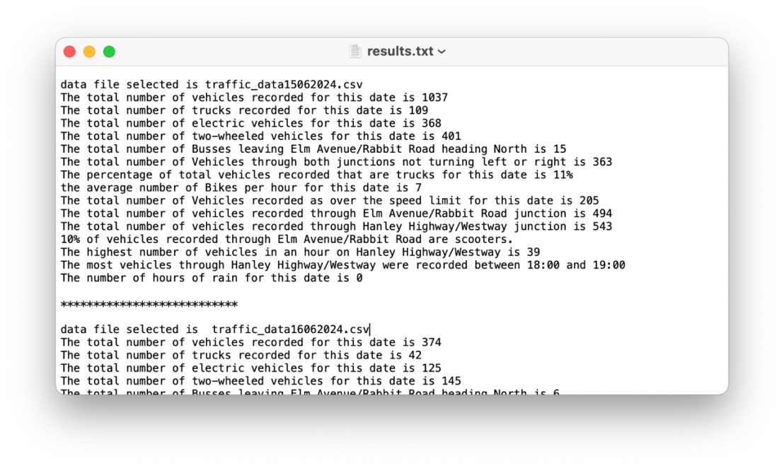

If the user selects run again (Task E: Code loops) with a new date selected, the new output data should be *appended* to this file.

## Task D. Histogram (20 marks)

* The program should use the **tkinter module** to produce a histogram comparing the volume of traffic (number of vehicles) for each junction by hour for the selected date. **The implementation should use a class-based design**. A HistogramApp class will encapsulate the entire application, including methods for setting up the Tkinter window, initializing the canvas, drawing the histogram, and dynamically scaling the data. The histogram should include axes, bars, and labels for hours and junctions. The class should take traffic data and the selected date as input parameters, making it flexible and reusable for other datasets. This design ensures modularity and maintainability, with each functionality encapsulated within appropriate methods of the class.The histogram should relate to the data file selected during the program run and work for any volume of vehicles in a selected twenty-four-hour period, it must use the graphics.py module (do not use any other graphing module to complete this section).
* You should include a **Title** with the **correct selected date**, a **labelled** x-axis and a **colour legend** indicating which colour corresponds to which junction (it doesn’t need to copy the look and colour choice of the example here).

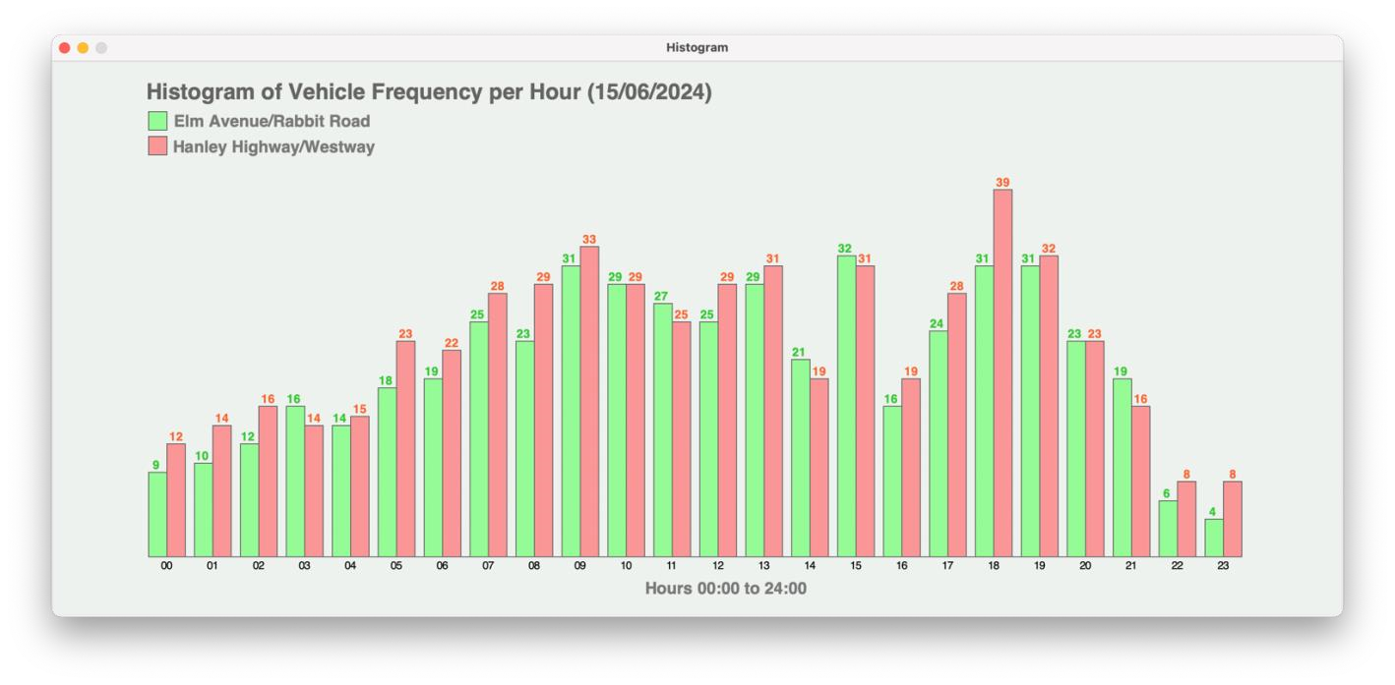

## Task E. Code loops to load and processes a new dataset (date) (8 marks)

The program loops to allow a staff member select **new** data set (CSV) for a different date.

The program should clear data from the previous loop, process the data for different selected dates individually and output the results until the staff member enters **‘N’** to the question “Do you want to select a data file for a different date?”. Optionally, they can use an input of **‘Y’** to continue and load a different CSV file**. You should Include code to catch lower case letter input.** See example of a single full program run below.

## Full Program Run Example (single run, results here are for illustration purposes only)

INPUT

Please enter the day of the survey in the format DD: **p**

Integer required

Please enter the day of the survey in the format DD: **32**

Out of range - value must be in the range 1 to 31.

Please enter the day of the survey in the format DD: **15**

Please enter the month of the survey in the format MM: **March**  Integer required

Please enter the month of the survey in the format MM: **13**

Out of range - value must be in the range 1 to 12.

Please enter the month of the survey in the format MM: **06**

Please enter the year of the survey in the format YYYY: **1997**

Out of range - value must lie in the range 2000 to 2024.

Please enter the year of the survey in the format YYYY: **2024**

OUTPUT

***************************

data file selected is traffic_data15062024.csv

***************************

The total number of vehicles recorded for this date is 1037

The total number of trucks recorded for this date is 109

The total number of electric vehicles for this date is 368

The total number of two-wheeled vehicles for this date is 401

The total number of Busses leaving Elm Avenue/Rabbit Road heading North is 15

The total number of Vehicles through both junctions not turning left or right is 363

The percentage of total vehicles recorded that are trucks for this date is 11% the average number of Bikes per hour for this date is 7

The total number of Vehicles recorded as over the speed limit for this date is 205

The total number of vehicles recorded through Elm Avenue/Rabbit Road junction is 494 The total number of vehicles recorded through Hanley Highway/Westway junction is 543

10% of vehicles recorded through Elm Avenue/Rabbit Road are scooters.

The highest number of vehicles in an hour on Hanley Highway/Westway is 39

The most vehicles through Hanley Highway/Westway were recorded between 18:00 and 19:00

The number of hours of rain for this date is 0

The program should now pop up a window containing a histogram of results using the graphics.py module (see part D) and save the Task B “Outcomes” output as a text file “results.txt”

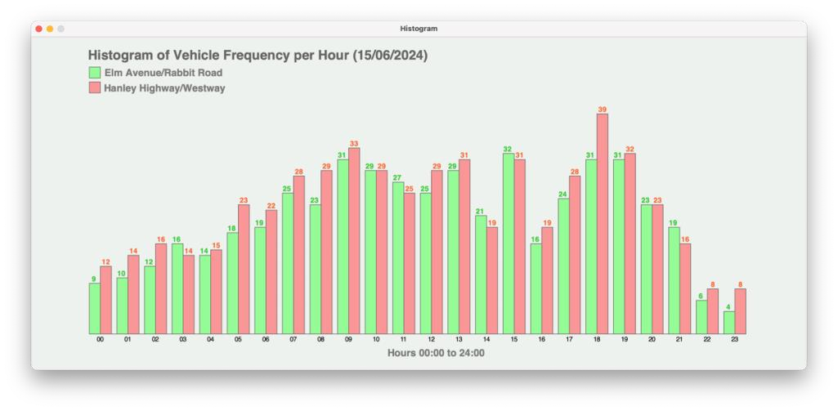

LOOP OR END

Do you want to select another data file for a different date? Y/N > **20**

Please enter “Y” or “N” **n**

End of run

## Coursework Demo (28%)

* You are expected to demonstrate your working solution to your tutor during a scheduled tutorial as shown on the weekly schedule. **NOTE: If you do not attend your demo (without agreed mitigating circumstances) your solution will be marked 0. mitigating circumstances for viva will result doing fresh coursework during refer/defer period**
* Demo marks are allocated for your ability to answer questions and demonstrate understanding of your solutions.
* If you cannot explain your code and are unable to point to a reference within your code of where this code was found (i.e., in a textbook or on the internet) then no marks will be given for the demo of that component.

**General Notes**

* Use user-defined functions in your solution as appropriate.
* Use descriptive names for your variables and functions.
* Comment your code extensively.
* Reference within your code any code adapted from external or other sources.
* Use only the tkinter module to render the histogram.

## References

• Reference any code taken from other sources in your program code with python program comments.

**Marking Scheme**

**A) Input Validation (Task A - 12 Marks)**

* **Design (2.4 Marks)**
  + **Input validation logic clarity (0-1.2):** Clearly structured validation logic, handling all scenarios.
  + **User-friendly prompts (0-1.2):** Detailed prompts to guide the user effectively.
* **Implementation (7.2 Marks)**
  + **Identifies wrong data type (0-3):** Validates data type errors.
  + **Identifies out-of-range values (0-2):** Validates range errors effectively.
  + **Handles edge cases (0-2.2):** Manages edge cases like leap years, empty input, or invalid formats.
* **Testing (2.4 Marks)**
  + **Input validation testing (0-1.2):** Tests for data type and range validations.
  + **Edge case testing (0-1.2):** Demonstrates robust handling of edge cases.

**B) Processed Outcomes (Task B - 24 Marks)**

* **Design (4.8 Marks)**
  + **Data processing logic clarity (0-2.4):** Clear structure for analyzing and summarizing data.
  + **Output clarity (0-2.4):** Well-structured, user-friendly results format.
* **Implementation (14.4 Marks)**
  + **Correctness of results (0-10):** Accurate data processing and calculations.
  + **Clarity in printed results (0-2):** Results are formatted and labeled clearly.
  + **Efficiency of code (0-2.4):** Processes data efficiently without unnecessary operations.
* **Testing (4.8 Marks)**
  + **Functional testing (0-3):** Validates correctness of all results against sample data.
  + **Boundary testing (0-1.8):** Tests for edge cases and large datasets.

**C) Saving to Text File (Task C - 12 Marks)**

* **Design (2.4 Marks)**
  + **Data storage design (0-1.2):** Clear plan for organizing and saving results.
  + **File handling strategy (0-1.2):** Ensures proper file creation, writing, and appending.
* **Implementation (7.2 Marks)**
  + **Correct saving of results (0-3):** Saves results accurately to the file.
  + **Appending data (0-2.2):** Appends results correctly without overwriting.
  + **Error handling (0-2):** Handles file errors (e.g., permissions, missing directories).
* **Testing (2.4 Marks)**
  + **File output testing (0-1.2):** Validates that results are saved correctly.
  + **Append testing (0-1.2):** Tests appending functionality for multiple runs.

**D) Histogram Display (Task D - 24 Marks)**

* **Design (4.8 Marks)**
  + **Histogram layout design (0-2.4):** Plans for scaling, axis labeling, and color coding.
  + **Graph clarity and usability (0-2.4):** Ensures graph is user-friendly and accessible.
* **Implementation (14.4 Marks)**
  + **Correctness of histogram (0-6):** Displays accurate data representation.
  + **Scaling and labeling (0-4):** Axis and scaling are correct and dynamically adapt to data.
  + **Graph accessibility (0-4.4):** Includes title, legend, and readable labels.
* **Testing (4.8 Marks)**
  + **Graph accuracy testing (0-2.4):** Validates graph matches input data.
  + **Graph usability testing (0-2.4):** Ensures graph is readable and meets requirements.

**E) Handling Multiple CSV Files (Task E - 12 Marks)**

* **Design (2.4 Marks)**
  + **Loop structure design (0-1.2):** Plans for handling multiple datasets.
  + **Data clearance and management (0-1.2):** Ensures previous data is cleared efficiently.
* **Implementation (7.2 Marks)**
  + **Loop functionality (0-3):** Processes multiple files correctly.
  + **User interaction (0-2.2):** Handles user inputs robustly for "Y" or "N".
  + **Data independence (0-2):** Ensures each dataset is processed independently.
* **Testing (2.4 Marks)**
  + **Loop testing (0-1.2):** Validates correct looping through multiple files.
  + **Error handling testing (0-1.2):** Ensures errors (e.g., missing files) are handled gracefully.

**F) Program Design (20 Marks)**

* **Design (4 Marks)**
  + **Overall modularity (0-2):** Well-structured code with clear separation of concerns.
  + **Error handling strategy (0-2):** Robust error handling for all components.
* **Implementation (12 Marks)**
  + **Use of functions and classes (0-6):** Modular code using appropriate functions and classes.
  + **Code readability (0-3):** Clean, well-commented, and easy-to-follow code.
  + **Naming conventions (0-3):** Descriptive names for variables, functions, and classes.
* **Testing (4 Marks)**
  + **Test coverage (0-2):** Comprehensive test cases for all functionalities.
  + **Robustness testing (0-2):** Ensures program handles unexpected inputs and edge cases.

**Marking Scheme Summary**

| **Component** | **Design (20%)** | **Implementation (60%)** | **Testing (20%)** | **Total Marks** |
| --- | --- | --- | --- | --- |
| **Task A: Input Validation** | 2.4 | 7.2 | 2.4 | 12 |
| **Task B: Processed Outcomes** | 4.8 | 14.4 | 4.8 | 24 |
| **Task C: Saving to Text File** | 2.4 | 7.2 | 2.4 | 12 |
| **Task D: Histogram Display** | 4.8 | 14.4 | 4.8 | 24 |
| **Task E: Multiple CSV Files** | 2.4 | 7.2 | 2.4 | 12 |
| **Task F: Program Design** | 4.0 | 12.0 | 4.0 | 20 |
| **Total** | 20 | 60 | 20 | 100 |

**Coursework Marks * 72/100 + Coursework Demo Marks * 28/100**

**Pass requirements**

**Pass** (40 marks or above)

**First-Class** (70 marks or above**)**