Yasitha Thilantha

Full-stack Software Engineer

[Yasitha.bangamuwage@gmail.com](mailto:Yasitha.bangamuwage@gmail.com)

+94770036482

Abstract

Proposed fully automated software application to backup Huawei switches configurations monthly based.

Huawei switch backup schedule manager

Software Application

Contents

Huawei switch backup schedule manager 2

Customer requirements 2

Proposed Solution 2

Python based automated software application. 2

Technical specifications of the proposed application development 4

Installation and Technical support 4

Final notes 4

# Huawei switch backup schedule manager

## Customer requirements

Need a software application to backup Huawei switches configurations monthly. (Every 4 weeks)

Each switch should maintain a separate backup folder and it should contain all the backup files (txt file formatted)

Application should be fully configurable to provide Huawei switch device infromation like IP address and credentials via text format.

Need to identify the software application status at any given time along with backup files generating info, application warning info and application usage error handling.

## Proposed Solution

### Python based automated software application.

This software application will be implemented using pure Python (version 3.12.0) scripting language and will run as a windows service in a respective windows computer (fully automated).

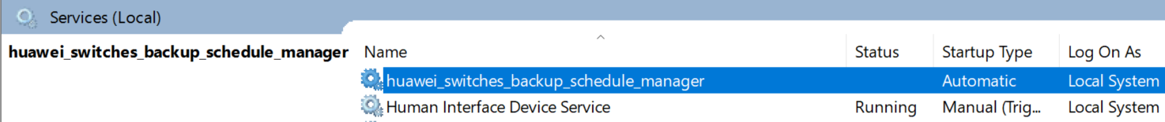

Figure : How implemented application configured as a windows service

Figure : Folder structure of the application

Scheduled software application will run every 4 weeks until the defined windows service stops or windows machine shuts down.

Application will generate and store backup files in dedicated folders according to the given switches information.

Each backup file will contain all the configuration information of the switch when the backup schedule task is executed.

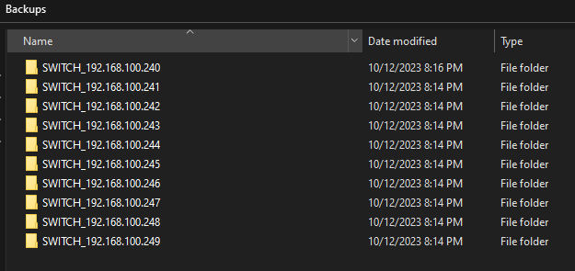

Figure : Switches backup folders

Figure : How backup files located in each switch backup folder.

Each backup file will be named with the device IP address and backup date time.

Ex: SWITCH_192.168.100.240-2023_10_12-07_48_27_PM.txt.

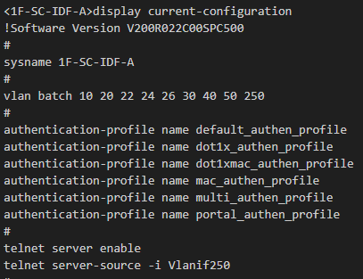

Figure : Backup configuration information of the switch

Application will manage separate log files to provide continuous feedback of work log.

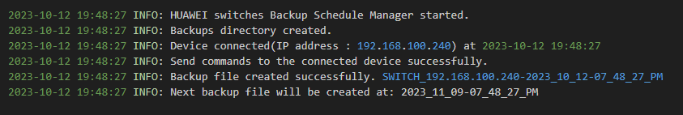

Figure : How log file give continues feedback of the application work status.

User can provide device information to the application via configuration text file.

User can always change the switch device information if needed (After changing the device information, windows service must restart)

Application can support multiple switches (limited) with same vendor and version.

If one of configured switch is not available or could not be able to connect, then it will be ignored, and it does not stop other switches scheduled backup file generation. (System administrator should diagnose failure switch separately, once it is fixed backup generation will start again)

User can always refer log files and follow the instructions to mitigate the application warnings and failures if occurs.

All the generated application log files will also be backed up to trace the work log.

### Technical specifications of the proposed application development

Python scripting language (version 3.12.0)

Open-source python scripting packages (netmiko, schedule, python-dotenv, pyinstaller)

Recommended operating system: Windows 10 or higher versions

Software license: MIT license

### Installation and Technical support

Fully step by step guided software installation documentation will be provided with the application itself.

Initial software installation can be arranged, and technical support can be provided.

### Final notes

Please provide your company direction on the above proposed solution to automate monthly backup configuration of Huawei switches.