Yasitha Thilantha

Full-stack Software Engineer

[Yasitha.bangamuwage@gmail.com](mailto:Yasitha.bangamuwage@gmail.com)

+94770036482

Abstract

Proposed fully automated software application to backup network switches configurations monthly based.

network switches backup schedule manager

Software Application

Contents

Network switch backup schedule manager 2

Customer requirements 2

Proposed Solution 2

Python based automated software application. 2

How application works 4

Features of the application (Release 1.0.0) 5

Limitations 5

Future releases 5

Technical specifications 6

Installation and Technical support 6

Pricing 6

Final notes 6

# Network switch backup schedule manager

## Customer requirements

Need a software application to backup network switches configurations monthly. (Every 4 weeks)

Each switch should maintain a separate backup folder and it should contain all the backup files (txt file formatted)

Application should be fully configurable to provide network switch device infromation like IP address and credentials via text format.

Need to identify the software application status at any given time along with backup files generating info, application warning info and application usage error handling.

## Proposed Solution

### Python based automated software application.

This software application will be implemented using pure Python (version 3.12.0) scripting language and will run as a windows service in a respective windows computer (fully automated).

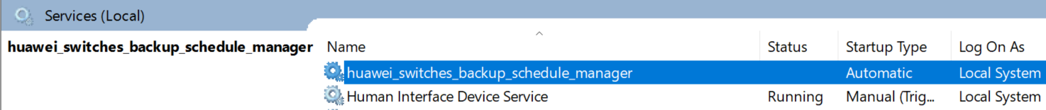

Figure : How implemented application configured as a window service.

Figure : Folder structure of the application

Scheduled software application will run every 4 weeks until the defined windows service stops or windows machine shuts down.

Application will generate and store backup files in dedicated folders according to the given switches information.

Each backup file will contain all the configuration information of the switch when the backup schedule task is executed.

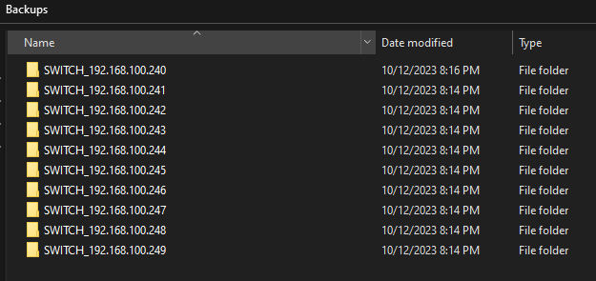

Figure : Switches backup folders

Figure : How backup files located in each switch backup folder.

Each backup file will be named with the device IP address and backup date time.

Ex: SWITCH_192.168.100.240-2023_10_12-07_48_27_PM.txt.

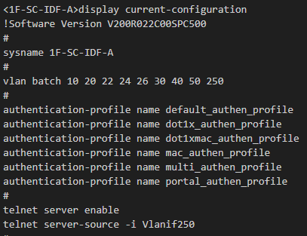

Figure : Backup configuration information of the switch

Application will manage separate log files to provide continuous feedback of work log.

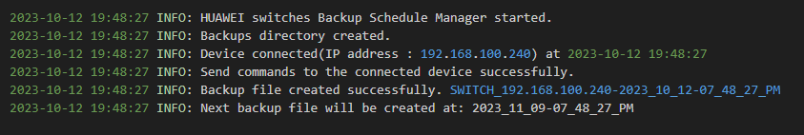

Figure : How log file give continues feedback of the application work status.

User can provide device information to the application via configuration text file.

User can always change the switch device information if needed (After changing the device information, windows service must restart)

Application can support multiple switches (limited) with same vendor and version.

If one of configured switch is not available or could not be able to connect, then it will be ignored, and it does not stop other switches scheduled backup file generation. (System administrator should diagnose failure switch separately, once it is fixed backup generation will start again)

User can always refer log files and follow the instructions to mitigate the application warnings and failures if occurs.

All the generated application log files will also be backed up to trace the work log.

### How application works

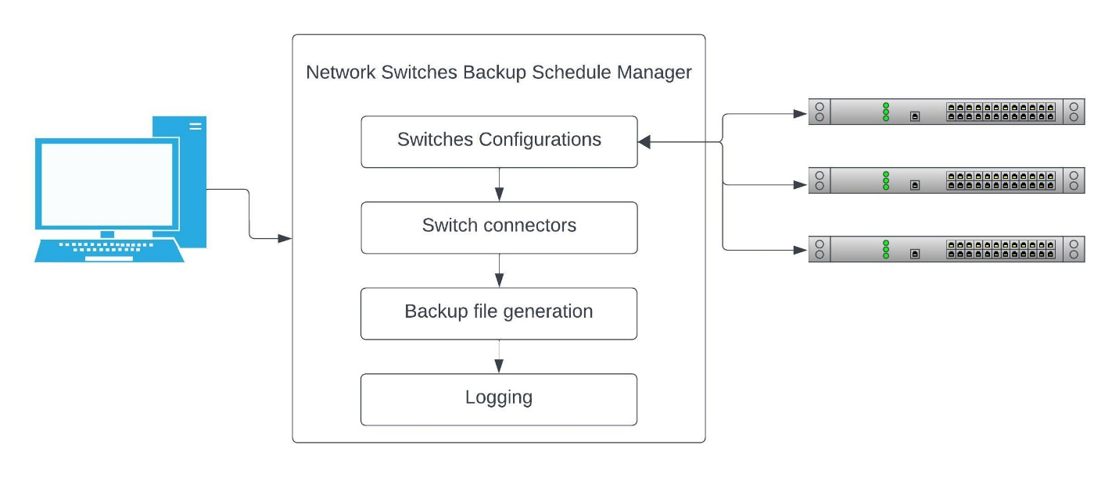

Figure :How application works

### Features of the application (Release 1.0.0)

* Support Huawei and Cisco XE network switches.
* Maximum ten switches per device type can handle asynchronously. (Application fully configured to Huawei and cisco both total 20 devices).
* Able to configure both device types or only single device type according to the network.
* User can provide device information and application configurations with less effort, and it will be a single task.
* Powerful logging mechanism to track application work history.
* Automatically scheduled all configured switches to backup after every four weeks once start the application.
* Can run the application in any windows server environment with less configurations like windows service.
* Application can get fully windows services features like run the application when windows server up.
* Can place the application in any folder structure and it will do the backup file generation and file creation automatically.
* All the application logs are automatically achieved to trace the history.
* Application scheduled task can be stopped to update device information if needed once it up again application will work again without breaking the backup functionality.
* Validate all the device information before connecting to each mentioned switches for better performance.
* Run only specific backup configuration related commands to get the data and close the connection when application task is completed to secure the connection.
* Full user manual documentation provides to install and configure.

### Limitations

All network switches need to configure SSH before connecting to the application.

### Future releases

* Can be able to change the backup generation duration time with custom value.
* Cab be able to add more network device types other than Huawei and cisco.
* Can be able to provide automated notification mechanism.
* Can be able to provide more network automation functionalities if requested.

### Technical specifications

Python scripting language (version 3.12.0)

Open-source python scripting packages (netmiko, schedule, pyinstaller, jsonschema)

Recommended operating system: Windows 10 or higher versions

Software license: MIT license

### Installation and Technical support

Fully step by step guided software installation documentation will be provided with the application itself.

Initial software installation can be arranged, and technical support can be provided.

### Pricing

|  |  |  |  |
| --- | --- | --- | --- |
| Item | Number of hours | Hourly rate $ | Amount $ |
| Design solution and the application structure. | 6 |  |  |
| Design and implement Huawei network switches connection. | 8 |  |  |
| Design and implement Cisco network switches connection. | 8 |  |  |
| Design and implement device configuration information to the application. | 5 |  |  |
| Design and implement backup file generation. | 4 |  |  |
| Design and implement application logging mechanism. | 6 |  |  |
| Design and implement application deployment process (Documentation). | 4 |  |  |
|  |  |  | 450 |

### Final notes

Please provide your company direction on the above proposed solution to automate monthly backup configuration of network switches.