
Arab American University – Palestine
Faculty of Engineering

AI-Powered Gamified Platform for Paediatric Speech Therapy Using Computer Vision and Generative Language Models
(NutoqAI / نُطق آي)
By
Hussein Salah Younis

Supervisor
Dr. Hussein Salah Younis

This thesis was submitted in partial fulfilment of the requirements for the bachelor's degree in Computer Systems Engineering

March 2026
© Arab American University 2026. All rights reserved.

Declaration
I Hussein Salah Younis, hereby declare that the work presented in this thesis has not been submitted for any other degree or professional qualification and that it is the result of my independent work.

Signed:

Date:

Acknowledgments
In the name of Allah, the Most Gracious, the Most Merciful
I would like to begin by dedicating this work to the memory of my father, Dr. Salah Younis. He has always been a tremendous source of inspiration and motivation for me to strive for success. His dedication to hard work and unwavering determination to achieve goals have made him an exemplary figure in my life. I am deeply grateful for the support and encouragement he provided throughout his life, and I hope that he would be proud of the accomplishments I have achieved.
I would also like to express my sincere gratitude to my supervisor, Dr Amjad Rattroot, for his valuable guidance and advice throughout the preparation of this thesis. His expertise and unwavering support have played a crucial role in the success of this thesis.
Furthermore, I extend my deepest thanks and appreciation to all those who have contributed to the completion of this master's thesis. Without your continuous support and encouragement, this achievement would not have been possible.
I would also like to acknowledge the faculty members and colleagues who have provided guidance and assistance during this thesis journey. Your experiences and expertise have greatly influenced the outcomes of this thesis, and I am truly grateful for your contributions.
To my family and friends, I express my heartfelt thanks for your unwavering support and encouragement at every stage of this thesis. Your moral support has been instrumental in my ability to achieve this milestone.
Finally, I eagerly anticipate presenting the findings of this thesis with pride and confidence, with the hope that it will contribute to knowledge and advancement in the field of study.
Once again, I would like to express my gratitude to everyone for their valuable contributions and continuous support.
Hussein Younis
March 2024

Abstract
The manufacturing of semiconductor wafers is a complex process that is prone to defects. In this study, we present DefectClassifierX, an automated pattern classification system that uses a convolutional neural network model based on the GoogLeNet architecture and leverages CUDA for faster training and testing speed. We aim to improve defect classification in the semiconductor manufacturing process by accurately classifying single and mixed wafer defect patterns. To validate our approach, we conducted thorough experimentation using the newly introduced dataset called "WM-300K+ wafer map [single and mixed]," which consists of 36 different defect patterns. The experiment results show that the precision, recall, and F1-score for testing our model were all measured at 0.97, indicating excellent performance. Also, the results demonstrate a remarkable level of accuracy, with an average classification accuracy of 99.9% for both single and mixed defect types. Our approach outperforms previous studies in wafer defect pattern classification and has the potential to significantly improve the efficiency and effectiveness of wafer defect analysis in semiconductor manufacturing. Additionally, we utilized hyperparameter tuning with Optuna and implemented a patience stop mechanism for improved convergence. Moreover, we incorporated the AdamW optimizer to further enhance the model's performance. DefectClassifierX is compatible with multiple operating systems, ensuring accessibility for a broader user base. While our results are encouraging, further research is needed to address limitations regarding dataset quality, computational resource requirements, and data augmentation techniques. Additionally, it is important to evaluate the model using real wafer map images for practical applicability assessment.

Table of contents

Declaration ii
Acknowledgments iii
Abstract iv
Table of contents 5
List of Tables 6
List of Figures 8
List of Abbreviations 10
Chapter 1: Introduction 13
1.1 Background Information 13
1.2 Research Problem and Questions 16
1.3 Aims and Objectives of the Study 17
1.4 Motivation And Significance of The Study 18
1.5 Research Scope and Outlines 19
1.6 Thesis Organization 19
Chapter 2: Preliminaries 20
2.1 Digital Images 20
Chapter 3: Literature Reviews 21
3.1 Overview of Relevant Literature 21

List of Tables
Table 1: Defect Patterns and Related Issues in Manufacturing. 13
Table 2: A comprehensive overview of the performance of different CNN models in defect classification. 20

List of Figures

Figure 1: A sample of silicon ingots and wafer surfaces 10
Figure 6: The RGB representation of digital image, explaining the color channels used in pre-processing raw images for CNN-based defect classification. 17

List of Abbreviations
ML Machine Learning
AI Artificial Intelligence
DL Deep Learning
CNN Convolutional Neural Network
CUDA Compute Unified Device Architecture
CBAM Convolutional Block Attention Module
ANN Artificial Neural Network
CCE Categorical Cross-Entropy
Relu Rectified Linear Activation Function
C+EL Center with Edge-Loc
C+ER Center with Edge-Ring
C+L Center with Loc
C+S Center with Scratch
L+S Loc with Scratch
D+S Donut with Scratch
D+EL Donut with Edge-Loc
D+ER Donut with Edge-Ring
D+L Donut with Loc
EL+L Edge-Loc with Loc
EL+S Edge-Loc with Scratch
ER+L Edge-Ring with Loc
ER+S Edge-Ring with Scratch
C+EL+S Center with Edge-Loc with Scratch
C+ER+S Center with Edge-Ring with Scratch
C+EL+L Center with Edge-Loc with Loc
C+ER+L Center with Edge-Ring with Loc
C+L+S Center with Loc with Scratch
D+EL+S Donut with Edge-Loc with Scratch
D+ER+S Donut with Edge-Ring with Scratch
D+EL+L Donut with Edge-Loc with Loc
D+ER+L Donut with Edge-Ring with Loc
D+L+S Donut with Loc with Scratch
EL+L+S Edge-Loc with Loc with Scratch
C+L+EL+S Center with Loc with Edge-Loc with Scratch
C+L+ER+S Center with Loc with Edge-Ring with Scratch
D+L+EL+S Donut with Loc with Edge-Loc with Scratch
D+L+ER+S Donut with Loc with Edge-Ring with Scratch
GPU Graphical Processing Unit
JSON JavaScript Object Notation
HTTP Hypertext Transfer Protocol
Apis Application Programming Interfaces
Urls Uniform Resource Locators
Adamw Adam With Weight Decay Regularization
Adam Adaptive Moment Estimation
ROC Receiver Operating Characteristic
TP True Positives
TN True Negatives
FP False Positives
FN False Negatives
TPR True Positive Rate
FPR False Positive Rate

Introduction
This chapter serves as an introduction to the study. It provides background information on the topic and presents the research problem and questions that will be addressed. The aims and objectives of the study are outlined, highlighting the purpose and goals. The significance and motivation behind the study are discussed, emphasizing its importance. Additionally, the chapter delves into the research scope, defining the boundaries and extent of the study. Lastly, the organization of the thesis is described, providing an overview of how the subsequent chapters are structured.

Background Information
The demand for electronic devices has significantly increased owing to the Fourth Industrial Revolution (Industry 4.0), These components and their connections are built on a semiconductor wafer typically composed of single-crystal Si, as shown in Figure 1.
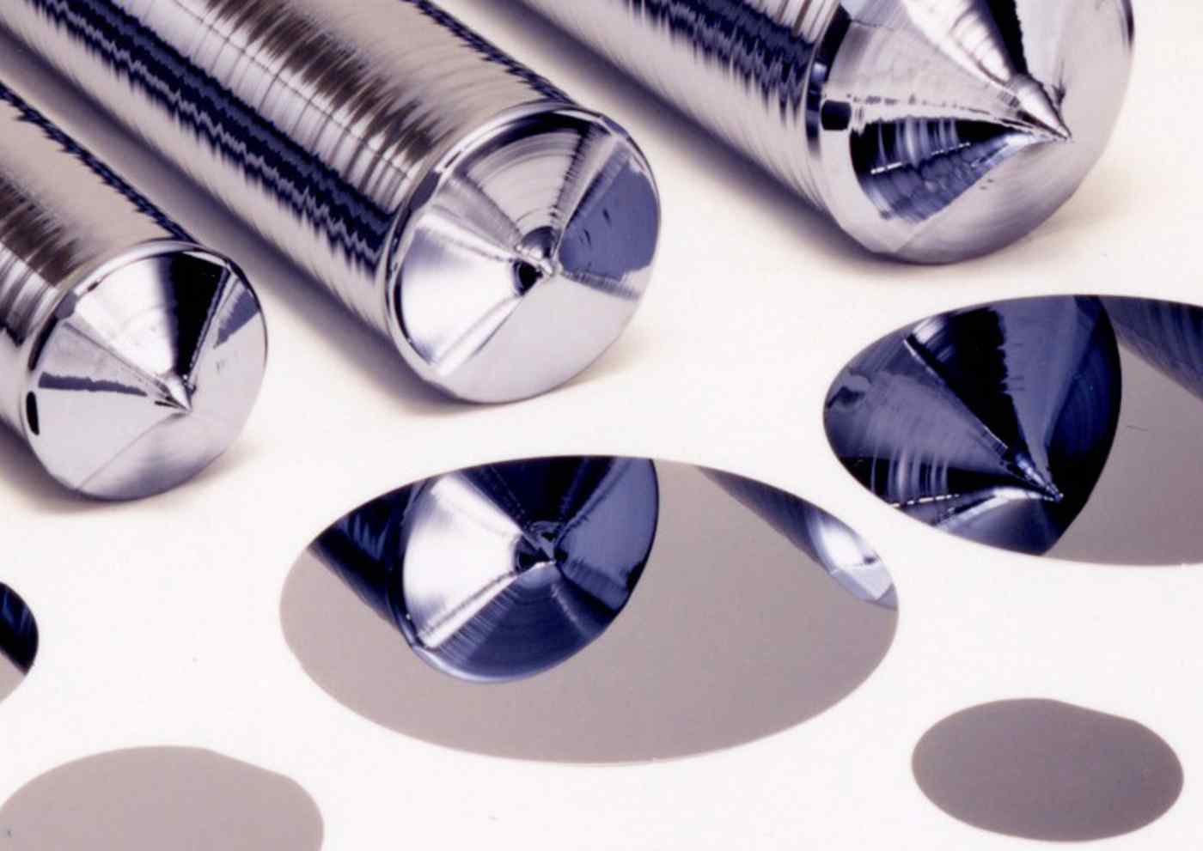
Figure 1: A sample of silicon ingots and wafer surfaces
In the context of silicon wafer manufacturing, the processes include general steps such as Wafer processing, Oxidation, Photomask, Etching, Film Deposition, Interconnection, Testing and Packaging. The details of these steps are as follows:
- Wafer processing: In this process, silica sand is heated to separate silicon and carbon monoxide until ultra-high-purity electronic-grade silicon (EG-Si) is obtained. Then the “EG-Si” is melted and cast into a large cylinder form called “ingot.” After that, the “ingot” is sliced into a certain thickness called "die" which is an unprocessed raw wafer.
- Oxidation: In this process, a protection layer is added to the wafer surface to protect it from chemical impurities, current leakage, and wafer slipping during the etching phase.
Semiconductor wafer manufacturing is a series of costly, complicated, and highly disciplinary processes in which the incidence of defects is significant. Complex and time-consuming diagnosis, inspection, and analysis processes are required in each phase to detect defects, which helps semiconductor engineers track and handle the source of failure in each phase before reaching the final production stage and ensure that the components are aligned correctly and operated correctly in a desired manner.
Table 1 provides a summary of different defect patterns encountered in the manufacturing process and their related issues. Each defect pattern is associated with specific causes and implications, ranging from alignment and etching problems to contamination, uneven deposition, material defects, insufficient material, impurities, equipment malfunctions, and mishandling by the machine. Understanding these defect patterns is crucial for identifying and addressing manufacturing issues effectively.
Table 1: Defect Patterns and Related Issues in Manufacturing.
Defect Pattern | Related Issues
Center | It indicates issues with alignment or positioning during the manufacturing process.
Donut | It may be caused by problems with the etching process or contamination during manufacturing.
Edge-Loc | It could be caused by improper handling or alignment during manufacturing.
Edge-Ring | It associated with problems encountered during the etching process.
Loc | It could be caused by various factors such as contamination, uneven deposition, or material defects.
Near-full | It could be caused by problems with the deposition process or insufficient material.
Random | It could be caused by various factors such as impurities, equipment malfunctions, or process variations.
Scratch | It often indicates mishandling by the machine or improper contact during manufacturing.

This study introduced a silicon wafer defect classification system using deep learning techniques by adapting a deep convolutional neural network (CNN) as a model for wafer defect classification using wafer-map images as inputs. This approach relies on a series of data pre-processing and data augmentation operations to produce an effective method to advance the classification of single or mixed-type wafer map defects. In addition, this study introduced an automated pattern classification system for wafer defects called “DefectClassifierX.” The motivation behind this study was to develop an accurate and efficient system for classifying silicon wafer defects by leveraging DL techniques.

Research Problem and Questions
The production of semiconductor wafers involves complex procedures and strict quality-control measures. Defects in wafer manufacturing are common and necessitate thorough assessment, inspection, and analysis at each stage of production. Early defect classification plays a crucial role in addressing this issue effectively. Deep learning techniques have shown promise for achieving accurate and automated defect classification. However, a major challenge is the limited availability of public datasets specifically designed for wafer map defects.
The challenges of deep-learning-based classification models for wafer map defects can be summarized as follows:
- Limited availability of datasets: One challenge in this research area is the scarcity of publicly available datasets for wafer map defects, which hampers the evaluation and comparison of deep-learning-based defect classification models on diverse datasets. Furthermore, owing to ownership rights and confidentiality concerns, electronic wafer designs are often inaccessible to researchers, making it difficult to obtain crucial resources for analysis.
- Preparation of data: To ensure the accurate classification of defects, it is crucial to identify and implement appropriate methods for data preparation before the training and testing phases of the deep learning-based model.
- Investigation of deep learning-based model for classification of mixed-type defects: It is important to assess the capability of the deep learning-based model to accurately classify multiple defects within a single wafer, particularly when dealing with mixed types of wafer defect patterns.
- Achieving high classification performance: It is essential to identify effective methods to achieve high classification performance using deep-learning-based models.
- Overcoming performance problems: It is necessary to find solutions to address performance problems, such as memory limits during the pre-processing of data, training, and evaluation of the DL model.
These challenges were mapped using the following questions:
- What are the appropriate methods for addressing class imbalance issues in an available dataset?
- What are the appropriate methods for preparing data before the training and testing phases of a DL model?
- How can mixed-type wafer defect patterns be generated? Can the DL model accurately classify multiple defects on a single wafer?
- What are the methods for achieving high classification performance using deep learning-based classification models?
- How can performance problems such as memory limits that may appear during the pre-processing of the data, training, and evaluation of the DL model be addressed?

Aims and Objectives of the Study
This study aims to revolutionize the classification of silicon wafer defects by developing an automated system that surpasses the limitations of traditional methods. A deep convolutional neural network architecture is employed as a model for classifying single and mixed types of wafer defects using wafer map images.
The approach involves data pre-processing and augmentation to enhance the accuracy of defect classification, reduce false positives and false negatives, and improve overall manufacturing efficiency. The implementation of this system can bring about significant implications for the semiconductor industry, including enhanced quality control, cost reduction, increased productivity, and improved customer satisfaction by achieving the objectives outlined below.
Therefore, this aim is achieved through the following objectives:
RO1: Produce a new, balanced wafer map defect dataset that includes various types of defects. Address the issues present in the current dataset, such as class imbalance, to ensure a more representative and balanced dataset for training and evaluation.
RO2: Publish the dataset to provide researchers with a representative and reliable resource for conducting in-depth studies and advancing the field of wafer map defect analysis.
RO3: Develop and deploy a customized DL model for accurate classification of wafer defects in an autonomous system that surpasses the performance of existing methods by achieving high precision and accuracy in categorizing different types of defects present on wafers.
RO4: Improve the DL model's capability to accurately classify mixed types of defect patterns in a single wafer map by developing techniques to address the complexity and variability associated with mixed-type defects, thereby achieving precise classification outcomes.
RO5: Enhance the processing speed and efficiency of the DL classification model and overcome performance limitations by employing parallel computation techniques such as Compute Unified Device Architecture (CUDA).

Motivation And Significance of The Study
This study aims to revolutionize wafer defect classification using deep learning techniques. Traditional methods have limitations in accuracy and efficiency, leading to quality control issues, increased costs, and decreased productivity. The available dataset also has issues such as class imbalance and limited labelled data, affecting classification accuracy and efficiency.
The proposed automated pattern classification system for wafer defects called "DefectClassifierX" utilizes deep learning, specifically a deep CNN architecture, to accurately classify both single and mixed types of wafer defects using wafer map images. The study employs modern techniques like data preprocessing and augmentation to overcome dataset problems, improve defect classification accuracy, reduce false positives and false negatives, and enhance manufacturing efficiency.
Implementing this system has significant implications for the semiconductor industry. It enhances quality control by accurately identifying and rectifying defects, increasing productivity through faster defect classification and allowing for timely interventions. Ultimately, it improves customer satisfaction by delivering high-quality electronic components.
The study's specific goals include producing a new and balanced wafer map defect dataset called "WM-300K+ wafer map [Single & Mixed]" for single and mixed types of defect patterns, publishing it to advance the field, developing and deploying a customized deep learning model for accurate classification, improving the model's capability to handle mixed-type defects, and enhancing process speed and efficiency through CUDA. This study has the potential to transform wafer defect classification, benefiting the semiconductor industry with enhanced quality control, cost reduction, increased productivity, and improved customer satisfaction.

Research Scope and Outlines
The research scope of this study is to create an accurate and effective system for classifying defects in silicon wafers through the application of DL techniques based on CNN that leverages wafer map images as input data. Various techniques for data preprocessing and augmentation are incorporated in the proposed methodology to enhance the classification of single or mixed types of wafer defect patterns. As a result, the baseline performance exceeds 90% accuracy. However, this research aims to achieve model performance with a maximum error rate of 10%. Therefore, we are introducing a production-ready software model solution. The "WM-811k" dataset is utilized, which includes single or mixed defect patterns and employs different strategies for data preprocessing to address imbalanced class issues. a new balanced wafer map defect dataset that includes various types of single and mixed defects will be published via the Kaggle website.
The study will present an application that takes input images of defects and outputs their respective defect classes. The application will be designed to be user-friendly, efficient, and reliable for seamless integration into the manufacturing process.

Thesis Organization
The rest of this thesis is organized into several chapters. Chapter 2 discusses key theories and concepts related to digital images and convolutional neural networks (CNNs).
Chapter 3 reviews the existing literature related to the research topic, identifies gaps or limitations in the existing literature, highlights areas where further research is needed.
Chapter 4 describes the dataset used in the research, analyzes its characteristics, explains the data preprocessing techniques applied, presents data augmentation techniques for increasing defect pattern frequencies and generating mixed defect patterns, and discusses the categorical encoding technique used for labels or classes.
Chapter 5 presents the proposed methodology for solving the research problem, explains the GoogLeNet model and its components, discusses the implementation details of the classification framework and application development, discusses hyperparameter tuning and optimization techniques, and discusses evaluation metrics for assessing model performance.
Chapter 6 lists the development tools and system requirements used in the research project, describes the experimental setup, presents the results obtained from training experiments, evaluates model performance, discusses memory limit issues encountered during experiments and their solutions, analyzes and discusses results in comparison with previous research findings.
Chapter 7 summarizes the contributions made by the research study, discusses limitations faced during the research project, proposes potential future research directions or extensions, and provides a concise conclusion summarizing key findings and outcomes of the study.

Theoretical Framework & Clinical Assessment Criteria
Early detection and initial diagnosis of speech disorders in children are crucial and represent a significant step in treatment, requiring adherence to established scientific principles to achieve optimal outcomes. In this chapter we discuss the current theoretical frameworks and accepted criteria for assessing a child's language development. It also examines age-based diagnostic approaches and how to classify and measure the severity of speech and language disorders in children based on established standards.
تعد عملية الكشف المبكر والتشخيص الاولي لاضطرابات النطق لدى الأطفال نقطة فارقة ومهمة في العلاج حيث لا بد من اتباع أسس علمية ومثبتة من أجل الحصول على أفضل النتائج. يناقش هذا الفصل الأطر النظرية والمعايير المعتمدة الحالية لتحديد نمو الطفل اللغوي. كما ويناقش التشخيص القائم على الفئات العمرية الحرجة وكيفية تصنيف وقياس شدة الاضطرابات النطقية والكلامية لدى الطفل بناء على معايير ثابتة.

Standardized Clinical Frameworks
هناك العديد من الباحثين العرب الذي قدموا العديد من الأطر والمعايير لتقييم اضطرابات التخاطب بناء على مجموعة من الاختبارات المقننة الطبية والتربوية، ولعل أبرزها:
- اختبار الباحثة نهلة الرفاعي والذي يعد أداة تقييم تقيس المهارات اللغوية والتواصل الاساسية صدر في سنة 1996، يتضمن هذا الاختبار عدة محاور تشمل الجانب الاستقبالي والتعبيري، الانتباه والتواصل البصري، مهارات التقليد وفهم الجمل.
  - الفئة العمرية المستهدفة: من سنتين الى 7 سنوات و5 شهور و29 يوم.
  - من عيوبه أنه غير مقنن حيث لا يوفر تغذية راجعة يمكن الاعتماد عليها بشكل كلي لعلاج الطفل وانما فقط يوفر درجة تقديرية لعمر الطفل اللغوي.
- اختبار النطق المصور للأطفال: أداة تشخيصية لحصر عيوب النطق وتقييم سلامة مخارج الحروف في مواضيع الكلمة المختلفة (أول، وسط، أخر الكلمة) للدكتور أحمد أبو حسيبة.
  - الفئة العمرية المستهدفة: من سنتين و5 أشهر الى 7 سنوات.
  - من عيوبه أنه يعتمد بشكل أساسي على الصور وبالتالي في حال كان الطفل لديه مشكلات بصرية أو تشتت انتباه حاد فقد يحصل على تقييم أقل من قدرته اللغوية الفعلية.
- مقياس شدة التلعثم المعرب (Riley, 2009 / SSI-4): الإطار المعتمد لتقييم اضطرابات طلاقة الكلام، وقياس النسبة المئوية للتكرار والإطالة والسلوكيات الحركية المصاحبة.

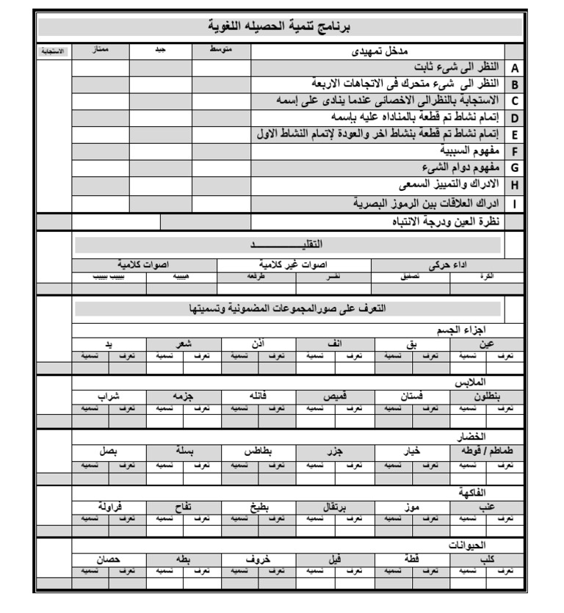
Many Arab researchers have presented numerous frameworks and criteria for assessing speech disorders based on a range of standardized medical and educational tests, perhaps the most prominent of which are:
Digital images play a vital role in the digital information system and contemporary communication because

مقياس شدة التلعثم المعرب (Riley, 2009 / SSI-4)
يعد مقياس شدة التلعثم العالمي المعروف باسم "Stuttering Severity Instrument - SSI" من أشهر الاختبارات التي توضح مسار حسابي رقمي دقيق لمدى شدة التلعثم لدى الطفل حيث يقيس ثلاثة أبعاد سريرية: التكرار (Frequency)، المدة الزمنية للقطع (Duration)، والسلوكيات الحركية المصاحبة (Physical Concomitants). قامت العديد من الجامعات العربية والمراكز المتخصصة في هذا المجال بتعريب هذا الاختبار ليتناسب مع البيئة العربية. يقوم هذا الاختبار على تقسيم الأطفال الى قسيمين رئيسيين:
- الأطفال الغير قادرين على القراءة وتتراوح أعمارهم من سن 2 الى 4 سنوات حيث يتم عرض صور أمام الطفل ويطلب منه وصف ما يشاهد لمدة تتراوح ما بين 3 الى 5 دقائق أو تسجيل صوت الطفل خلال اللعب بالدمى.
- الأطفال القادرين على القراءة وتترامح أعمارهم ما بين 5 الى 6 سنوات حيث يتم عرض فقرة ويطلب منهم قراءة النص أو القراءة العفوية ومن ثم تحليل ذلك.
يقوم هذا الاختبار على تسجيل القراءة لحوالي من 50 الى 100 كلمة/مقطع مع استبعاد أول 25 كلمة من الحسابات كفترة إحماء (Warm-up phase) حيث في العادة يكون الطفل في البداية يعاني من التوتر مما يؤدي الى ارتفاع مؤقت في شدة التلعثم خلال تلك الفترة.
يتم حساب نسبة اضطراب الطلاقة والتكرار في العينة المسجلة وفق المعادلة التالية:

$SS=\left(\frac{N_{stuttered}}{N_{total}-25}\right)*100\%$ | (1)
حيث أن:
- $N_{stuttered}$ تمثل عدد الكلمات التي حدث فيها تلعثم صريح.
- $N_{total}$ تمثل اجمالي عدد الكلمات التي قرأها الطفل.
من ثم يتم رصد التلعثم زمانيا من خلال حساب المتوسط الحسابي لأطول ثلاث نوبات تلعثم من خلال المعادلة:
$D_{avg}=\frac{D_{1}+D_{2}+D_{3}}{3}$ | (2)
حيث تمثل القيم ($D_{1},D_{2},D_{3}$) الفترات الزمنية بالثواني لأطول 3 سكتات أو تشنجات نطقية على حدة.

Table 2: مصفوفة تحويل النسبة المئوية للتلعثم (%SS) في القراءة إلى نقاط معيارية
%SS | Frequency Score | الدلالة العيادية السريرية
$$SS< 1\%$$ | 0 | طلاقة طبيعية ضمن النطاق الآمن
$$1\%≤ SS≤2\%$$ | 2 | مؤشر أولي على تعثر طفيف وعابر
$$3\%≤ SS≤4\%$$ | 4 | بداية الخروج عن نمط الكلام الطبيعي
$$5\%≤ SS≤7\%$$ | 6 | تكرار ملحوظ يعيق انسيابية الحديث
$$8\%≤ SS≤11\%$$ | 8 | اضطراب طلاقة متوسط الشدة
$$12\%≤ SS≤15\%$$ | 10 | اضطراب طلاقة شديد ومقيد للتواصل
$$16\%≤ SS≤20\%$$ | 12 | اضطراب حاد وتفتت في إنتاج الكلمات
$$SS\%>20\%$$ | 14-18 | عجز فونولوجي كامل في تدفق القراءة

Table 3: مصفوفة تحويل متوسط مدة نوبات التلعثم $D_{avg}$إلى نقاط معيارية
$$D_{avg}$$ | Duration Score | الدلالة العيادية السريرية
أقل من 0.5 ثانية | 2 | وقفات خاطفة لا تخل بالسياق العام
0.5 - 0.9 ثانية | 4 | حبس صوتي قصير المدى
1.0 - 1.9 ثانية | 6 | تشنج عضلي ملحوظ في أعضاء النطق
2.0 - 2.9 ثانية | 8 | حبس صوتي حاد ومجهد للطفل
3.0 - 4.9 ثوانٍ | 10 | انقطاع طويل مصحوب بضغط هوائي
5.0 ثوانٍ فأكثر | 12-14 | انسداد كامل لمجرى النطق (Blockage)

يتم احتساب الدرجة الكلية للاضطراب من خلال جمع النقاط المعيارية للتكرار والمدة، مضافاً إليها نقاط السلوكيات المصاحبة (Physical Concomitants Score) والتي تتراوح قيمتها الإجمالية من (0 إلى 15) نقطة بناءً على فحص خمس مجموعات عضلية وسلوكية (الأصوات المشتتة، التعبيرات الوجهية، حركات الرأس، حركات الأطراف) حيث يُعطى كل سلوك تقييماً عيادياً من 0 (لا يوجد) إلى 5 (شديد جداً):
$Total Score =Frequency Score+Duration Score+Physical Concomitants Score$ | (3)
بناءً على الناتج النهائي للدرجة الكلية (Total Score)، يتم استخراج التشخيص ومستوى الشدة بدقة وفقاً لجدول التصنيف المعياري للأطفال (من سن 4 إلى 12 سنة):

Table 4: تصنيف مستوى شدة التلعثم بناءً على الدرجة الكلية المجمعة
Total Score Range | Severity Level | التوجيه والقرار العلاجي المعتمد عيادياً
0-8 | طبيعي / سليم (Very Mild / Normal) | لا يتطلب تدخلاً عيادياً مباشراً؛ توصية بنصائح وقائية للأهل.
9-15 | بسيط (Mild) | جلسات إرشاد وتدريبات استرخاء وتشكيل الطلاقة اللفظية.
16-25 | متوسط (Moderate) | خطة علاجية مخصصة؛ تدريب على التحكم بمعدل سرعة الكلام.
26-31 | شديد (Severe) | علاج مكثف ومستمر؛ دمج الدعم السلوكي والمعرفي للطفل.
32 and more | شديد جداً (Very Severe) | عجز تواصل كلي؛ يستدعي تأهيلاً سلوكياً ونفسياً وتداخلاً شاملاً.

اختبار الرفاعي للنمو اللغوي
يهدف هذا الاختبار الى قياس النسبة الكلية للتطور والنمو اللغوي للطفل مقارنتا بعمره الزمني حيث يتم طرح مجموعة من الأسئلة في الجانب الاستقبالي والتعبيري وبناء على ذلك يتم حساب العمر اللغوي للطفل وفق المعادلة التالية:
$LQ=\left(\frac{LA}{CA}\right)*100$ | (1)
حيث أن:
- $LQ$ يمثل الحاصل اللغوي للطفل.
- LA (Language Age): العمر اللغوي للطفل (بالشهور)
- CA (Chronological Age): العمر الزمني الفعلي للطفل (بالشهور).

LQ Range | Clinical Classification | System Action / Track
$$≥130$$ | Very Superior / Linguistic Giftedness | Advanced enrichment exercises.
120 – 129 | Superior / High Average Language Intelligence | Complex storytelling and narrative tracks.
110 – 119 | High Average | General preventive activities.
90 – 109 | Average (Normal Range) | Normal development; reassurance report for parents.
80 – 89 | Low Average / Borderline Delay | "Preventive monitoring" and intensive home stimulation.
70 – 79 | Mild to Moderate Language Delay | Trigger Flag: Mandatory therapy plan & specialist referral.
$$<70$$ | Severe Language Delay | Critical Alert: Lock auto-diagnosis; mandate cognitive/hearing tests.

اختبار اللغة التعريبي المقنن للبيئة العربية (الرفاعي، 2010)
يتم هذا الاختبار من خلال مسارين الأول من خلال الفحص المباشر للطفل أو من خلال استبيان موجه للأهل في حال تعذر فحص الطفل بشكل مباشر. يقسم هذا الاختبار الى ثلاثة أجزاء يقيس كل منها جانب محدد من مهارات التواصل.
أولاً: محاور التطبيق العيادي (Clinical Assessment Pillars)
ينقسم تطبيق الاختبار إلى ثلاثة أجزاء رئيسية يقيس كل منها جانباً محدداً من مهارات التواصل:
- تقييم اللغة الاستقبالية (Receptive Language Evaluation):
  - كيف يُطبق: يقيس مدى فهم واستيعاب الطفل للغة المنطوقة والمفاهيم المحيطة به دون أن يُطلب منه التحدث.
  - أمثلة عيادية للتطبيق:
    - التعرف على المجموعات الضمنية: يُعرض أمام الطفل مجموعة صور (تفاحة، موزة، سيارة) ويُقال له: "أشر إلى الفاكهة".
    - تنفيذ الأوامر المركبة: يُطلب من الطفل تنفيذ أمر من خطوتين مثل: "ضع القلم على الطاولة ثم افتح الصندوق".
    - فهم القواعد: عرض صورتين (قطة واحدة، وثلاث قطط) وسؤال الطفل: "أين هي القطط؟" (لقياس فهم صيغة الجمع).
- تقييم اللغة التعبيرية (Expressive Language Evaluation):
  - كيف يُطبق: يقيس قدرة الطفل على استخدام الكلمات وصياغة الجمل للتعبير عن أفكاره واحتياجاته.
  - أمثلة عيادية للتطبيق:
    - التسمية التعبيرية: الإشارة إلى مجسم أو صورة (كلب) وسؤال الطفل: "ما هذا؟" (يجب أن ينطق الكلمة).
    - بناء الجمل وقواعدها: عرض صورة لطفل يشرب الماء، وسؤال الطفل: "ماذا يفعل الولد هنا؟" (يُقيم الأخصائي هل قال "ولد يشرب" أم اكتفى بكلمة "مي").
    - إعادة الجمل: يلفظ الفاحص جملة مثل "السيارة الحمراء سريعة جداً" ويطلب من الطفل إعادة إنتاجها بدقة لتقييم الذاكرة السمعية اللفظية وسياق القواعد.
- سياق التواصل وعتبة المفردات (Pragmatics & Vocabulary Cap):
  - التركيز على حجم الحصيلة اللغوية وسياق استخدام اللغة في مواقف الحياة اليومية (مثل التعبير عن الجوع، الألم، أو طلب المساعدة).

ثانياً: شروط وقواعد تطبيق الاختبار (Standard Testing Rules)
أثناء تطبيق اختبار الرفاعي، يلتزم الفاحص (أو النظام البرمجي) بالقواعد القياسية التالية لضمان عدم إجهاد الطفل:
- قاعدة البداية (Starting Point): لا يبدأ الاختبار من السؤال الأول لكل الأطفال. بل يبدأ من بند مخصص متوافق مع العمر الزمني للطفل (مثلاً: طفل عمره 4 سنوات يبدأ من البند رقم 20 مباشرة لأن ما قبله يفترض أنه يتقنه تِلقائياً).
- سقف الاختبار (Ceiling Rule): يتوقف تطبيق الاختبار فوراً إذا أخطأ الطفل في عدد محدد من الإجابات المتتالية (مثلاً: 5 أخطاء متتالية). هذا يعني عيادياً أن الطفل وصل إلى الحد الأقصى لقدراته اللغوية، ولا داعي لإكمال باقي الأسئلة الصعبة.

Preliminaries
In this chapter, an overview of key theories and concepts related to the topic are discussed, including digital images and convolutional neural networks.

Digital Images
Digital images play a vital role in the digital information system and contemporary communication because of their capacity to visually depict and graphically convey information. Within computer vision, a digital image is formed through the amalgamation of an illumination source with the reflection of light rays from said source onto the scene being recorded. A digital image can be described mathematically as a function $f (x,y)$, of coordinates (x, y). The value assigned to each coordinate represents the intensity or amplitude of the image at that point. Each element in the image is referred to as a pixel and holds information regarding color or intensity as shown in Figure 6.
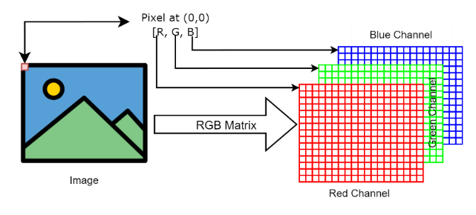
Figure 6: The RGB representation of digital image, explaining the color channels used in pre-processing raw images for CNN-based defect classification.
Typically, color information is represented using color models such as RGB, CIELAB, XYZ or CMYK [36]. RGB color space is an 8-bit depth where each pixel is represented as a tuple as demonstrated in the following equation :
$〈R, G, B〉∈{\left\{0…255\right\}}^{3}$ | (1)

Literature Reviews
In this chapter, an overview of relevant literature is presented. It explores existing research and identifies gaps in the literature that the study aims to address.

Overview of Relevant Literature
Several prior studies have been conducted on wafer defect classification, with each study incorporating different datasets, CNN architectures, and training techniques. In Table 2, a comprehensive overview of these studies is presented. It also includes details such as the utilized dataset, number of defect patterns considered in the analysis, whether single or mixed defects were classified, the specific CNN architecture employed in each study and its corresponding test accuracy for classification.
Table 3: A comprehensive overview of the performance of different CNN models in defect classification.
Ref | Dataset used | #’s defects patterners | Single or Mixed defects classification | CNN architecture | Accuracy
 | WM-811K | 8 | Single | Proposed architecture with 13 layers | 93.25%
 | WM-811K and MixedWM38 | 38 | Single and Mixed | (WM-PeleeNet) with 9 layers | 93.6% for single and 97.5% for mixed
 | WM-811K | 8 | Single | (ShuffleNet-v2) with 7 layers | 96.93%
 | WM-811K | 9 | Single | (CNN-WDI) with 16 layers | 96.2%
 | Dataset-TT | 12 | Single | (ResNet) with (VGG-16) | 96.2%
 | WM-811K | 8 | Single | (ResNet-18) | 95.46%
 | WM-811K | 9 | Single | (YOLO) version 3, 3-tiny and 4 | 95.7%
 | MixedWM38 | 38 | Single and Mixed | (U-Net) | 95.8%
Our work | pre-processed WM-811K | 36 | Single and Mixed | (Modified GoogLeNet) | 99.9%

Researchers in the field of wafer defect classification have made significant contributions to CNN architectures. While some researchers have designed their own CNN architectures, others have utilized existing ones. However, they face challenges such as imbalanced datasets and issues with overfitting and underfitting during model training. Researchers have employed data augmentation, regularization techniques, and attention mechanisms to tackle these problems. Additionally, investigations into the efficacy of current CNN architectures for accurately classifying various wafer defects are being conducted. Furthermore, semantic segmentation has been applied by some researchers to segment different defect patterns on wafer maps. As a result of these efforts from the research community improvements in accuracy and efficiency within wafer defect classification systems can be observed.

System Methodology & Algorithmic Design
In this chapter, an overview of key theories and concepts related to the topic are discussed, including digital images and convolutional neural networks.

Guided-Reading Stutter Detector
The core of the Guided-Reading Stutter Detector relies on a hybrid pipeline combining deep-learning-based speech synthesis, sequence alignment, and advanced digital signal processing (DSP) to detect, classify, and localize stuttering events in Arabic speech. The system architecture is structured into three main phases: Input & Audio Reference Generation, Acoustic & Sequence Feature Extraction, and Multi-Class Classification.

Input and Audio Reference Generation
To evaluate speech disfluencies, the system first establishes a deterministic baseline (the "Perfect Reading") for a given Arabic text input $T$.

Text-to-Speech Synthesis (TTS)
An input Arabic sentence $T$, comprised of a sequence of expected words
$W_{\text{exp}}=\left\{w_{1},w_{2},…,w_{N}\right\}$, is synthesized into clean reference audio using Habibi-TTS (built on the F5-TTS non-autoregressive DiT architecture) conditioned on a standard Modern Standard Arabic (MSA) reference voice:
$${\text{Audio}}_{\text{ref}},f_{s}=\text{Habibi-TTS}\left(T,\text{Dialect_ID}\right)$$
Where $f_{s}=16,000\text{ Hz}$ represents the target sampling rate.

Word-Level Time Alignment
To extract the expected boundaries for each word in the generated reference audio, OpenAI's Whisper (Turbo) model is executed with word-level timestamp estimation enabled ($word_timestamps=True$):
$$Φ_{\text{ref}}=\text{Whisper}\left({\text{Audio}}_{\text{ref}}\right)={\left\{\left\langle w_{i},t_{\text{start},i}^{\text{ref}},t_{\text{end},i}^{\text{ref}}\right\rangle \right\}}_{i=1}^{M}$$
This yields a set of time-aligned reference words, where the duration of each reference word is computed as:
$$D_{\text{ref}}\left(i\right)=t_{\text{end},i}^{\text{ref}}-t_{\text{start},i}^{\text{ref}}$$

Acoustic and Sequence Feature Extraction
When a user records their reading of the same sentence, the system captures ${\text{Audio}}_{\text{user}}$, resamples it to $16\text{ kHz}$, and applies a two-step feature extraction process: boundary refinement and physical pitch/energy analysis.

Energy-Refined Word Onsets
To mitigate the inherent $≈100\text{ ms}$ window quantization error found in standard automatic speech recognition (ASR) timestamps, the system refines the initial word boundaries. For a Whisper-estimated onset boundary $t_{\text{start}}^{\text{approx}}$, a local search frame is isolated:
$$\text{Search Boundary}=\left[\max\left(0,t_{\text{start}}^{\text{approx}}-0.05\right),t_{\text{end}}^{\text{approx}}\right]$$
The discrete Root Mean Square (RMS) energy $x_{\text{RMS}}$ of the localized signal frame $x\left[n\right]$ is computed over a window size $L=512$ and hop size $H=128$:
$$x_{\text{RMS}}\left[m\right]=\sqrt{\frac{1}{L}\sum_{n=0}^{L-1}{x}{\left[m⋅H+n\right]}^{2}}$$
The high-precision refined onset timestamp $t_{\text{start}}^{\text{refined}}$ is defined as the earliest temporal coordinate where the local frame energy crosses the $5\%$ threshold of the local peak RMS energy:
$$t_{\text{start}}^{\text{refined}}=\min\left\{t | x_{\text{RMS}}\left[t\right]≥0.05⋅\max\left(x_{\text{RMS}}\right)\right\}$$
Consequently, the definitive user word duration calculation is adjusted to:
$$D_{\text{user}}\left(i\right)=t_{\text{end},i}^{\text{user}}-t_{\text{start},i}^{\text{refined}}$$

Fundamental Frequency ($F_{0}$) Variance
To evaluate vocal cord tension and distinguish natural inflection from the monotonic acoustic signature of a prolongation, the Probabilistic YIN (pYIN) algorithm tracks the fundamental pitch tracking trajectory within the isolated voiced frames:
$$F_{0}\left(t\right)=\text{pYIN}\left({\text{Audio}}_{\text{user}}\left[t_{\text{start}}^{\text{refined}}:t_{\text{end}}\right]\right)$$
The standard deviation of the fundamental frequency ($σ_{F_{0}}$) measures pitch flatness across $K$ valid voiced frames:
$$σ_{F_{0}}=\sqrt{\frac{1}{K}\sum_{k=1}^{K}{{\left(F_{0,k}-μ_{F_{0}}\right)}^{2}}}$$

Comparative Analytics & Disfluency Classification
The system applies the Gestalt Pattern Matching algorithm (difflib.SequenceMatcher) to map the text sequences, establishing a bi-directional index map $M:W_{\text{exp}}↔W_{\text{user}}$. Unmapped words are flagged as deletions or insertions.
Every aligned word index $i$ is subjected to a multi-variate conditional heuristic tree to yields its classification label $L\left(i\right)$:
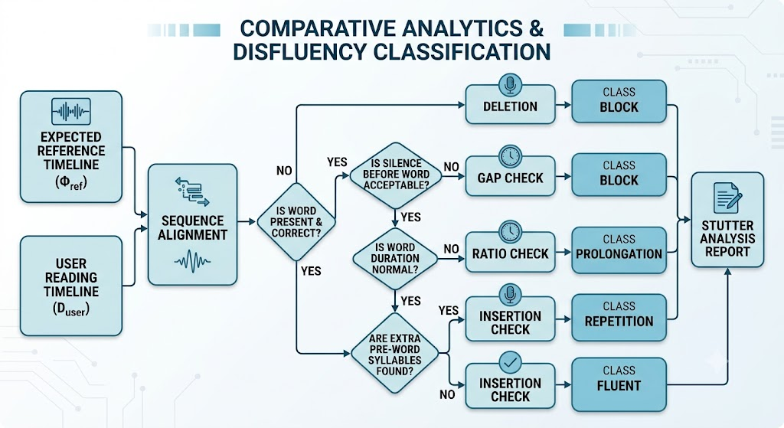

Mathematical Classification Matrix
To evaluate vocal

Silent Block (الحصار)
A target segment is classified as a silent block if the word is omitted, if the pre-word acoustic silence exceeds acceptable boundaries, or if the initial onset energy is severely attenuated:
$$L\left(i\right)=\text{"Block"}⟺w_{i}∉W_{\text{user}} ∨ Δt_{\text{gap}}>0.35\text{ s} ∨ {\text{RMS}}_{\text{onset}}<0.02$$
Where $Δt_{\text{gap}}$ isolates the comparative silence offset between the user and reference timelines:
$$Δt_{\text{gap}}=\left(t_{\text{start},i}^{\text{user}}-t_{\text{end},i-1}^{\text{user}}\right)-\left(t_{\text{start},i}^{\text{ref}}-t_{\text{end},i-1}^{\text{ref}}\right)$$

Prolongation (إطالة)
A word is flagged as an involuntary prolongation if the duration ratio exceeds the standard deviation threshold, validated by a highly flat pitch configuration ($σ_{F_{0}}$):
$$L\left(i\right)=\text{"Prolongation"}⟺\left(\frac{D_{\text{user}}\left(i\right)}{D_{\text{ref}}\left(i\right)}>1.6\right) ∧ \left(σ_{F_{0}}<15\text{ Hz} ∨ \frac{D_{\text{user}}\left(i\right)}{D_{\text{ref}}\left(i\right)}>2.16\right)$$

Repetition (تكرار)
A repetition event is registered if unmapped text insertions exist within the immediate contextual window preceding the mapped target word:
$$L\left(i\right)=\text{"Repetition"}⟺∃ w_{u}∈W_{\text{user}}∖M \text{for }u∈[M\left(i\right)-2,M\left(i\right))$$

Fluent (طلاقة)
If the observed parameters satisfy all constraints without violating any boundary conditions, the word is marked as fluent:
$$L\left(i\right)=\text{"Fluent"}$$

Image was uploaded by Yoshifumi Uesaka from Nikkei staff writer (source Image URL)
The Kaggle website is an online platform for data science and machine learning that hosts a wide range of datasets.

