**Project Report Template**

**Title of Project:** AR/VR Rehab Games  
**Name of the Innovator:** Yasmeen M S  
**Start Date:** 27-09-2025

**End Date: 31-10-2025**

***Day 1: Empathise & Define***

*Step 1: Understanding the Need*

* Which problem am I trying to solve?

I am trying to solve the problem of low patient motivation, high costs, and lack of accessible, data-driven tracking for hand mobility rehabilitation after a stroke, hand fracture, etc.

* Who is affected by this problem?
* How did I find out about this? [Select whichever is applicable]
* Interviews
* Observation
* Online Research
* AI Tools

*Step 2: What is the problem?*

The problem is that traditional physiotherapy for hand mobility is often repetitive, boring, and limited to clinical visits. Patients, especially those recovering at home, struggle with motivation, consistency, and a clear understanding of their progress. Therapists lack precise, real-time data on home-based exercise performance, making it difficult to adapt treatment plans effectively.

Why is this problem important to solve?

This problem is important because effective and consistent rehabilitation is crucial for regaining hand function, which is essential for daily living and quality of life. By solving this, we can make recovery more engaging, accessible, and affordable. A data-driven, gamified approach can "bridge the gap between clinical physiotherapy and home-based recovery," leading to better patient outcomes, higher motivation, and reduced long-term healthcare costs.

*AI Tools you can use for Step 1 and 2:*

**AI Tools Used:**

**Google Scholar / Perplexity AI**

* Used to research existing clinical studies on AR/VR in physiotherapy, identify gaps, and understand the specific motor skills that need to be targeted (e.g., for stroke vs. fracture).
* Helped define the clinical relevance and key metrics to track (joint angles, grip strength, stability).

ChatGPT/Gemini

* Used for brainstorming the problem statement and refining the "Why is this important" section.
* Helped structure the user personas (patient, therapist) and their specific pain points.

***Day 2: Ideate***

*Step 3: Brainstorming solutions*

List **at least 5 different solutions** (wild or realistic):

• A simple mobile app with video-guided hand exercises and a manual progress log.

• A physical, sensor-embedded glove (smart glove) that connects to an app to track movement without VR.

• A web-based tele-rehabilitation platform for live video sessions with a therapist.

• A subscription box with physical therapy tools (putty, grip trainers) and a gamified progress-tracking website.

• A "beat-saber" style rhythm game specifically designed for wrist and finger flexion/extension.

• **Advanced AR/VR Rehabilitation App (The chosen idea)** – A complete immersive platform with multiple gamified exercises, AI-driven progress tracking, and a personalized dashboard.

*Step 4: My favourite solution:*

*My favorite solution is the* ***Advanced AR/VR Rehabilitation Application****. This app will create an immersive, clinically relevant environment where patients perform physiotherapy exercises through four interactive AR/VR games:* ***Apple Catching*** *(reflexes, wrist rotation),* ***Rock Climbing*** *(grip strength, shoulder stability),* ***Wall Pushing*** *(upper limb extension), and* ***Puzzle Solving*** *(fine motor skills). It integrates precise hand-tracking and an AI-driven dashboard to monitor metrics and adapt exercise difficulty.*

*Step 5: Why am I choosing this solution?*

I am choosing this solution because it directly tackles the core problem of patient motivation through gamification. The immersive AR/VR environment makes repetitive exercises engaging. It is a data-driven solution that provides precise, objective metrics (joint angles, grip duration) to both the patient and therapist, which is a significant improvement over subjective, home-based recovery. The AI-driven adaptability ensures the rehabilitation remains challenging yet achievable, personalizing the recovery journey.

*AI Tools you can use for Step 3-5:*

**AI Tools for Step 3–5**

**ChatGPT / Claude AI**

* **Used to brainstorm the list of 5+ solutions.**
* **Helped generate and refine the concepts for the four specific AR/VR games.**
* **Assisted in writing the detailed descriptions for "My favourite solution" and "Why am I choosing this."**

**Canva AI / Midjourney**

* **Used to generate concept art and visual mood boards for the immersive environments (e.g., "a serene orchard for apple catching," "a 3D puzzle in space").**

**AI Research Tools (Google Scholar)**

* **Used to validate that the four chosen game mechanics (catching, gripping, pushing, fine motor) align with established physiotherapy principles for hand mobility.**

***Day 3: Prototype & Test***

*Step 6: Prototype – Building my first version*

What will my solution look like?

• **Home Screen/Main Menu:** An immersive, calm VR lobby. Users can log in, view their profile, and select a game.

• **Game 1: Apple Catching:** A 3D orchard environment. Apples and other fruits fall; the user must catch the apples (requiring wrist rotation and coordination) and avoid other objects.

• **Game 2: Rock Climbing:** A virtual climbing wall. The user must reach, grip, and hold onto virtual rocks for 5 seconds to progress, with animations and feedback.

• **Game 3: Wall Pushing:** The user is in a room with a "virtual wall" that reacts with color/force indicators as they perform extension exercises.

• **Game 4: Puzzle Solving:** A 3D space where the user manipulates and aligns virtual puzzle pieces, requiring fine motor control and cognitive focus.

• **Personalized Dashboard:** A 2D UI overlay (or a separate "room") showing interactive graphs of joint angles, stability, grip duration, and task completion time.

opportunities.

**Design Style:**

* Immersive, engaging, and realistic 3D environments.
* Clinically-focused but gamified UI.
* Clear, high-contrast text and visuals for the dashboard, accessible to users who may have visual or cognitive impairments.
* Responsive audio and haptic feedback to reinforce successful movements.

**Prototype Tools:**

* **Game Engine:** Unity or Unreal Engine.
* **VR/AR SDK:** Meta Quest SDK (for hand tracking) or Leap Motion.
* **3D Modeling Software:** Blender (for creating assets like apples, rocks, puzzles).

What AI tools will I need to build this?

* **Game Engine AI (e.g., Unity ML-Agents)**
* To control the game logic, physics (e.g., falling apples), and enemy/object behavior.
* **Gesture Recognition / Hand Tracking AI (Part of VR SDK)**
* Crucial for precisely tracking joint angles, finger movements, and grip strength from the headset or sensor data.
* **Machine Learning Libraries (Python: TensorFlow, Scikit-learn)**
* To build the backend AI-driven recommendation engine. This model will analyze the dashboard data (performance, stability) and suggest which game or difficulty level the patient should try next.
* **AI Data Visualization Tools**
* To help generate the interactive progress graphs on the patient dashboard.

What AI tools I finally selected to build this solution?

* **Meta Quest SDK (for its built-in AI Hand Tracking)**
* **Python (with TensorFlow) (for the backend recommendation model)**

**< Build The Innovation>**

**<DASHBOAD OF THE TOOL>**

**Tool Link:**  [**https://mgx-8qbx8sbxh0g.mgx.world**](https://mgx-8qbx8sbxh0g.mgx.world)

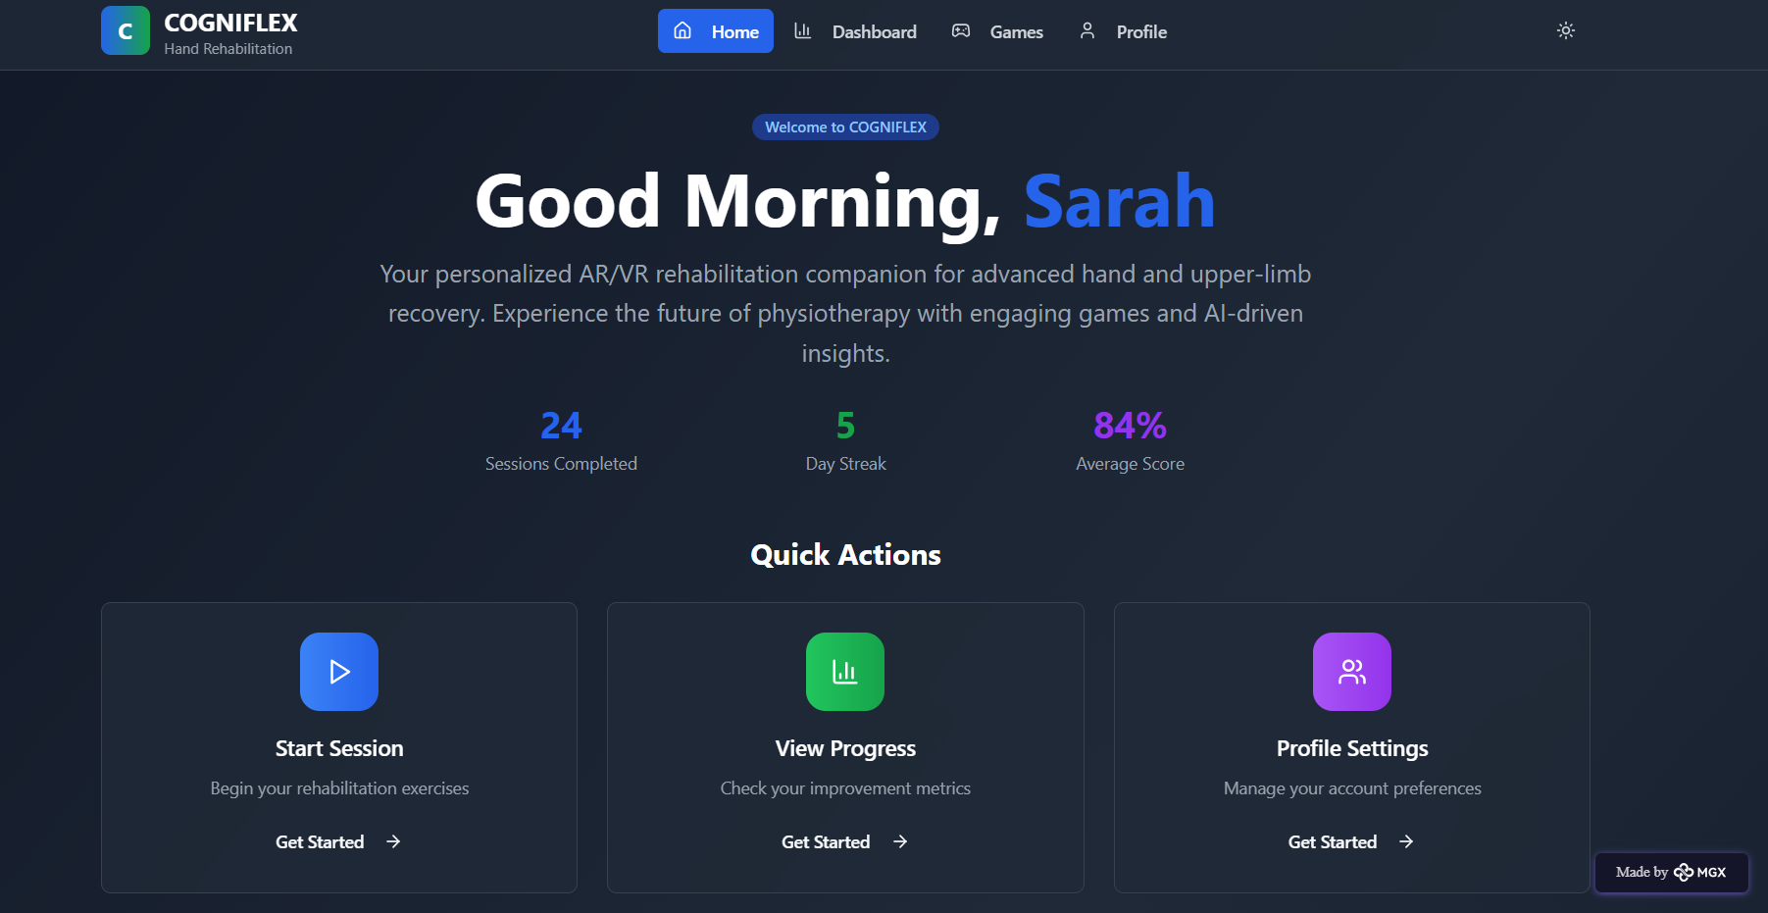

Internal Working of tool:

Profile Creation:

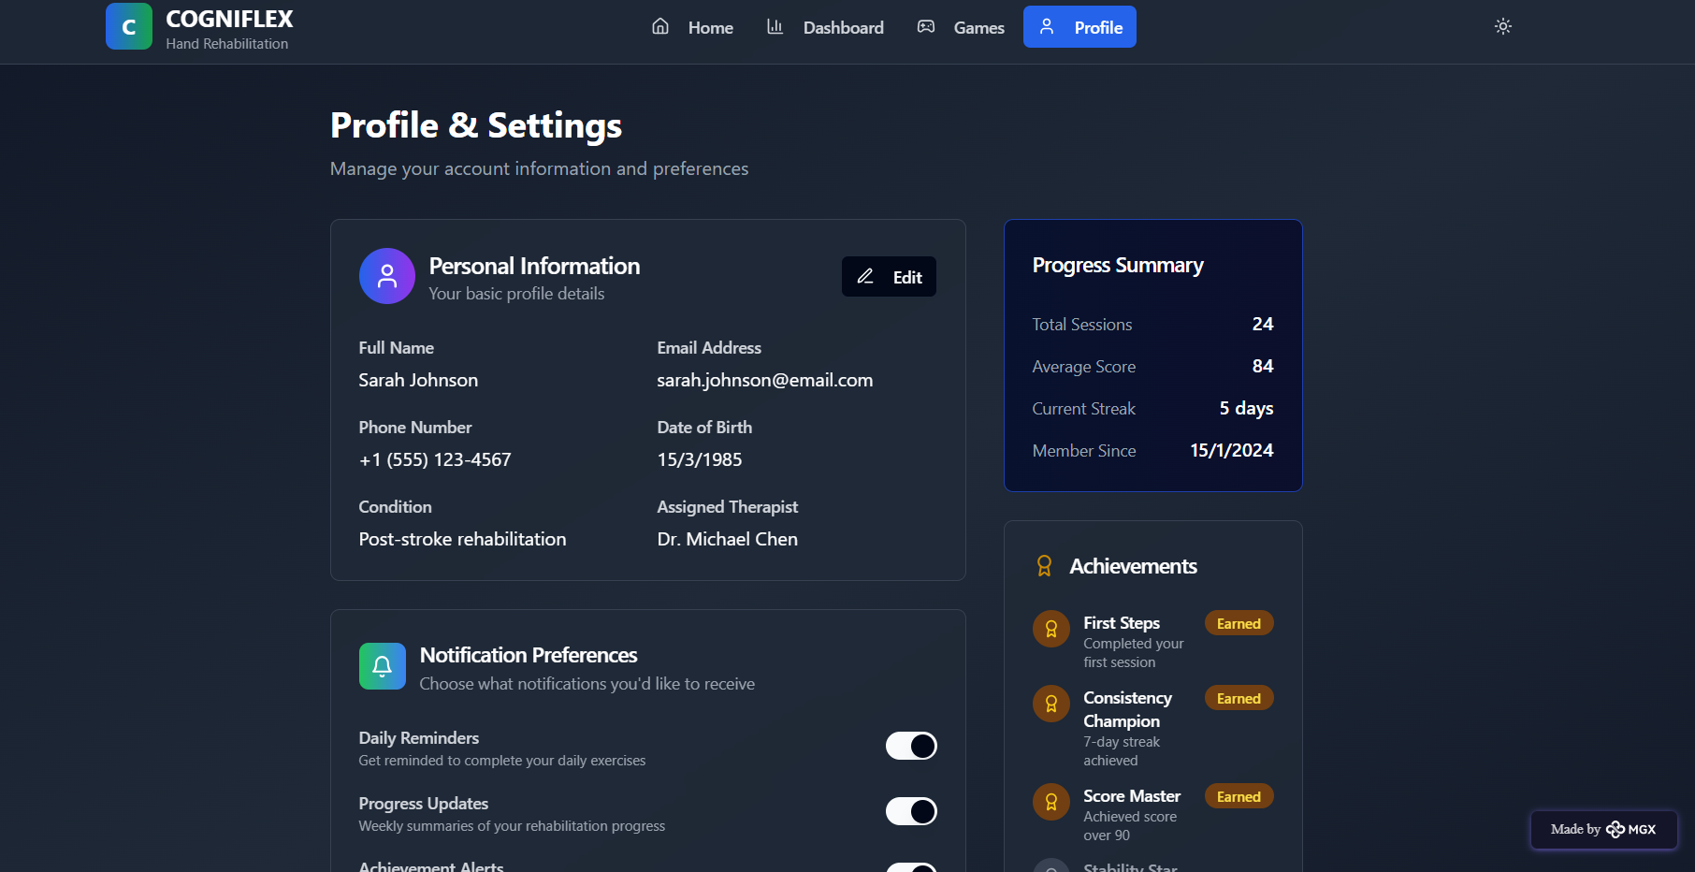

*Step 7: Test – Getting Feedback*

Who did I share my solution with?

* • Physiotherapists – to check for clinical relevance and data accuracy.
* • Patients (2) recovering from hand fractures – to get feedback on usability, motivation, and comfort.
* • Peers (game developers) – for suggestions on improving game mechanics and user experience.

What feedback did I receive?

**Feedback: Pros and Cons Pros (Positive Insights from Feedback):**

1. Highly engaging. One patient said it was the "first time rehab felt like fun."
2. The hand tracking in the Puzzle Solving and Apple Catching games was seen as very precise and intuitive.
3. Therapists were very impressed with the detailed data on the dashboard, especially the joint angle graphs. Cons (Areas to Improve Noted in Feedback):
4. Some users experienced mild "VR sickness" (nausea) after 15 minutes.
5. The "Rock Climbing" game was too difficult for one patient, who felt "stuck" and lost motivation.
6. Therapists wanted a way to export the dashboard data to their clinic's Electronic Health Record (EHR) system.

**My Response for The Feedback:**  
This prototype successfully proves the core concept: gamified, data-driven VR rehab is highly motivating and provides valuable clinical data. The feedback is crucial for the next iteration. To address the cons, we will implement user-selectable "comfort modes" (like teleport movement) to reduce VR sickness. We will add adjustable difficulty levels to all games, especially "Rock climbing," to ensure a smoother progression for new patients. Finally, developing an API for EHR integration is now a top priority for the production-ready version to ensure seamless clinical adoption.👍 What works well:

**What Works Well**

* **The core gamification loop is highly effective at improving patient motivation and consistency.**
* **The fine motor skill tracking in the Puzzle game is precise and clinically relevant.**
* **The dashboard visualization is clear and provides actionable insights for therapists.**

🔧 What needs improvement:

• Patient comfort settings to reduce or eliminate VR sickness.

• Scalable difficulty settings for all four games to adapt to different recovery stages.

• Data export functionality or an API to integrate with existing clinical (EHR) systems.

***Day 4: Showcase***

*Step 8: Presenting my Innovation:***Presenting my Innovation:** I am presenting an **Advanced AR/VR Rehabilitation Application** for hand mobility recovery. This system is designed for individuals recovering from strokes, hand fractures, or scapular dyskinesia.

It features four immersive, gamified exercises:

* **Apple Catching:** To enhance reflexes and wrist rotation.
* **Rock Climbing:** To strengthen grip and shoulder stability.
* **Wall Pushing:** To focus on upper limb extension and strength.
* **Puzzle Solving:** To improve fine motor skills and cognitive focus.

**Impact:** This app bridges the gap between clinical and home-based recovery, offering an affordable, portable, and highly motivating solution. It transforms rehabilitation from a chore into an engaging experience, improving patient consistency and recovery outcomes.

**<SHOWCASE YOUR INNOVATION TO YOUR PEERS>**

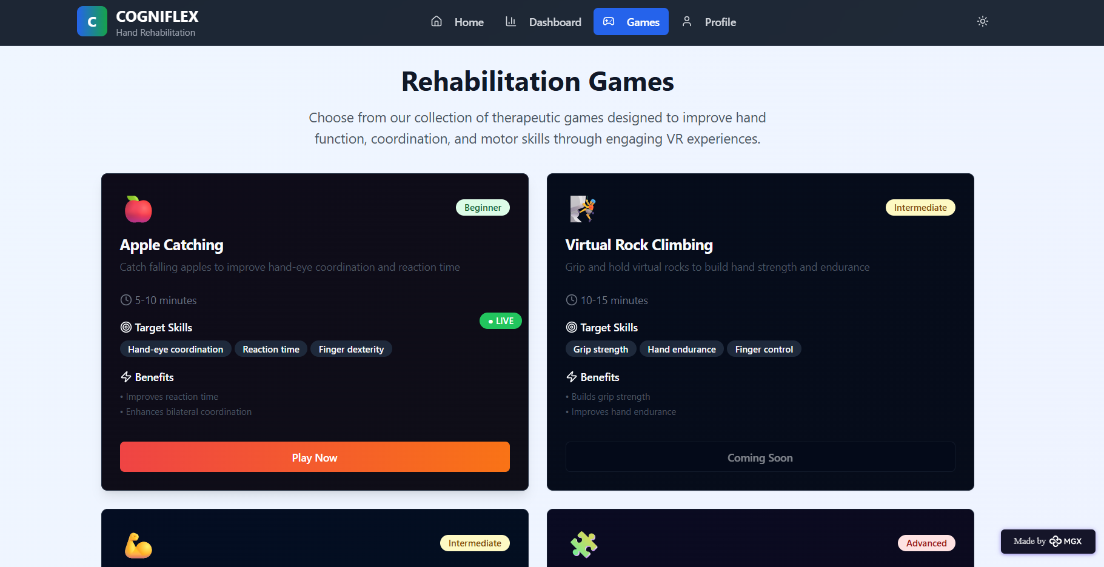

*Step 9: Reflections*

* What did I enjoy the most during this project-based learning activity?

• **What did I enjoy the most during this project-based learning activity?** I enjoyed designing the four distinct game mechanics and seeing them come to life in the Unity prototype. The most rewarding moment was during testing, when a patient completed an exercise set and was genuinely excited to see their "score" and progress on the dashboard, which confirmed the core idea of "gamified motivation" was working.

• **What was my biggest challenge during this project-based learning activity?** My biggest challenge was calibrating the AI hand-tracking algorithms. It was difficult to get the system to be sensitive enough to detect fine motor movements in the Puzzle game without being "jittery" or misinterpreting gestures. Integrating the backend Python AI model (for recommendations) with the real-time C# scripts in Unity was also a significant technical hurdle.

**Take-home task**

<https://github.com/punithhcreator/Careerpath-No-code-application>

*AI Tools you can use for Step 8:*

**Canva AI:** You can use this to design your pitch document. Download your pitch document as a PDF file and upload on GitHub