Event Management System
Project: Training Events Management System
Group 2
A training event can be a workshop, a course or an internship. It can last one day, a few days or several weeks, depending on its type and material. A trainer (an individual or an organization with several trainers) requests the training, a manager reviews and organizes it, and participants find it, apply, attend and receive a certificate of completion. Some trainings are free and some are paid.
Scope: our group builds the front end only (HTML, CSS and JavaScript). All data is sample data written in the code, nothing is saved, and no real payments are made. The diagrams in this document show the full design that the interface represents.

1. Purpose of the System
Q: What problem does this system solve?
Training centers and universities often organize workshops, courses and internships with paper forms, social-media posts and spreadsheets. This causes lost or duplicated applications, overbooked trainings, double-booked rooms, unclear payment status and late communication with participants. The system puts the whole lifecycle in one place: a trainer requests a training, a manager approves and schedules it, and participants browse, apply, pay when needed and receive updates. After the training, attendance is recorded and certificates of completion are issued.
Q: Why is event management important?
- Manage resources, rooms, and time.
- It saves staff time, gives applicants a fair and transparent process, keeps payments traceable, and produces records and reports that help plan future trainings.
- Advertise trainings.
- Prepare students for the job market.
- Provide the means for experts and institutions to plan trainings for individuals

2. User Roles
Q: Who will use the system, and what actions can each role perform?
Role | Who they are | Main actions
Participant | A learner who registers an account | Register and log in, browse trainings, search and filter, view training details, apply for a training, provide info and documents, pay for paid trainings, withdraw, track application status and attendance, download certificates of completion, receive notifications
Trainer  (Individual or Organization) | The person or organization that requests and delivers a training. An organization account lists the trainers who teach under it. | Submit, edit or cancel a training request (type, category, dates, capacity, fee or free, resources, attendance minimum for the certificate), set eligibility criteria, review applications when review is required (accept or decline), record attendance for each session, view statistics for own trainings. Organizations also manage their trainer members.
Manager  (Training Manager) | Staff member who runs training operations | Review training requests (approve, reject or ask for changes), schedule sessions, assign rooms, allocate resources, view payments and process refunds, send announcements, view and export operational reports (including attendance and certificates issued)
Admin  (System Administrator) | Staff member who runs the platform itself | Manage user accounts and roles, manage categories, maintain the list of rooms and resources, manage the certificate template, system settings, view system-wide reports

User Roles
Task | Responsible | Notes
Submit / edit / cancel a training request | Trainer | Cancelling after the training is published needs Manager confirmation
Approve, reject or return a request for changes | Manager | Rejection includes a reason that the trainer sees
Set eligibility criteria and review applications | Trainer | Only when the training requires review; otherwise the system accepts automatically
Schedule sessions, assign rooms, allocate resources | Manager | The system blocks room and time clashes
Add rooms, resources and categories | Admin | Master data; the Manager only picks from these lists
Create or deactivate accounts, assign roles | Admin | Trainers and participants register themselves
Make a payment | Participant | Online through the payment gateway (simulated in our demo)
Verify payments | System | Done automatically through the payment gateway; no manual check
View payments and process refunds | Manager | Refunds go back to the participant through the gateway
Record attendance | Trainer | For every session of the training; the sheet lists only confirmed participants
Issue certificates of completion | System | Automatically when the training is completed, only for participants who meet the attendance minimum
Download or print a certificate | Participant | From “My trainings”; each certificate has a unique number
Automatic notifications (status changes) | System | For example: request approved, application accepted, payment confirmed, certificate ready
Announcements (reminders, room changes) | Manager | Optional: trainers message their own participants
Generate reports | System | Created automatically from the data
View reports | Trainer, Manager, Admin | Trainer: own trainings only. Manager: all trainings (enrollments, revenue, room usage, attendance). Admin: platform reports and everything else
Export reports (PDF / Excel) | Manager, Admin

Figure 1 – Use case diagram. Individual and Organization Trainers are both Trainers. «include» means the step always happens; «extend» means it happens only under the condition shown.
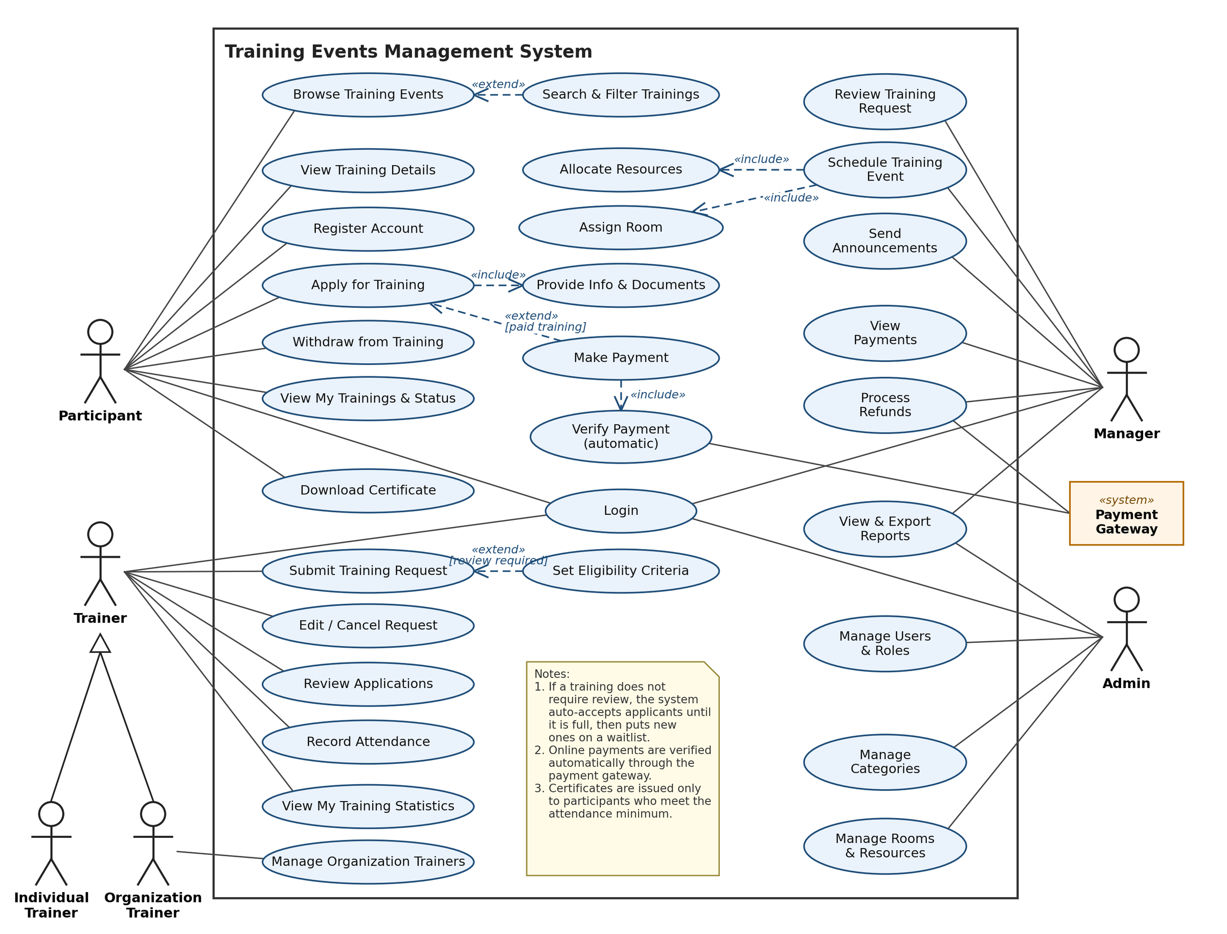
Figure 1 – Use case diagram of the Training Events Management System

3. Core Features
- Training request and approval workflow: trainers submit requests with all details; managers approve, reject or ask for changes.
- Training catalog with search and filters: by type (workshop, course, internship), category, date, and free or paid.
- Online applications: optional eligibility review by the trainer, capacity limits with a waitlist, and withdrawal.
- Scheduling with rooms and resources: supports one-day to multi-week trainings and prevents room and time clashes.
- Payments for paid trainings: free trainings skip this step; payments are verified automatically, and the manager handles refunds.
- Notifications and role-based dashboards and reports for trainers, managers and admins.
- Attendance tracking: trainers record attendance for every session; participants see their own attendance, and managers see attendance in reports.
- Certificates of completion: the system issues a certificate automatically to participants who complete the training and meet the attendance minimum; participants can download or print it.

Key business rules
- Duration: one training has one or more sessions (date, start time, end time, room). A one-day workshop has one session; a four-week course has many.
- Free vs. paid: if a training is free, the payment step is skipped, and the applicant is enrolled right after acceptance.
- Review vs. automatic acceptance: if the trainer requires review, applications wait for the trainer’s decision. Otherwise, the system accepts applicants automatically until the training is full.
- Pay after acceptance: for trainings that require review, payment is requested only after the applicant is accepted, so nobody pays and is then declined.
- Payment verification: online payments are verified automatically through the payment gateway. The Manager can view all payments and process refunds.
- Capacity and waitlist: confirmed participants can never exceed the capacity. Extra applicants join a waitlist; when someone withdraws, the first person on the waitlist is offered the seat.
- Withdrawal and refund: a participant can withdraw before the training starts. Refunds follow a policy the group defines (for example, full refund up to 3 days before the start), handled by the Manager.
- Rooms: a room cannot host two sessions at the same time, and its capacity must fit the training’s capacity.
- Attendance: the trainer marks each confirmed participant as present or absent for every session. Attendance rate = sessions attended ÷ total sessions.
- Certificates: when the training is completed, participants whose attendance rate meets the minimum set in the request (for example 80%) receive a certificate with a unique number; the others are marked “Not completed”.
- Training status: Pending → Changes requested → Approved → Open for registration → Full / Closed → Ongoing → Completed (or Rejected / Cancelled).
- Application status: Submitted → Under review → Accepted / Declined / Waitlisted → Awaiting payment → Confirmed → Completed (certificate issued) / Not completed (or Withdrawn).

4. System Modules
Q: Break the system into modules and briefly describe what each module does.
We use 7 modules. Each one groups related use cases and is owned by one team member. The modules connect through the login module and the shared data (see Figure 2).
# | Module | What it does | Main users
1 | User & Access Management | Registration, login and logout, roles and permissions, user profiles, organization trainer accounts and their members | All, Admin
2 | Training Requests & Approval | Create, edit, submit and cancel training requests; manager review with approve, reject or request changes | Trainer, Manager
3 | Scheduling & Resources | Create sessions (dates and times), assign rooms, allocate resources, detect clashes, publish the training | Manager, Admin
4 | Training Catalog & Applications | Browse, search and filter trainings; apply with info and documents; trainer review; capacity, waitlist and withdrawal | Participant, Trainer
5 | Payments | Paid or free logic, online payment with automatic verification through the gateway, receipts, payment list and refunds | Participant, Manager
6 | Notifications & Reports | Automatic notifications, announcements, role-based dashboards, reports and export | All
7 | Attendance & Certificates | Attendance sheet for every session, attendance rates, completion check against the attendance minimum, automatic certificates of completion with a unique number, download and print | Trainer, Participant, Manager

Module overview
How the seven modules connect: everyone logs in through Module 1, the core workflow passes a training from request to enrollment (Modules 2 → 5) and then to attendance and certificates (Module 7), and Module 6 turns status changes into notifications and reports.
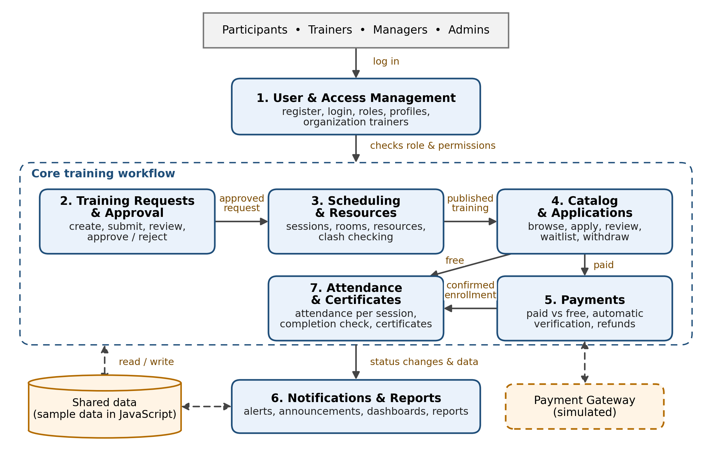
Figure 2 – Module overview diagram

5. Tools & Technologies
Q: Which technologies could be used?
Layer | Technology
Front end | HTML, CSS, JavaScript (Bootstrap)
Data | Sample data written in JavaScript
Version control | Git + GitHub
Editor | VS Code
Design | Figma (wireframes), draw.io or Canva (diagrams)
Notifications | In-page alerts list
Payments | Simulated online payment page
Attendance & certificates | Attendance checklist per session; printable HTML certificate (browser Print → Save as PDF)

6. Next Steps
Q: What should the group do first to start development?
- Agree on scope and roles using this document and the core features.
- Finish the design: use case, activity and module diagrams, plus simple wireframes of the main pages.
- Set up GitHub: one repository, a folder structure, a README, and one shared layout (header, navigation, footer, colors) that every page reuses.
- Build login, registration and role switching first, because every other module depends on them.
- Then each member builds their own pages in parallel, and the group integrates and tests every week.

Plan
Phase | Work | Output
1. Analysis & design | Finalize requirements and roles, use case, activity and module diagrams, wireframes | This document, diagrams, wireframes
2. Foundation | GitHub repo, shared layout and CSS, registration, login and role switching | Working shell with 5 role views
3. Module development | Each member builds their pages (HTML, CSS and JavaScript) | Modules 2–7 working on their own
4. Integration & testing | Connect the pages and run the four test scenarios below; fix bugs | Complete end-to-end flows
5. Polish & presentation | UI cleanup, sample data, final report, slides and demo rehearsal | Final site, report and demo

Member Roles
Give each member a vertical slice: their modules from the page design to the interaction. This avoids the common problem of one person doing all the HTML while another waits for it.
Member | Modules | Pages and tasks
Shaima  (team lead) | 1. User & Access  6. Notifications & Reports | Home page, register, login, top navigation and role switcher, profiles, Admin dashboard (users, roles, categories, rooms), Alerts page, Manager reports. Also sets up the GitHub repo and the shared layout and CSS.
Yasmeena | 2. Training Requests  3. Scheduling & Resources  7. Attendance & Certificates | Trainer request form and the trainer’s own trainings list, Manager review page (approve, reject or ask for changes), session scheduling, room and resource assignment with clash check, attendance sheet for each session and the printable certificate page.
Shora | 4. Catalog & Applications  5. Payments | Training list with filters, details page, application form, “My trainings”, waitlist and withdrawal, trainer’s application review page, payment page with automatic verification, manager payments list and refunds.

System Diagrams

Activity diagram: training request and approval
Shows how a training goes from the trainer’s request to a published, scheduled event, including the “changes needed” loop and the room clash check.
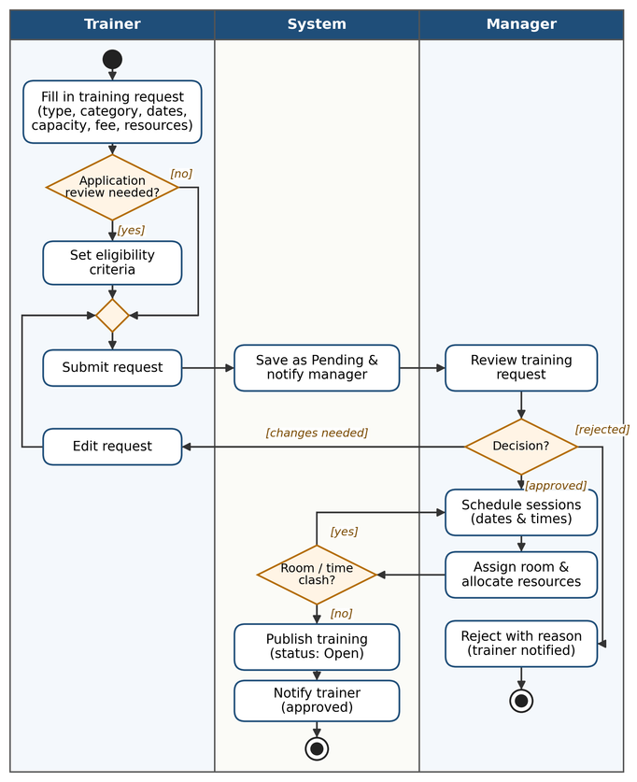
Figure 3 – Activity diagram: training request, approval and scheduling

Activity diagram: application, enrollment and certificate
Shows the participant’s path from applying to receiving a certificate, with the four decisions that make each case different: seats available, review required, paid or free, and attendance minimum met.
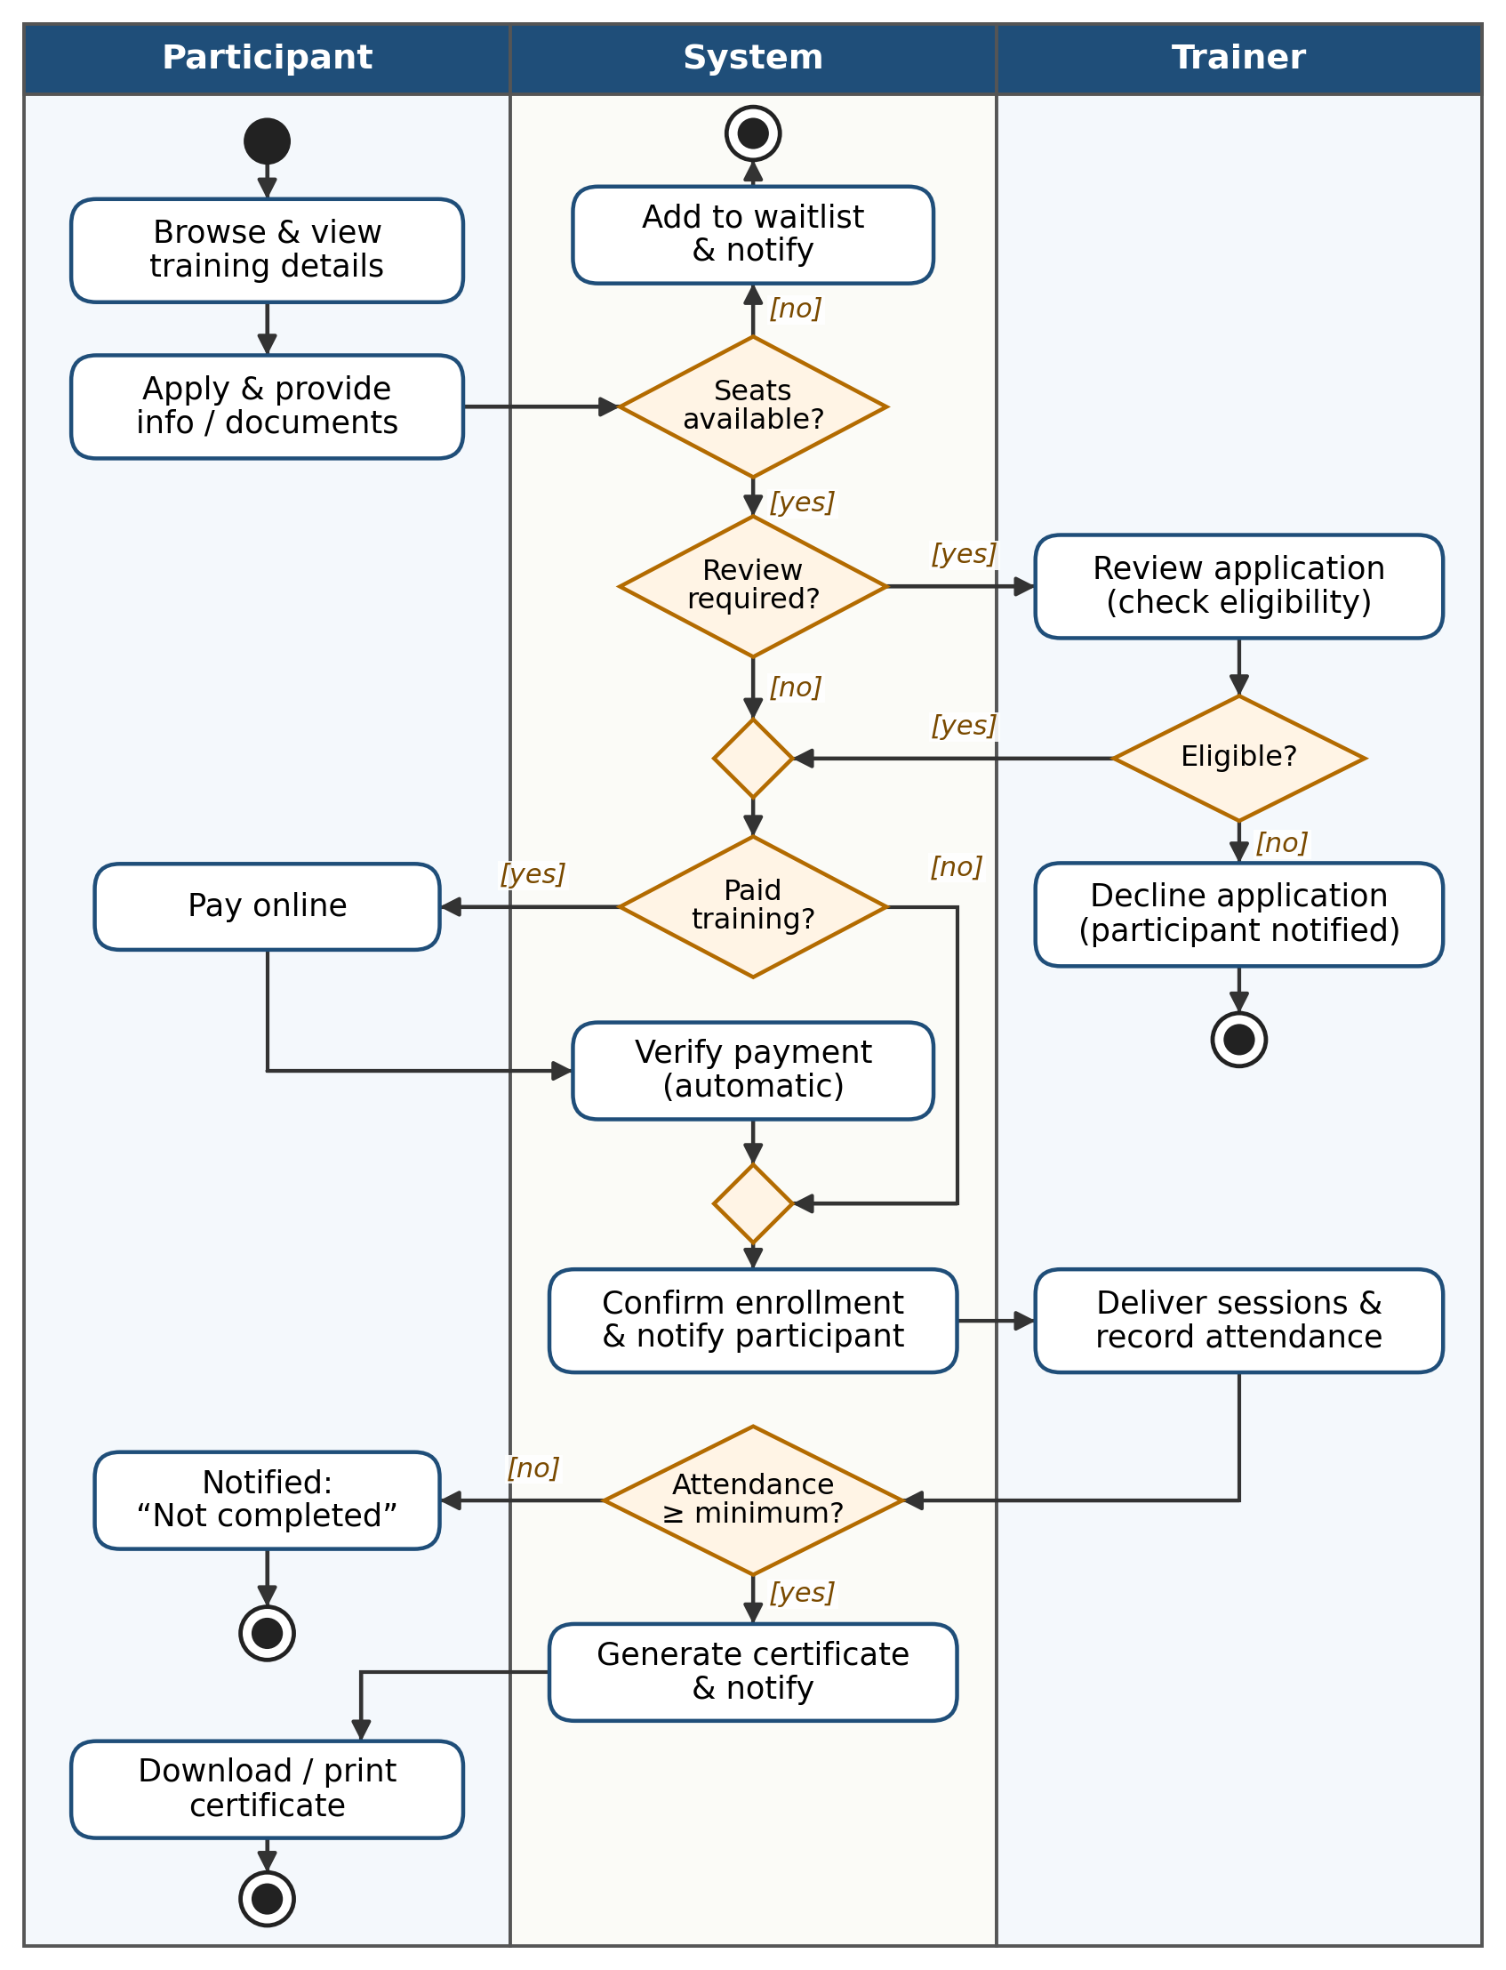
Figure 4 – Activity diagram: application, payment, attendance and certificate

Sample WireFrames

- Home Page
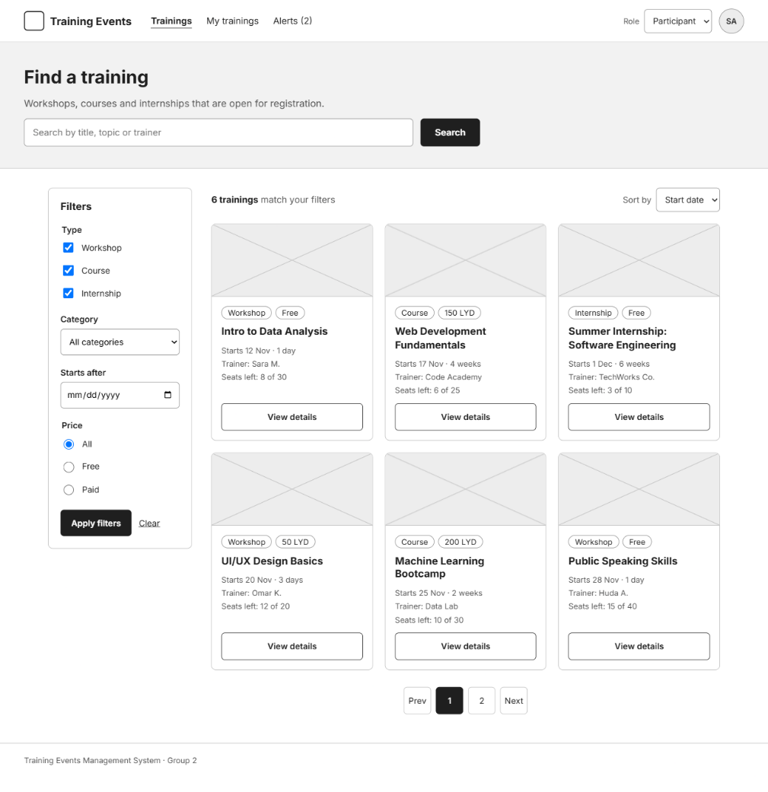
- Training Details and Apply:

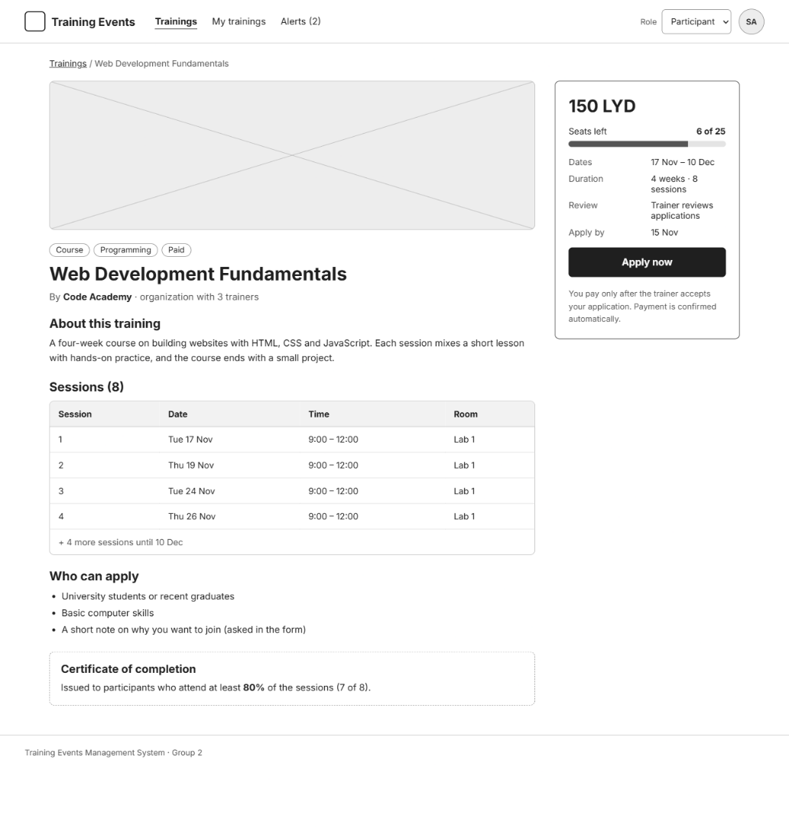
- Trainer: Request a new training:
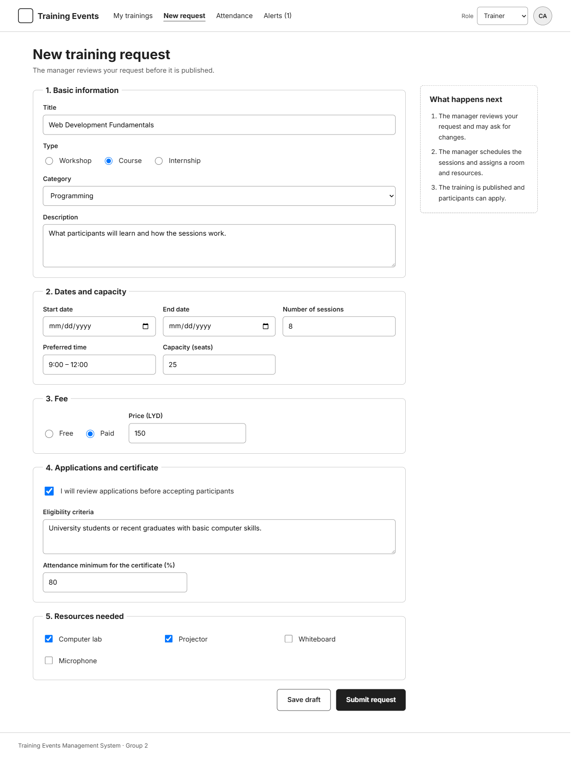

- Manager: Review request


