Computer Networks Project

Done by:

Fatema Al Zahraa Sherif

Norhan Hazem Mohammed

Yasmen Yasser

Nour Mohey

**TABLES:**

**Part 1: Design and Implement a VLSM Addressing Scheme.**

**//reordering**

10.1.0.0/12

|  |  |  |  |  |  |  |
| --- | --- | --- | --- | --- | --- | --- |
| VLAN 10 | 61 | 62 | 10.1.0.0/26 | 1 | 62 | 63 |
| VLAN 70 | 31 | 62 | 10.1.0.64/26 | 65 | 126 | 127 |
| VLAN 20 | 30 | 30 | 10.1.0.128/27 | 129 | 158 | 159 |
| VLAN 60 | 29 | 30 | 10.1.0.160/27 | 161 | 190 | 191 |
| VLAN 80 | 25 | 30 | 10.1.0.192/27 | 193 | 222 | 223 |
| VLAN 40 | 20 | 30 | 10.1.0.224/27 | 225 | 254 | 255 |
| VLAN 50 | 15 | 30 | 10.1.1.0/27 | 1 | 30 | 31 |
| VLAN 25 | 12 | 14 | 10.1.1.32/28 | 33 | 46 | 47 |
| **From SW-S to MIU-MIU-GW** | 7 | 14 | 10.1.1.48/28 | 49 | 62 | 63 |
| MAIN-MLS to MIU-GW | 2 | 2 | 10.1.1.64/30 | 65 | 66 | 67 |
| **From N-MLS to MIU-MIU-GW** | 2 | 2 | 10.1.1.68/30 | 69 | 70 | 71 |
| **From S-MLS to MIU-MIU-GW** | 2 | 2 | 10.1.1.72/30 | 73 | 74 | 75 |
| **From R-MLS to MIU-MIU-GW** | 2 | 2 | 10.1.1.76/30 | 77 | 78 | 79 |

**Subnet Table**

|  |  |  |  |  |  |  |  |
| --- | --- | --- | --- | --- | --- | --- | --- |
| **1.Subnet Description** | **VLAN ID** | **VLAN Name** | **Required Number of Hosts** | **Network Address/CIDR** | **First Usable Host Address** | **Last Usable Host Address** | **Broadcast Address** |
| **Main** | VLAN 10 |  | 61 | 10.1.0.0/26 | 1 | 62 | 63 |
| VLAN 20 |  | 30 | 10.1.0.128/27 | 129 | 158 | 159 |
| **S** | VLAN 25 |  | 12 | 10.1.1.32/28 | 33 | 46 | 47 |
| VLAN 40 |  | 20 | 10.1.0.224/27 | 225 | 254 | 255 |
| **N** | VLAN 50 |  | 15 | 10.1.1.0/27 | 1 | 30 | 31 |
| VLAN 60 |  | 29 | 10.1.0.160/27 | 161 | 190 | 191 |
| **R** | VLAN 70 |  | 31 | 10.1.0.64/26 | 65 | 126 | 127 |
| VLAN 80 |  | 25 | 10.1.0.192/27 | 193 | 222 | 223 |
| **From Main-MLS to MIU-MIU-GW** | - |  | 2 | 10.1.1.64/30 | 65 | 66 | 67 |
| **From N-MLS to MIU-MIU-GW** | - |  | 2 | 10.1.1.68/30 | 69 | 70 | 71 |
| **From S-MLS to MIU-MIU-GW** | - |  | 2 | 10.1.1.72/30 | 73 | 74 | 75 |
| **From R-MLS to MIU-MIU-GW** | - |  | 2 | 10.1.1.76/30 | 77 | 78 | 79 |
| **From SW-S to MIU-MIU-GW** | - |  | 7 | 10.1.1.48/28 | 49 | 62 | 63 |

**Addressing Table**

|  |  |  |  |  |  |
| --- | --- | --- | --- | --- | --- |
| **Device** | **Interface** | **Address** | **Subnet Mask** | **Default Gateway** | **VLAN ID** |
| **Main-MLS** | G1/1/1 | 10.1.1.65/30 | 255.255.255.252 | - | - |
| VLAN 10 | 10.1.0.1/26 | 255.255.255.192 | N/A |  |
| VLAN 20 | 10.1.0.129/27 | 255.255.255.224 |  |  |
| **S-MLS** | G1/1/1 | 10.1.1.73/30 | 255.255.255.252 |  |  |
| VLAN  25 | 10.1.1.33/28 | 255.255.255.240 |  |  |
| VLAN  40 | 10.1.0.225/27 | 255.255.255.224 |  |  |
| **N-MLS** | G1/1/1 | 10.1.1.69/30 | 255.255.255.252 |  |  |
| VLAN  50 | 10.1.1.1/27 | 255.255.255.224 |  |  |
| VLAN  60 | 10.1.0.161/27 | 255.255.255.224 |  |  |
| **R-MLS** | G1/0/5 | 10.1.1.77/30 | 255.255.255.252 |  |  |
| VLAN  70 | 10.1.0.65/26 | 255.255.255.192 |  |  |
| VLAN  80 | 10.1.0.193/27 | 255.255.255.224 |  |  |
| **MIU-MIU-GW** | Gig0/0 | 209.165.200.226/30 | 255.255.255.252 |  |  |
| Gig0/1 | 10.1.1.78/30 | 255.255.255.252 |  |  |
| Gig0/0/0 | 10.1.1.49/30 | 255.255.255.252 |  |  |
| Gig0/1/0 | 10.1.1.66/30 | 255.255.255.252 |  |  |
| Gig0/2/0 | 10.1.1.74/30 | 255.255.255.252 |  |  |
| Gig0/3/0 | 10.1.1.70/30 | 255.255.255.252 |  |  |
| **ISP** | Gig 0/0 | 209.165.200.225 | 255.255.255.240 |  |  |
| Gig 0/1 | 64.100.1.1 | 255.255.255.224 |  |  |
| Gig 0/2 | 64.100.2.1 | 255.255.255.224 |  |  |
| **Branch-GW** | Gig 0/0.2 | 192.168.2.1 | 255.255.255.0 |  |  |
| Gig 0/0.3 | 192.168.3.1 | 255.255.255.0 |  |  |
| Gig 0/1 | 64.100.1.2 | 255.255.255.224 |  |  |
| **Wireless Home Router** | G0/1 | 64.100.2.2 | 255.255.255.224 |  |  |
| Router IP | 192.168.10.1 | 255.255.255.128 |  |  |

**Hosts Address**

|  |  |  |  |  |
| --- | --- | --- | --- | --- |
| **PC-number** | **VLAN ID** | **IP Address** | **Subnet Mask** | **Default Gateway** |
| **MIU** | | | | |
| **PC-1** | 10 | From DHCP Server | From DHCP Server | From DHCP Server |
| **PC-2** | 10 | From DHCP Server | From DHCP Server | From DHCP Server |
| **PC-3** | 25 | From DHCP Server | From DHCP Server | From DHCP Server |
| **PC-4** | 25 | From DHCP Server | From DHCP Server | From DHCP Server |
| **PC-5** | 25 | From DHCP Server | From DHCP Server | From DHCP Server |
| **PC-6** | 40 | From DHCP Server | From DHCP Server | From DHCP Server |
| **PC-7** | 50 | 10.1.1.30/27 | 255.255.255.224 | 10.1.1.1 |
| **PC-8** | 60 | 10.1.0.190/27 | 255.255.255.224 | 10.1.0.161 |
| **PC-9** | 70 | 10.1.0.126/26 | 255.255.255.192 | 10.1.0.65 |
| **PC-10** | 80 | 10.1.0.222/27 | 255.255.255.224 | 10.1.0.193 |
| **MIU_ Branch 1** | | | | |
| **PC-11** |  | From DHCP Server | From DHCP Server | From DHCP Server |
| **PC-12** |  | From DHCP Server | From DHCP Server | From DHCP Server |
| **Wireless Home Network** | | | | |
| **Laptop** |  |  |  |  |
| **Tablet** |  |  |  |  |
| **Smartphone** |  |  |  |  |
| **Servers** | | | | |
| **DHCP Server** | 10.1.1.62 | 255.255.255.240 | 10.1.1.49 | 10.1.1.62 |
| **Email Server** | 10.1.1.61 | 255.255.255.240 | 10.1.1.49 | 10.1.1.61 |
| **Web server** | 10.1.0.100 | 255.255.255.192 | 10.1.0.1 | 10.1.0.100 |
| **DNS server** | 10.1.1.58 | 255.255.255.240 | 10.1.1.49 | 10.1.1.58 |
| **NTP and Syslog server** | 10.1.1.59 | 255.255.255.240 | 10.1.1.49 | 10.1.1.59 |

**Part2: Build the Network and Configure Basic Device Settings and Interface Addressing**

**Step2-a:**

no ip domain-lookup

hostname MIU-GW

security passwords min-length 10

enable secret CSC1234567

line console 0

password MIU1234567

login

exit

service password-encryption

banner motd ^ Authorized Access Only! ^

step2-b:

interface gigabitEthernet 0/0

ip address 10.1.1.1 255.255.255.0

no shutdown

exit

interface gigabitEthernet 0/1

ip address 10.1.2.1 255.255.255.0

no shutdown

exit

step2-c:

ip domain-name miu.local

username admin privilege 15 secret MIUadmin123

crypto key generate rsa

1024

line vty 0 4

transport input ssh

login local

exit

saving: copu running-config startup-config

**Part 3: Configure Network Infrastructure Settings (VLANs, Trunking, Inter-VLAN Routing EtherChannel).**

**Step1:**

enable

configure terminal

vlan 10

name Staff

exit

vlan 20

name Students

exit

step 2:

interface fastethernet 0/1

switchport mode access

switchport access vlan 10

exit

interface fastethernet 0/2

switchport mode access

switchport access vlan 20

exit

show vlan brief

step 3:

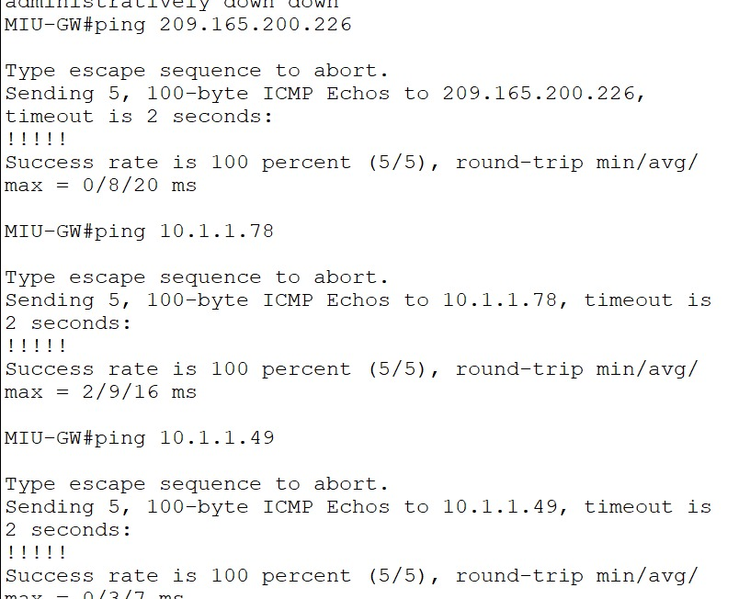**MIU-GW Interfaces Pinging:**

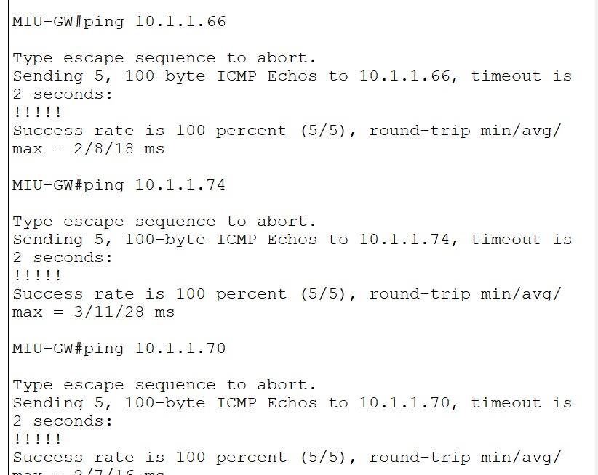

**part 6:**

**- Dynamic NAT with PAT and Static NAT setup**

**- Web server configuration and troubleshooting**

**- End-to-end connectivity testing (ping/traceroute)**

