Project: Network Traffic Management Lab (iperf3 + Linux tc)

  - Lab Topology (both networks)
  - LAN Client VM → generates traffic
  - LAN Server VM → receives traffic
  - Same subnet, test port: 5201

Network 1 — Baseline + Traffic Shaping (TBF rate limiting)
Goal
Measure baseline throughput, then apply bandwidth shaping (simulate congestion), re-test, and rollback.

Step N1.1 — Confirm IP config (Client)
Run on: Ubuntu Client

ip a
ip route

✅ Evidence: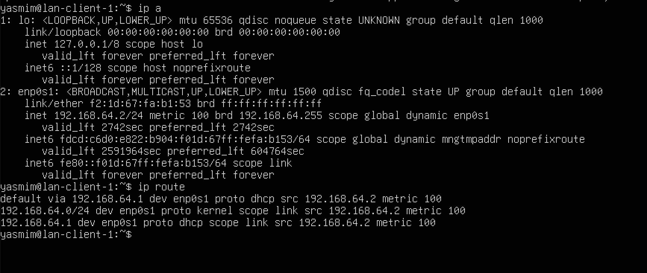
- Evidences/Network 1/Evaluate stage/ip a + route_client1.png

Step N1.2 — SSH + Port 22 checks (Server)

Run on: Ubuntu Server

sudo systemctl status ssh
sudo ss -lntp | grep :22 || echo "Port 22 not listening"

✅ Evidence: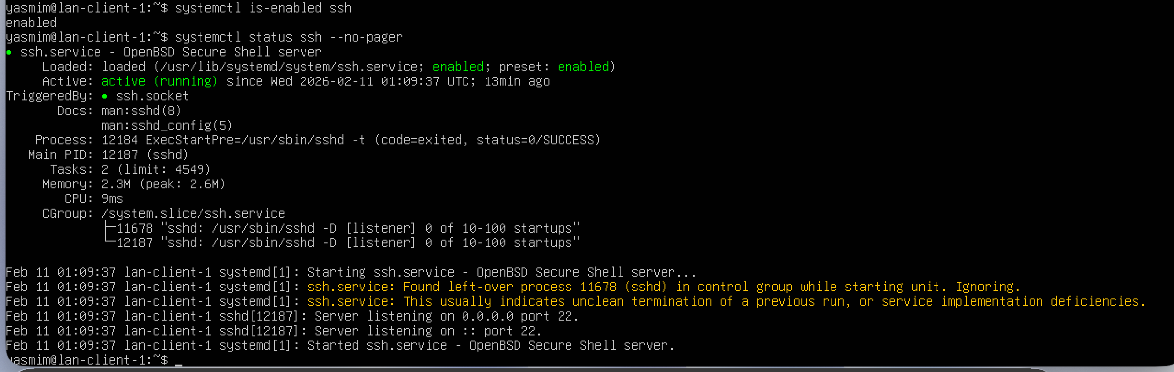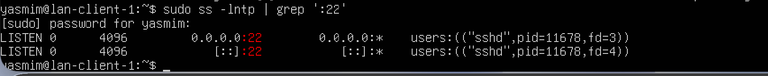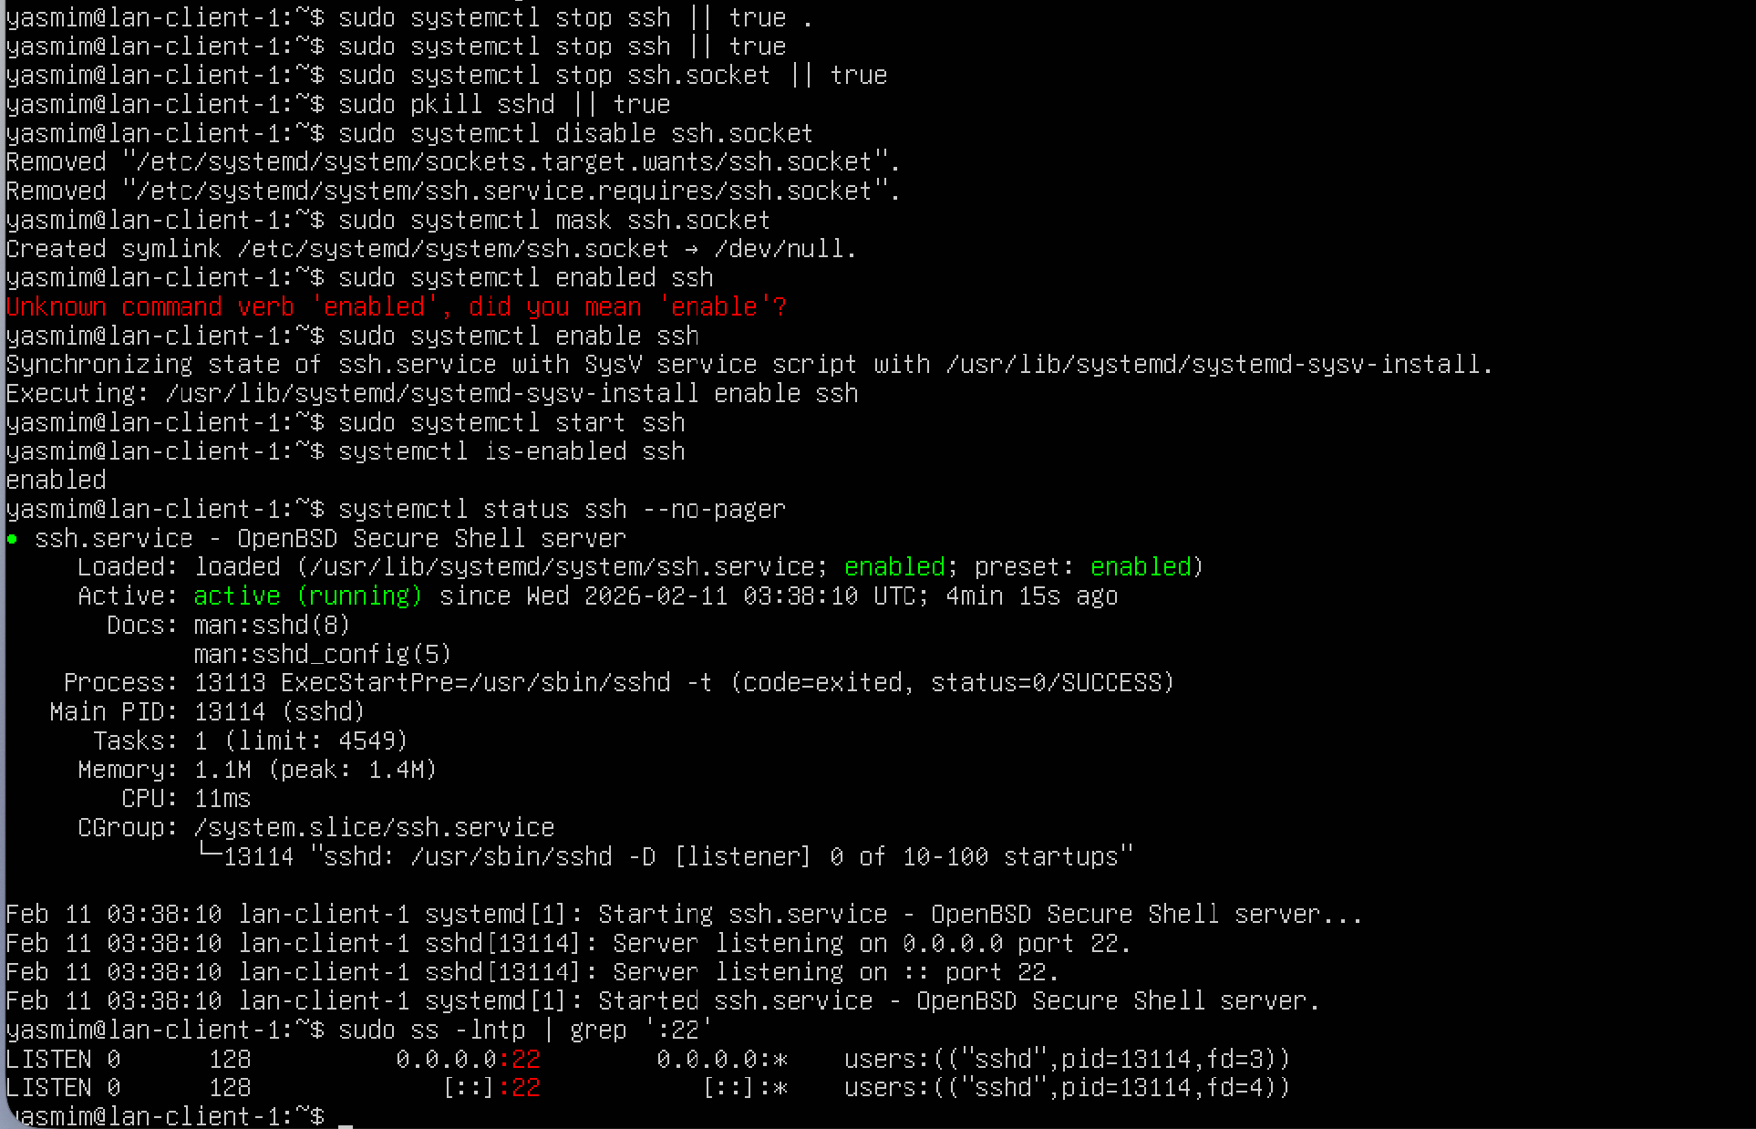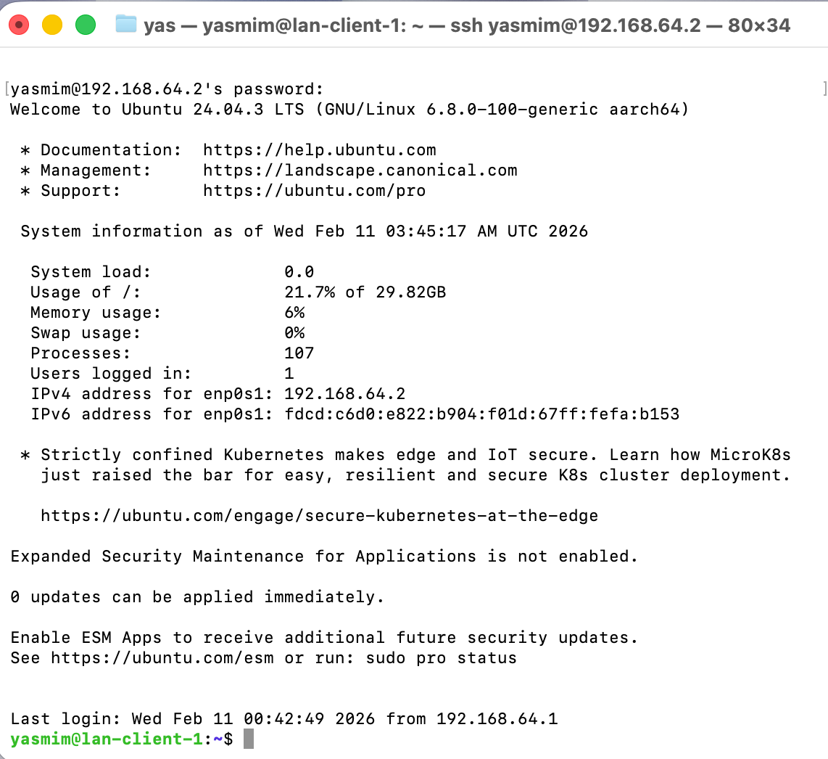
- Evidences/Network 1/Traffic control/Enabled+verified status.png
- Evidences/Network 1/Traffic control/Port 22 listener check.png
- Evidences/Network 1/Traffic control/Port listening.png
- Evidences/Network 1/Evaluate stage/fix SSH.png (if you used it)
- Evidences/Network 1/Evaluate stage/Terminal_Login_Ubuntu.png

Step N1.3 — Start iperf3 server (Server)
Run on: Ubuntu Server

iperf3 -s

✅ Evidence: 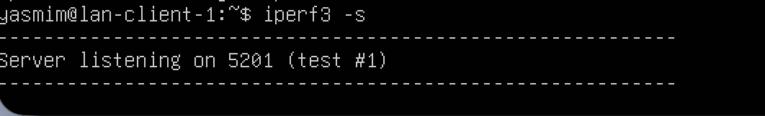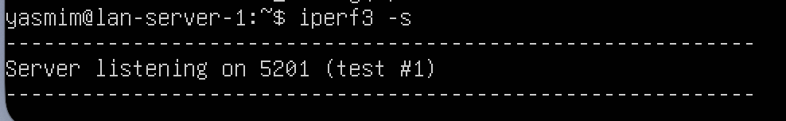
- Evidences/Network 1/Traffic control/Client server listening on 5201....png
- Evidences/Network 1/Evaluate stage/Server listening on 5201.png

Step N1.4 — Run baseline throughput test (Client)
Run on: Ubuntu Client

iperf3 -c 192.168.64.3 -t 10

✅ Evidence: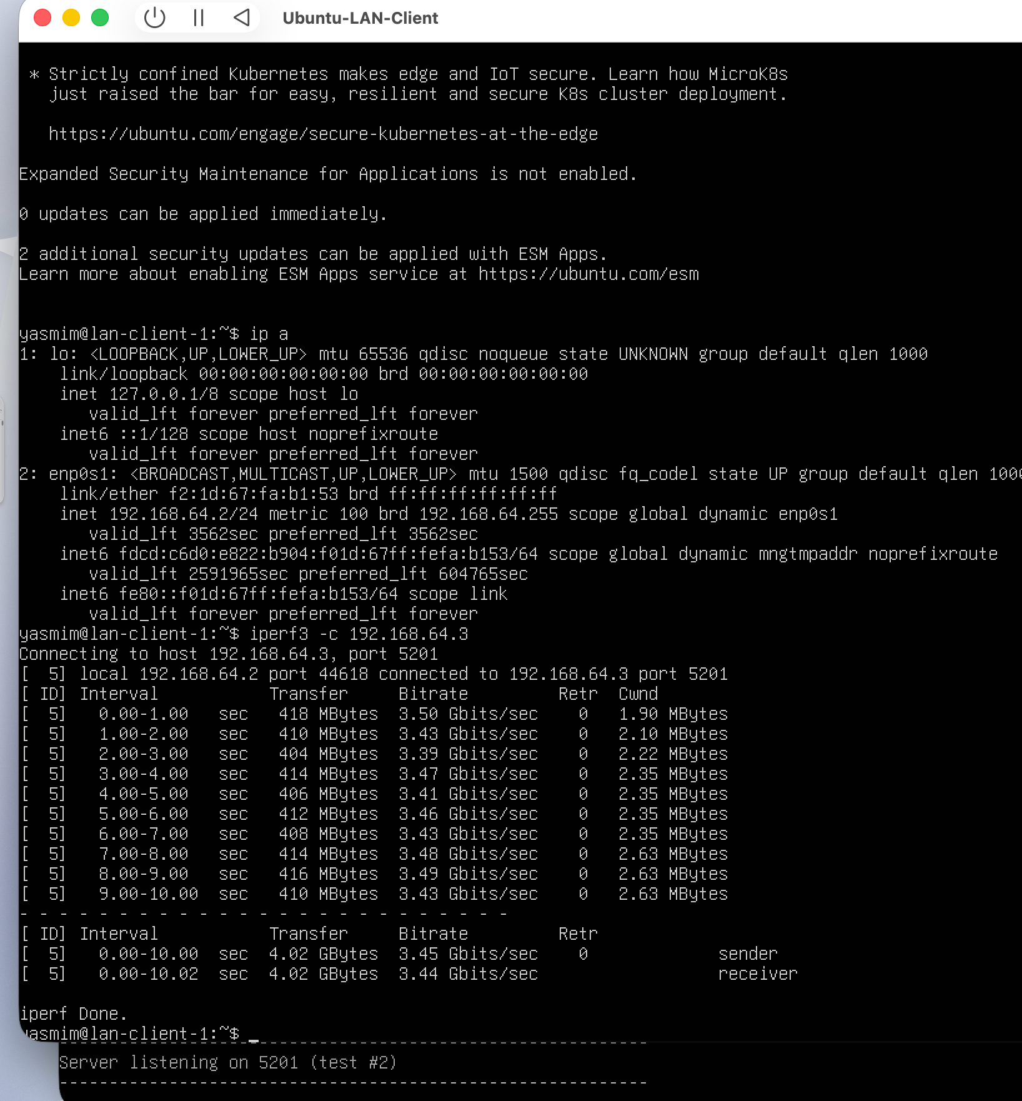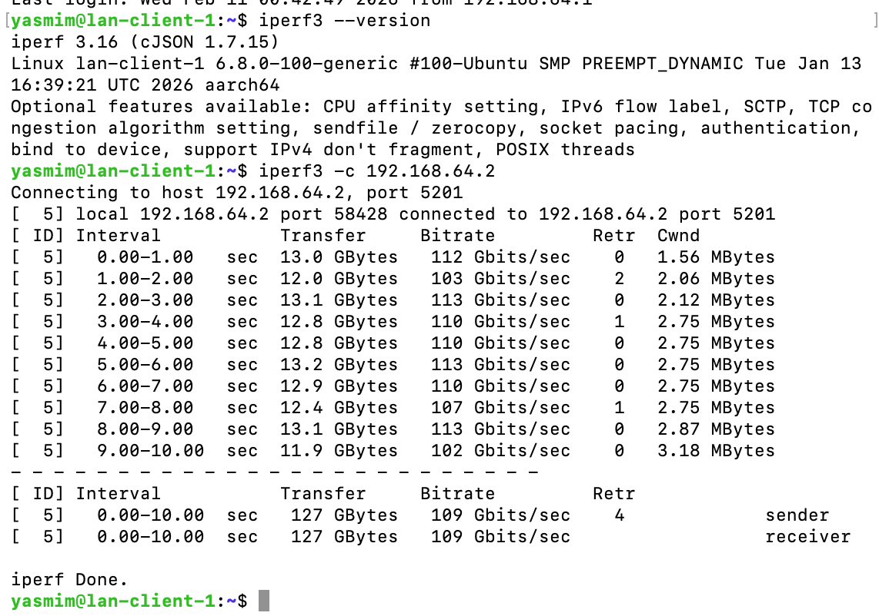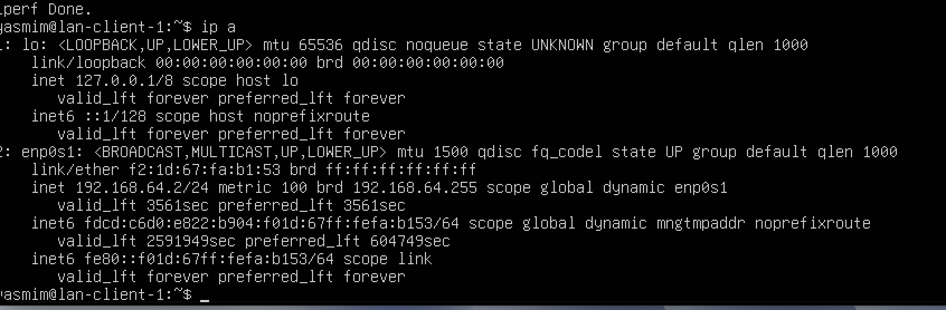
- Evidences/Network 1/Evaluate stage/iperf3 CLIENT to SERVER.png
- Evidences/Network 1/Evaluate stage/iperf3 test result.png
- Evidences/Network 1/Traffic control/Baseline throughput.png

Step N1.5 — Check current qdisc (Server)
Run on: Ubuntu Server

sudo tc qdisc show dev enp0s1

✅ Evidence: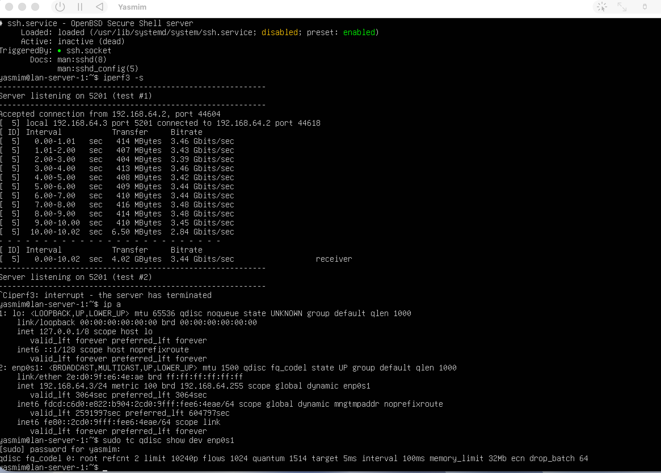
- Evidences/Network 1/Traffic control/qdisc.png

Step N1.6 — Apply traffic shaping (TBF) (Server)
Run on: Ubuntu Server

sudo tc qdisc add dev enp0s1 root tbf rate 50mbit burst 32kbit latency 400ms
sudo tc qdisc show dev enp0s1

✅ Evidence: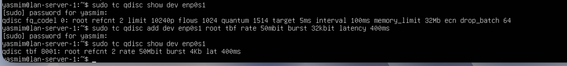
- Evidences/Network 1/Traffic control/TC applied.png

Step N1.7 — Re-test after shaping (Client)
Run on: Ubuntu Client

iperf3 -c 192.168.64.3 -t 10

✅ Evidence: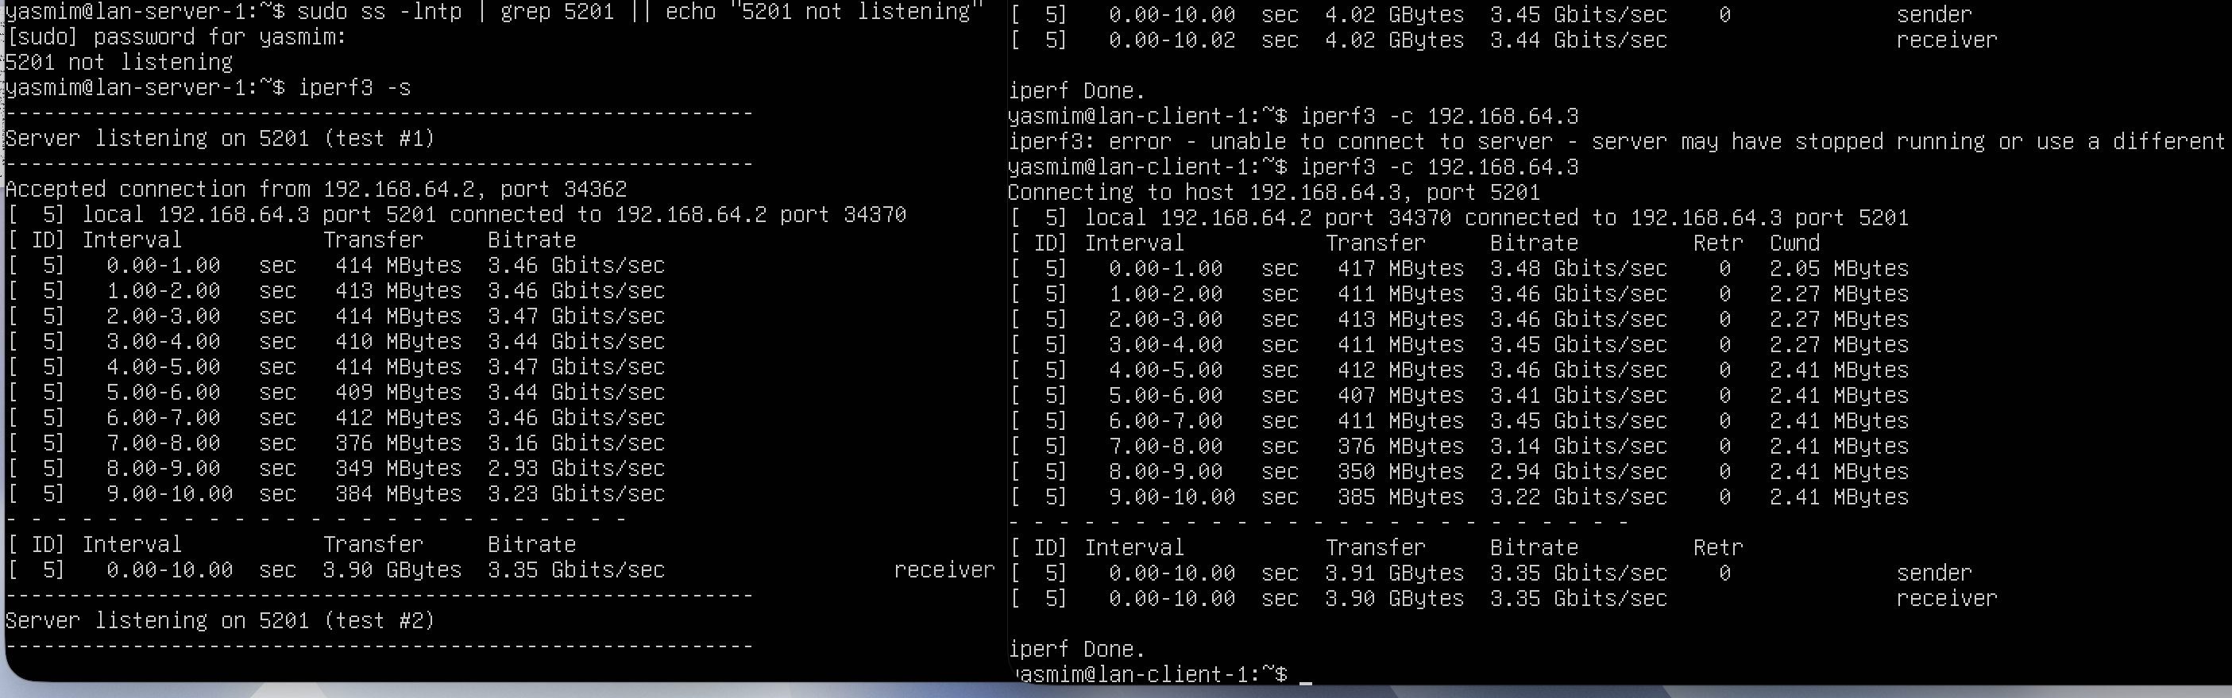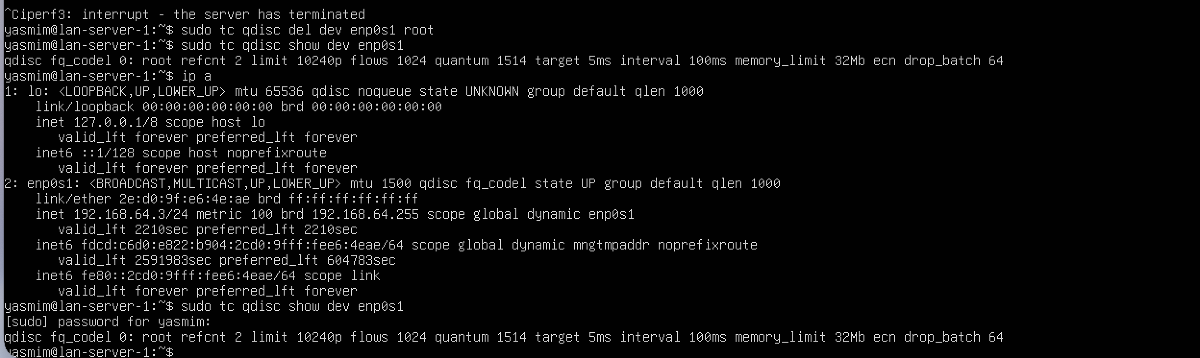
- Evidences/Network 1/Traffic control/test after tc_limited speed.png
- Evidences/Network 1/Traffic control/tc shaping.png

Step N1.8 — Rollback (remove shaping) (Server)
Run on: Ubuntu Server

sudo tc qdisc del dev enp0s1 root 2>/dev/null
sudo tc qdisc show dev enp0s1

✅ Evidence:
- Evidences/Network 1/Traffic control/tc removed.png

Network 2 — Baseline + NetEm impairment (delay/jitter/loss)

Goal
Simulate unstable WAN conditions using netem and observe impact.

Step N2.1 — Ensure no old tc rule is active (Server)
Run on: Ubuntu Server

sudo tc qdisc del dev enp0s1 root 2>/dev/null
sudo tc qdisc show dev enp0s1

✅ Evidence: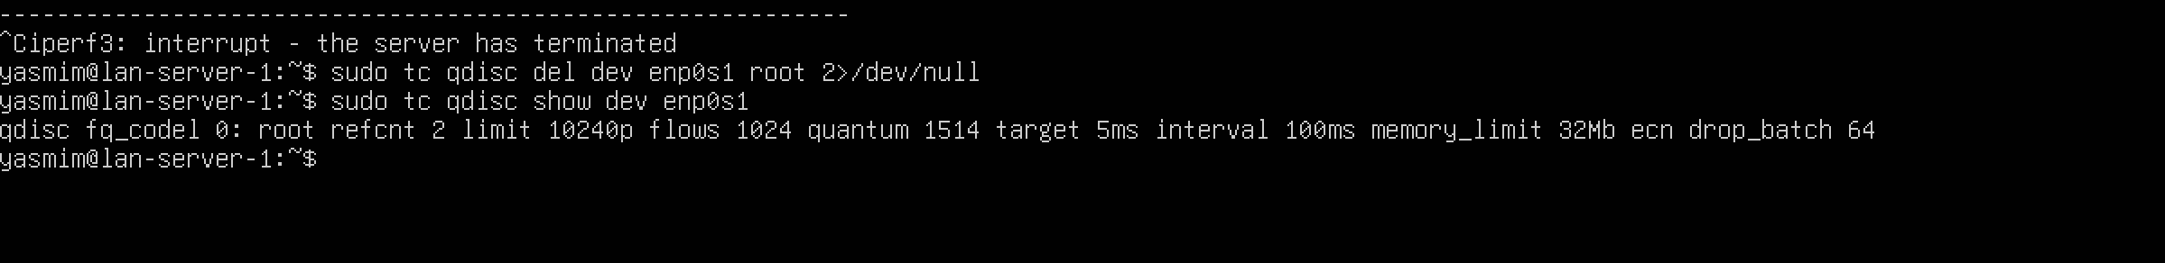
- Evidences/Network 2/N2_tc_removed.png

Step N2.2 — Start iperf3 server (Server)
Run on: Ubuntu Server

iperf3 -s

✅ Evidence: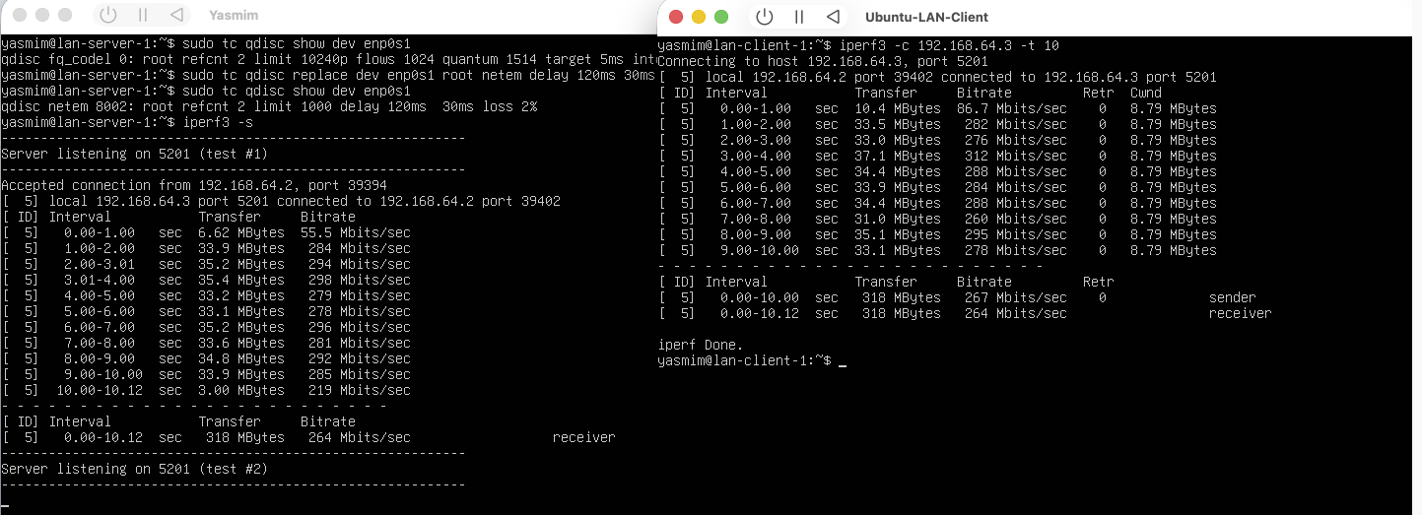
- Evidences/Network 2/N2_Server_listening.png

Step N2.3 — Baseline throughput (Client)
Run on: Ubuntu Client

iperf3 -c 192.168.64.3 -t 10
✅ Evidence: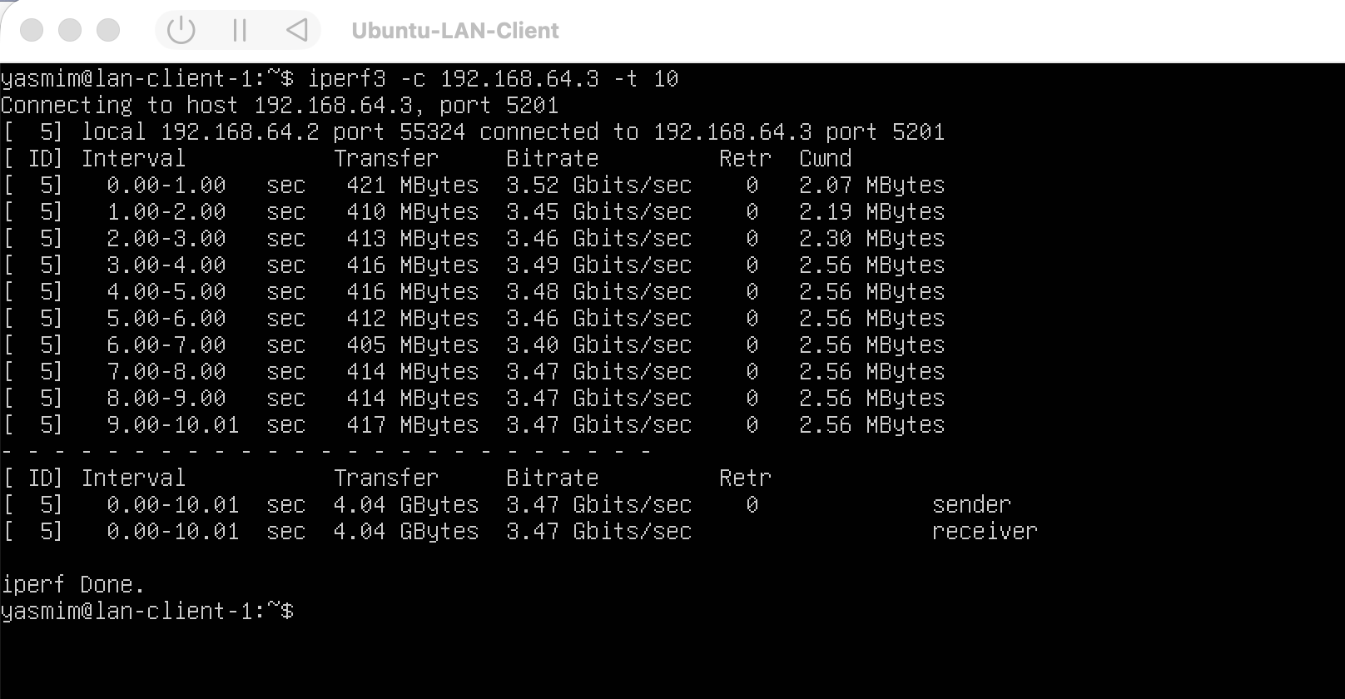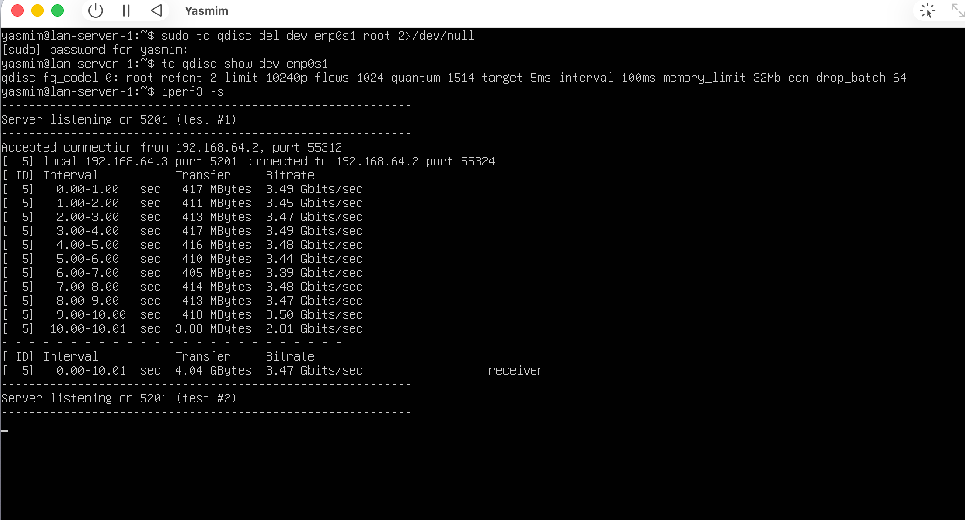
- Evidences/Network 2/Client_N2_baseline_iperf_test.png
- Evidences/Network 2/Server_N2_baseline_iperf_test.png

Step N2.4 — Apply netem impairment (Server)
Run on: Ubuntu Server

sudo tc qdisc replace dev enp0s1 root netem delay 120ms 30ms loss 2%
sudo tc qdisc show dev enp0s1

✅ Evidence: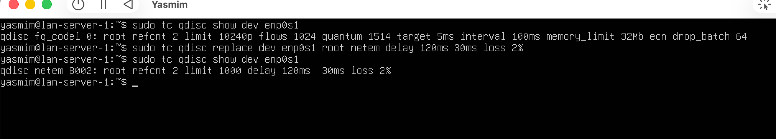
- Evidences/Network 2/N2_tc_netem_applied.png

Step N2.5 — Test after impairment (Client)
Run on: Ubuntu Client

iperf3 -c 192.168.64.3 -t 10
ping -c 20 192.168.64.3

✅ Evidence:
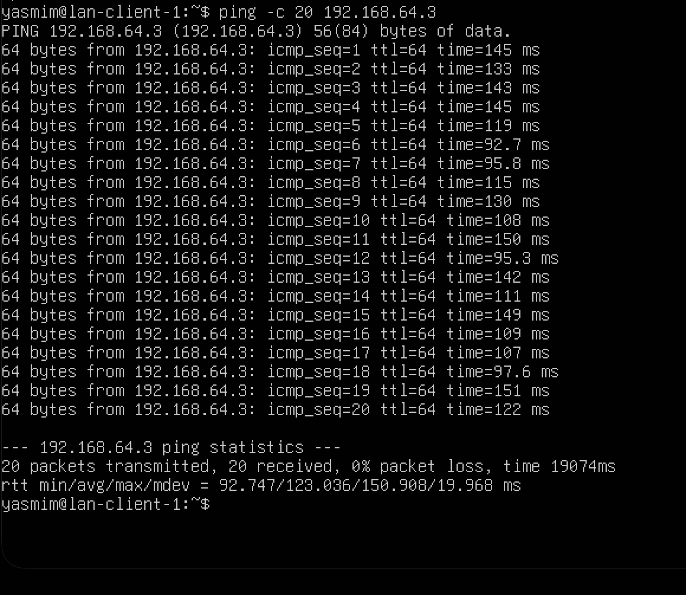
- Evidences/Network 2/ N2_tc_netem_applied.png

Step N2.6 — Rollback (remove netem) (Server)
Run on: Ubuntu Server

sudo tc qdisc del dev enp0s1 root 2>/dev/null
sudo tc qdisc show dev enp0s1

✅ Evidence:
- Evidences/Network 2/N2_tc_removed.png

✅ Evidence Mapping Summary

Network 1 evidence list

- IP & route validation: Evaluate stage/ip a + route_client1.png
- iperf server ready: Evaluate stage/Server listening on 5201.png + Traffic control/Client server listening on 5201...png
- baseline throughput: Evaluate stage/iperf3 CLIENT to SERVER.png + Traffic control/Baseline throughput.png
- qdisc baseline: Traffic control/qdisc.png
- TBF applied: Traffic control/TC applied.png
- throughput reduced after shaping: Traffic control/test after tc_limited speed.png
- rollback (tc removed): Traffic control/tc removed.png

Network 2 evidence list

- tc cleared: N2_tc_removed.png
- iperf server ready: N2_Server_listening.png
- baseline throughput: Client_N2_baseline_iperf_test.png + Server_N2_baseline_iperf_test.png
- netem applied: N2_tc_netem_applied.png
- performance impact after netem: N2_iperf_after_netem.png

