Describe your data and one or more of your questions from the point of view of measurement theory, guided by the steps in Voje et al. 2023 Figure 1 (note that this is not the same as Figure I). That is: describe the theoretical context, relevant attributes, what you will measure on what kind of scale, and how this will affect your statistical analyses.
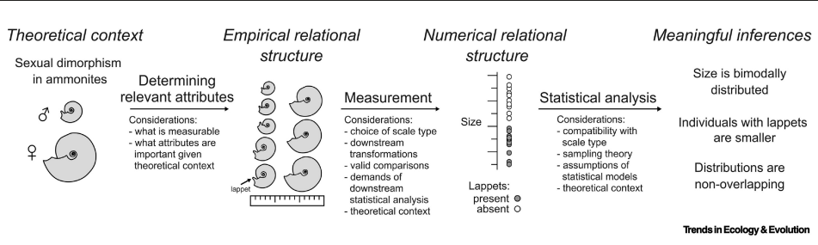
Theoretical context
The theoretical context of this data is sex-specific evolutionary processes and attributes. Particularly, how males and females show differences in patterns of genomics variation. And how this can be used to achieve an overarching goal in identifying and mapping the female-determining region of Xenopus longipes. In this case, the attribute of interest is not directly observable, but can be inferred from statistical summaries of genomics data.
Empirical relational structure
The key relevant empirical attribute is the sex of individuals, which is a binary biological attribute, so male and female, that will structure all downstream analyses and comparisons. The dataset consists of:
- Reduced Representation Genome Sequencing (RRGS) reads from 34 X. longipes individuals
- A long-read reference genome assembly
- RNA-seq data from the developing gonads of 12 individuals
From this dataset, we can use allele frequencies, sequence coverage, heterozygosity, and gene expression to compare between the sexes across genomic loci or windows. Since the empirical relational structure is defined by group-level comparisons, meaningful relationships will be differences and similarities between sexes at specific genomic regions. Regions showing consistent sex-specific patterns across multiple metrics are predicted to represent sex-linked regions.
Numerical Relational structure
To represent the empirical attributes described above, several summary statistics will be used with its own measurement scale.
Starting with sequencing coverage, will be calculated using bamCoverage, normalized to the genome-wide median. Coverage is measured on a ratio scale, with a true zero indicating absence of mapped reads. There can be several scenarios when it comes to coverage, keeping in mind that X. longipes have female heterozygosity:
- Regions with approximately zero coverage in males but non-zero coverage in females may indicate female-specific (w-linked) regions.
- Regions with approximately half the normalized coverage in one sex relative to the other may reflect sex-linked dosage differences.
Next, heterozygosity (or sometimes referred to as polymorphisms) will be estimated using genotype likelihood–based methods (e.g. ANGSD) and association analyses (e.g. PLINK). It will be measured on a ratio scale, representing the proportion of heterozygous sites. Elevated heterozygosity in one sex relative to the other – females in case of female heterogametey - may indicate sex-linked regions, whereas uniformly low heterozygosity is expected for autosomal regions. Since our available data is low-coverage, Next Generation Sequencing, we will focus on the ANGSD output, as opposed to PLINK association which is designed for high-confidence called genotypes. In the ANGSD output, a Likelihood Ratio Test (LRT) is computed for polymorphic sites. A p-value is generated for such sites to define highly confident and clear polymorphic sites. P-values will be transformed to -log₁₀(P) for easier and more meaningful visualization.
Then, Fixation Index (FST) will be a ratio that quantifies the genetic diversity due to differences between two populations – in this case the two populations will be male and female phenotypes. The values will range from 0 to 1. We will compare the FST scores between genomic windows with ‘high’ FST scores indicating sex-linked windows (due to differences between the populations) and ‘low’ FST scores indicating autosomal windows.
Sex-biased gene expression: we can infer the sex biased expression of genes from RNA sequence we can do gene ontology. We can infer expression from ratio of male to female expression. Since RNA-seq data is not yet available, I will not discuss it in detail.
Meaningful inferences
All the statistical analyses discussed above will be leveraged to understand the genetic basis and evolution of developmental traits such as sex determination and overall generate empirical evidence with which to test models of sex chromosome turnover
Also, for at least one comparison discuss how you will decide whether a difference is “important” – you could specify a cutoff level or describe how you will investigate this question further.
In the type of analyses that will be performed, biological importance will be inferred during the exploration of the data. Here, I’ll discuss FST scores and -log₁₀(P) values.
Differences in FST between genomic windows will be considered biologically important if they are extreme relative to the genome-wide distribution, rather than based on an absolute threshold. For example, windows falling within the upper tail (e.g. top 1% or 0.5%) of sex-specific FST values will be treated as candidate sex-linked regions. This approach defines importance relative to the empirical background level of differentiation expected across the genome.
For association analyses, –log₁₀(P) values may be used as a screening criterion (e.g. –log₁₀(P) ~ 5–6), but these thresholds will be interpreted as evidence against a null hypothesis rather than as measures of effect size. Loci exceeding such thresholds will be evaluated further using effect-size–based metrics (e.g. FST, coverage differences) to assess their biological relevance.

