**Task-4 Setup and Use a Firewall**

**Open Windows Defender Firewall**

**Step 1:** Click on windows and search for Windows Defender Firewall with Advanced Security

**Step 2:** On the left-hand panel, click on Inbound Rules. A list of inbound rules is displayed

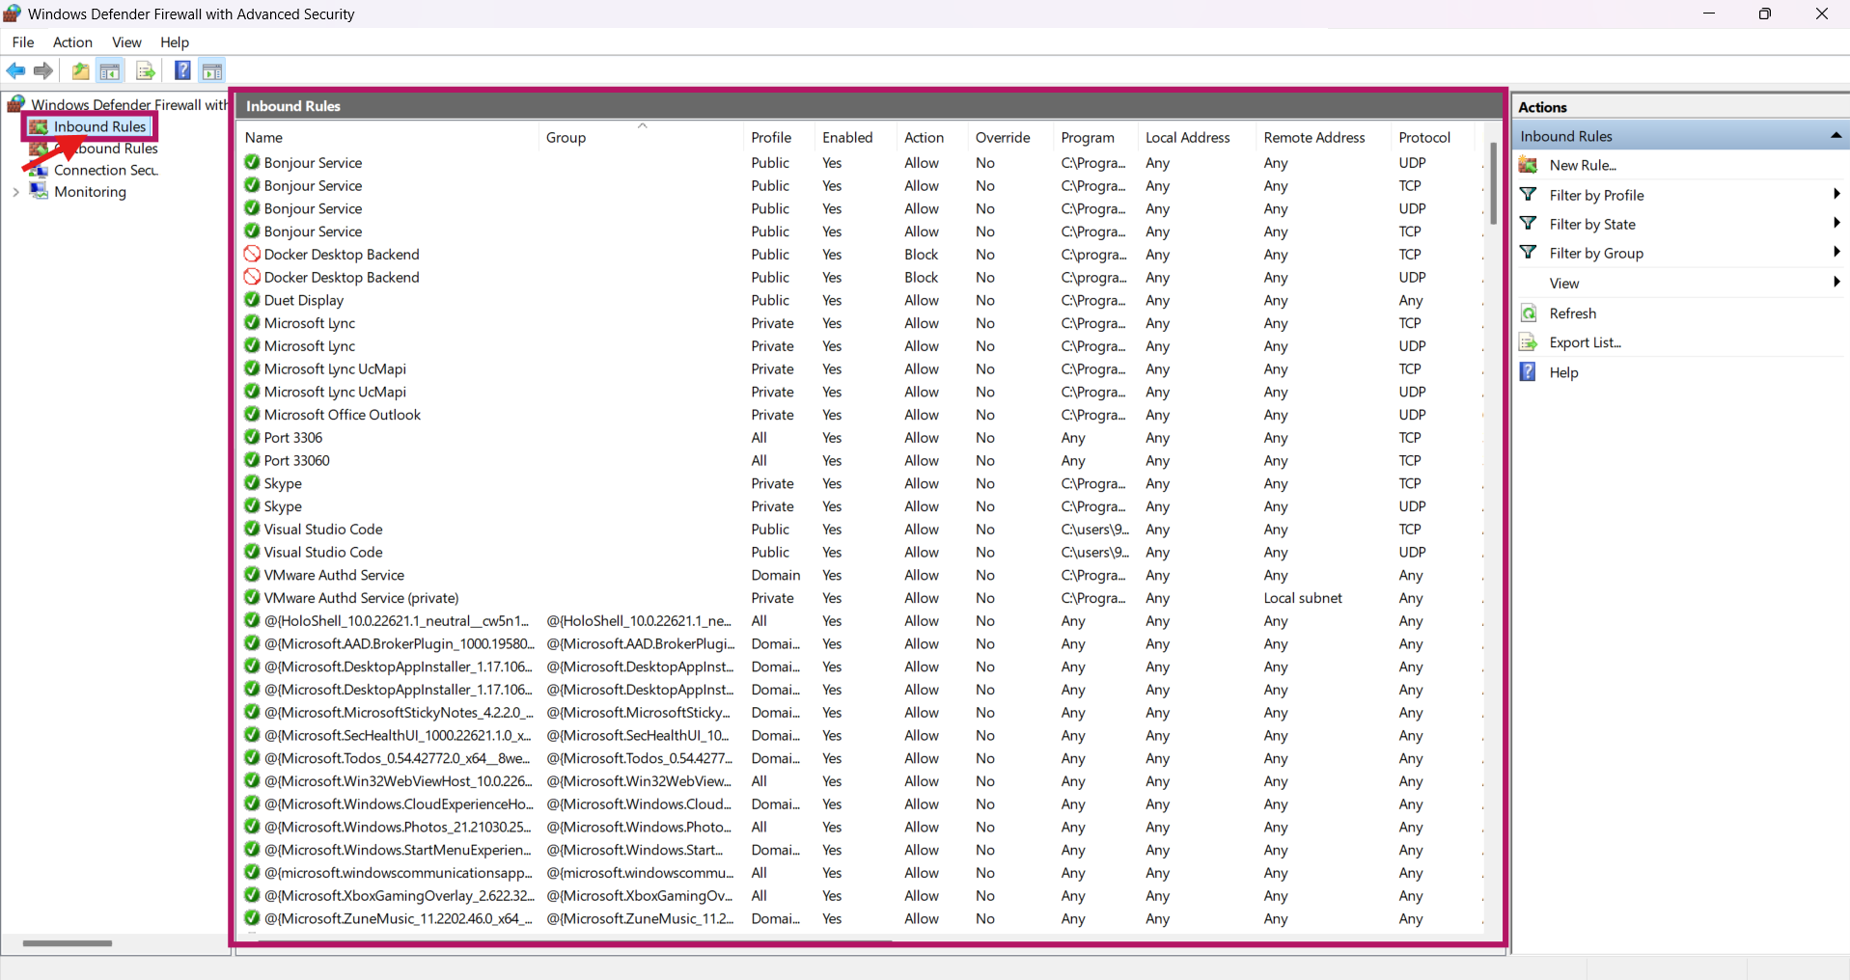

**Step 3:** On the left-hand panel, click on Outbound Rules and the respective list of rules is displayed

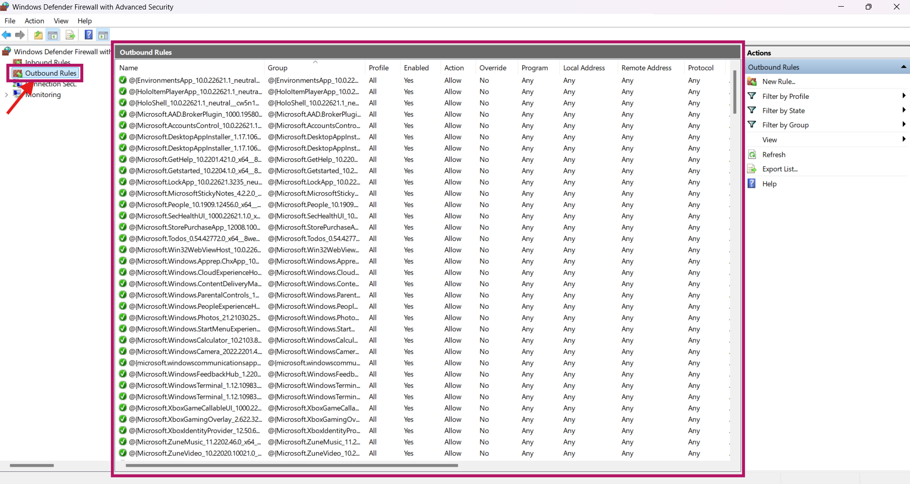

**Setup a Firewall Rule:**

**Step 1:** On the right-hand side of the Inbound Rules list under the Actions tab, click on New Rule

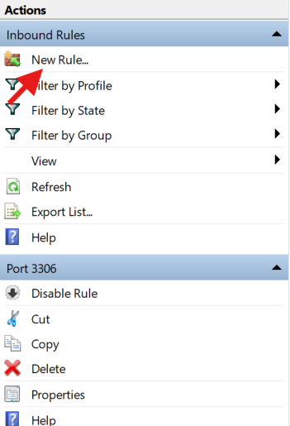

**Step 2:** Select the Rule Type as Port and click Next

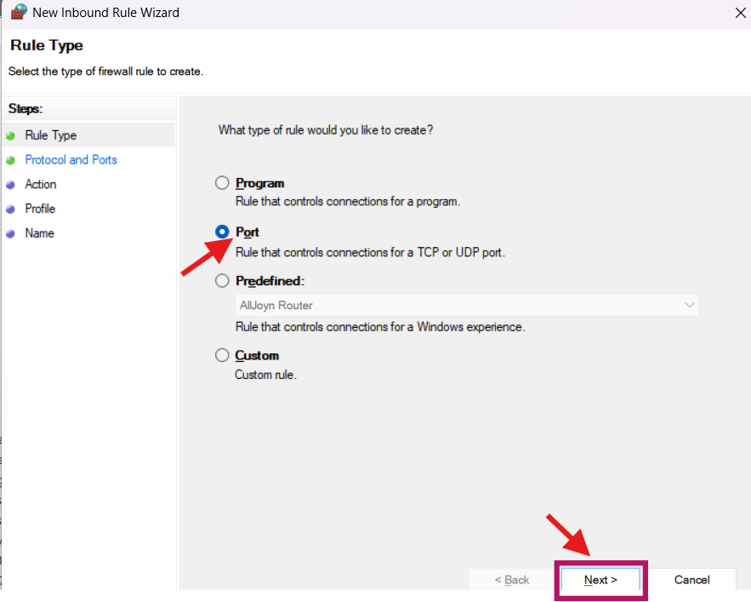

**Step 3:** On the next page, select “TCP” and "Specific local ports" and enter 23 in the text box. Click Next

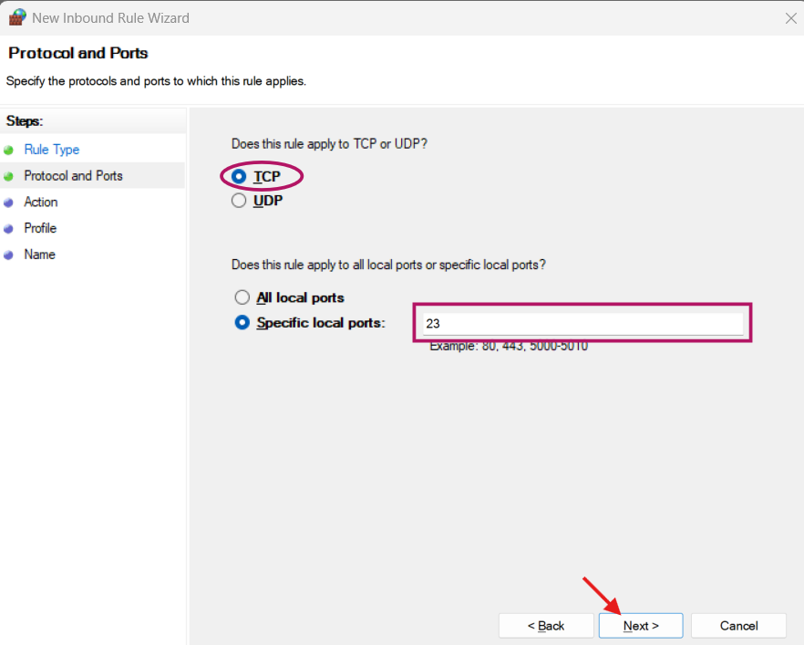

**Step 4:** Select “Block the connection” and click Next

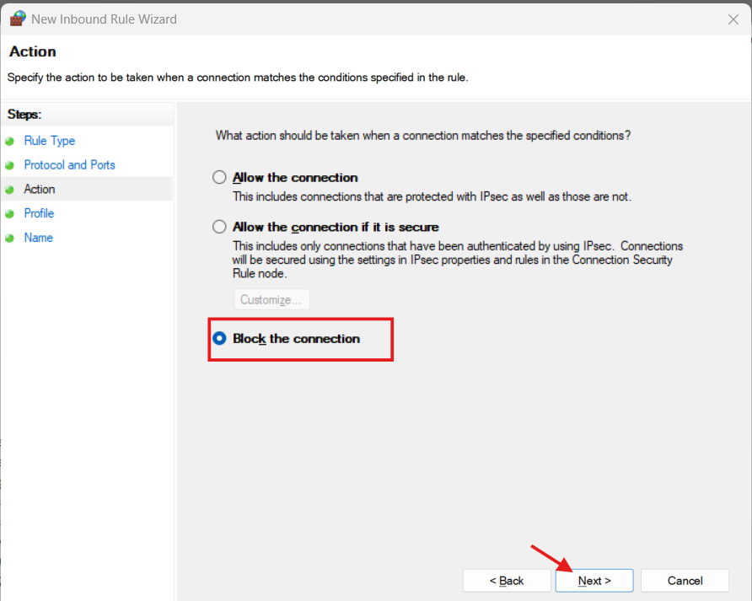

**Step 5:** Select all the profiles and click Next

**Step 6:** Give a descriptive name for the rule and click Finish

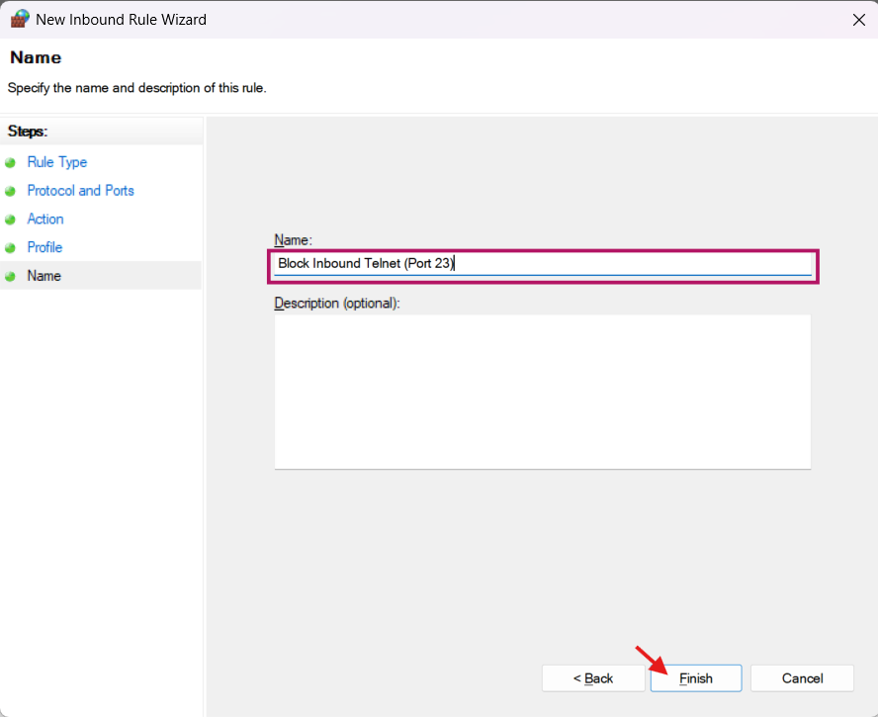

**Step 7:** Check whether the rule is added to the Inbound Rules list

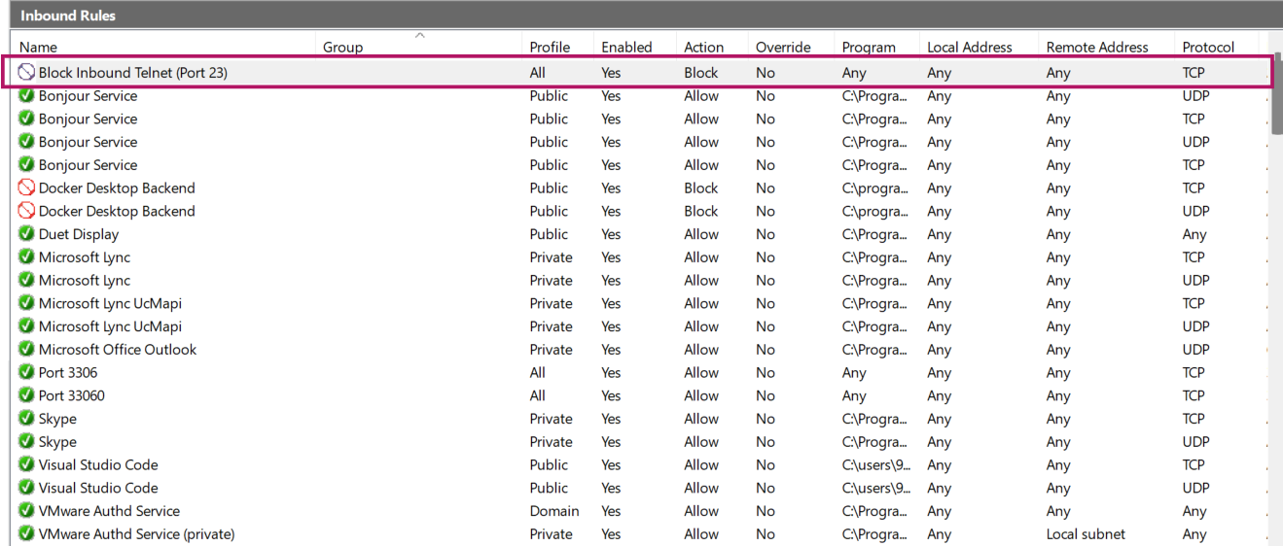

**Testing the Firewall Rule:**

**Step 1:** Go to website <https://www.whatismyip.com/> to check the public IP address

**Step 2:** Open PowerShell and run the command Test-NetConnection -ComputerName <IP_address_of_your_Windows_machine> -Port 23

**Summarization of the Firewall Rule execution**

An attempt to establish a connection to TCP port 23 has failed due to the Inbound Rule that is being setup.

**TcpTestSucceeded : False:** This is the definitive indicator that the TCP connection on port 23 was not successful. This is what you want to see when blocking a port

**WARNING: Ping to 110.224.90.18 failed with status: TimedOut and PingSucceeded : False:** This is an additional confirmation that even ICMP (ping) traffic is not reaching the target. This further suggests a strong network-level block (either by your firewall or a router/ISP).

**SourceAddress : 192.168.94.138:** This shows that the test was initiated from a private IP address within your local network.

**ComputerName / RemoteAddress : 110.224.90.18:** This confirms you were trying to connect to your public IP address.