**TASK 5 - Packet Capture using Wireshark**

**Wireshark**

1. Click on the Wi-Fi tab below after opening the Wireshark tool

1. Open the command prompt and ping any domain of your choice

1. All the packets are captured by the Wireshark tool
2. Stop the capture and save the file

**Packet Analysis**

1. Open the saved Wireshark file to analyze the packets

1. Filtered the packets with **DNS** protocol

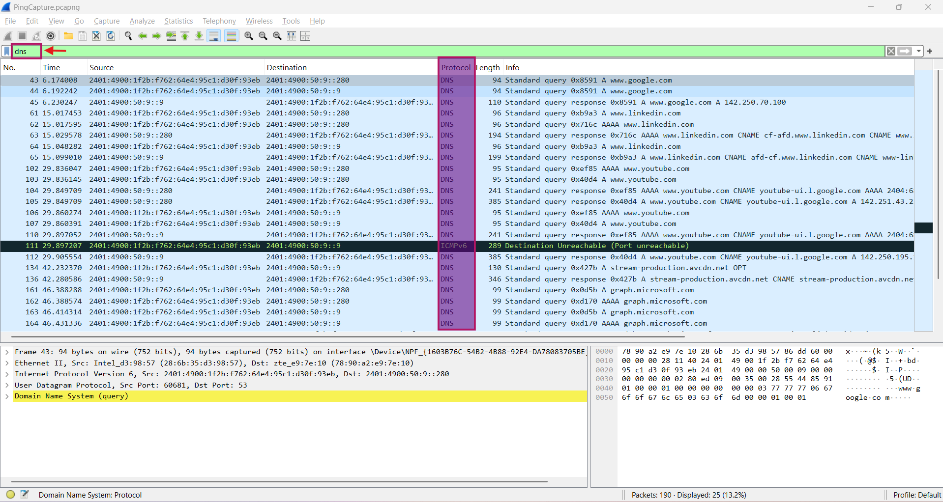

1. There are packets with DNS queries sent for each domain that are pinged using command prompt and the respective response
2. Let us filter the **HTTP** packets from the saved file

1. Filtering the packets with **TCP** protocol

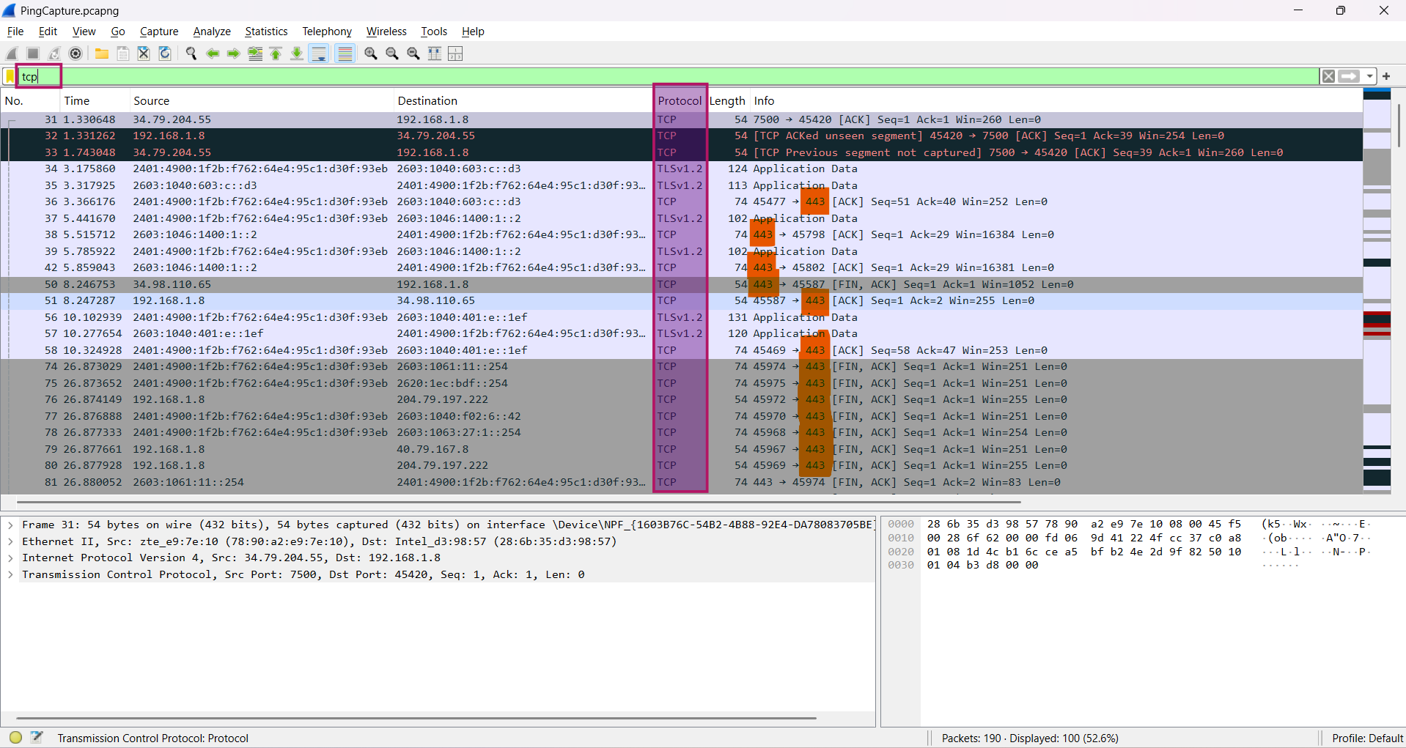

1. In this capture, we can also look at the port numbers associated with the protocol. Port number 443 indicates that it uses a secure communication method
2. We can also filter protocols along with port numbers. There are no port numbers **80** in the captured packets

1. Let us try using the **UDP** protocol with port numbers **80** and **443**

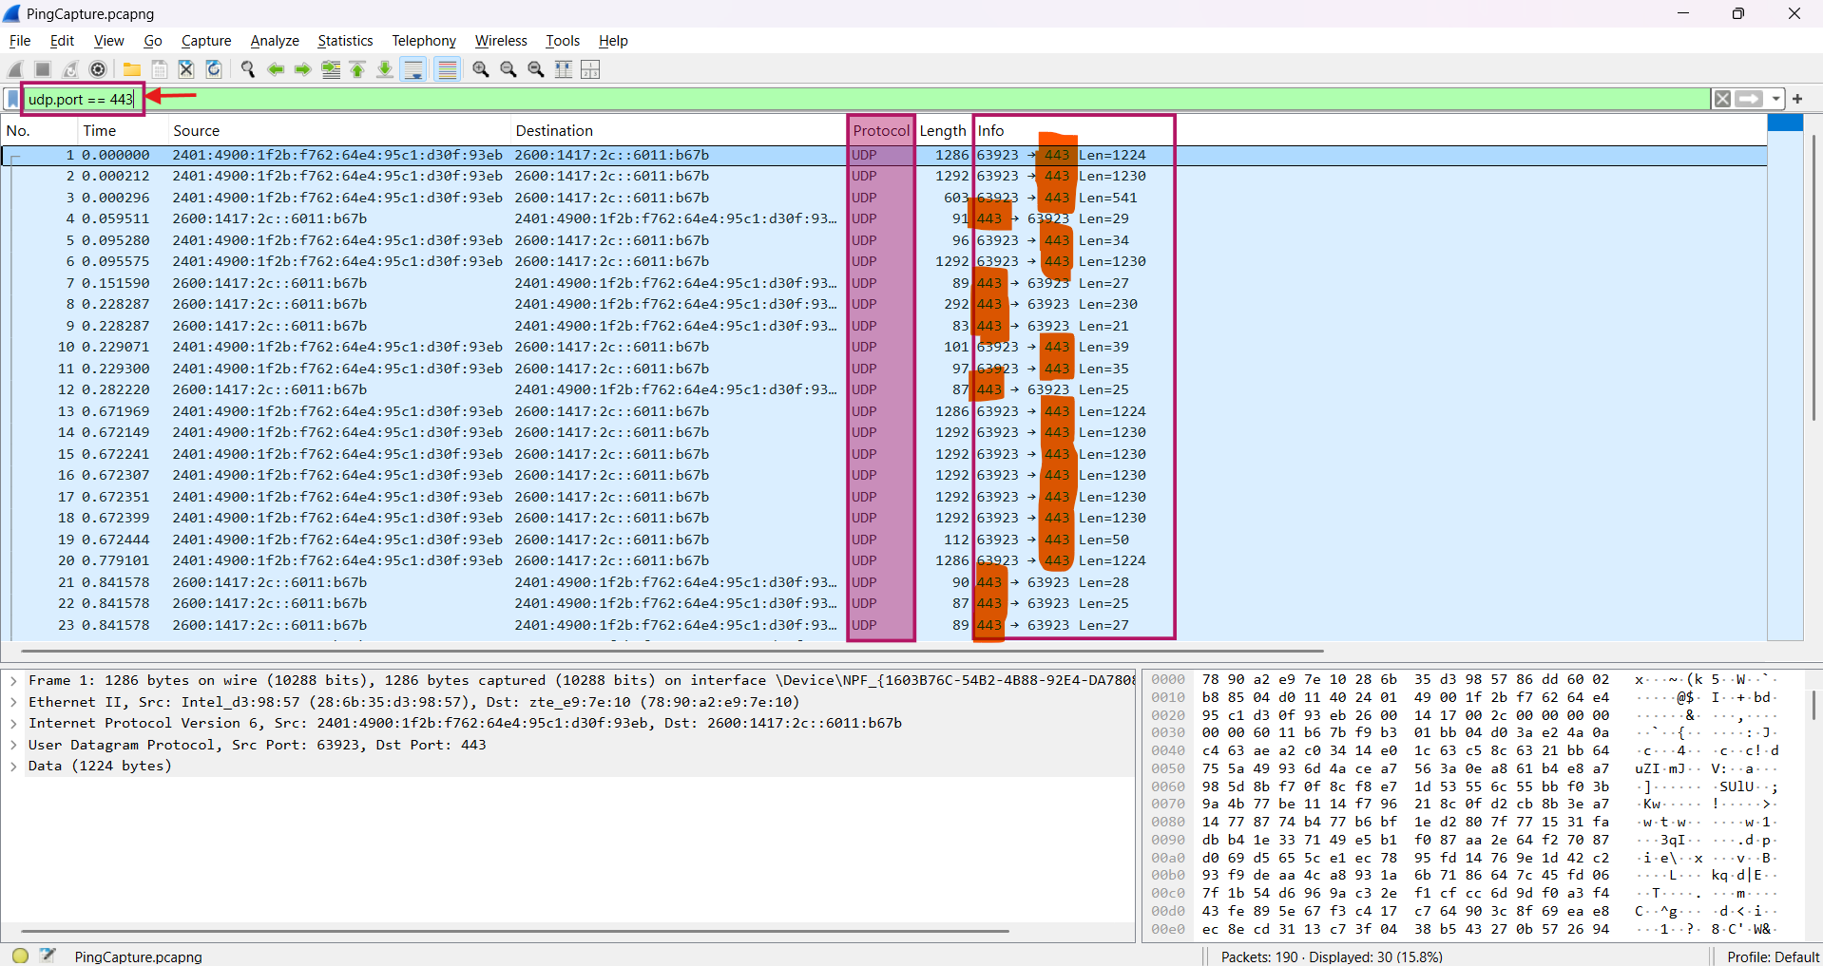

1. In the filter below for **ARP**, we can see the broadcast request asking for the corresponding MAC address to the known IP address

