

RESEARCH & PROJECT SUBMISSIONS

**Program: CESS**

***Course Code: CSE 341***

***Course Name: Internet Programming***

***Examination Committee***

**Dr. Hesham Farag**

**Done by**

|  |  |
| --- | --- |
| Mariam Yasser Abdelmageed Meckawy | 18P3059 |
| Yasmin Haitham Abdelmoaty | 18P3102 |
| Mohamed Yasser AbdelSamad Hassan | 18P7713 |
| Mohammed Mamdouh Ibrahim | 18P8906 |

**Ain Shams University**

**Faculty of Engineering**

**Spring Semester – 2022**

**Table of Contents**

1. Introduction 3

2. System Pages 3

2.1 Sign up page 3

2.2 Log in page 4

**List of Figures**

Figure 1 sign up page 3

Figure 2 log in page 4

# Introduction

The final project of this course is an online library management system. The system allows the user to sign up and make a new personal account on the website, search for a certain book and borrow it, as well as allow the admin to login and perform certain tasks like add a new book and all its details and the number of copies available, delete a book from the database or edit the details of a certain book. Furthermore, the admin can manage the members’ database.

All styles are written in css, where functions, database and main code are written using javascript, php and HTML.

# System Pages

## 2.1 Sign up page

The new member adds a new username, email, password and password again for re-check, then these information are saved in the database for later use.

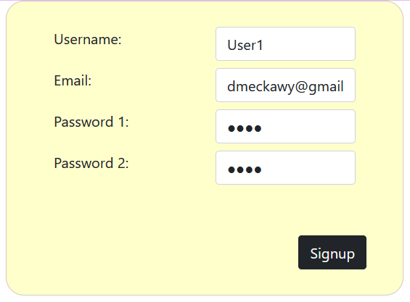

Figure 1 sign up page

## 2.2 Log in page

Then the member fills the log in page text fields with the previously saved information about himself as shown in the figure below.

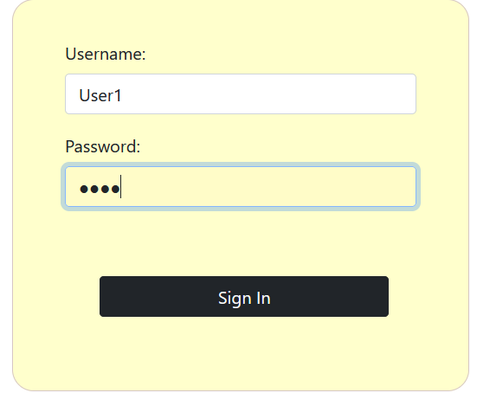

Figure 2 log in page