Kazakhstan Household Deposit Dollarization Index
Data Analysis and Economic Forecasting, KBTU
Pipilova Yasmin, Maratova Gulzat. 19 October 2026
We built a small website that shows what share of household bank savings in Kazakhstan is kept in foreign currency, explains what moved this number last month, and tells a bank treasury when to keep more dollars ready. This note describes, in order, the indicator, the data, the model, how much we can trust it, the website, and the decision rule. All numbers in the note are produced by our code: the full tables are in outputs/report_tables.md and the charts in outputs/figures/ in the repository.
1. The indicator
Table 1 is the indicator card. In short: dollarization is the foreign-currency deposits of households divided by all household deposits. In August 2026 it was 19.17%, 0.09 percentage points lower than in July. It was about 80% at the start of 2016, after the tenge was floated, and has fallen almost every year since (Appendix C, Figure 1).
Element | Specification
Concept | The share of household bank deposits in Kazakhstan held in foreign currency. It measures how far households protect their savings against the tenge, which weakens the transmission of NBK monetary policy and creates foreign-currency liquidity risk for banks. A bank treasury needs the number to plan its foreign-currency liquidity buffer.
Formula | D_t = 100 × FX_t / (KZT_t + FX_t), where FX_t is the sum of household demand, conditional, term and savings deposits in foreign currency, and KZT_t is the same sum in national currency (million KZT, end of month t). The NBK "Total" equals KZT_t + FX_t; the code checks this every month (tolerance 5 million KZT). Not a composite index: no weights are involved
Unit and scale | Percent of total household deposits, 0–100
Frequency and lag | Monthly, end-of-month stocks. Published by the NBK around the 15th of the following month
Coverage | Kazakhstan, household (individual) deposits in banks, including accounts of non-resident individuals. Data: 2010-01 to 2026-08 (200 months). Main model sample: 2016-01 onwards (after the move to a floating tenge in August 2015).
Source | National Bank of Kazakhstan, "Household deposits in banks of Kazakhstan", XLSX export, retrieved 2026-10-04. Revisions: possible (December 2019 includes final turnovers, per NBK footnote); checked by re-downloading before submission.
Transformations | Components summed; text numbers parsed; empty cells for savings deposits before their introduction set to 0. No deflation, seasonal adjustment or interpolation of the indicator itself. Alternative measure: dollarization at a constant exchange rate (foreign-currency deposits converted to USD at the end-of-month rate, then back to KZT at the January 2016 end-of-month rate), which removes the pure revaluation effect.
Known weaknesses | (1) Revaluation: when the tenge weakens, FX deposits rise in KZT terms even if nobody buys foreign currency, so D_t rises mechanically. (2) Cash dollars held outside banks are not covered. (3) Includes non-resident individuals' accounts. (4) Households only; the NBK headline figure for all deposits (about 20% in 2026) differs. (5) Regulatory changes (cap on FX deposit rates, lower guarantee on FX deposits) shift the level and can create structural breaks. (6) FX deposits in USD terms moved within about 10–16 billion USD over 2014–2026 without a clear downward trend, so most of the fall in D_t reflects growth of tenge deposits, not sales of dollars.
Table 1. Indicator card
2. Data and how we process it
We use five free public series, all downloaded on 4 October 2026: household deposits by currency, the daily official USD/KZT rate and household deposit interest rates in tenge and in foreign currency, all from the National Bank of Kazakhstan (NBK), the monthly consumer price index from the Bureau of National Statistics (Taldau); and the Brent oil price from FRED. The exact pages, menu paths and every manual step are written down in data/raw/SOURCES.md. The downloaded files are never edited by hand.
The script src/ingest.py turns these files into one monthly table. Daily exchange rates are averaged by month to measure how much the tenge weakened, and the rate on the last day of the month is used to value dollar deposits. The interest-rate gap is the tenge deposit rate minus the foreign-currency deposit rate. Monthly price changes are chained into yearly inflation. Two small gaps had to be filled: the NBK API has no rates for 20 December 2022 and for most of August 2023, so missing days take the previous day’s rate, and the August 2023 monthly average (451.94 tenge per dollar) was copied from the NBK annual file. The whole project, from raw files to the website, is rebuilt with one command: run.bat. Deleting the processed data and running it again gives exactly the same table.
3. What the literature says
Before building the model we checked whether our idea matches earlier research. Neanidis and Savva (2009) study transition economies and find that a weaker national currency raises deposit dollarization, that the interest-rate gap matters, and that dollarization moves step by step towards a long-run "desired" level. This supports our choice of factors and our error-correction model, which is built exactly around such a long-run level. Ben Naceur, Hosny and Hadjian (2019) study the Caucasus and Central Asia, including Kazakhstan, and find that unstable inflation and exchange rates keep dollarization high. From this paper we learned to add exchange-rate volatility as an extra factor, which we test in Section 5. Two recent studies point the same way: Dalgic (2024) explains that households keep dollar deposits as insurance, because the local currency loses value in bad times, and Vargas and Sanchez (2023) find that low and stable inflation is the main condition for reducing dollarization. Our method, the bounds test for a long-run relationship, comes from Pesaran, Shin and Smith (2001).
4. The model and the results
Before estimating anything we wrote down our plan and the signs we expected. We explain the monthly change in dollarization with four factors: tenge depreciation (expected to raise dollarization), the tenge minus dollar deposit rate (a higher tenge rate should lower it), inflation (should raise it) and the oil price of the previous month (higher oil supports the tenge, so it should lower dollarization). We use an ARDL model in error-correction form: it says how dollarization reacts to the factors this month and how quickly it returns to its long-run level. The model is estimated on January 2016 to June 2024 (99 months after lags); the computer tried 243 combinations of lags and chose the best one by the AIC criterion. Standard errors are Newey-West (HAC), which stay valid when the errors are uneven over time.
What the coefficient shows | Estimate | p-value | Meaning in plain words
Speed of return to the long-run level | −0.031 | 0.032 | About 3% of a gap closes each month (half-life ≈ 22 months)
Tenge depreciation, this month | +0.189 | 0.050 | 1% weaker tenge → dollarization +0.19 pp in the same month
Tenge depreciation, long run | +6.78 | 0.107 | Right sign, not significant
Tenge minus dollar deposit rate, long run | −4.38 | 0.068 | Right sign, significant only at 10%
Inflation, long run | −0.52 | 0.663 | Wrong sign, not significant
Oil price, long run | +30.9 | 0.166 | Wrong sign, not significant
R² (of the monthly change) | 0.256 | F-test 0.002 | Factors together are significant
Table 2. Main results (the full table with all 14 terms is in Appendix A).
Tests. We checked the model with the standard tests. It passes three: the errors are not correlated over time (Breusch-Godfrey p = 0.128), the factors are not too similar to each other (largest VIF 3.8), and the coefficients are stable by CUSUM (p = 0.96). It fails three, and we report them: the errors are larger in crisis months (Breusch-Pagan p < 0.001, which is why we use HAC errors), they are not normally distributed (Jarque-Bera p < 0.001, mainly because of March 2020), and the Chow test finds breaks in March 2020 and March 2022. The bounds test says there is a long-run relationship, but only just (F = 3.80 against the critical value 3.79). The R² of 0.26 looks low, but it describes monthly changes, which are noisy, for the level it would be close to 1 and would mean nothing.
Forecast test. We kept the last 26 months (July 2024 to August 2026) aside and never used them to build the model. On these months we compared the model with the simplest possible forecast: "next month will be the same as this month" (a random walk). The model’s average error is 0.73 pp, the simple forecast’s is 0.52 pp, so the model loses to the benchmark (ratio 1.40, Appendix C, Figure 3). Our plan said in advance that in this case the model must not be used for forecasting. We therefore use it to explain past movements, and the website says this.
What we changed from the plan: every factor has at least one lag, because the error-correction form needs it; oil enters with a one-month shift, as planned; and after the main model we added extra checks, the reverse-direction test and the decision rule, without changing the main model.
Our new element is a monthly series for households only, split into a part caused by exchange-rate revaluation and a part caused by real behaviour, and connected to a decision rule for banks.
5. How much we can trust it
Does the number measure what we want? Not fully. Dollars kept as cash at home are not counted, so the true dollarization of savings is higher, especially in a crisis. Also, when the tenge weakens, existing dollar deposits are simply worth more tenge, so the share rises even if nobody buys dollars. To separate this, we also calculate dollarization at a fixed exchange rate (January 2016). It is 15.7% instead of 19.2% today (Appendix C, Figure 2).
Do the factors really cause the change? We cannot prove it, so we call our results connections, not effects. Some factors are missing, for example the ruble exchange rate and the NBK’s own measures against dollarization. The ruble probably makes our depreciation effect look larger than it is. The direction could also go the other way, so we tested whether dollarization moves the exchange rate. A vector autoregression (VAR) found no such effect (Granger test p = 0.295, dollarization explains less than 1% of exchange-rate fluctuations). At first the test looked strongly significant, but this came from using the monthly average exchange rate while deposits are counted at the end of the month; with matching dates the effect disappears. So in our data the tenge drives dollarization, not the reverse.
Where does it hold? Only for 2016-2024: a floating tenge, inflation targeting and oil between 27 and 118 dollars per barrel, with two big shocks (2020 and 2022). It should not be used for a fixed exchange rate or for the 2014-2015 devaluations.
Could it be chance? We tried many models: 243 for the main model and 2,430 across all checks, and we report all of them. With so many tests some results can be significant by chance. After a strict correction for this (Bonferroni) no single factor stays significant. We also have only 99 months, so a factor that is not significant may still matter.
Robustness. We re-estimated the model in different ways to see whether the conclusions hold (Table 3, all eight versions in Appendix B). The most important result is the third check: when the exchange-rate effect is removed from the indicator, the effect of depreciation disappears. This means the link between a weaker tenge and higher dollarization is mostly revaluation of existing dollars, not people buying new ones. Exchange-rate volatility, the factor we added from the literature, has a negative coefficient (-0.93, p = 0.06), and the effect of depreciation is stronger when dollarization is already high.
Check | What we changed | Depreciation effect | Result
Different sample | Start in December 2011 instead of 2016 | +0.253, significant | Conclusion holds
Different specification | Logit of dollarization instead of percent | +0.006, weakly significant | Same sign, weaker
Different measure | Dollarization at a fixed exchange rate | -0.006, p = 0.85 | Effect disappears-it is revaluation
From the literature | Add exchange-rate volatility | +0.118, significant | Volatility −0.93 (p = 0.06)
Table 3. Robustness checks. In none of them does the model beat the simple forecast.
6. The website
The project has three parts. The data part (src/ingest.py) reads the raw files and makes the monthly table. The model part (src/model.py and the scripts for checks, the VAR and the decision rule) estimates everything and saves the results in model/artifact.json and in outputs/. The website (src/app.py, made with Streamlit) only reads these saved files: it does no calculations of its own and has no numbers typed into it. The command run.bat installs everything, rebuilds all numbers, checks that the 13 main numbers are the same as in this note (the headline must match within ±0.01 pp) and opens the site. On a fresh copy on the second laptop this took about 4.5 minutes.
On one page the user sees: the latest dollarization with its month and change, the signal for the bank treasury, the history since 2010, the months when the signal fired, what moved the number last month, a slider to try "what if the tenge weakens by X%" with an uncertainty band, a plain sentence saying the model does not beat the simple forecast, the data sources, the reverse-direction test, and a list of what the indicator cannot tell. If the data file is missing, the site says how to rebuild it, if the model file is missing, it says so and still shows the data. Without internet it works from saved data and says that the data are cached. We checked all ten acceptance tests from the guide by hand and with a script, and all pass (68 automated tests).
7. Decision rule
User: the treasury of a commercial bank. Decision: whether to keep more foreign currency ready this month. Rule: if dollarization rises by more than 0.60 pp in a month and dollarization at a fixed exchange rate also rises by more than 0.44 pp, increase the foreign-currency buffer (red signal); if only the first condition holds, watch but do not add (amber); otherwise do nothing (green). Because: a rise only in the normal measure is revaluation and brings no new demand for dollars, while a rise at a fixed rate means people are really changing tenge into dollars. Both thresholds are rises that happen in only one month out of ten in 2016-2024. In those years the rule gave 8 red signals, including the shocks of August 2018, March 2020 and February 2022, and 3 amber ones. In the 26 test months it gave one amber signal (November 2024). In August 2026 the signal is green (Appendix C, Figure 4).

Contribution statement
Yasmin: downloaded and documented the data, the indicator card, ran the data pipeline, added the robustness checks, the VAR, the decision rule, the report tables and figures, did the acceptance tests, the website design.
Gulzat: wrote the model (src/model.py) and the pre-registration, built the website (src/app.py) and its tests, added the limits text, the VAR and decision-rule blocks to the site, and tested the project on a fresh copy.

Appendix
A. Main model: full results and tests
Term | Coefficient | HAC s.e. | p
Constant | −1.901 | 2.138 | 0.376
Dollarization level, t−1 | −0.031 | 0.014 | 0.032
Depreciation level, t−1 | 0.208 | 0.078 | 0.010
Rate spread level, t−1 | −0.134 | 0.110 | 0.226
Inflation level, t−1 | −0.016 | 0.032 | 0.619
Oil (log, lagged) level, t−1 | 0.948 | 0.540 | 0.083
Δ Dollarization, t−1 | −0.181 | 0.154 | 0.244
Δ Dollarization, t−2 | −0.117 | 0.132 | 0.378
Δ Depreciation, t | 0.189 | 0.095 | 0.050
Δ Rate spread, t | −0.058 | 0.338 | 0.864
Δ Inflation, t | −0.306 | 0.205 | 0.140
Δ Inflation, t−1 | 0.267 | 0.147 | 0.073
Δ Oil, t | 1.066 | 1.305 | 0.416
Δ Oil, t−1 | −2.225 | 1.746 | 0.206
Dependent variable: monthly change in dollarization, pp. 99 months (2016-01 to 2024-06). R² 0.256, adjusted R² 0.143, F = 2.90 (p = 0.002), Durbin–Watson 1.98.
Test | Result | Conclusion
Unit roots (ADF, KPSS) | Depreciation I(0); rate gap and oil I(1); dollarization and inflation unclear; none I(2) | Bounds test can be used
Bounds test | F = 3.80; 5% critical values 2.64 and 3.79 | Long-run relationship, borderline
Breusch–Godfrey | p = 0.128 | No autocorrelation
Breusch–Pagan | p < 0.001 | Heteroskedasticity, HAC errors used
Jarque–Bera | p < 0.001 | Errors not normal
CUSUM | p = 0.957 | Stable
Chow, March 2020 / March 2022 | p = 0.007 / p < 0.001 | Breaks
Largest VIF | 3.80 | No multicollinearity
Forecast test, 26 months | Error 0.73 pp vs 0.52 pp for the simple forecast | Simple forecast wins
Tests of the main model.
B. All robustness versions
Version | Depreciation effect | Long-run test | Forecast error vs simple forecast
Main model | +0.189 (p = 0.05) | yes | 1.41 times
Sample from 2011 | +0.253 (p < 0.01) | yes | 1.51 times
Logit of dollarization | +0.006 (p = 0.05) | unclear | 1.18 times
Fixed exchange rate | −0.006 (p = 0.85) | no | 1.06 times
3-month depreciation | +0.080 (p = 0.15) | unclear | 1.24 times
+ exchange-rate volatility | +0.118 (p = 0.03) | yes | 1.80 times
+ depreciation × level | −0.388; interaction +1.425 (p = 0.005) | unclear | 1.02 times
+ break dummies 2020, 2022 | +0.188 (p = 0.03) | yes | 1.72 times
Every version uses the same 26 test months. 2,430 model versions were tried in total.
C. Figures
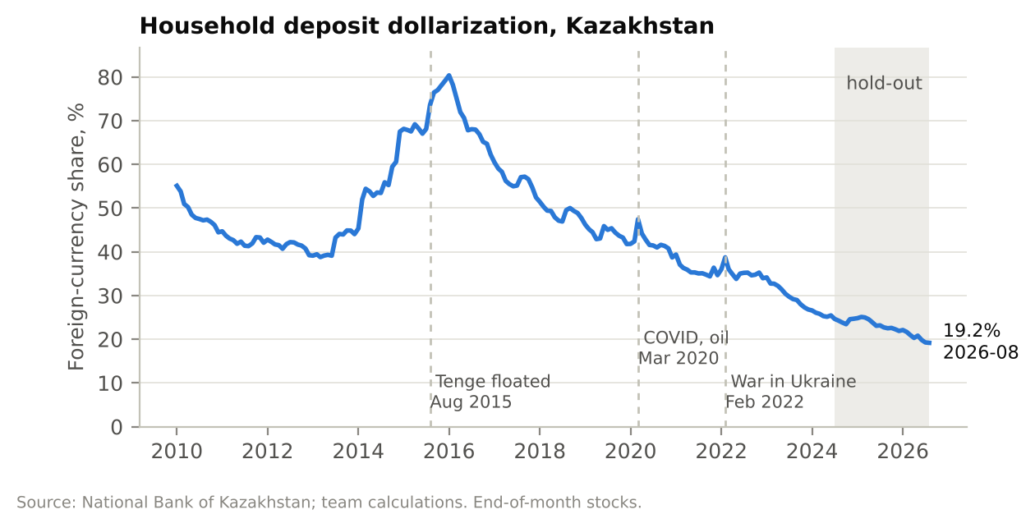
Figure 1. Dollarization of household deposits since 2010.
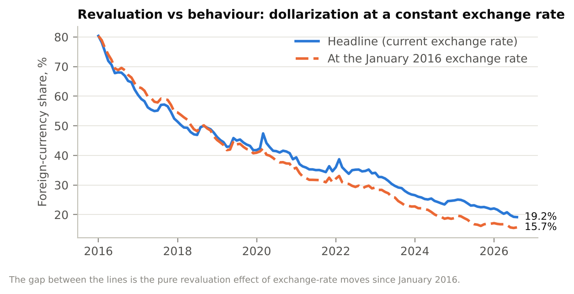
Figure 2. Normal dollarization and dollarization at a fixed exchange rate.
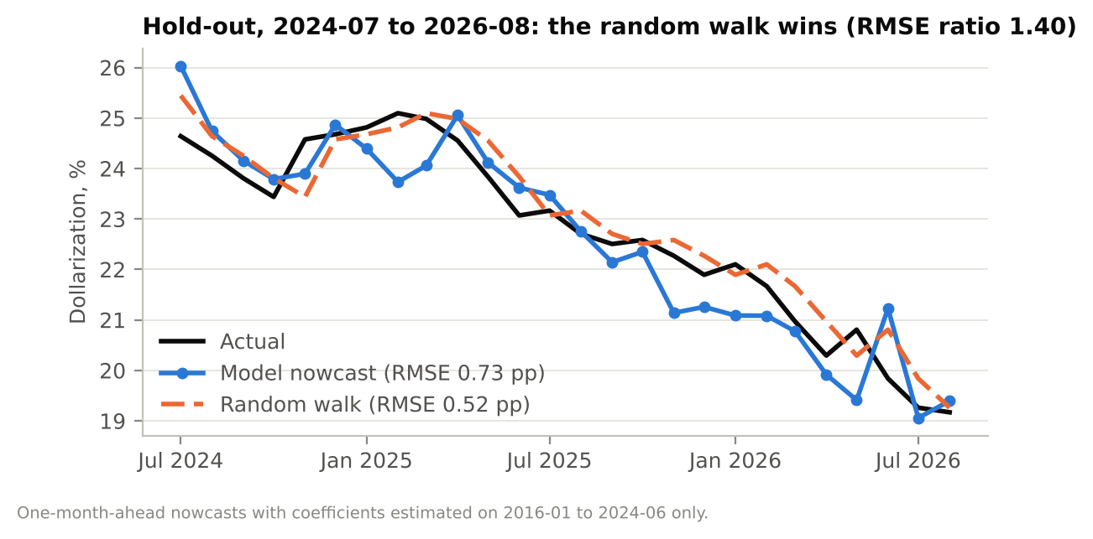
Figure 3. Test months: actual values, the model and the simple forecast.
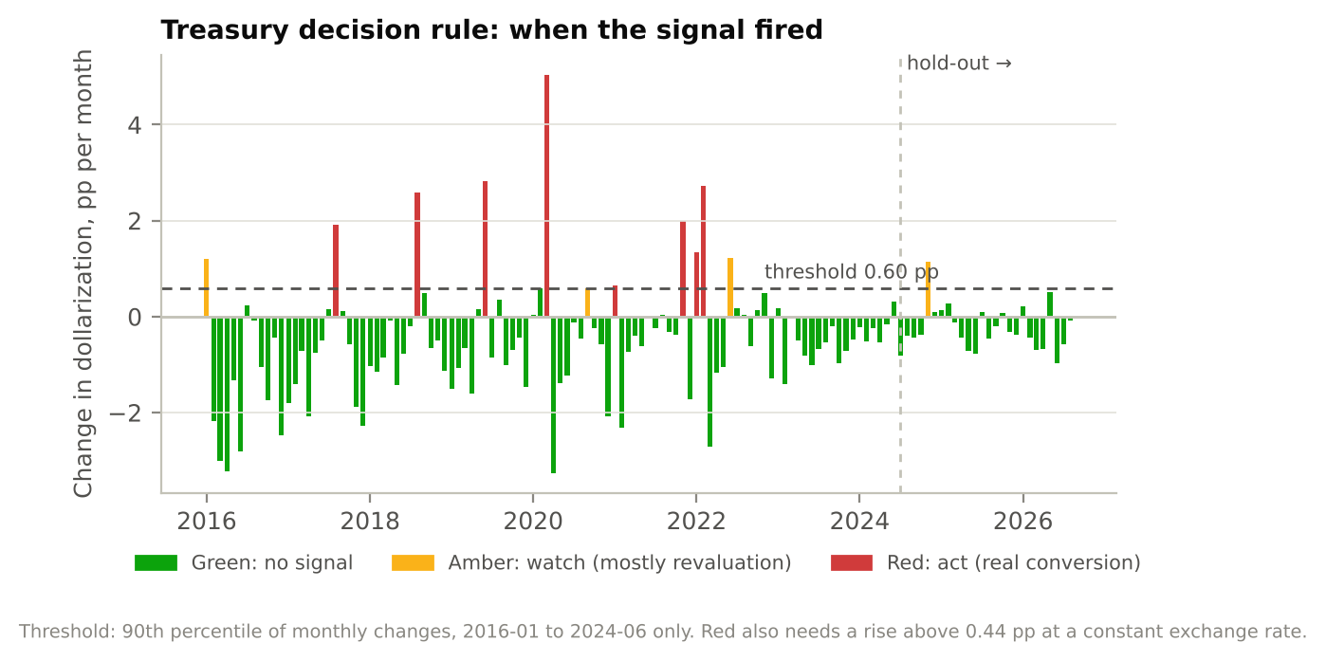
Figure 4. Decision rule: when the signal fired.
D. References
Ben Naceur, S., Hosny, A., & Hadjian, G. (2019). How to de-dollarize financial systems in the Caucasus and Central Asia? Empirical Economics, 56(6), 1979–1999. https://doi.org/10.1007/s00181-018-1419-6
Bureau of National Statistics of the Republic of Kazakhstan. (2026). Consumer price index, previous month = 100 (code KSP 261601) [Data set]. Taldau. Retrieved October 4, 2026, from https://taldau.stat.gov.kz
Dalgic, H. C. (2024). Financial dollarization in emerging markets: An insurance arrangement. International Economic Review, 65(3), 1189–1219. https://doi.org/10.1111/iere.12686
International Monetary Fund. (2026). Global price of Brent crude [POILBREUSDM]. Federal Reserve Bank of St. Louis (FRED). Retrieved October 4, 2026, from https://fred.stlouisfed.org/series/POILBREUSDM
National Bank of the Republic of Kazakhstan. (2026a). Household deposits in banks of Kazakhstan [Data set]. Retrieved October 4, 2026, from https://nationalbank.kz/ru/depositspopulation/vklady-naseleniya-v-bankah-kazahstana
National Bank of the Republic of Kazakhstan. (2026b). Interest rates on deposits by maturity and currency [Data set]. Retrieved October 4, 2026, from https://nationalbank.kz/ru/interestratesofbanksonat/stavki-voznagrazhdeniya-bankov-po-privlechennym-depozitampo-srokam-i-vidam-valyut
National Bank of the Republic of Kazakhstan. (2026c). Official exchange rates [API get_rates.cfm]. Retrieved October 4, 2026, from https://nationalbank.kz/rss/get_rates.cfm
Neanidis, K. C., & Savva, C. S. (2009). Financial dollarization: Short-run determinants in transition economies. Journal of Banking & Finance, 33(10), 1860–1873. https://ideas.repec.org/a/eee/jbfina/v33y2009i10p1860-1873.html
Pesaran, M. H., Shin, Y., & Smith, R. J. (2001). Bounds testing approaches to the analysis of level relationships. Journal of Applied Econometrics, 16(3), 289–326. https://doi.org/10.1002/jae.616
Vargas, M., & Sanchez, J. (2023). Taming financial dollarization: Determinants and effective policies – The case of Uruguay (IMF Working Paper No. 2023/244). International Monetary Fund. https://www.imf.org/en/Publications/WP/Issues/2023/11/24/Taming-Financial-Dollarization-Determinants-and-Effective-Policies-The-Case-of-Uruguay-541781
E. Use of AI tools
We used Claude, a chat assistant. It wrote the code of the project following our instructions, explained the methods to us. Examples of our prompts: "Add to the project and to the site how dollarization affects the exchange rate"; "We need all the evidence for the report: regression table, R², p-values, ADF test, multicollinearity, autocorrelation"; "Make the site design like this example".
What we checked ourselves: we ran every script and all automated tests on our laptops, we compared the numbers in this note with outputs/report_tables.md and with the website, the script src/check.py confirms that 13 main numbers reproduce, we did the acceptance tests by hand, we downloaded all data ourselves from the official websites, we did a small literature review, we decided the thresholds to make action.

