
Faculty of Engineering & Technology
Electrical & Computer Engineering Department
ENCS5399, Control Systems
Assignment

Prepared by: Yasmin Al Shawawrh.
ID_Number: 1220848.

Instructor: Dr. Mahran Quraan.

Section: 1.

BIRZEIT

June – 2025

Contents:

Table of Figures: ii
Question1: 1
Question2: 3
Question3: 5
Question4: 7
Question5: 10

Table of Figures:

Figure 1:Q1 MATLAB Script code. 1
Figure 2:Q1 MATLAB Scripts result. 1
Figure 3: Q1 MATLAB Simulink. 2
Figure 4:Q1 MATLAB Simulink result. 2
Figure 5: Q2 MATLAB Script code. 3
Figure 6:Q2 MATLAB scripts result. 4
Figure 7: Q2 MATLAB scripts curve. 4
Figure 8: Q3 MATLAB Script code. 5
Figure 9: Q3 MATLAB scripts result. 5
Figure 10: Q3 MATLAB scripts curve. 6
Figure 11; Q4 by hand solution. 7
Figure 12: Q4 MATLAB Simulink. 8
Figure 13: Q4 MATLAB Simulink result. 8
Figure 14: Q4 MATLAB Script code. 9
Figure 15: Q4 MATLAB scripts curve. 9
Figure 16: Q5 part 1 code. 10
Figure 17: Q5 part 1 curve. 10
Figure 18: Q5 part 2 code. 11
Figure 19: Q5 part 2 the desired pole and gain. 11
Figure 20: Q5 part 1 curve. 11
Figure 21: Q5 part 3 by hand solution. 12
Figure 22: Q5 part 3 code. 13
Figure 23: Q5 part 3 the desired pole and gain. 13
Figure 24: Q5 part 4 code. 14
Figure 25: Q5 part 4 curve. 14
Figure 26: Q5 MATLAB Simulink (uncompensated). 15
Figure 27: Q5 MATLAB Simulink result (uncompensated). 15
Figure 28: Q5 MATLAB Simulink (uncompensated) with feedback. 15
Figure 29: Q5 MATLAB Simulink result (uncompensated) with feedback. 15
Figure 30: Q5 MATLAB Simulink (compensated). 16
Figure 33: Q5 MATLAB Simulink result (compensated) with feedback. 16
Figure 32: Q5 MATLAB Simulink (compensated) with feedback. 16
Figure 31: Q5 MATLAB Simulink result (compensated). 16

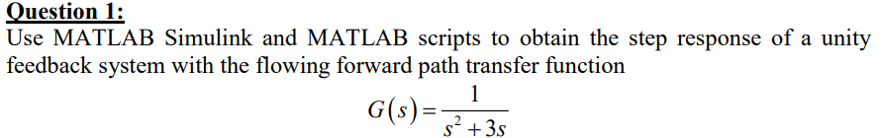
Question1:

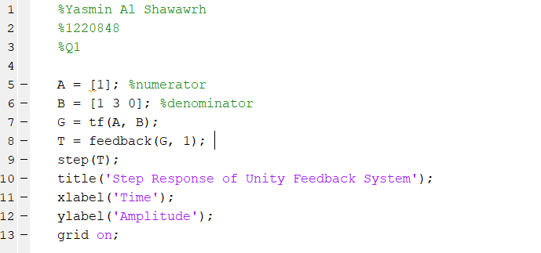
MATLAB scripts (code):

Figure 1:Q1 MATLAB Script code.
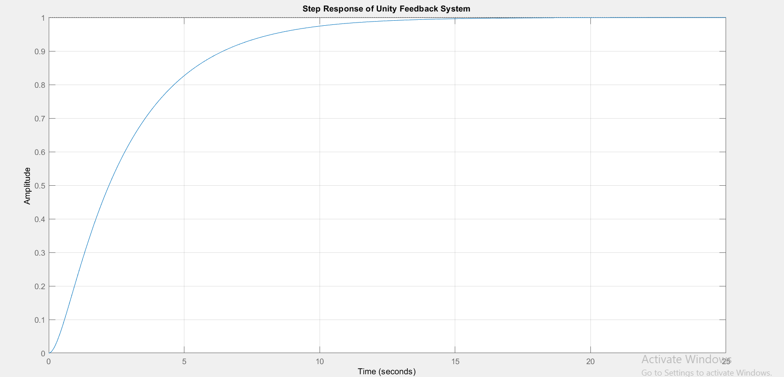
MATLAB scripts result:
Figure 2:Q1 MATLAB Scripts result.

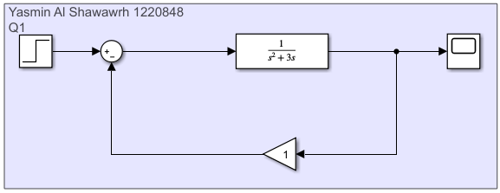
MATLAB Simulink:

Figure 3: Q1 MATLAB Simulink.

MATLAB Simulink result:
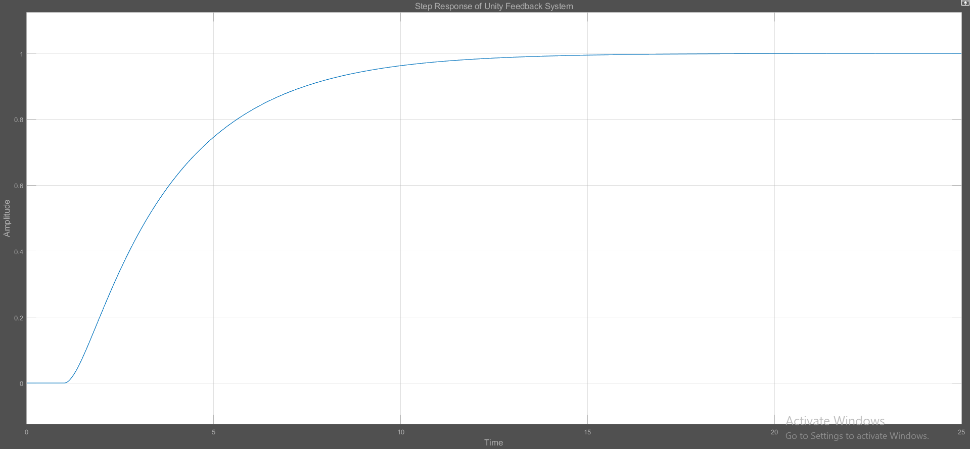
Figure 4:Q1 MATLAB Simulink result.

Question2:
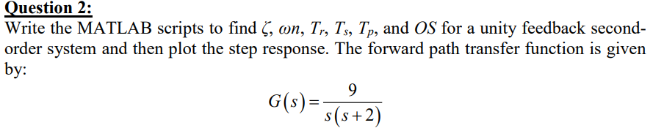
G(s) =$\frac{9}{s^{2}+2s​}$
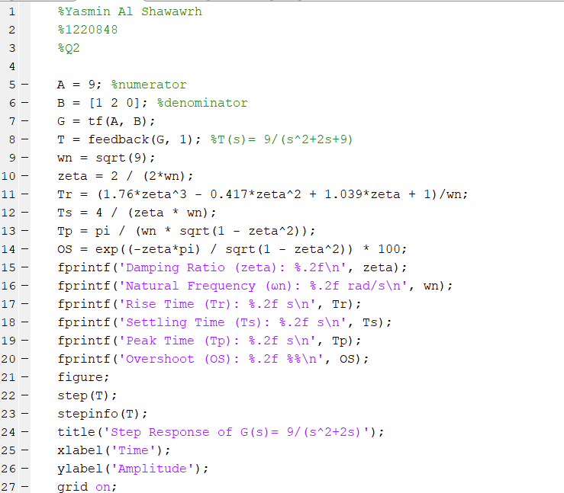
MATLAB scripts (code):

Figure 5: Q2 MATLAB Script code.

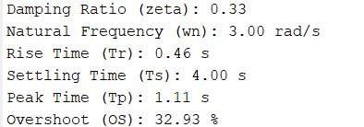
MATLAB scripts result:

Figure 6:Q2 MATLAB scripts result.
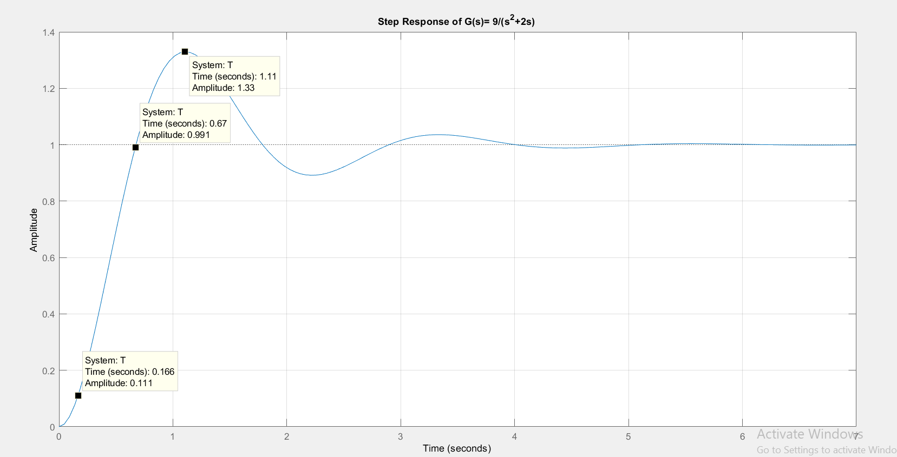
Figure 7: Q2 MATLAB scripts curve.

From the output step response curve, I can find key performance values by looking at the shape of the graph. The rise time (Tr) is how long it takes for the curve to first reach the final value. The peak time (Tp) is when the curve reaches its highest point. The settling time (Ts) is when the curve stays close to the final value without big changes. The overshoot (OS) is how much the curve goes above the final value. These values help describe how fast and stable the system responds.

Question3:
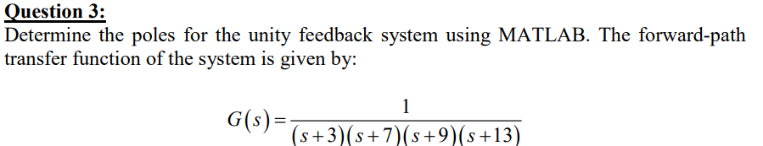
MATLAB scripts (code):
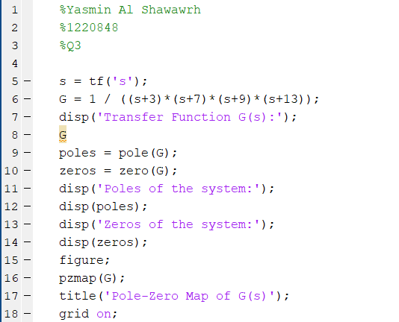

Figure 8: Q3 MATLAB Script code.
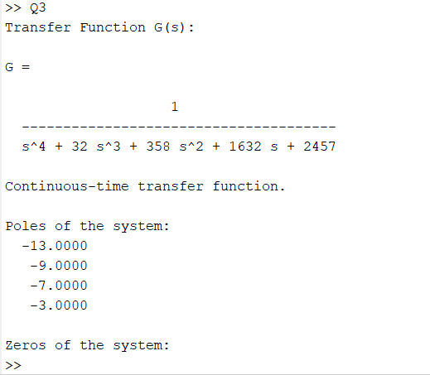
MATLAB scripts result:

Figure 9: Q3 MATLAB scripts result.
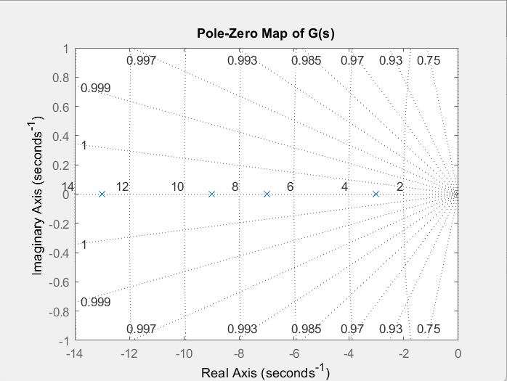

Figure 10: Q3 MATLAB scripts curve.

Question4:
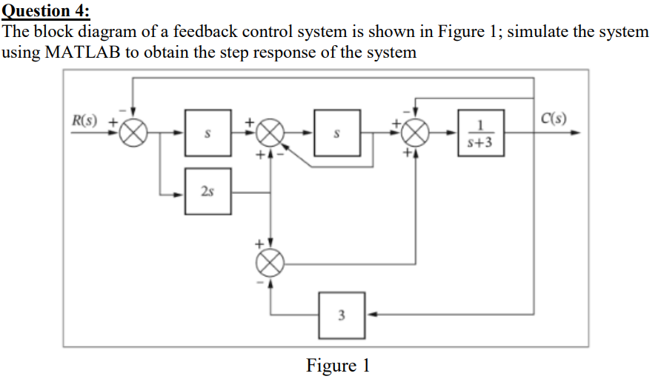

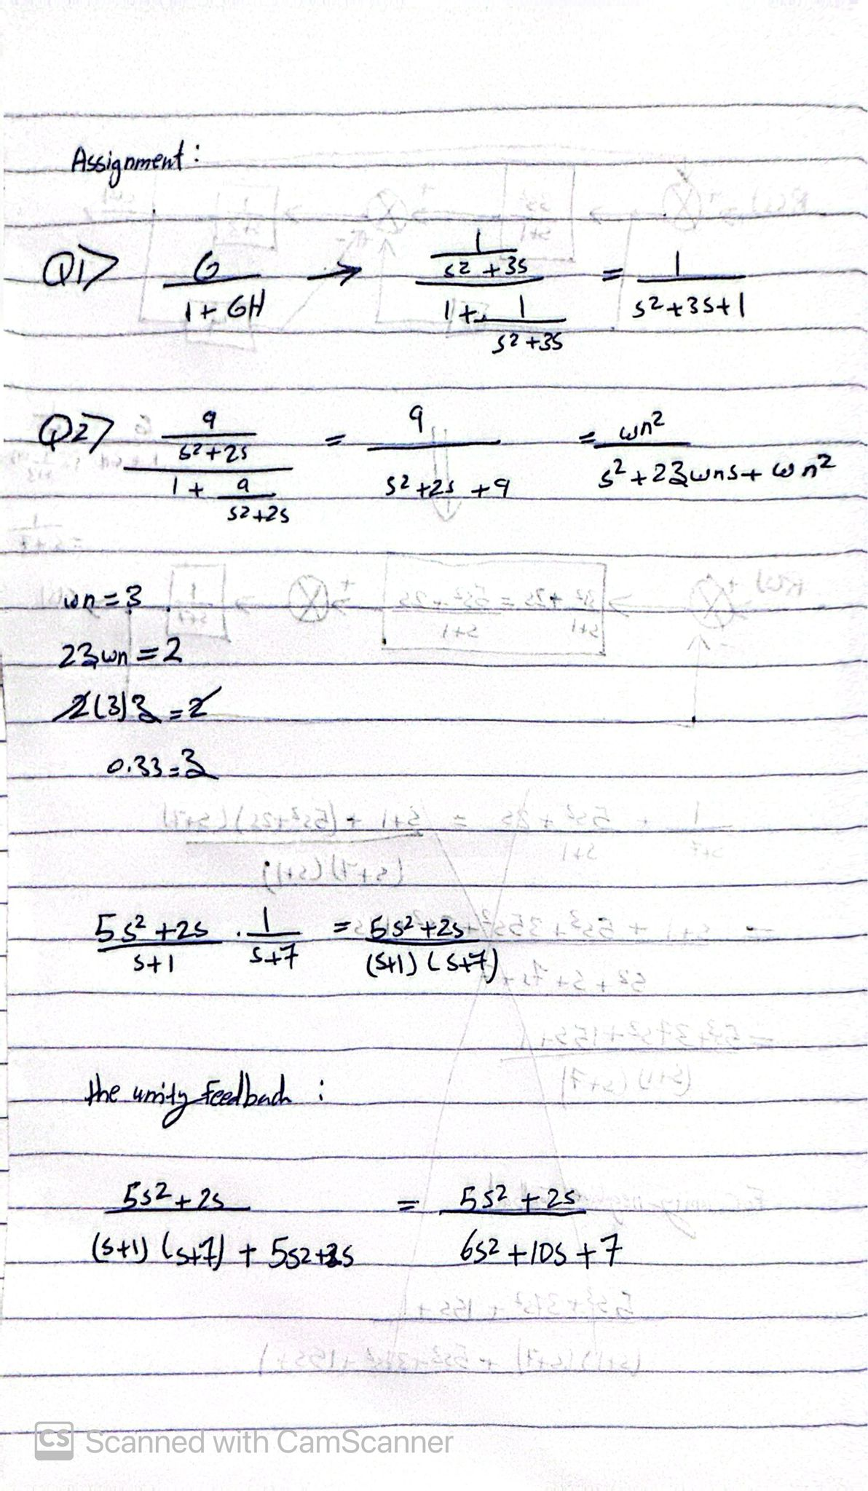
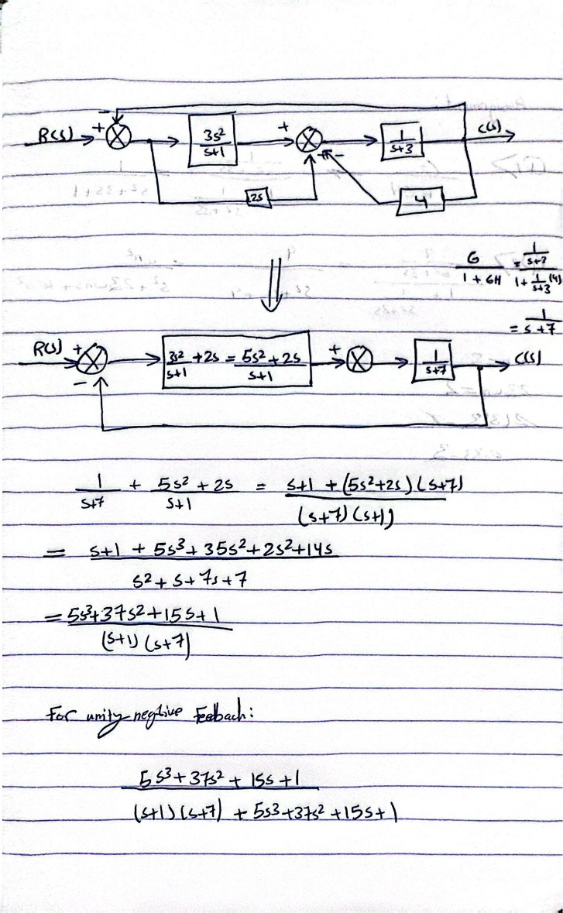
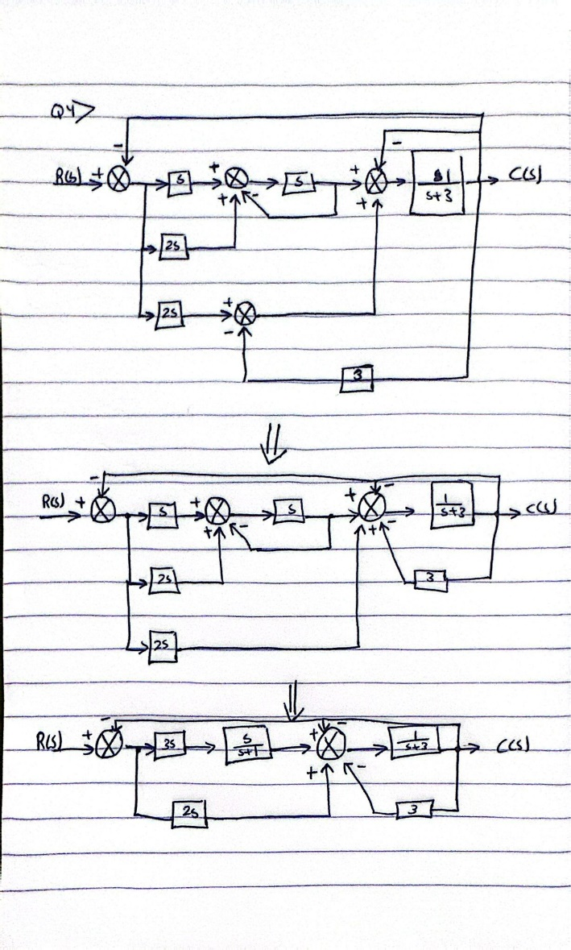
Figure 11; Q4 by hand solution.

MATLAB Simulink:
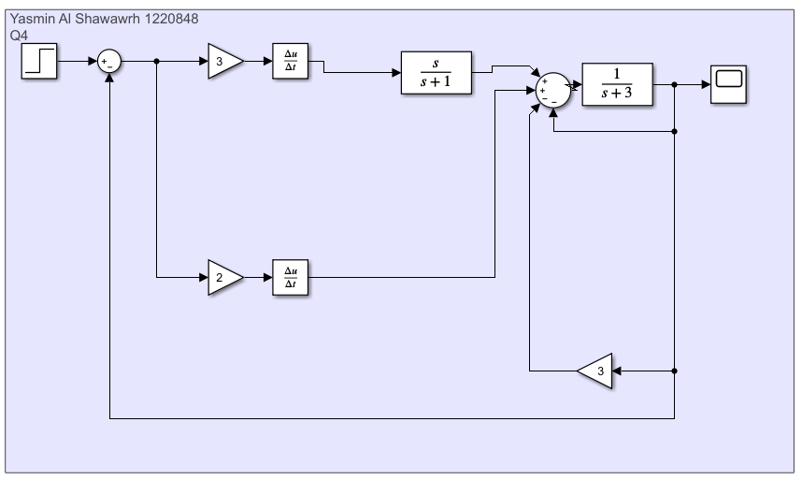
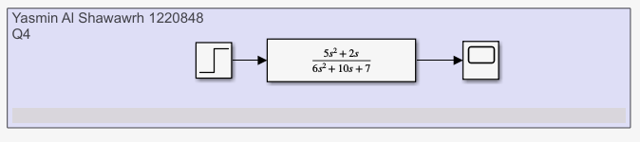
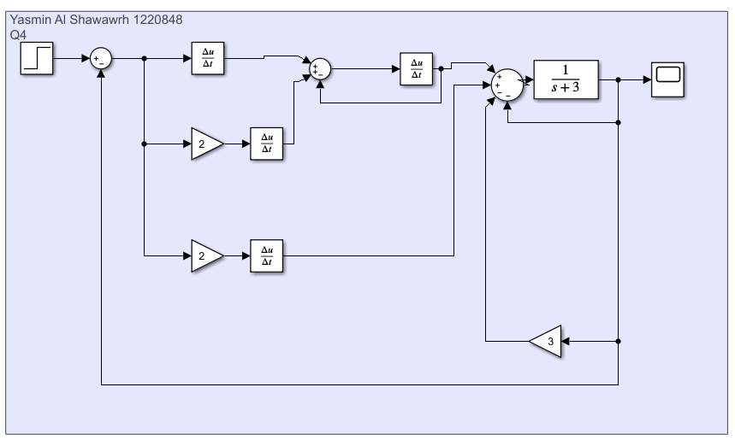
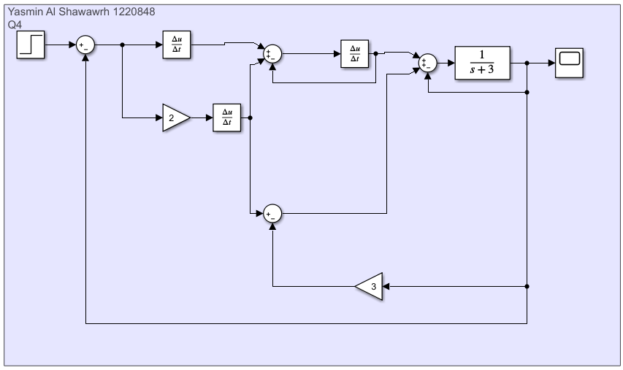

Figure 12: Q4 MATLAB Simulink.

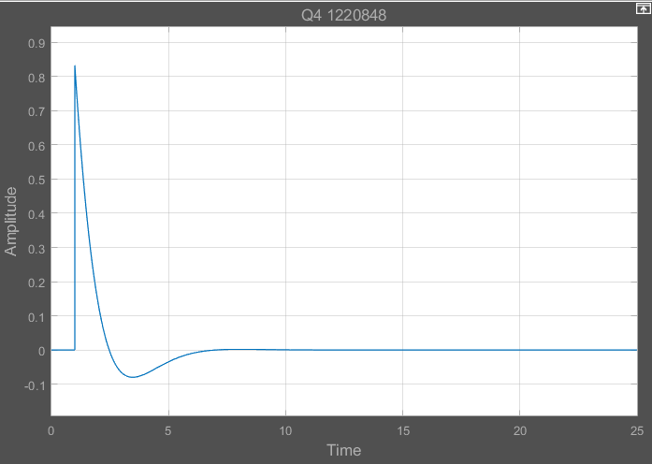
MATLAB Simulink result:
Figure 13: Q4 MATLAB Simulink result.

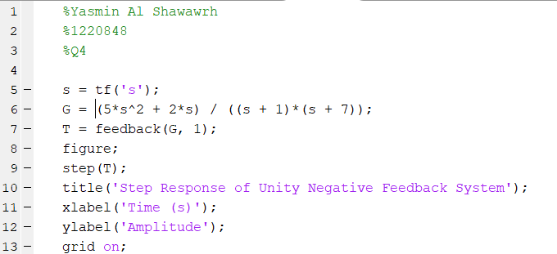
MATLAB scripts (code):

Figure 14: Q4 MATLAB Script code.

MATLAB scripts result:
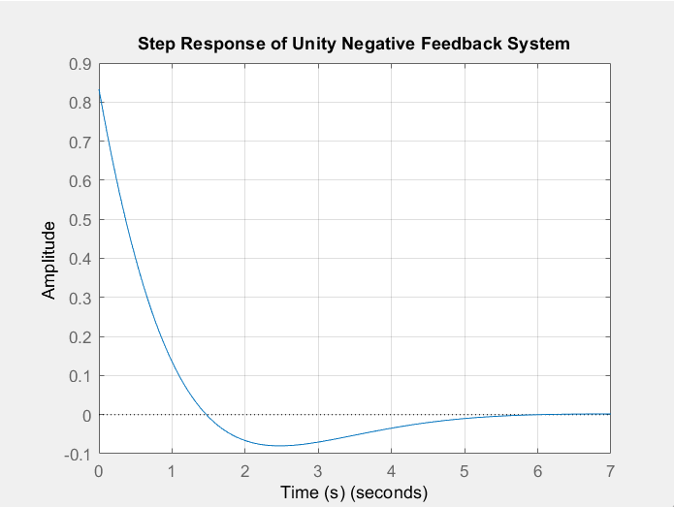
Figure 15: Q4 MATLAB scripts curve.

Question5:
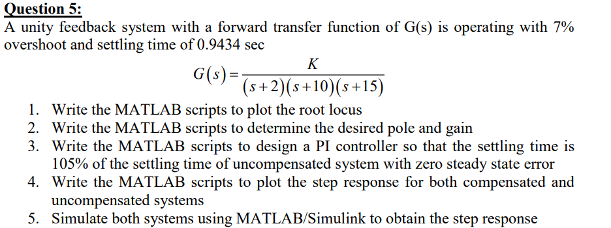
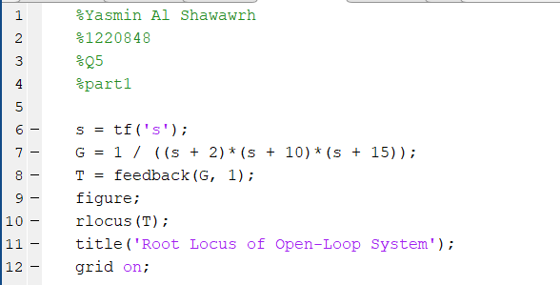
Part 1:

Figure 16: Q5 part 1 code.
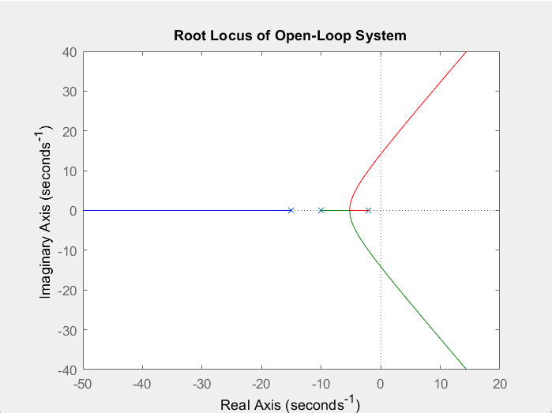
Figure 17: Q5 part 1 curve.

Part 2:
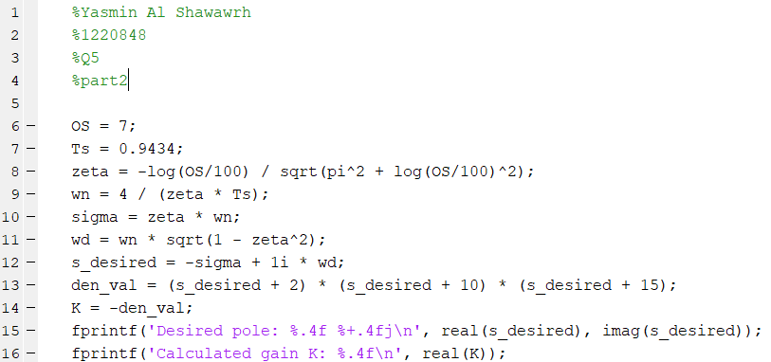

Figure 18: Q5 part 2 code.

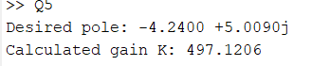
Figure 19: Q5 part 2 the desired pole and gain.
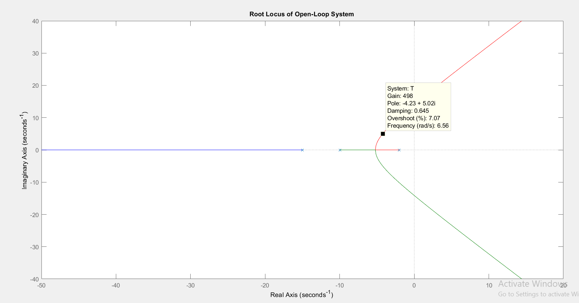

Figure 20: Q5 part 1 curve.

We selected the desired pole on the root locus curve based on system specifications. From that point, the corresponding gain was found to be approximately 498 as shown above.

Part 3:

The new system has zero steady-state error.
The settling time becomes 105% of the original: Ts,new=1.05×0.9434=0.9906 sec
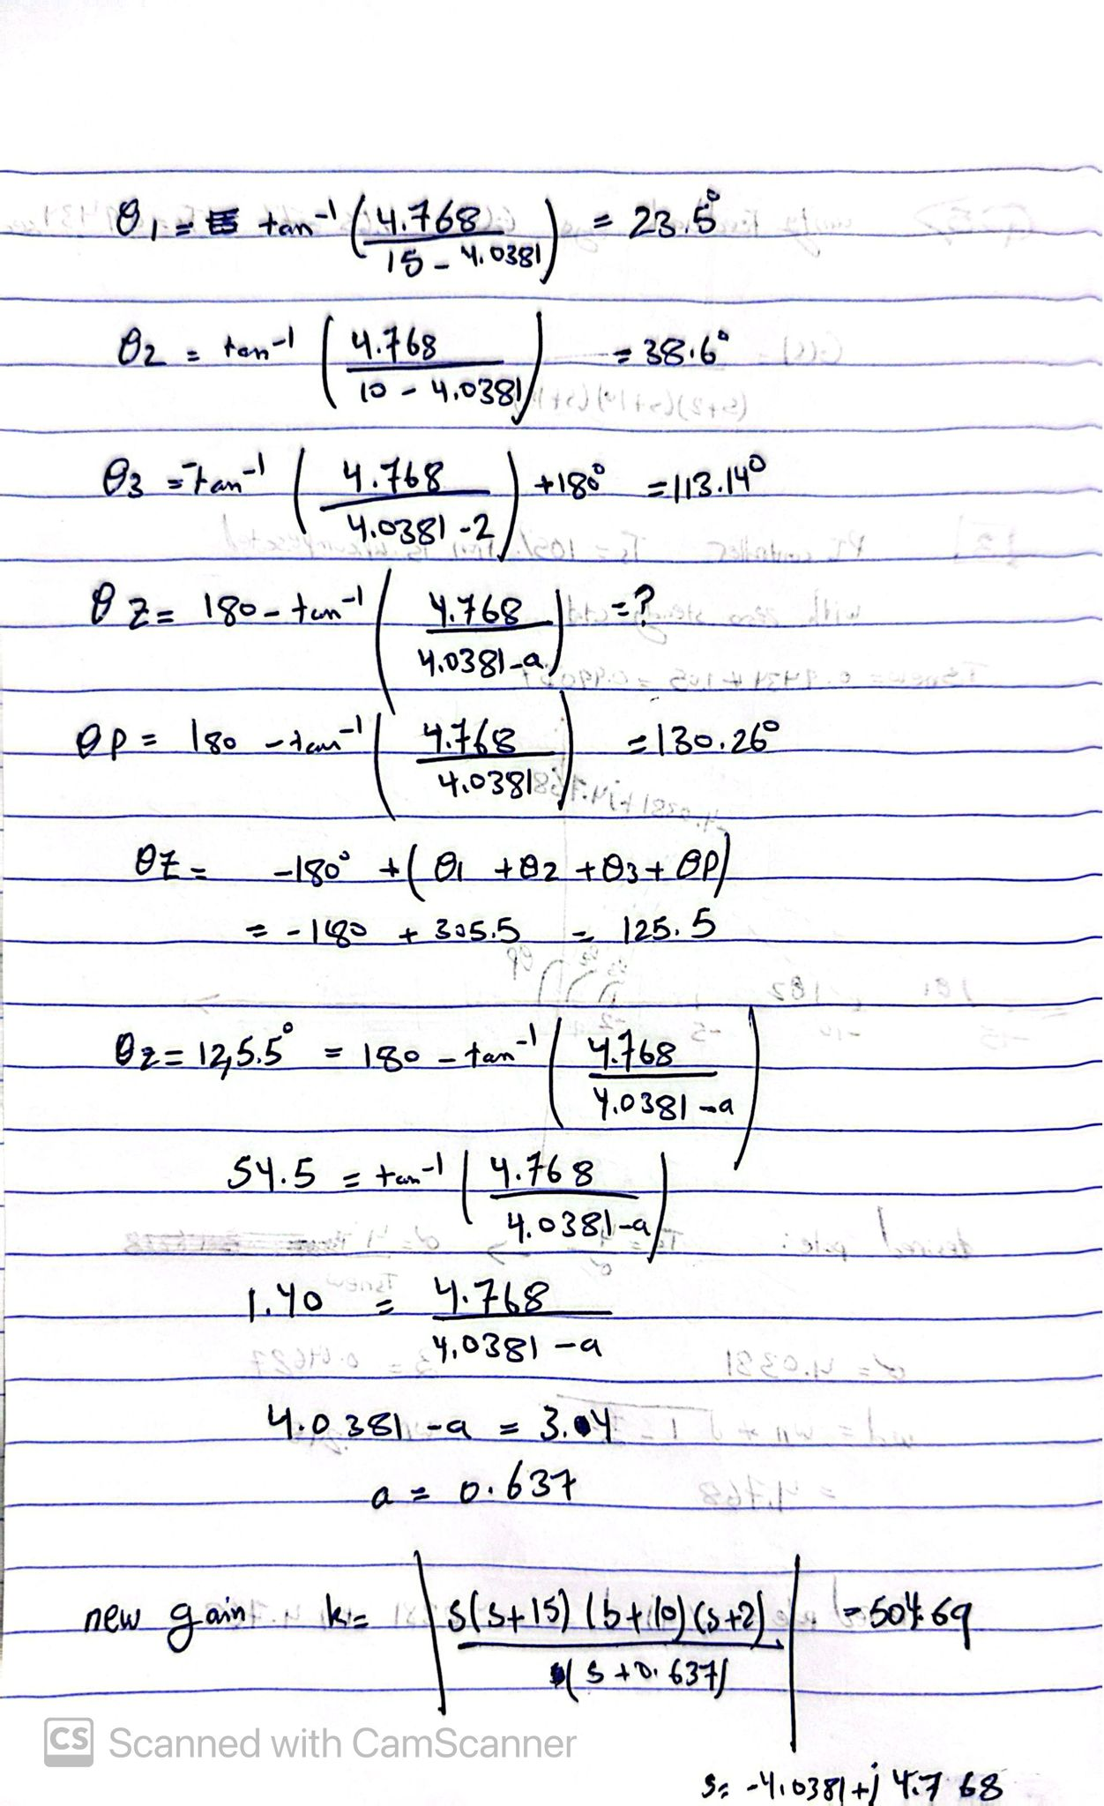
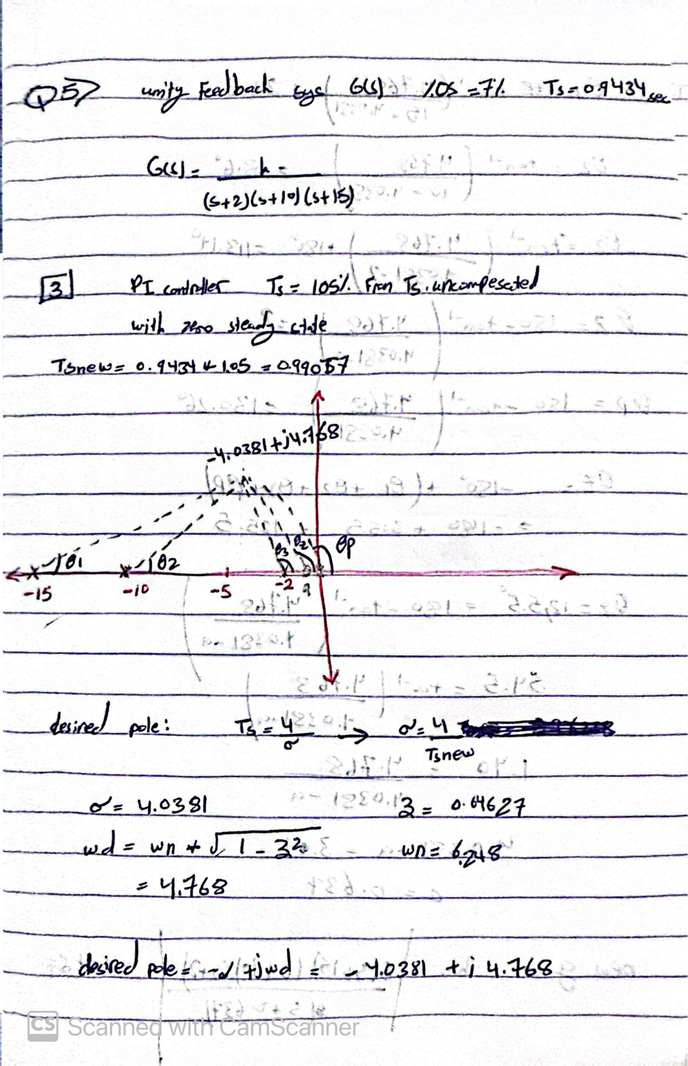
443

Figure 21: Q5 part 3 by hand solution.

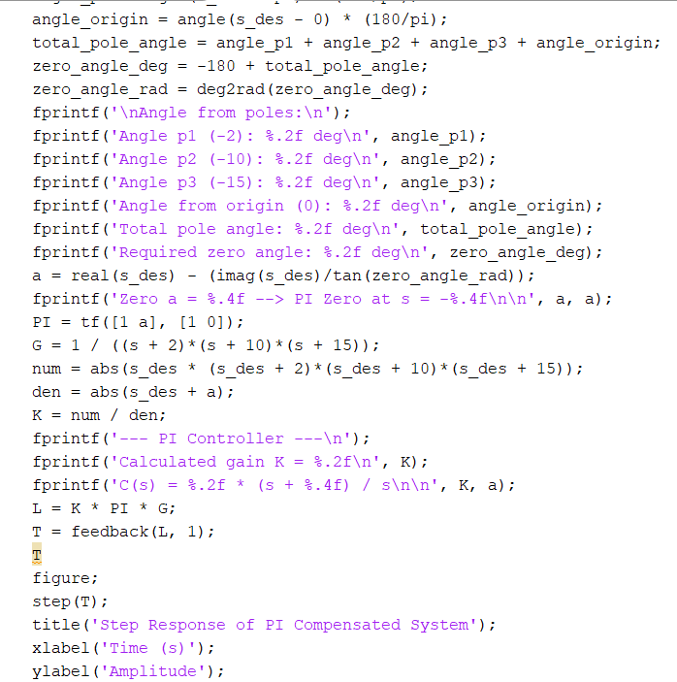
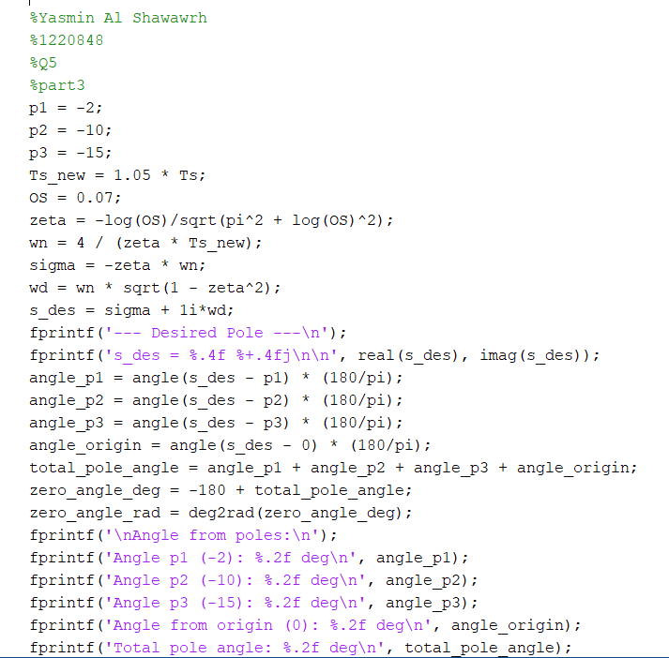
Figure 22: Q5 part 3 code.
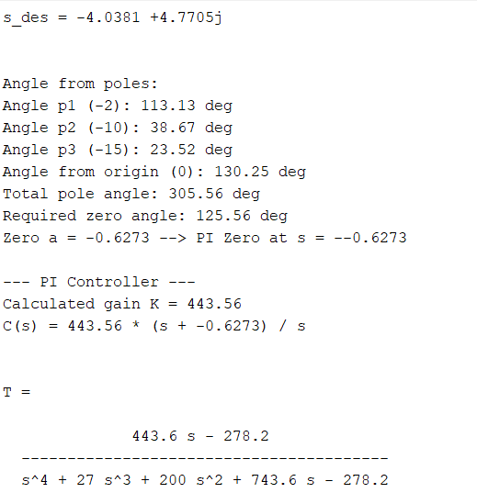

Figure 23: Q5 part 3 the desired pole and gain.

Part 4:
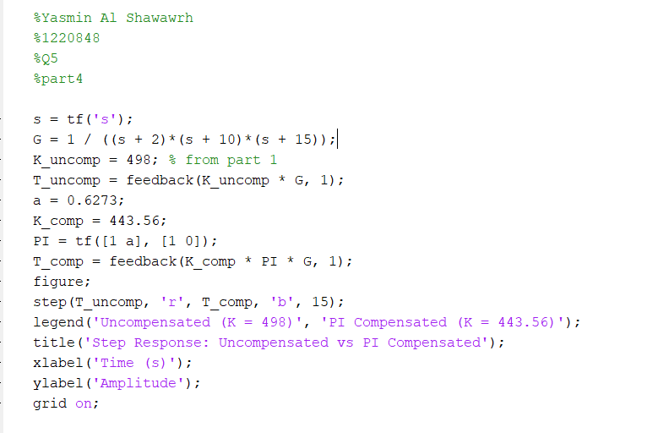
Figure 24: Q5 part 4 code.

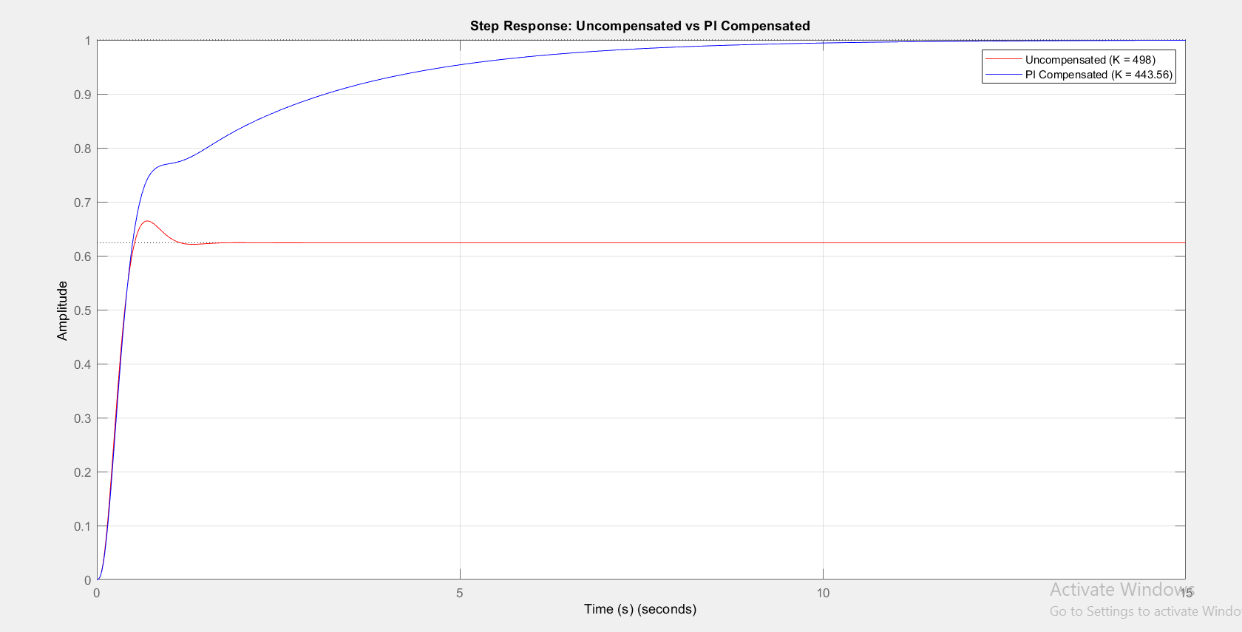
Figure 25: Q5 part 4 curve.

The uncompensated system is faster but doesn't reach the final value. The PI compensated system is slightly slower but achieves zero steady-state error.

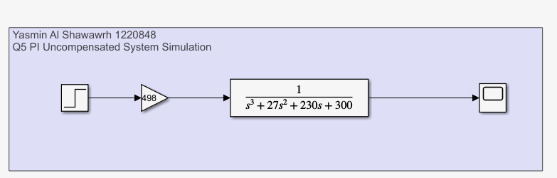
Part 5:

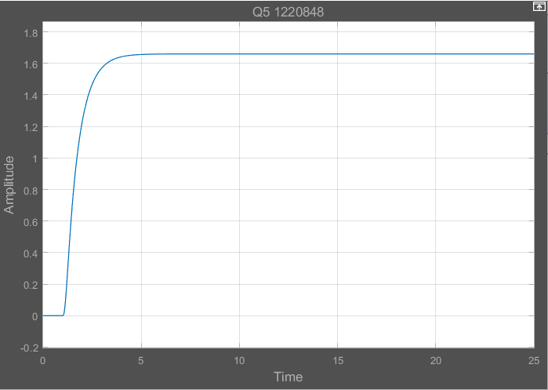
Figure 26: Q5 MATLAB Simulink (uncompensated).

Figure 27: Q5 MATLAB Simulink result (uncompensated).
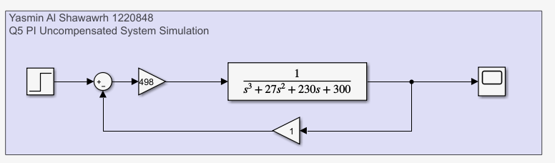
Figure 28: Q5 MATLAB Simulink (uncompensated) with feedback.

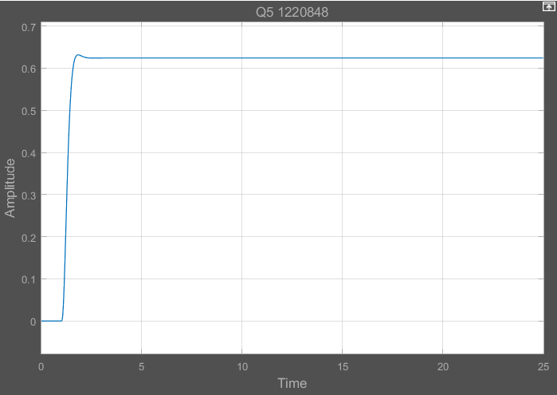

Figure 29: Q5 MATLAB Simulink result (uncompensated) with feedback.
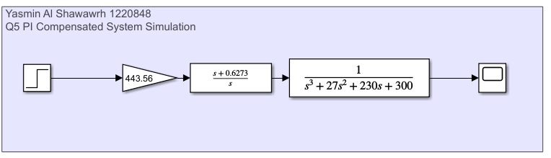
Figure 30: Q5 MATLAB Simulink (compensated).

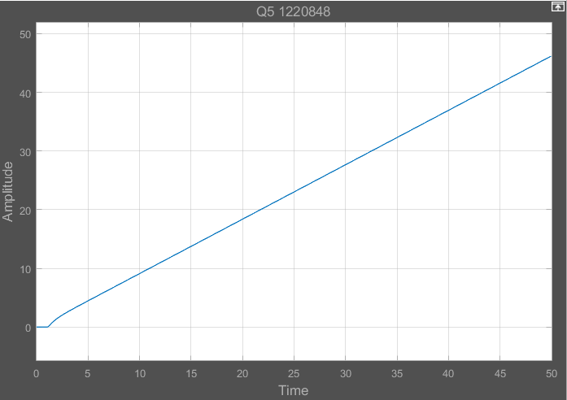
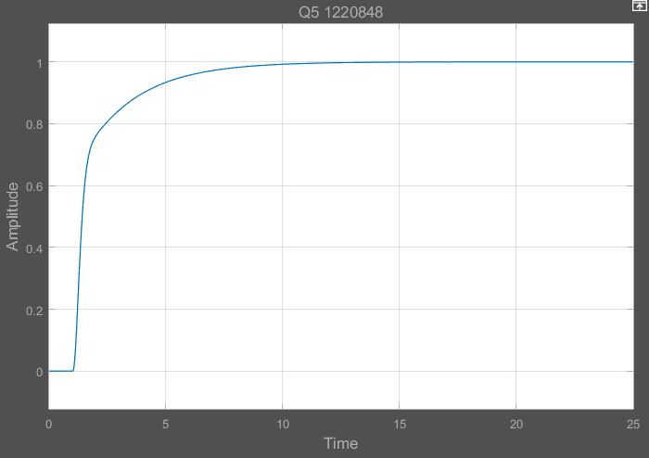
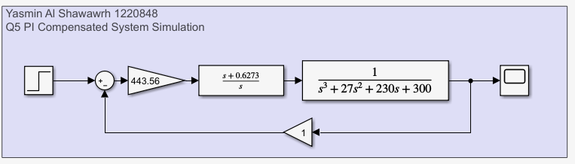
Figure 33: Q5 MATLAB Simulink result (compensated) with feedback.
Figure 32: Q5 MATLAB Simulink (compensated) with feedback.
Figure 31: Q5 MATLAB Simulink result (compensated).

