
Faculty of Engineering & Technology
Electrical & Computer Engineering Department
Operating Systems – ENCS3390
Project Report

Prepared by:
Name: Yasmin Al Shawawrh. Number: 1220848.

Instructor: Abdel Salam Sayyad.

Date: 8/12/2024.

Abstract

This project explores the performance of different parallel processing techniques for counting word frequencies in a large text dataset, and identifying the top 10 most frequent words. The project compares three approaches: a naive approach, where all tasks are executed sequentially without parallelism; a multiprocessing approach, which utilizes multiple child processes to run tasks concurrently; and a multithreading approach, which leverages multiple threads for parallel execution. The performance of each approach is evaluated by measuring the execution time and analyzing the impact of varying the number of processes and threads (2, 4, 6, and 8). Additionally, the project applies Amdahl's Law to analyze the theoretical speedup and determine the optimal number of processes or threads based on the available cores. The results are presented in a comparative table, followed by a discussion on the differences in performance and the effectiveness of parallelism in speeding up word frequency computation. The findings offer insights into the trade-offs between simplicity, efficiency, and parallel computing strategies in processing large datasets.

Table of Contents

Abstract II
Table of figures IV
List of tables V
Theory 1
- Naïve Approach 1
- Multiprocessing Approach 1
- Multithreading Approach 1
Discussion and Analysis 2
- Naïve Approach 2
- Multiprocessing Approach 6
- Multithreading Approach 12
Project Questions 18
Conclusion 23

Table of figures

Figure 1: Naïve Approach Code. 4
Figure 2: Naïve Approach output. 4
Figure 3: Multiprocessing Approach Code. 9
Figure 4: Multiprocessing Approach output for (2 childs). 9
Figure 5: Multiprocessing Approach output for (4 childs). 9
Figure 6: Multiprocessing Approach output for (6 childs). 10
Figure 7: Multiprocessing Approach output for (8 childs). 10
Figure8 : multithreading Approach Code. 14
Figure 9: Multithreadind Approach output for (2 threads). 15
Figure 10: Multithreadind Approach output for (4 threads). 15
Figure 11: Multithreadind Approach output for (6 threads). 15
Figure 12: Multithreadind Approach output for (8 threads). 16

List of tables

Table 1: Multiprocessing Approach table. 11
Table 2: Multithreading Approach table. 17
Table 3: Three Approaches table. 22

Theory

Naïve Approach

The naive approach is a basic and simple method of solving a problem. It involves performing tasks one step at a time, without using any advanced techniques or trying to make the process faster. While it is easy to understand and implement, this approach can be slow and inefficient, especially for larger or more complex problems. It doesn't use multiple resources or try to improve speed, making it a good starting point to compare with more advanced methods like using multiple processors or optimizing the process. Despite its limitations, the naive approach can be useful for small problems where speed isn't as important.

Multiprocessing Approach

The multiprocessing approach refers to using multiple processes to perform tasks simultaneously, allowing a program to take advantage of multiple CPU cores. Each process runs independently and can perform a specific part of a larger task, helping to speed up the overall execution. This approach is especially useful for tasks that require a lot of computation, as it divides the work among several processes, reducing the time needed to complete the task. However, it also requires proper management of processes to ensure they work together efficiently.

Multithreading Approach

The multithreading approach involves using multiple threads within a single process to execute tasks concurrently. Each thread can perform a specific part of the task, allowing the program to handle multiple operations at the same time. This is particularly useful for programs that need to perform tasks like handling multiple user inputs, performing background operations, or processing data in parallel. Unlike multiprocessing, where each process runs in its own memory space, threads share the same memory space within a process, making communication between them easier and more efficient. However, this also requires careful management to avoid conflicts or errors when multiple threads access the same data.

Discussion and Analysis

Naïve Approach

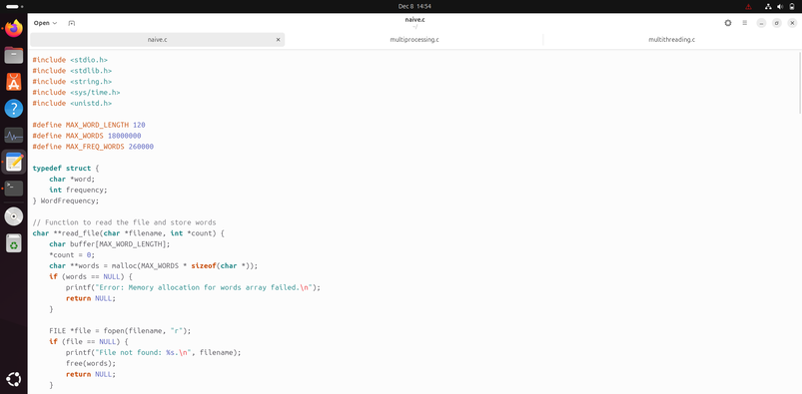
- Code
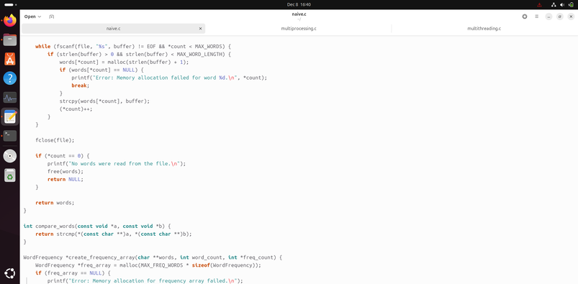
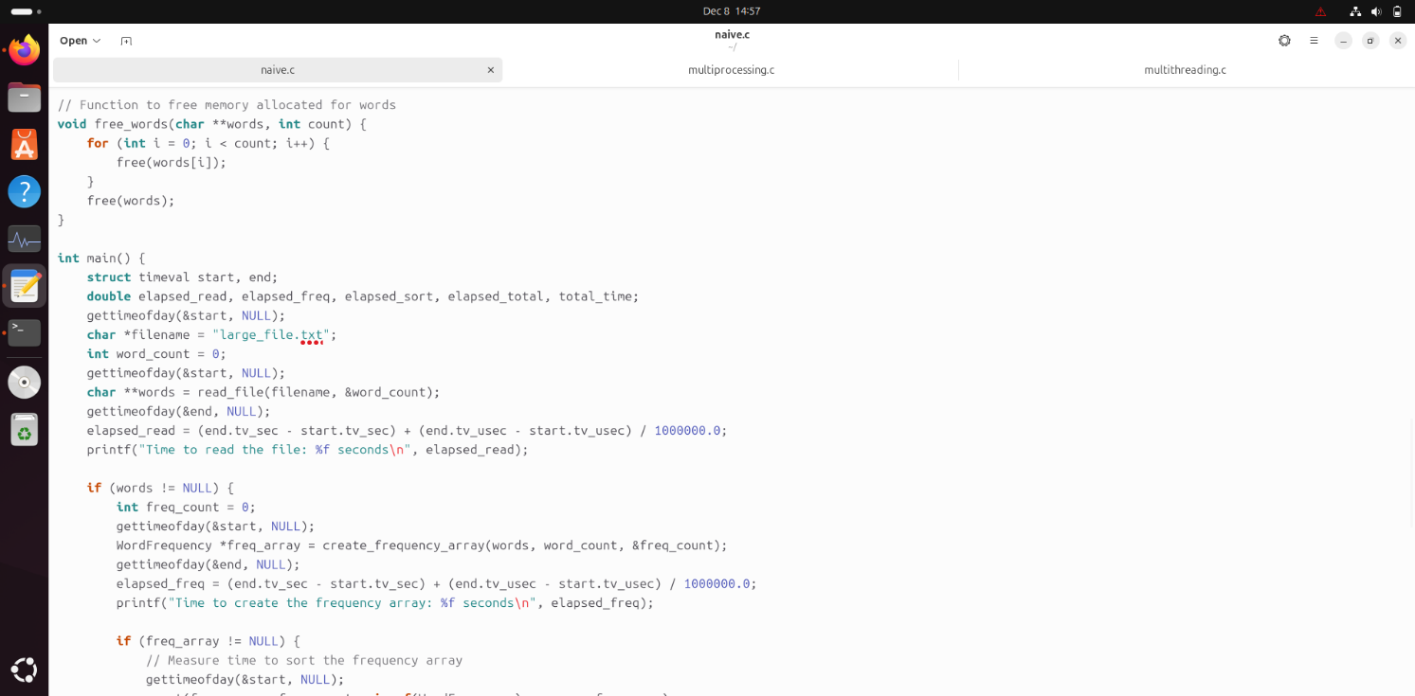
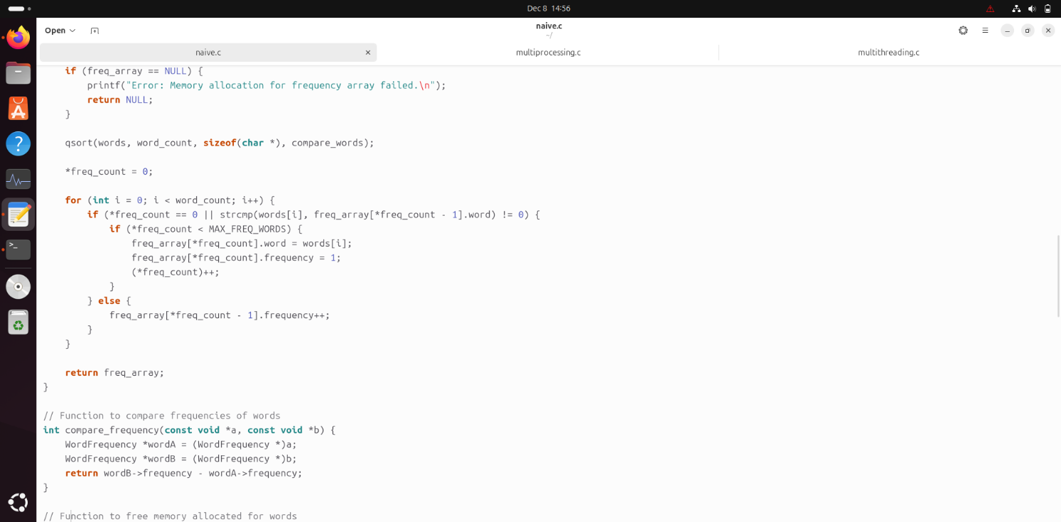
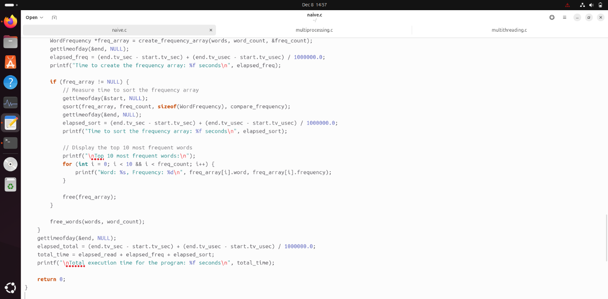
Figure 1: Naïve Approach Code.

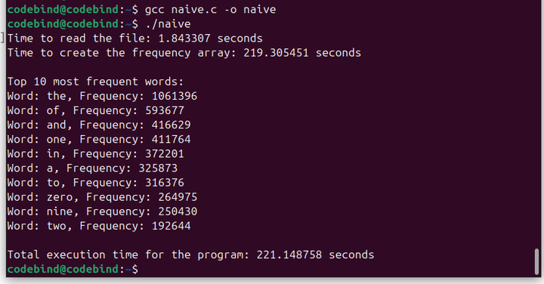
- Output
Figure 2: Naïve Approach output.

- Analysis

The program reads a text file (in this case, large_file.txt) and identifies the top 10 most frequent words by employing a naive approach, which does not involve any child processes or threads. The program begins by reading the file into an array of words using the read_file function. It uses the fscanf function to read each word and stores it dynamically in memory. After the file is read, the words are sorted using qsort, and a frequency array is created to count how many times each word appears using the create_frequency_array function. The program then sorts this frequency array in descending order of word frequencies. For performance measurement, the gettimeofday function is used to track the time taken to read the file, create the frequency array, and sort it. The program prints the top 10 most frequent words, along with their frequencies, and also measures the total execution time. The approach is considered naive because it processes the data sequentially without the use of parallelism.
Performance (Throughput) = $\frac{1}{Time}$
The naive approach in this program calculates the top 10 most frequent words without using any parallelization, meaning it processes the task sequentially, one step at a time. While this method may not be the fastest, it serves as a basic building block for future optimizations. By measuring performance through throughput (1/time), we can see that while the execution time might be higher, this approach establishes the groundwork for more advanced techniques, such as parallelization, which can significantly improve speed and resource utilization in subsequent iterations of the program.

Multiprocessing Approach

- Code
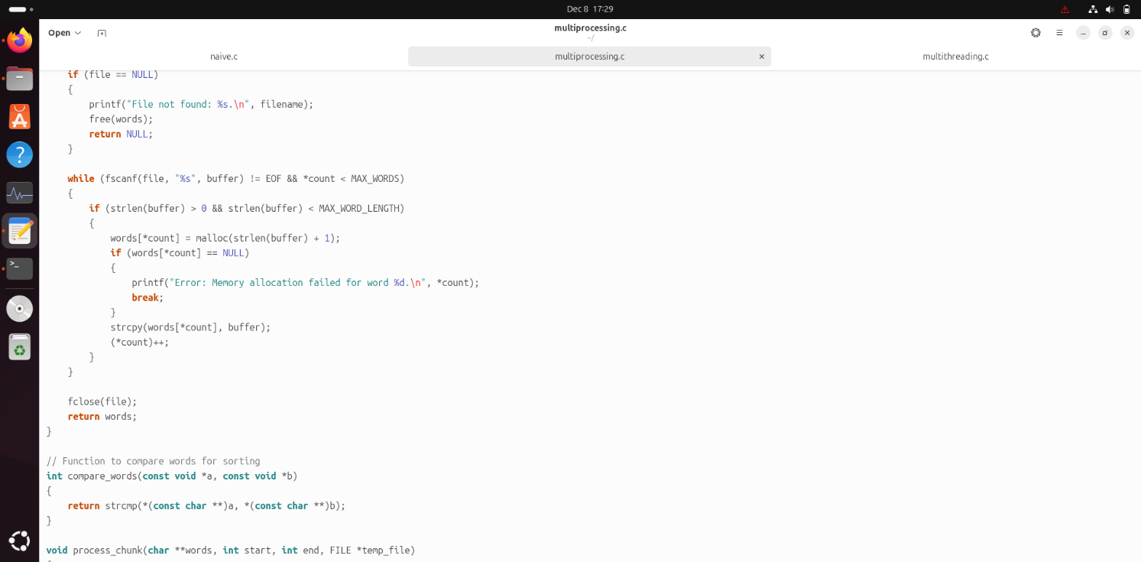
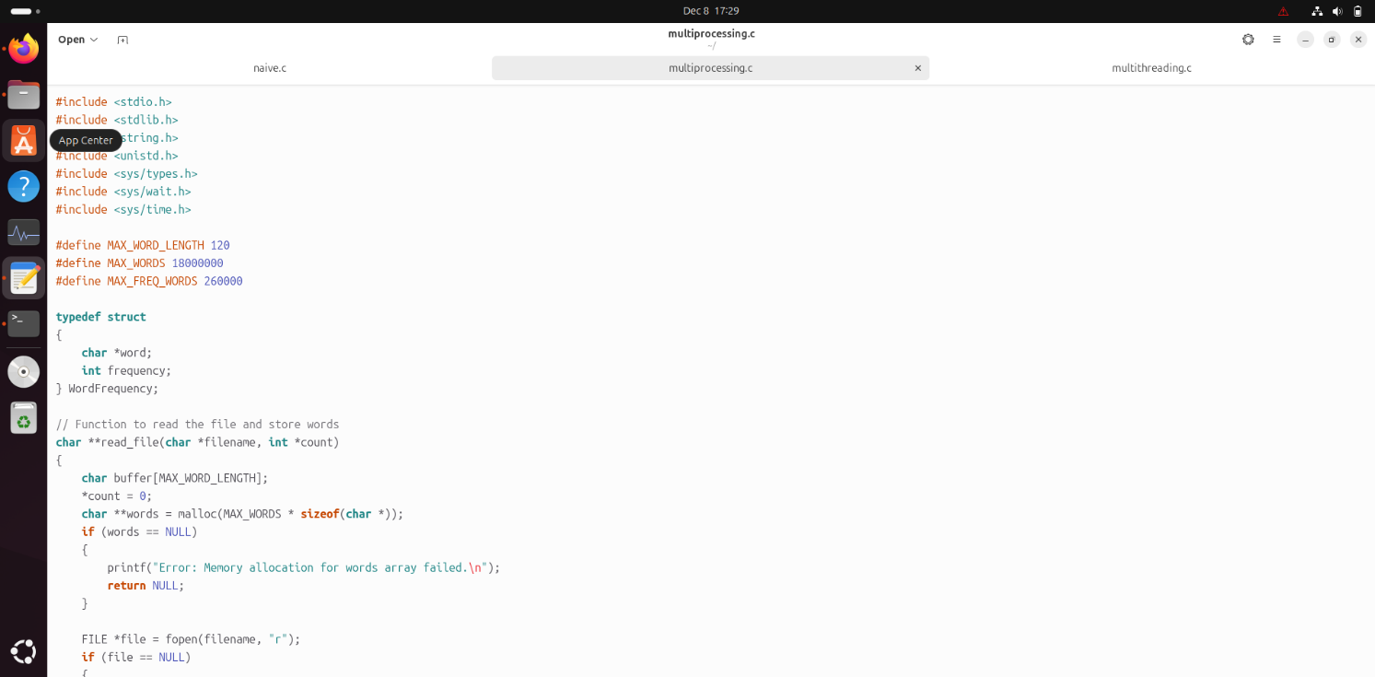

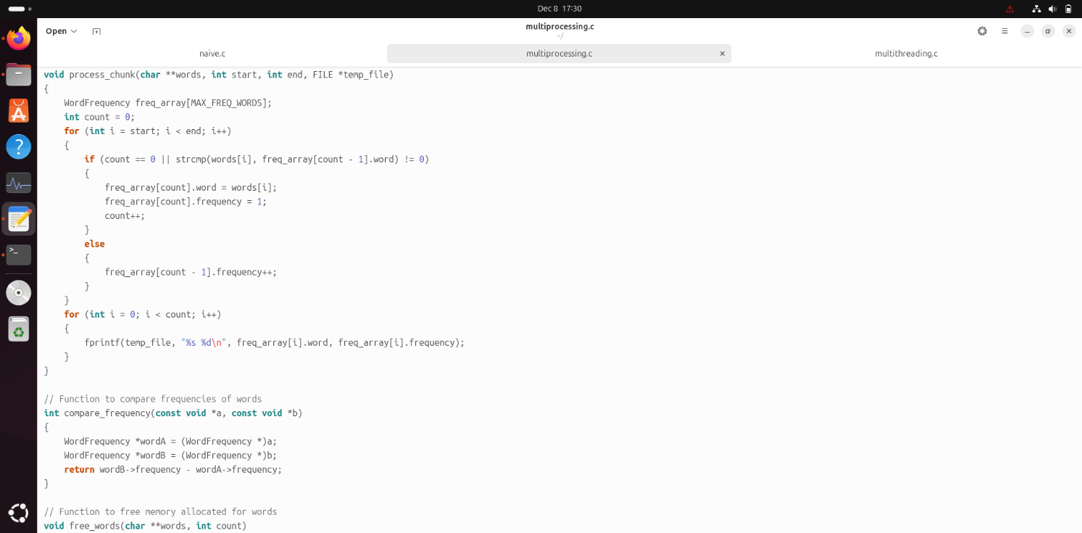
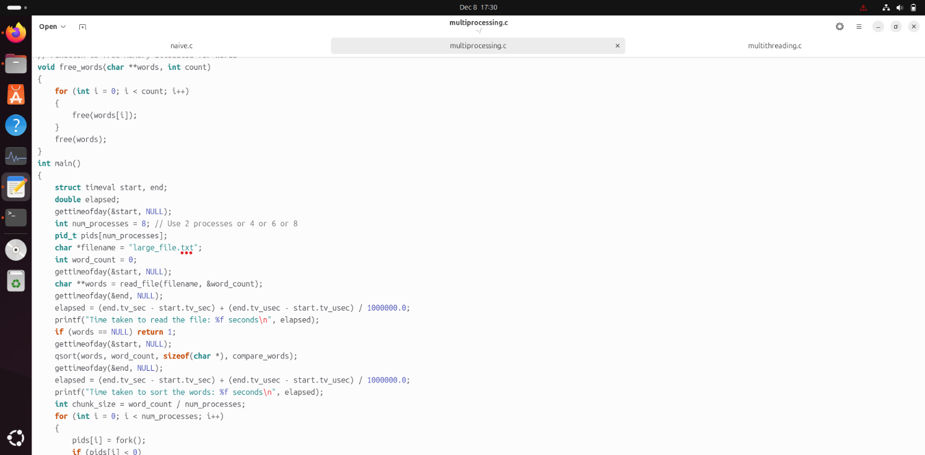

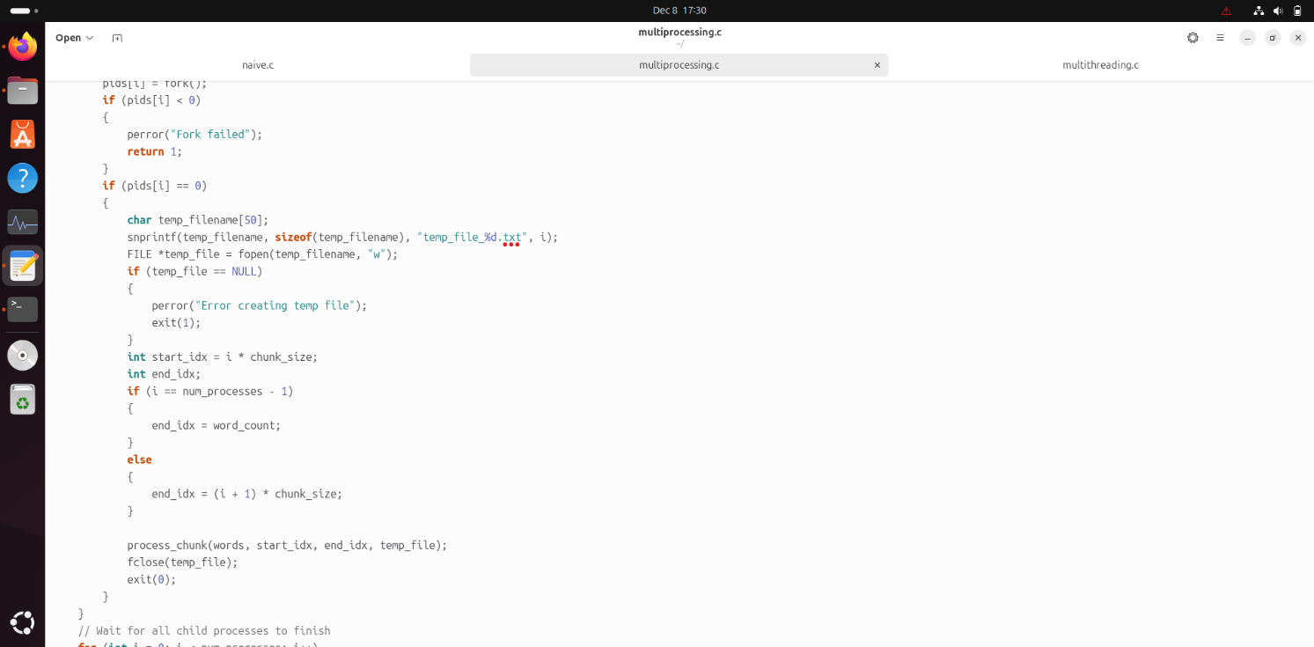
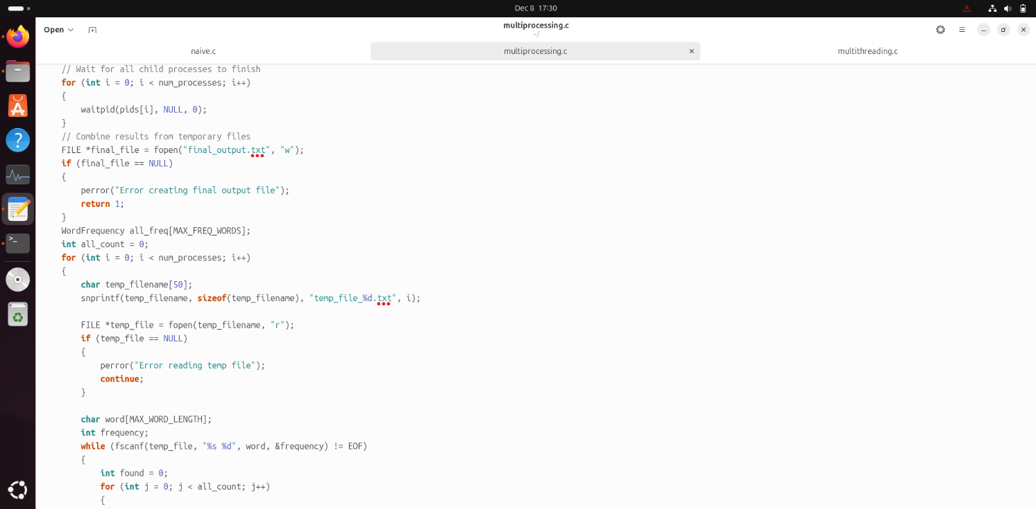
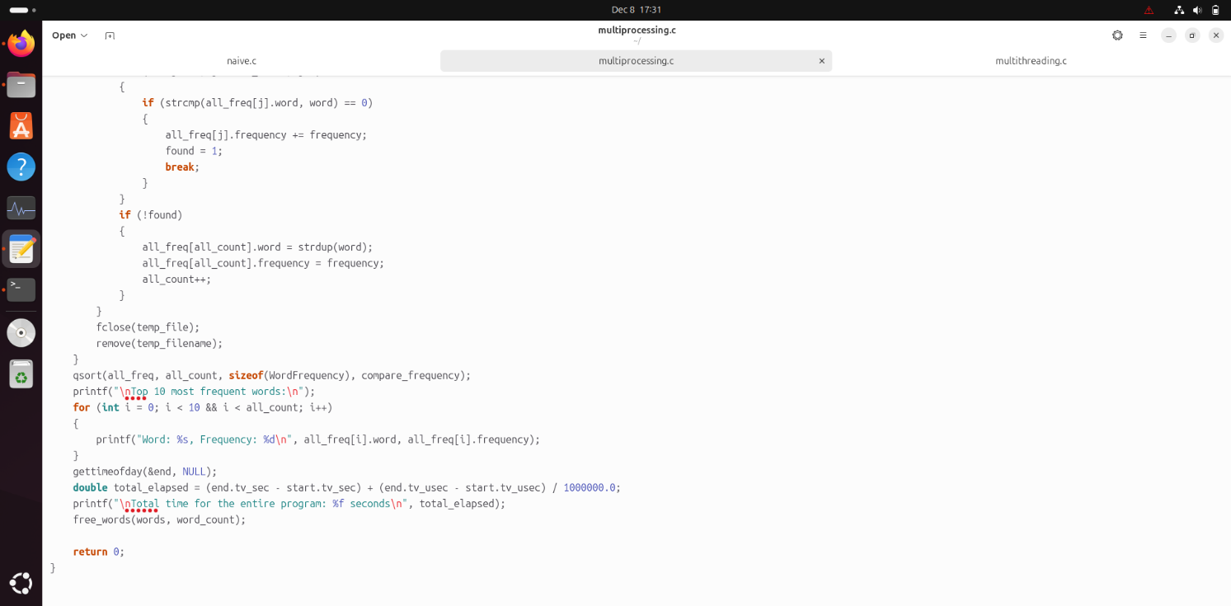
Figure 3: Multiprocessing Approach Code.

- Output
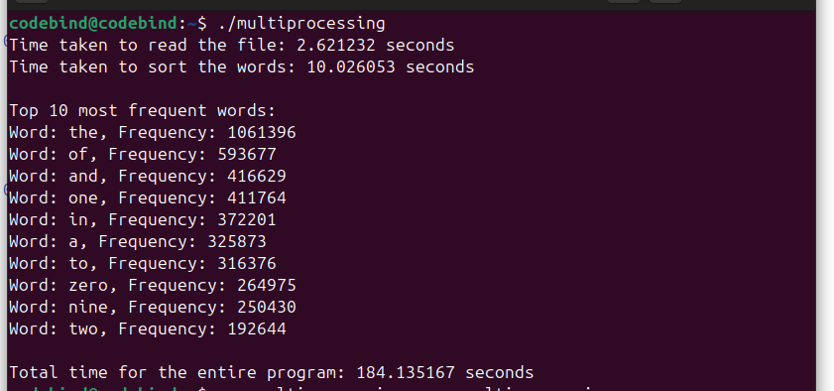

Figure 4: Multiprocessing Approach output for (2 childs).

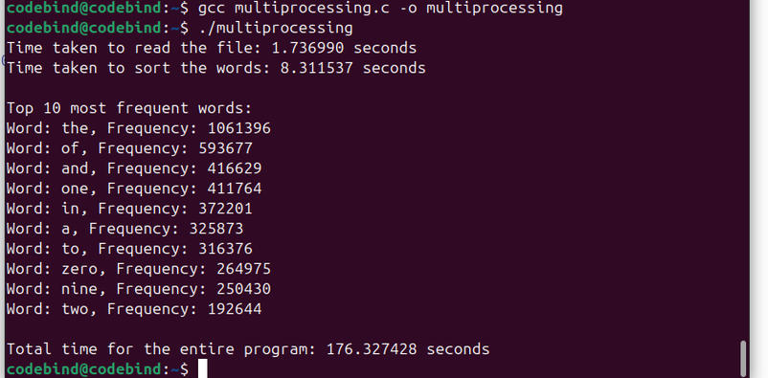

Figure 5: Multiprocessing Approach output for (4 childs).

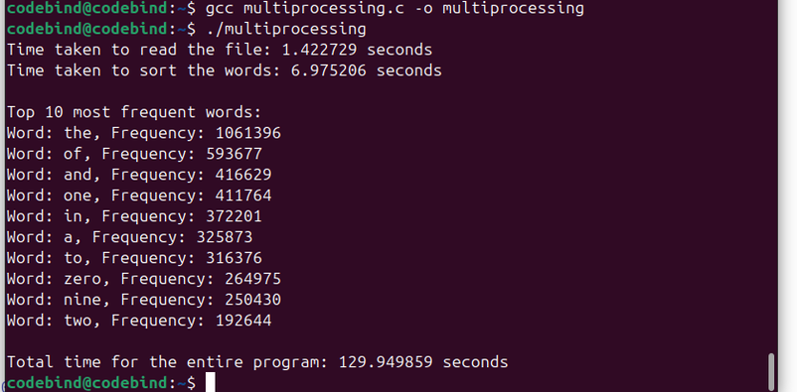

Figure 6: Multiprocessing Approach output for (6 childs).

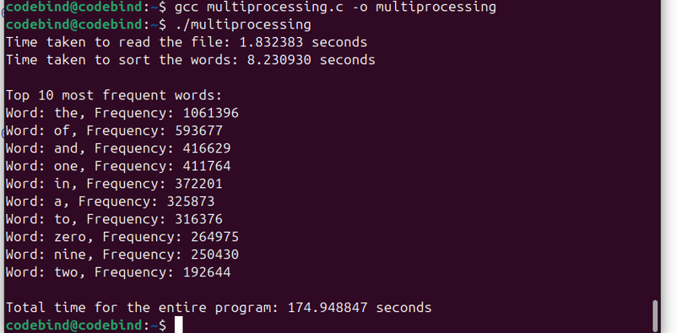
Figure 7: Multiprocessing Approach output for (8 childs).

- Analysis
This program efficiently calculates word frequencies from a large text file by leveraging parallel processing. By dividing the workload across multiple processes and merging their results, it optimizes execution time for large datasets. Each child process operates independently in separate memory spaces, necessitating a final merging step to combine their results into a cohesive output. This approach is especially useful for processing extensive datasets on multicore systems.
The program begins by reading the input text file using the read_file function. Each word is stored dynamically in memory, allowing flexibility for varying word lengths. After reading the words, the program uses the qsort function to alphabetically sort the array. Sorting ensures that identical words are grouped together, simplifying the frequency calculation in subsequent steps.
Creating Child Processes and Dividing Work: to take advantage of parallel processing, the program divides the sorted word array into equal chunks, with each chunk assigned to a separate child process. The fork system call creates these processes, and each operates in its own memory space. This isolation ensures that each process can safely calculate word frequencies within its assigned range using the process_chunk function. The results are written to separate temporary files for each process. While this design avoids memory conflicts, the independent memory spaces of the child processes require a merging step to consolidate the results later.
Merging Results from Child Processes: fter all child processes complete their tasks, the parent process combines their outputs. Using the waitpid function, the parent ensures that all child processes finish before proceeding. The temporary files generated by each process are then read, and the word-frequency pairs are combined. If a word from a temporary file matches an existing word in the global frequency array, their frequencies are aggregated. Otherwise, a new entry is created. This merging step is essential since each process worked in isolated memory spaces, and without it, the results would remain fragmented.
Once the results are merged, the program sorts the global frequency array in descending order of frequency using qsort. This allows the most frequent words to appear first in the output. The program then displays the top 10 most frequent words, demonstrating its ability to process large text files and extract meaningful insights.

- Different Number of processes

Number of processes | Execution Time | Performance
2 processes | 196.78254sec | 5.08175166ms-1
4 processes | 186.3755955sec | 5.365498 ms-1
6 processes | 138.347824sec | 7.228155 ms-1
8 processes | 185.01216sec | 5.40505 ms-1
Table 1: Multiprocessing Approach table.

Why does the execution time change when using different numbers of child processes in parallel?
As the number of processes increases, the execution time typically decreases because the workload is divided among multiple processes, allowing for parallel execution on available CPU cores, which improves performance. However, once the number of processes exceeds the number of available CPU cores, the system starts to experience overhead due to context switching, where the CPU has to switch between processes, causing a decrease in efficiency. As shown in our outputs.

Multithreading Approach

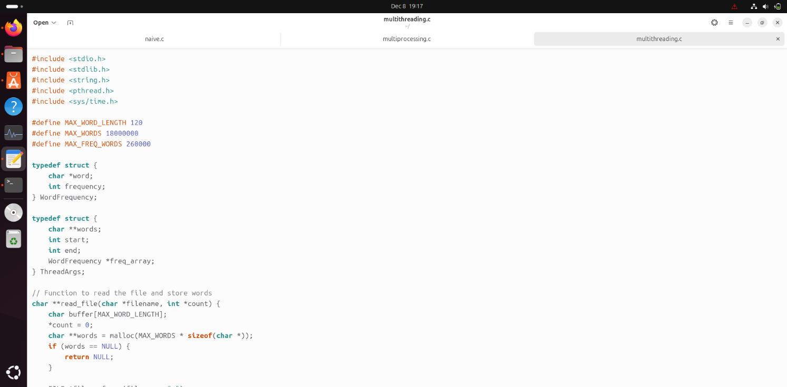
- Code
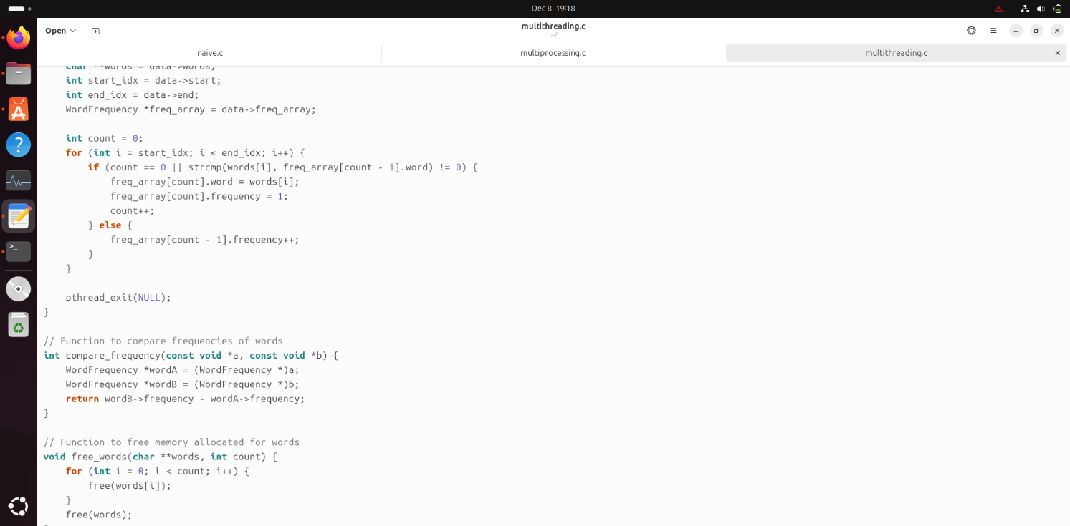
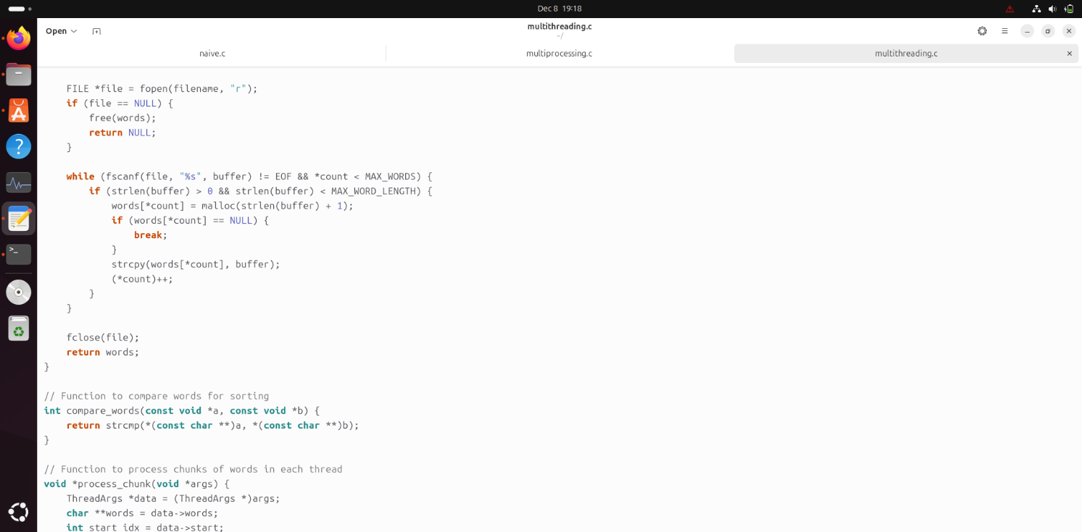
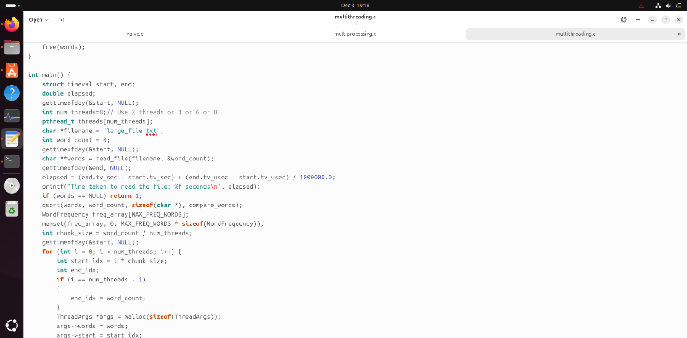
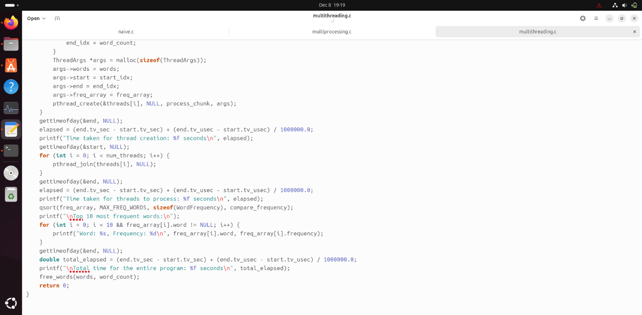
Figure8 : multithreading Approach Code.

- Output
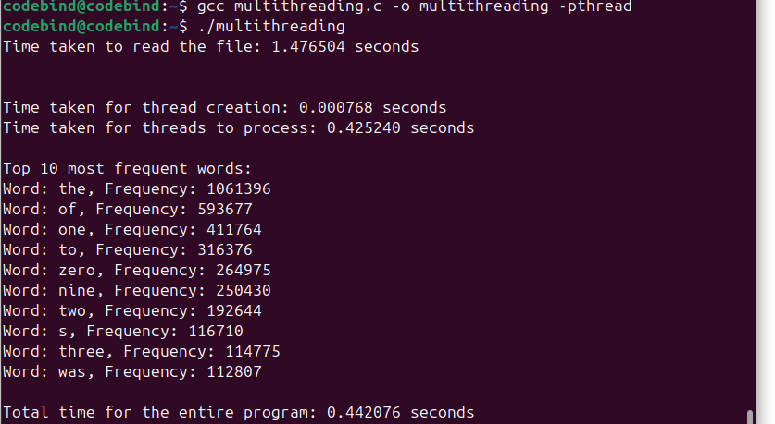

Figure 9: Multithreadind Approach output for (2 threads).

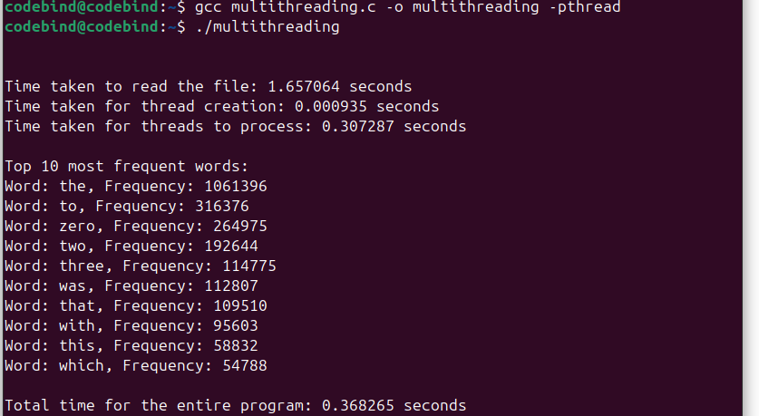

Figure 10: Multithreadind Approach output for (4 threads).
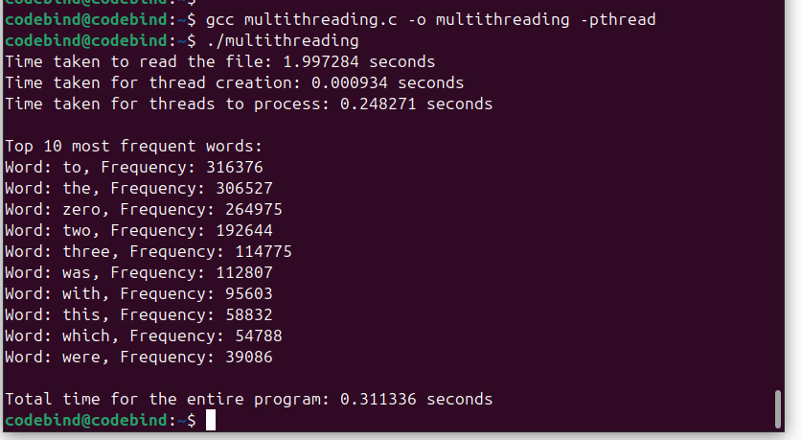

Figure 11: Multithreadind Approach output for (6 threads).
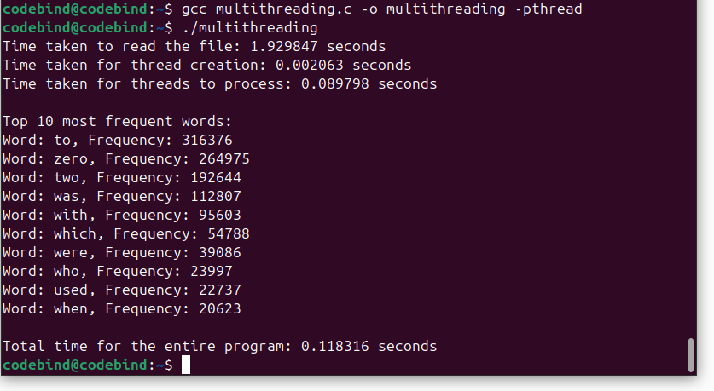

Figure 12: Multithreadind Approach output for (8 threads).

- Analysis

This program is designed to process a large text file, count the frequency of each word, and display the top 10 most frequent words. To optimize performance, the program uses multithreading to divide the workload among multiple threads. Each thread processes a portion of the word list, leveraging shared memory to update word frequencies. The goal of this approach is to speed up the word frequency counting process by utilizing multiple CPU cores in parallel.
The program begins by reading a text file into memory. A function (read_file) is used to open the file, read each word, and store it in a dynamically allocated array of strings. Once all the words are loaded into memory, the program sorts the array of words alphabetically using the qsort function.
Thread Creation and Work Division: to accelerate the word frequency counting, the program creates multiple threads. The number of threads can be specified, and each thread processes a specific chunk of the sorted word array. The total word count is divided by the number of threads, ensuring that each thread handles an approximately equal portion of the work. For instance, if there are 8 threads, each thread will handle about 1/8th of the total word list.
In the main function, the program calculates the chunk size for each thread, then creates and starts each thread using pthread_create. Each thread is given a segment of the word list to process, along with a shared frequency array where the results will be stored. Although all threads work in parallel on different chunks of the word list, they all update the same frequency array in shared memory, which introduces the need for synchronization to avoid race conditions.
The program processes word frequencies by dividing the word list into chunks, with each thread responsible for processing its assigned chunk. Each thread counts the occurrences of words within its chunk, updating a shared frequency array. However, since there is no synchronization, multiple threads could modify the same memory location, which may result in race conditions and incorrect word counts.
After creating the threads, the program uses pthread_join to ensure that all threads complete their tasks before proceeding. Once processing is finished, the frequency array is sorted, and the top 10 most frequent words are displayed. The program also measures the time taken for each stage, from reading the file to sorting the results. Finally, all dynamically allocated memory is freed to avoid memory leaks.
- Different Number of threads

Number of threads | Execution Time | Performance
2 threads | 10.344588 | 0.0966689
4 threads | 10.27077 | 0.0973636
6 threads | 10.2113 | 0.097906
8 threads | 10.0208 | 0.099792
Table 2: Multithreading Approach table.

Why is the output different between the naive and multithreading versions of the program?
The output differs between the naive (single-threaded) and multithreading versions, as shown in our results, due to the presence of race conditions in the multi-threaded approach. In the naive version, the program processes the word list sequentially, ensuring that word frequencies are accurately counted. In the multi-threaded version, multiple threads work on different chunks of the word list simultaneously, all modifying the same shared frequency array. Since the program does not implement synchronization mechanisms (such as mutexes or locks) to manage concurrent access to shared memory, this can lead to race conditions and incorrect frequencies. However, in this particular project, the lack of synchronization is acceptable, as it was not required to implement such mechanisms.

Project Questions

- Describe your environment: computer specs (Cores? Speed? Memory?), OS, programming language, and IDE tool, and whether you used a virtual machine.
I worked on this project using a virtual machine running Ubuntu 24.04. My personal computer has an 11th Gen Intel(R) Core (TM) i5-1135G7 processor with 4 cores and 8 logical processors, running at a base speed of 2.40 GHz. The system has 8 GB of memory. I worked in the terminal for coding, using the GCC compiler to compile the C code. I did not use an IDE for this project.
- How you achieved the multiprocessing and multithreading requirements, i.e. The API and functions that you used.
In this project, both multithreading and multiprocessing techniques were implemented to process large word lists efficiently. For multithreading, I used the POSIX Threads (pthreads) library in C. The pthread_create() function was used to spawn multiple threads, each processing a chunk of the word list and counting the frequency of each word. The pthread_join() function ensured that the main program waited for all threads to finish before continuing. This approach allows concurrent processing within the same memory space, but the program does not use synchronization mechanisms, making it more prone to race conditions.
For multiprocessing, I used the fork() system call to create child processes. Each child process processes its assigned chunk of the word list, calculates word frequencies, and writes the results to a temporary file. The parent process waits for all child processes to complete using the waitpid() function. Afterward, the program combines the results from the temporary files, calculates the final word frequencies, and prints the top 10 most frequent words. Multiprocessing creates independent memory spaces for each process, which reduces the risk of race conditions compared to multithreading, but requires handling inter-process communication and temporary files.
Both techniques allowed for parallel processing of large datasets, but multithreading is generally faster and more efficient in this case, as all threads share the same memory space. However, due to the lack of synchronization in multithreading, the results may be slightly incorrect in terms of word frequencies, as threads can modify shared memory locations concurrently without proper locking mechanisms. In contrast, multiprocessing avoids this issue by working with separate memory spaces for each process.
- An analysis according to Amdahl’s law. What percentage is the serial part of your code? What is the maximum speedup according to the available number of cores? What is the optimal number of child processes or threads?

For naïve the percentage of serial part is = serial part / total time = (221.149699/224.18758) *100%=98.6%
The serial parts (read from file) are common between naïve, multiprocessing and multithreading and it is almost = 2.35960525sec
Amdahl's Law:
S=1/ (s + p/n)​
S: speed
s: serial part
p: parallel part
n: number of process or threads

2 Processes:
Execution Time: 196.78254 sec
Parallel Time: 196.78254−2.35960525=194.42293475 sec
Serial Percentage: (2.35960525/196.78254) ×100=1.20%
S=1/ (2.35960525+(194.42293475/2)) =0.01004 ms−1

4 Processes:
Execution Time: 186.3755955 sec
Parallel Time: 186.3755955−2.35960525=184.01599025 sec
Serial Percentage: (2.35960525/186.3755955) ×100=1.27%
S=1/(2.35960525+(184.01599025/4)) =0.02067 ms−1

6 Processes:
Execution Time: 138.347824 sec
Parallel Time: 138.347824−2.35960525=135.98821875 sec
Serial Percentage: (2.35960525/138.347824) ×100=1.71%
S=1/ (2.35960525+(135.98821875/6) =0.03996 ms−1

8 Processes:
Execution Time: 185.01216 sec
Parallel Time: 185.01216−2.35960525=182.65255475 sec
Serial Percentage: (2.35960525/185.01216) ×100=1.27%
S=1/ (2.35960525+(182.65255475/8)) =0.03971 ms−1

2 Threads:
Execution Time: 10.344588 sec
Parallel Time: 10.344588−2.35960525=7.98498275 sec
Serial Percentage: (2.35960525/10.344588) ×100=22.81%
S=1/ (2.35960525+(7.98498275/2)) =ms−1

4 Threads:
Execution Time: 10.27077 sec
Parallel Time: 10.27077−2.35960525=7.91116475 sec
Serial Percentage: (2.35960525/10.27077) ×100=22.97%
S=1/ (2.35960525+(7.91116475/4) =0.2305 ms−1

6 Threads:
Execution Time: 10.2113 sec
Parallel Time: 10.2113−2.35960525=.85169475 sec
Serial Percentage: (2.35960525/10.2113) ×100=23.11%
S=1/ (2.35960525+(7.85169475/6)) = ms−1

8 Threads:
Execution Time: 10.0208 sec
Parallel Time: 10.0208−2.35960525=7.66119475 sec
Serial Percentage: (2.35960525/10.0208) ×100=23.55%
S=1/ (2.35960525+(7.66119475/8)) =0.3015 ms−1

The optimal number of child processes is 6, as it achieves the lowest execution time (138.34 seconds) compared to 2, 4, or 8 processes; adding more than 6 processes introduces overhead, leading to worse performance. For threads, the optimal number is 8, with the lowest execution time of 10.02 seconds, as threads continue to scale better in this case without significant overhead. Therefore, for large-scale tasks involving processes, 6 is optimal, while for smaller-scale or thread-focused tasks, 8 threads provide the best performance.

- A table that compares the performance of the 3 approaches.

Approach | Execution Time | Performance
naive | 224.18758sec | 4.521843ms-1
2 processes | 196.78254sec | 5.08175166ms-1
4 processes | 186.3755955sec | 5.365498 ms-1
6 processes | 138.347824sec | 7.228155 ms-1
8 processes | 185.01216sec | 5.40505 ms-1
2 threads | 10.344588sec | 0.0966689
4 threads | 10.27077sec | 0.0973636
6 threads | 10.2113sec | 0.097906
8 threads | 10.0208sec | 0.099792
Table 3: Three Approaches table.

Comment on the differences in performance
The performance differences between the naive approach, multiprocessing, and multithreading highlight the impact of parallelization. The naive approach, being entirely serial, has the highest execution time (224.19 seconds) and does not utilize available cores, with 98.6% of the code being serial. Multiprocessing reduces execution time significantly by leveraging multiple CPU cores, achieving the best performance with 6 processes (138.35 seconds) due to an optimal balance of workload and process management. However, adding more processes beyond this point results in diminishing returns due to overhead. Multithreading delivers the fastest execution time (10.02 seconds with 8 threads) but offers marginal improvements with additional threads because of memory access contention and synchronization overhead. While multiprocessing is optimal for CPU-intensive tasks, multithreading benefits from reduced overhead and efficient memory sharing, making it the fastest overall. For this workload, multiprocessing with 6 processes provides the best balance, while multithreading with 8 threads achieves the shortest execution time

Conclusion

In conclusion, this project shows how using parallel computing techniques like multiprocessing and multithreading can greatly improve the performance of programs that handle large amounts of data. The naive approach, which runs everything sequentially, takes the longest time and doesn’t scale well. Multiprocessing makes good use of multiple CPU cores, with six processes being the most efficient balance. On the other hand, multithreading achieves the fastest results with eight threads, as it reduces overhead. This project highlights how understanding the task and system can help choose the right parallel approach to save time and improve efficiency. It demonstrates the power of parallel computing to make programs faster and more scalable.

