**Git Repository Commands**

**Following commands used to create git repository file:**

**git init:** Itis a command used to create a new Git repository. When you run this command in a directory, it initializes a new repository there, making it a Git-managed project. It sets up the necessary

**git status:** It is a command that shows the current state of the working directory and staging area. It helps you understand which changes are staged for the next commit, which files are modified, and which files are untracked.

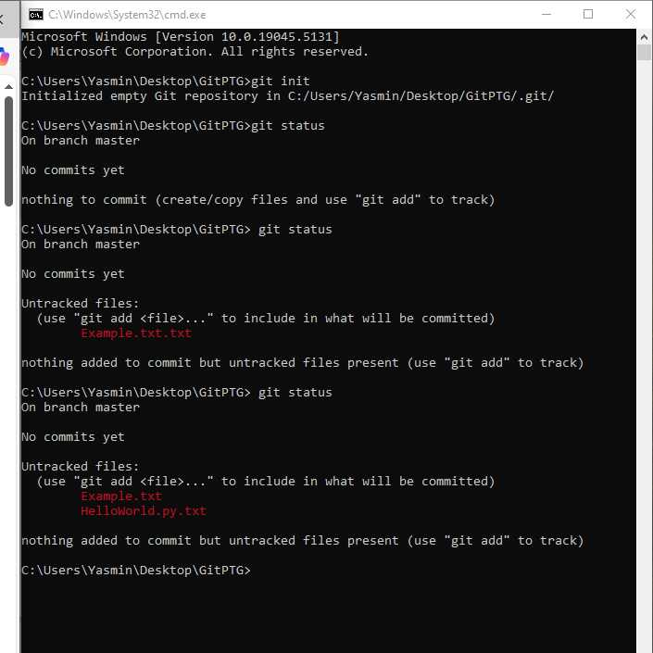

**git add filename:** It is used to stage a specific file (or files) for the next commit in Git. This command tells Git that you want to include the changes made to the file in the next commit. It doesn't actually commit the changes; it just prepares them for commit.

**git commit –m “message”:** It is used to save the staged changes to the repository with a commit message. The -m option allows you to provide a short message describing the changes made in the commit.

**git push –u origin master:** It is used to upload your local commits to a remote repository. The origin refers to the default name for the remote repository. master refers to the branch you want to push your changes to, which is commonly the default branch for a new Git repository.

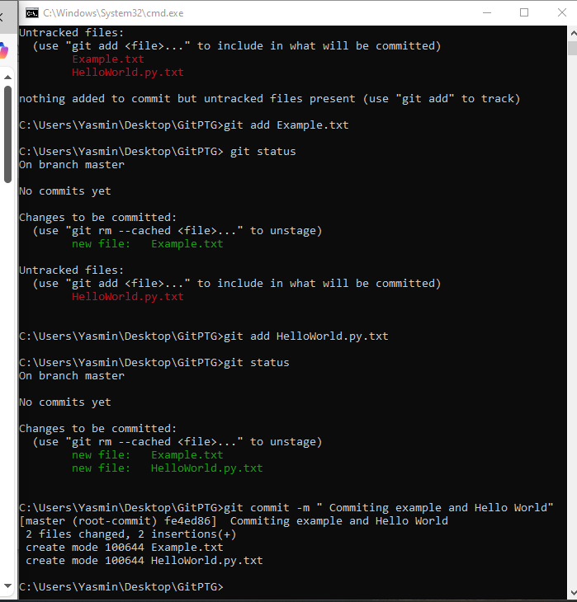

**git branch:** It s a command used in Git to manage branches in your repository. A **branch** is essentially a pointer to a specific commit, and it's used to create an isolated environment where you can work on a feature, bugfix, or experiment without affecting the main project.

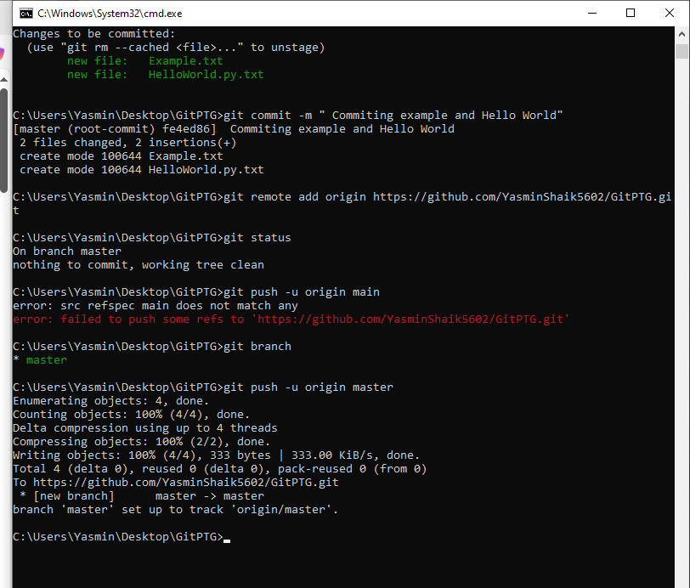

**git checkout –b “Branch-name”:** It is used in Git to **create a new branch** and **switch to that branch** at the same time.

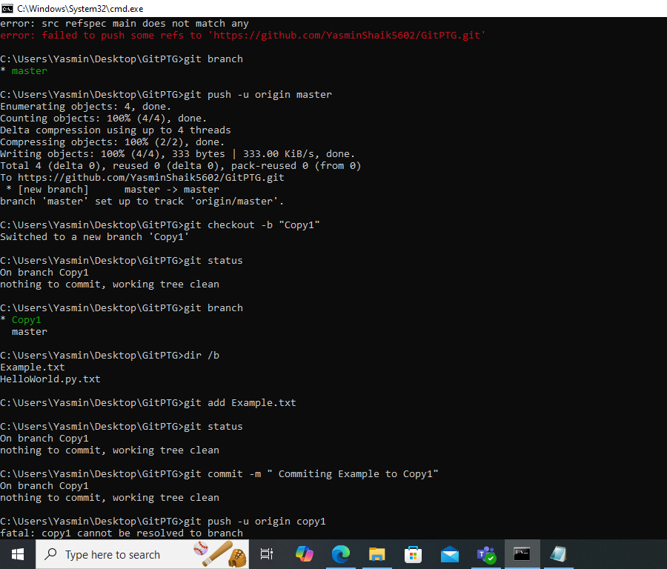

**git merge:** It is a Git command used to **combine changes from two different branches** into one. This is typically done when you want to incorporate changes from one branch (like a feature branch) into another (such as the master or main branch).

**dir /b:** It is a command used in **Windows Command Prompt (CMD)** to list the contents of a directory in **bare format**. The /b flag stands for **bare**, which means it only shows the names of files and directories, without additional details like file size, date modified, etc.

