**Name:** Yasmina Taimour Salah.

**B.N:** 1036.

**Topic:** Artificial Intelligence.

**Application Brief:**

Artificial intelligence refers to the simulation of human intelligence in machines that are customized to think like humans and mimic their actions. The term may also be applied to any machine that shows characteristics related with a human brain such as learning and problem-solving.

The perfect characteristic of artificial intelligence is its ability to rationalize and take actions that have the most excellent chance of accomplishing a particular goal.

Now we can’t live without artificial intelligence since it makes our life easier and comfortable.

**Screenshots:**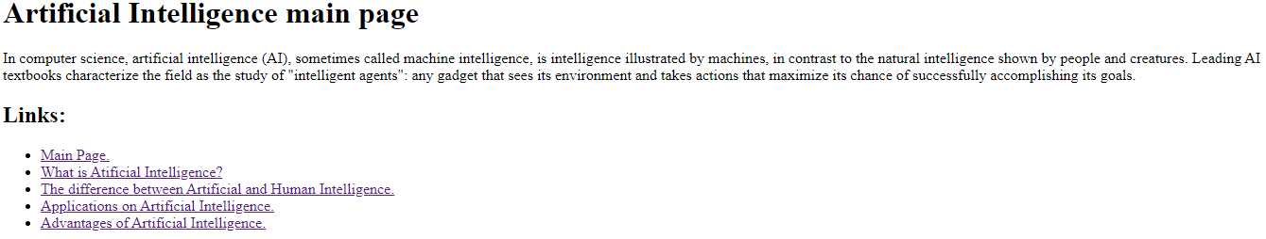

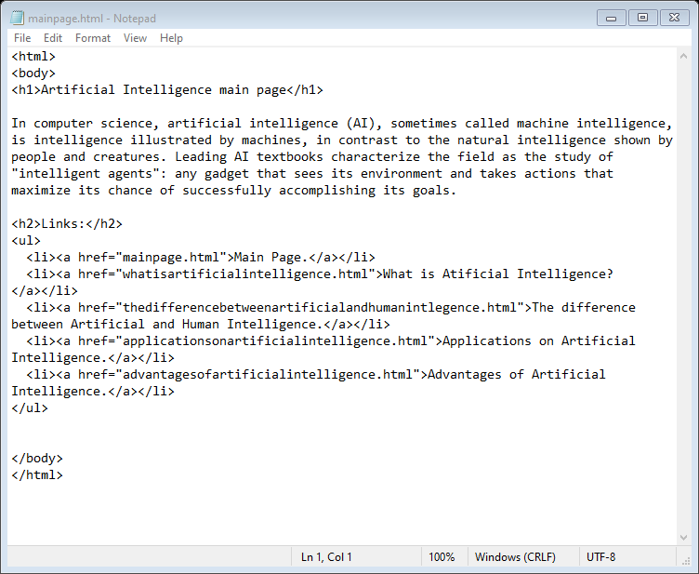**Source code:**

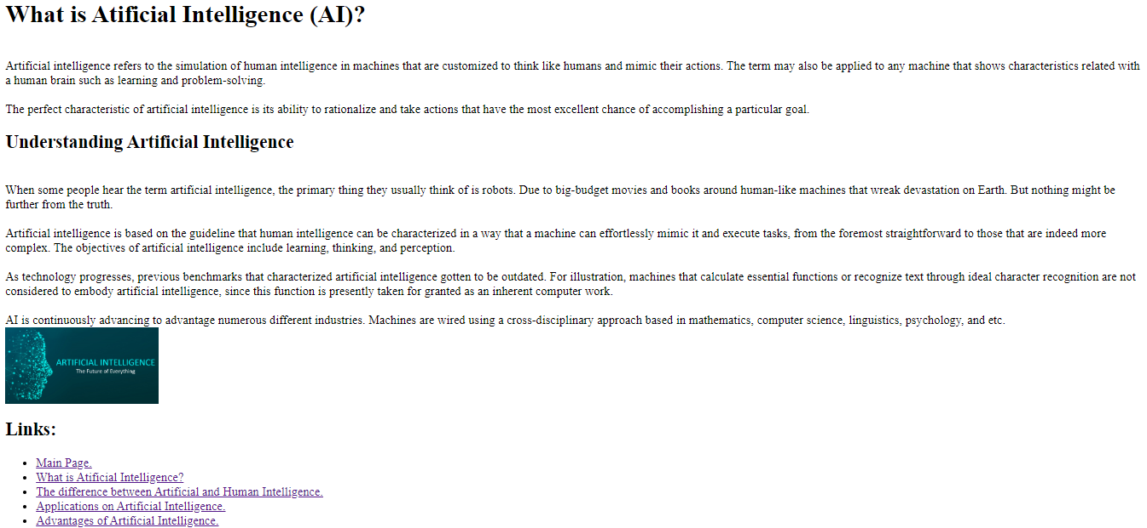

**Source code:**

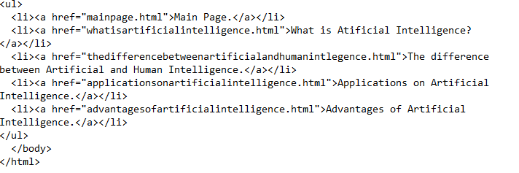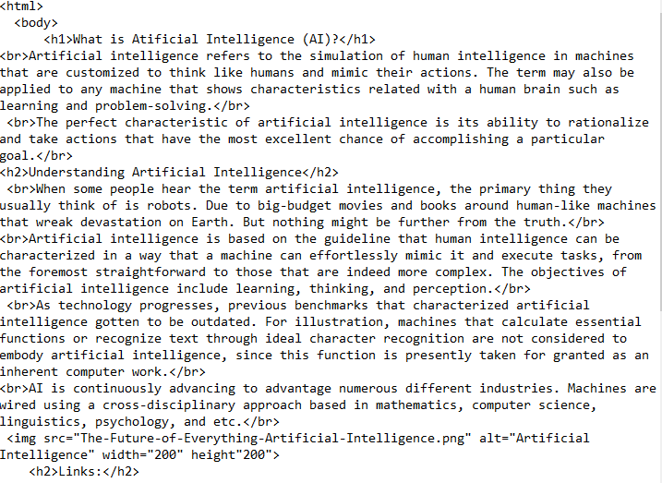

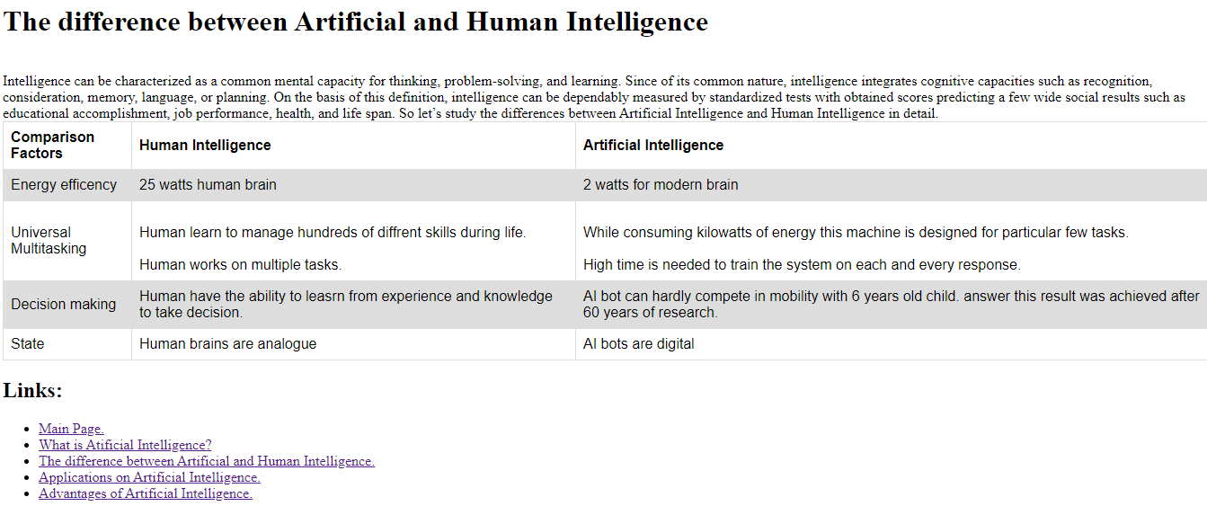

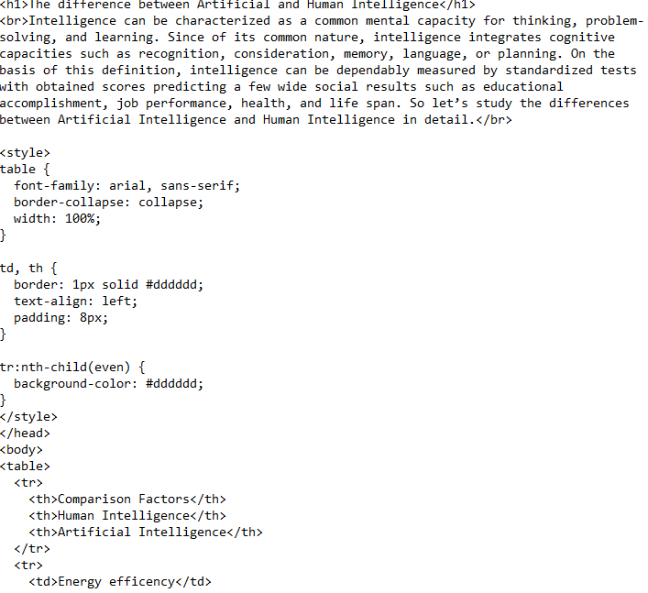**Source code:**

