1. **Why is a Mac address not sufficient to transport data on the internet?**

- the Internet runs on IP routing. A Mac address must have an associated IP address in order to access the Internet. something like a MAC address would be sufficient to transport data on the Internet if it had been designed to do that. It wasn't designed to do that. The entire routing of the Internet is designed around IP addresses (either IPv4 or IPv6) and was never designed around MAC addresses.

**2) Will we need private ip addresses with ipv6?**

-IPv6 has had two versions of private addressing – deprecated site-local addressing and the current Unique Local Unicast Addresses (ULAs).

**3) In nslookup command Why Google appear in one IP address for each location while Yahoo for example doesn't?**

for google, the request goes in through the load balancer, and then to a 10/32 net, and then the server replies directly using the load balancer’s public address, rather than forcing the load balance to do double duty as a router.

**4) How to allow someone to ping to your computer without turning off your firewall?**

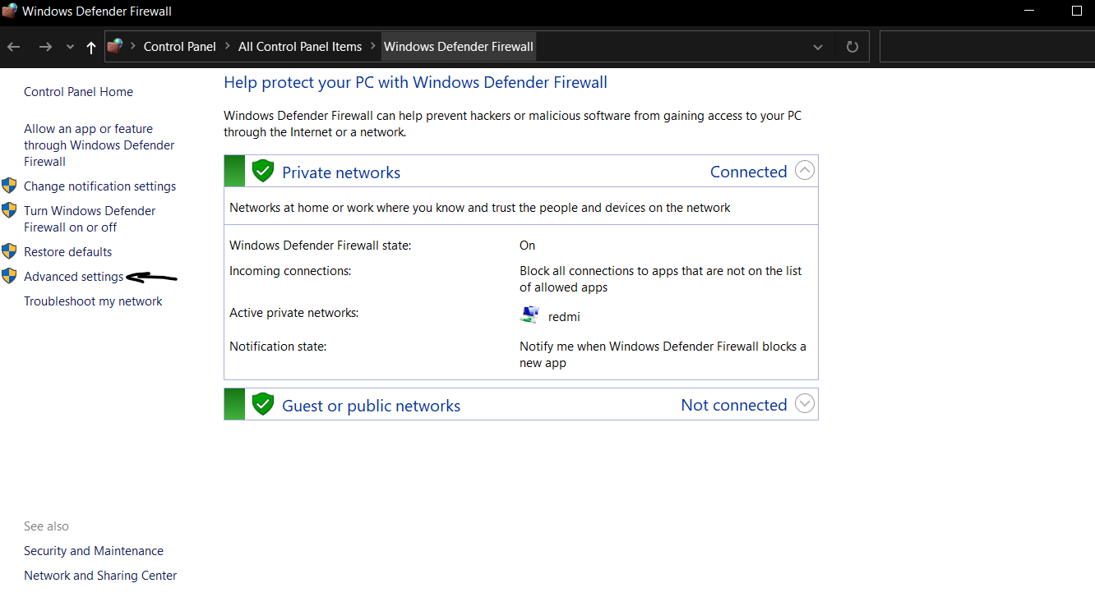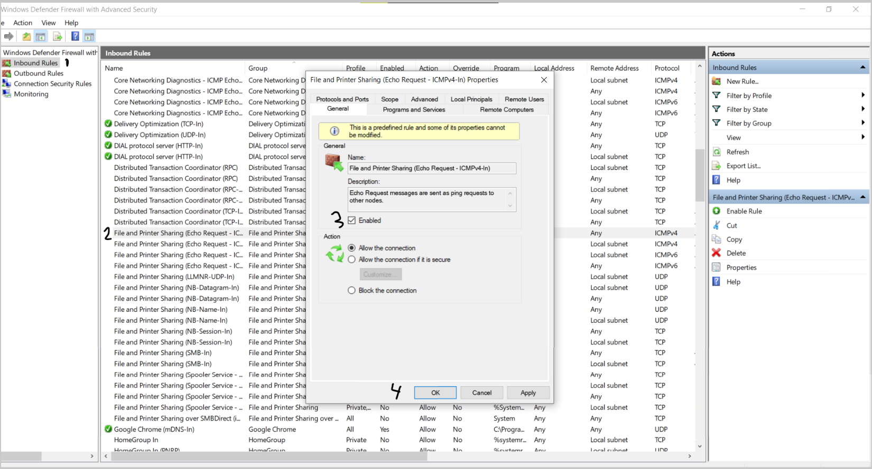

**5) Create a mail server with users**

