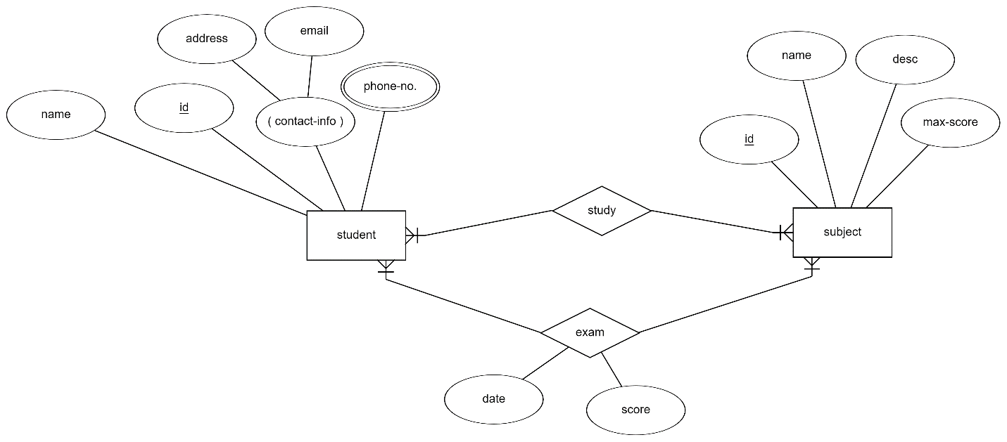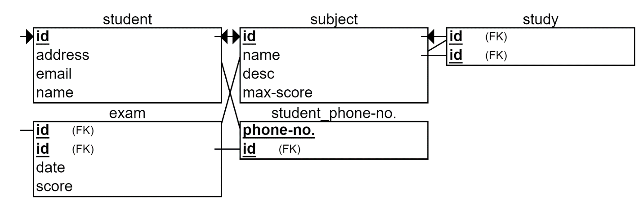

Student:

CREATE TABLE `iti`.`student` (

`id` INT NOT NULL,

`name` VARCHAR(45) NULL,

`email` VARCHAR(45) NULL,

PRIMARY KEY (`id`),

UNIQUE INDEX `id_UNIQUE` (`id` ASC) VISIBLE);

Student_phone

CREATE TABLE `iti`.`student_phoneno.` (

`student_id` INT NOT NULL,

`phone_no.` VARCHAR(45) NOT NULL,

PRIMARY KEY (`phone_no.`, `student_id`),

CONSTRAINT `student_id`

FOREIGN KEY (`student_id`)

REFERENCES `iti`.`student` (`id`)

ON DELETE NO ACTION

ON UPDATE NO ACTION);

Subject:

CREATE TABLE `iti`.`subject` (

`id` INT NOT NULL,

`name` VARCHAR(45) NULL,

`desc` VARCHAR(45) NULL,

`max_score` INT NULL,

PRIMARY KEY (`id`));

Study:

CREATE TABLE `iti`.`study` (

`student_id` INT NOT NULL,

`subject_id` INT NOT NULL,

PRIMARY KEY (`student_id`, `subject_id`),

CONSTRAINT `sudent_id`

FOREIGN KEY (`student_id`)

REFERENCES `iti`.`student` (`id`)

ON DELETE NO ACTION

ON UPDATE NO ACTION);

ALTER TABLE `iti`.`study`

ADD CONSTRAINT `subject_id`

FOREIGN KEY ()

REFERENCES `iti`.`subject` ();

Exam

CREATE TABLE `iti`.`exam` (

`student_id` INT NOT NULL,

`subject_id` INT NOT NULL,

`date` DATE NULL,

`score` INT NULL,

PRIMARY KEY (`student_id`, `subject_id`),

CONSTRAINT `student`

FOREIGN KEY (`student_id`)

REFERENCES `iti`.`student` (`id`)

ON DELETE NO ACTION

ON UPDATE NO ACTION);

ALTER TABLE `iti`.`exam`

ADD INDEX `subject_idx` (`subject_id` ASC) VISIBLE;

;

ALTER TABLE `iti`.`exam`

ADD CONSTRAINT `subject`

FOREIGN KEY (`subject_id`)

REFERENCES `iti`.`subject` (`id`)

ON DELETE NO ACTION

ON UPDATE NO ACTION;