1. Install Apache HTTP server
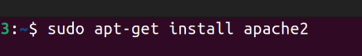

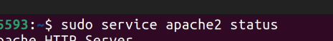

sudo service apache2 start
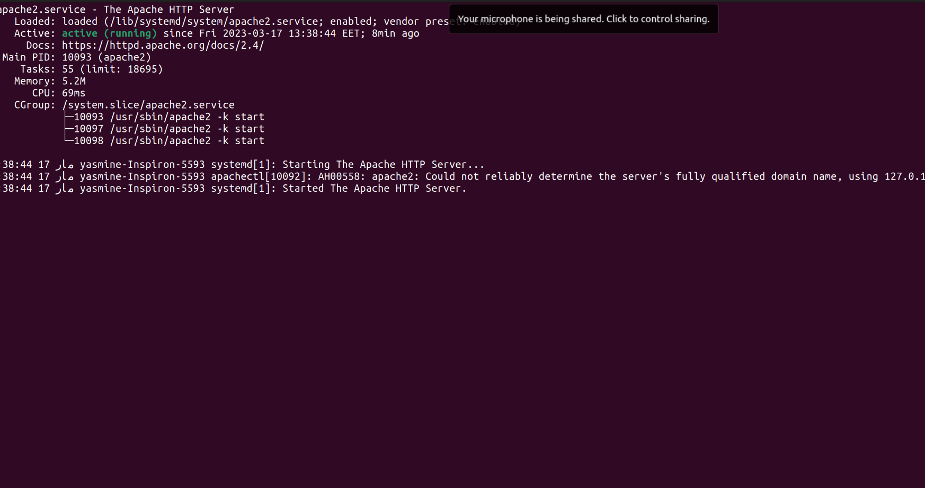
2. Create two simple html pages named “page1.html, page2.html” then use the suitable directive to automatically redirect from localhost/page1.html to localhost/page2.html.
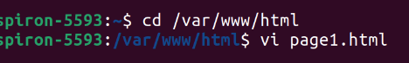

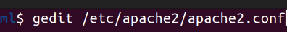

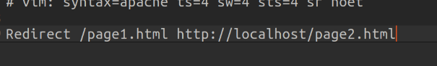

3. Ask for user name and password when accessing a directory.
4. Apply authentication before downloading PDF files.
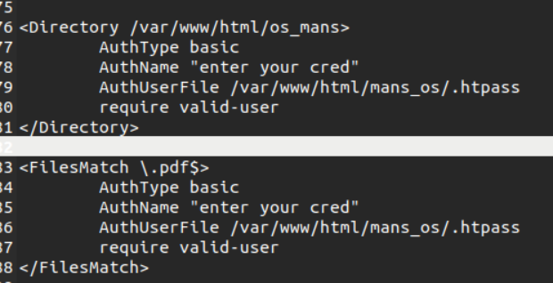
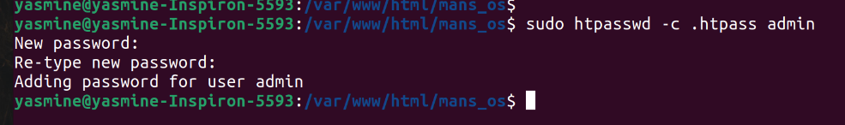

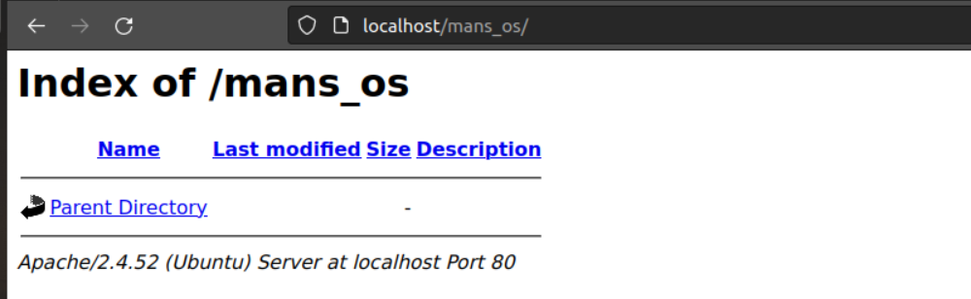

5. Create a directory then allow access to one of your classmates only.
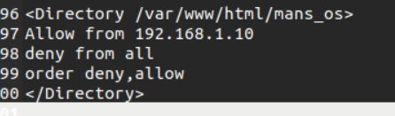

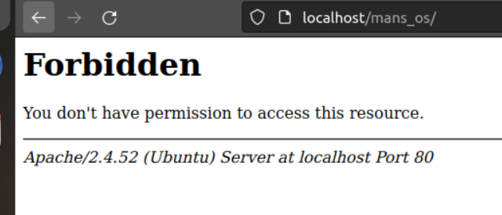

6. Disable listing the directory content (hint use indexs)
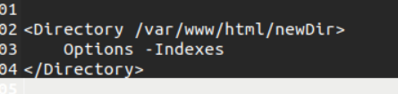

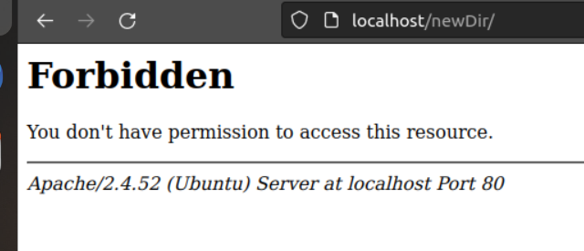

7. Change the default index page to be default.html instead of index.html (use
DirectoryIndex)
