8. Identify the file types of the following: /etc/passwd, /dev/pts/0, /etc, /dev/sda

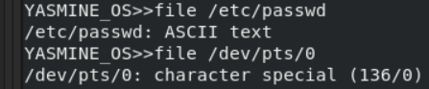

9. List the inode numbers of /, /etc, /etc/hosts.
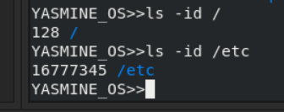

10. Copy /etc/passwd to your home directory, use the commands diff and cmp, and Edit in the
file you copied, and then use these commands again, and check the output.
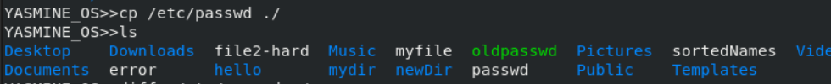
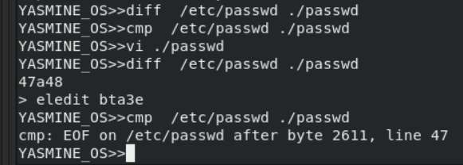
11. Create a symbolic link of /etc/passwd in /boot.
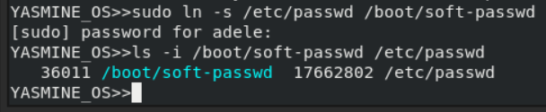
12. Create a hard link of /etc/passwd in /boot. Could you? Why?
it's not allowed to create hard
links across partitions
