1. Use systemctl to view the status of all the system services.
Difference between static state , indirect?
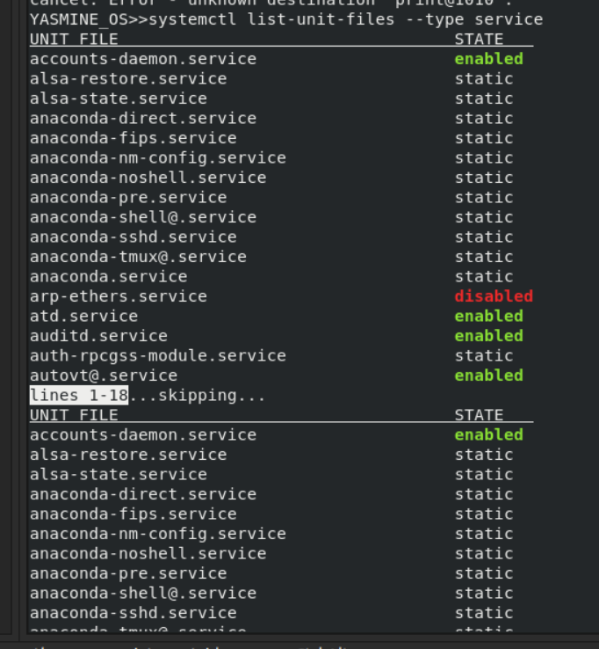

2. Change the default run level back to multi-user.target and reboot.
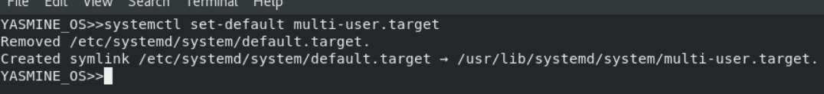
3. Send mail to the root user.
4. Verify that you have received this mail
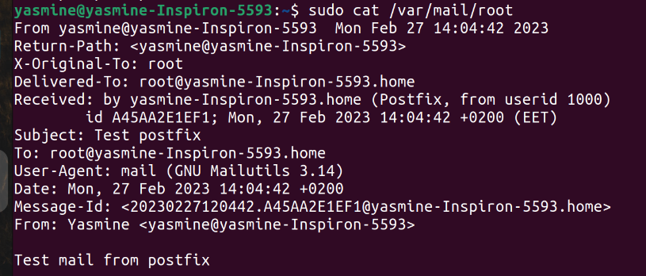

5. Use systemctl utility to stop postfix service.
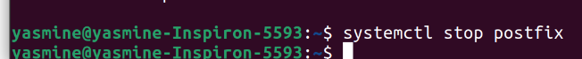
6. Send mail again to the root user.
7. Verify that you have received this mail.
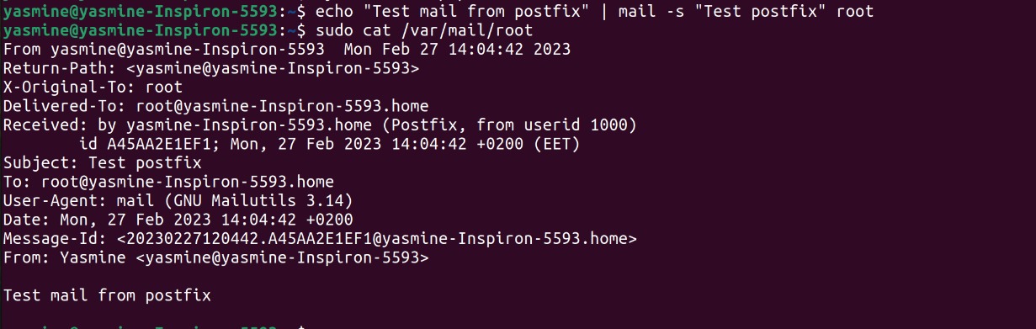

8. Use systemctl utility to start postfix service.

9. Verify that you have received this mail.
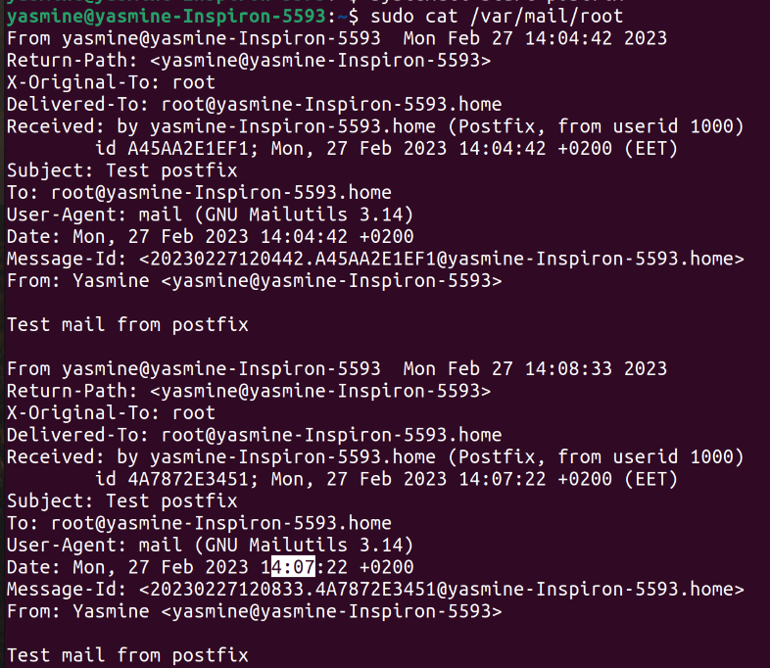

10. Edit in the GRUB2 configuration file and change the timeout variable equal 20
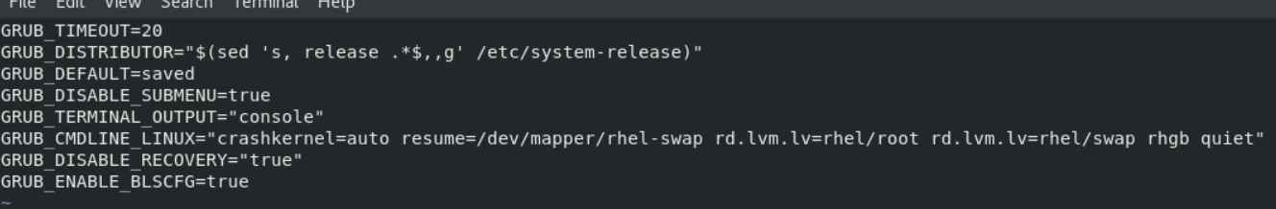
seconds.

11. Edit in the GRUB2 configuration file and change your default operating system
-1 means no default os , wait for you to choose
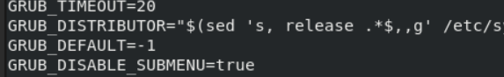

12. Install a new printer called "tty12" using the system-config-printer utility. Have the
printer queue be "/dev/tty12" and specify a "Text Only Printer" for its model type.

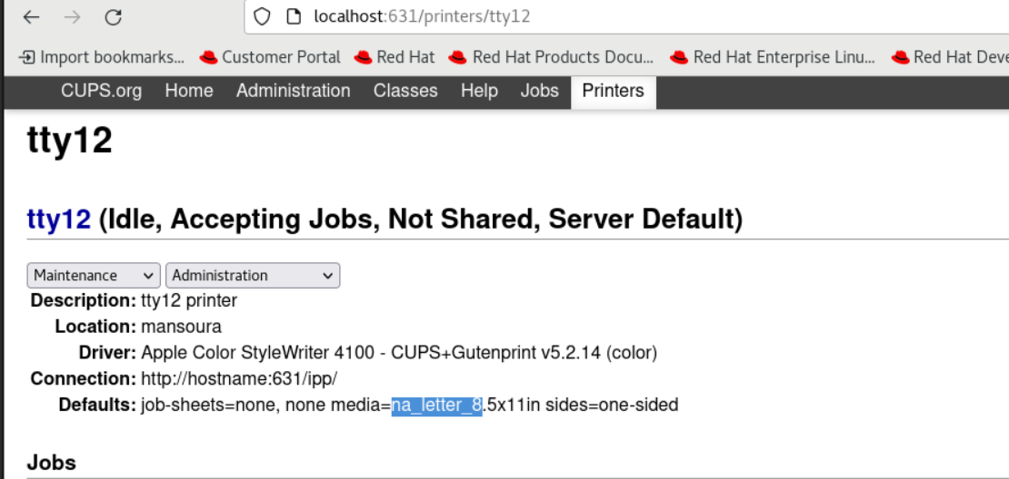
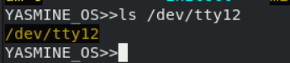

13. Print the file /etc/hosts to the printer and view the /dev/tty12 console to ensure that the
print job went to the "printer".
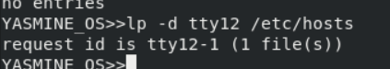

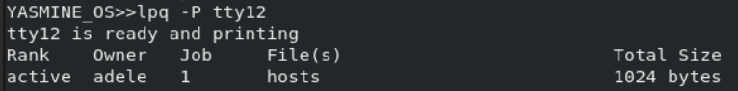
14. Prevent jobs from leaving the tty12 printer queue to the printer. Do not prevent users
from sending jobs to the tty12 printer queue.
Disable
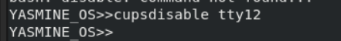

15. Print three files (/etc/hosts, /etc/xinetd.conf, and /etc/hosts.allow) to the tty12 printer
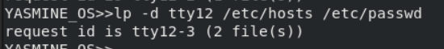

16. View the print queue.
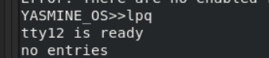

17. Remove the second print job from the tty12 printer queue, and then allow the print jobs
from the queue to be printed.
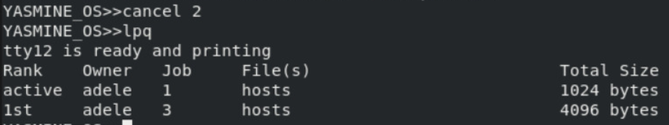


18. Prevent print jobs from going to the tty12 printer's print queue.


19. Verify this by trying to print the /etc/hosts file.
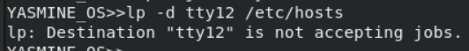

20. Delete the tty12 printer with the lpadmin command.
Lpadmin -x tty12

21. You want to know some information about the status of the system every ten minutes
today between the hours of 8:00 AM and 5:00 PM. to help investigate some
performance issues you have been having. You suspect it might be memory related
and want to keep an eye on those resources.
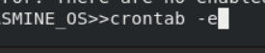

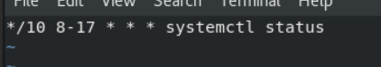

22. Use mail as the root user to check for e-mail from the cron jobs you have scheduled.
23. How could you send the output from these cron jobs to another e-mail address (the
manager user)?
24. Use mail as the manager user to check for e-mail from the cron jobs you have
scheduled.

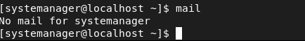

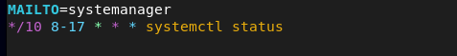

if neither at.deny nor at.allow exists will the root be allowd to use at command
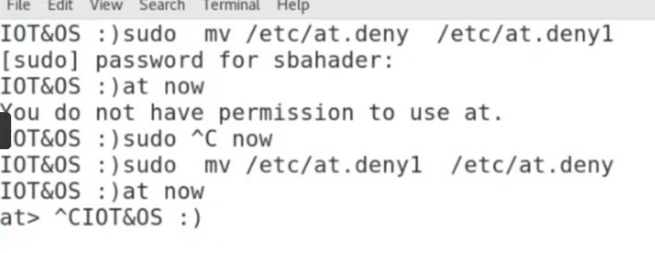
only superuser is allowd

