1. Using the useradd command, add accounts for the following users in your system:
user1, user2, user3, user4, user5, user6 and user7. Remember to give each user a
password.
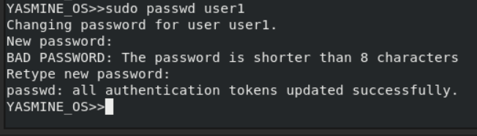
2. Using the groupadd command, add the following groups to your system.
Group
GID
sales
10000
hr
10001
web
10002
Why should you set GID in this manner instead of allowing the system to set the GID
by default?
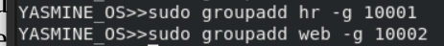

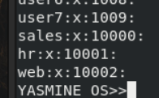

3. Using the usermod command to add user1 and user2 to the sales auxiliary group,
user3 and user4 to the hr auxiliary group. User5 and user6 to web auxiliary group.
And add user7 to all auxiliary groups

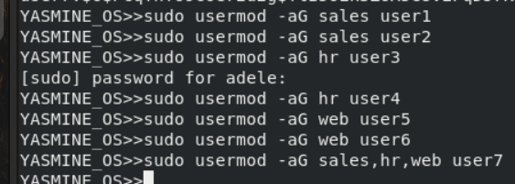

4. Login as each user and use id command to verify that they are in the appropriate
groups. How else might you verify this information?
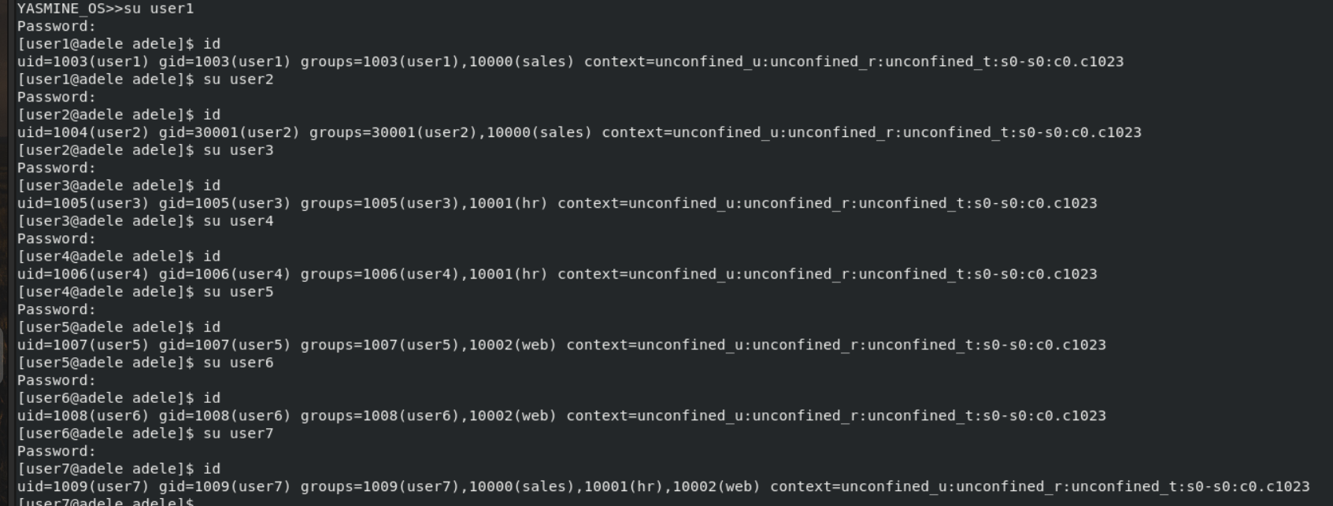
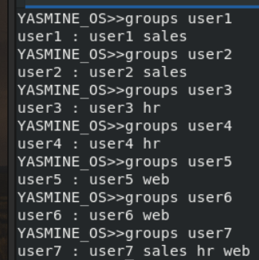

5. Create a directory called /depts with a sales, hr, and web directory within the
/depts directory.
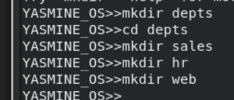

6. Using the chgrp command, set the group ownership of each directory to the group
with the matching name
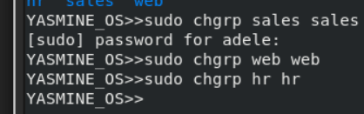
7. Set the permissions on the /depts directory to 755, and each subdirectory to 770
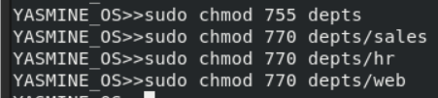

8. Set the set-gid bit on each departmental directory
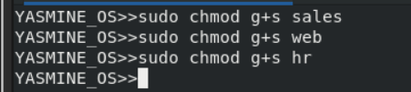

9. Use the su command to switch to the user2 account and attempt the following
commands:
touch /depts/sales/user2.txt
touch /depts/hr/ user2.txt
touch /depts/web/ user2.txt

Which of these commands succeeded and which failed? What is the group
ownership of the files that were created?
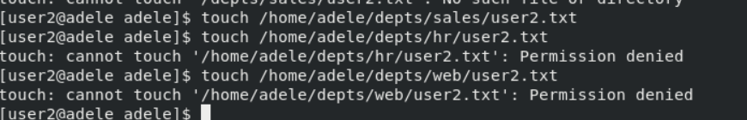

10. Configure sudoers file to allow user3 and user4 to use /bin/mount and
/bin/umount commands, while allowing user5 only to use fdisk command.
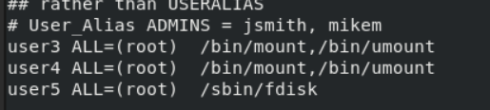
11. Login by user3 and try to umount /boot.
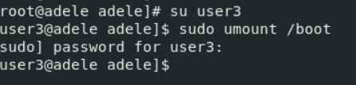

12. Login by user4 and remount /boot. Also try to view the partition table using fdisk.
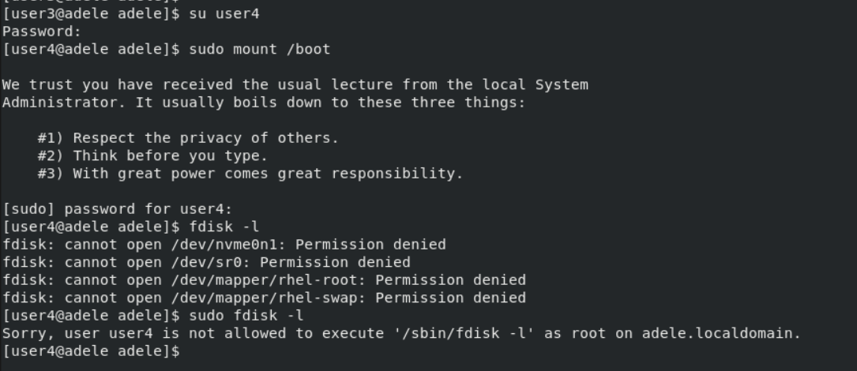
13. Create a directory with permissions rwxrwx---, grant a second group (sales) r-x
permissions
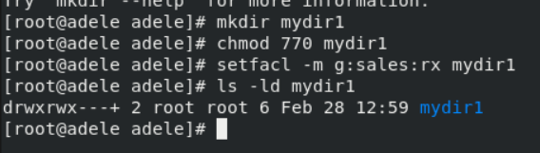
14. create a file on that directory and grant read and write to a second group (sales)
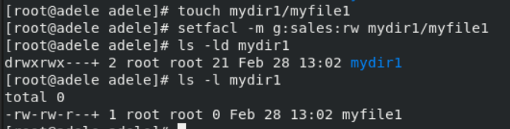
15. set the the owning group as the owning group of any newly created file in that
directory.
setfacl -m g:sales:rx mydir1
:inactive in /etc/passwd

The number of days after password expires that account is disabled

