1. Use fdisk -l to locate information about the partition sizes.
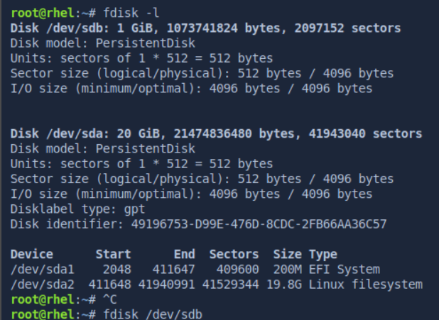
2. Use fdisk to add a new logical partition that is 1GB in size.
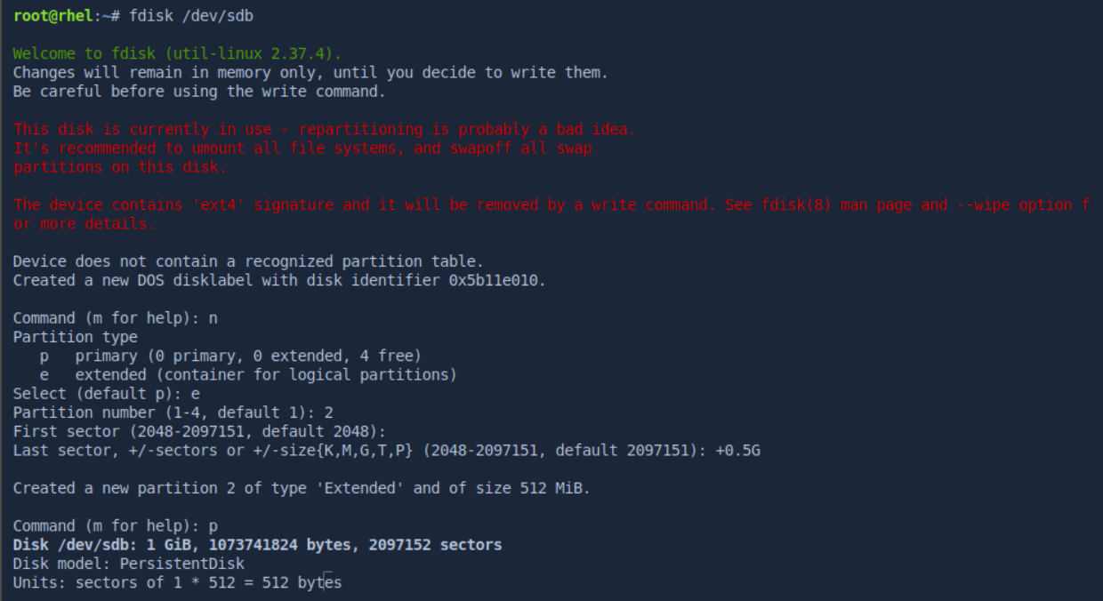

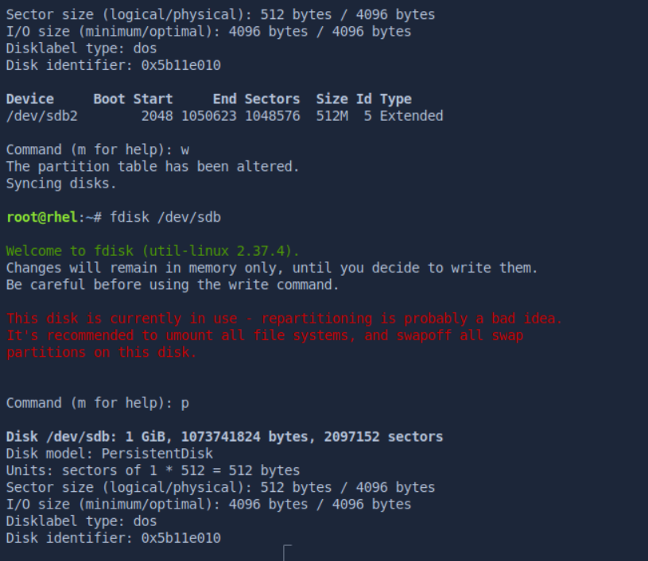
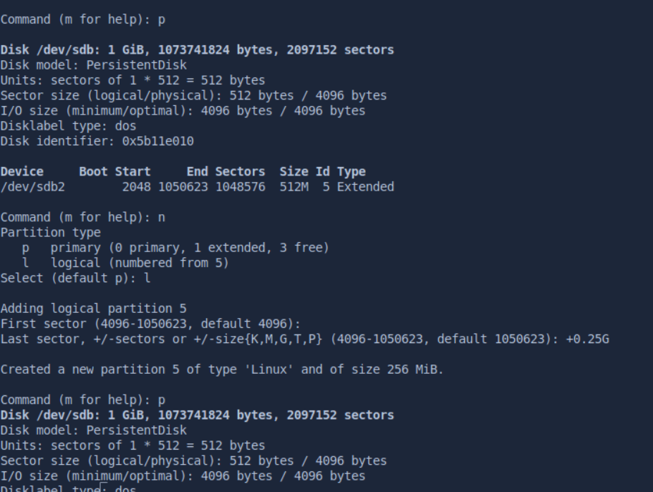

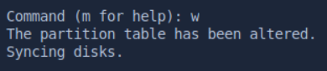

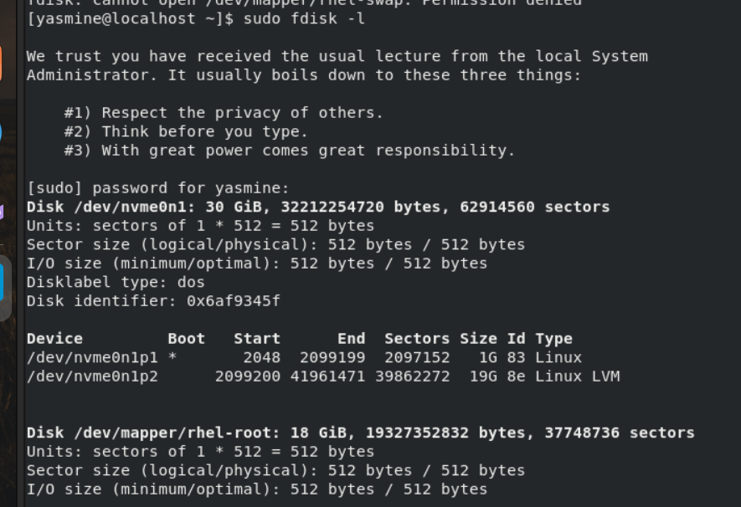
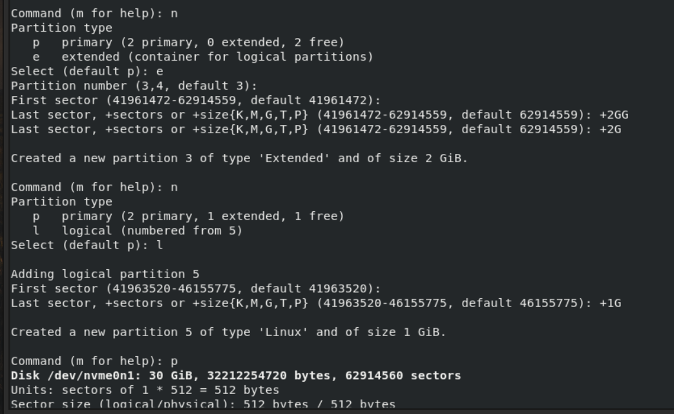
3. Did the kernel feel the changes? Display the content of /proc/partitions file? What
did you notice? How to overcome that?
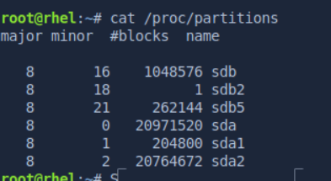

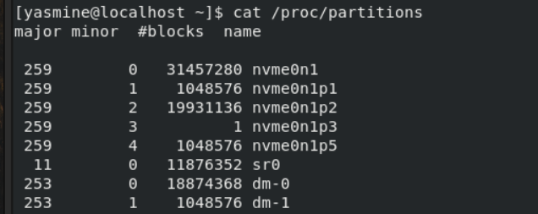
4. Make a new ext2 file system on the new logical partition you just created.
Bonus: Try creating the ext2 filesystem with 2k blocks and one inode per
every 4k (two blocks) of filesystem.

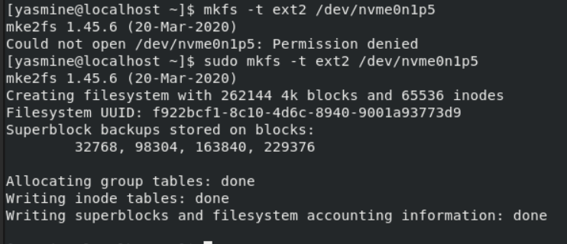
5. Create a directory, name it /data.

6. Add a label to the new filesystem, name it data.
7. Add a new entry to /etc/fstab for the new filesystem using the label you just create.

8. Mount the new filesystem.
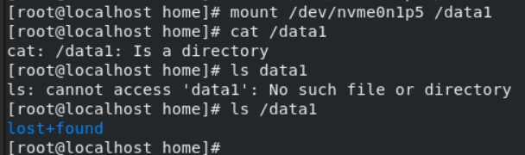

9. Display your swap size.
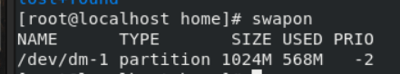

10. Create a swap file of size 512MB.
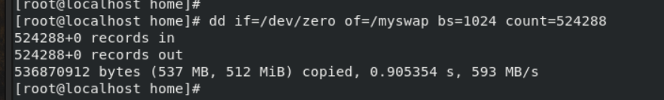
11. Add the swap file to the virtual memory of the system.
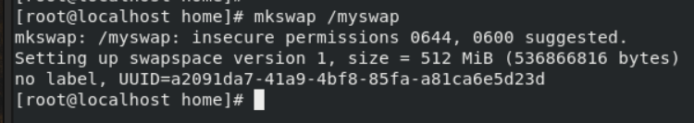
12. Display the swap size
