1- Find out what device node the /boot partition is
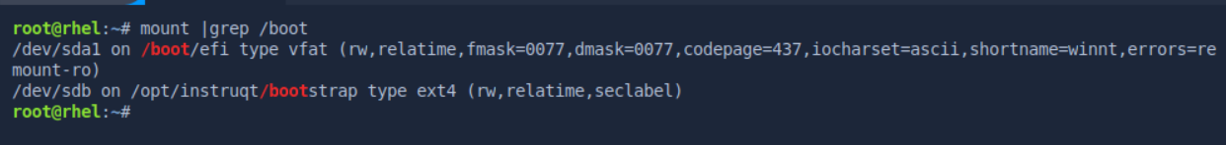
2- Estimate the size in bytes of a level-zero dump for /boot
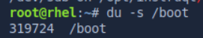
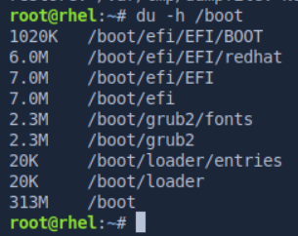

3- Back up the data of /boot to a dump file in /var/tmp/dumpfile
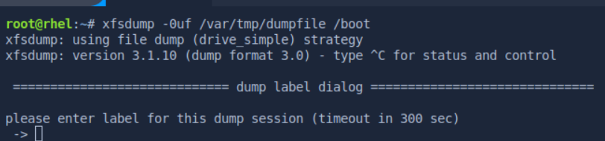
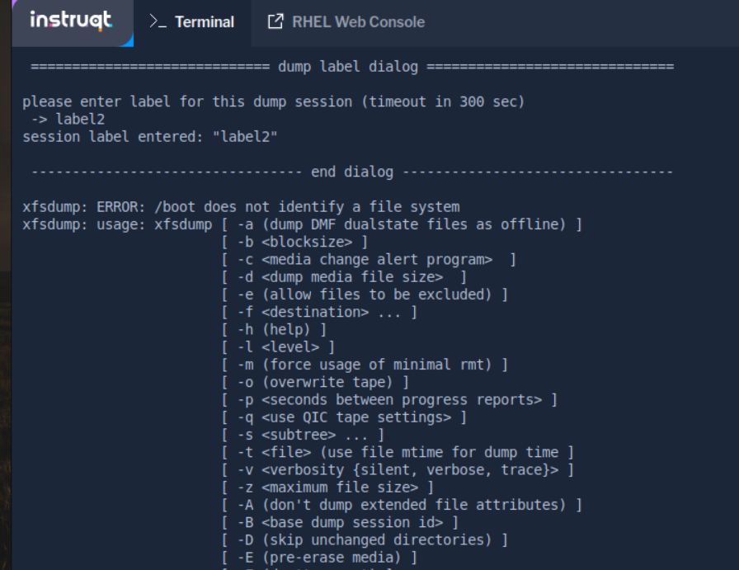

4- Look in the /etc/dumpdates file and see how the dump command recorded the timestamp of the
full backup
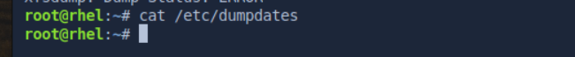
5- Use the restore command to view the contents of the dump file
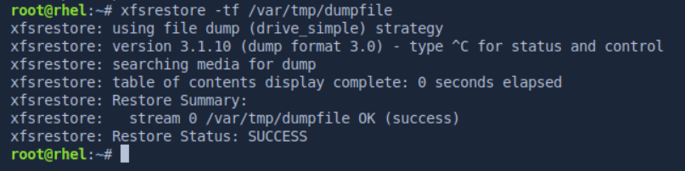
6- Use restore command in the interactive mode to extract /grub/splash.xpm.gz and /grub/grub.conf
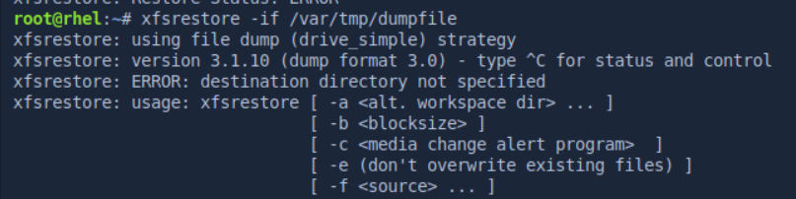
7- Use the fdisk command to create 2 Linux LVM (0x8e) partitions using "unpartitioned" space on
your hard disk. These partitions should all be the same size; to speed up the lab, do not make them
larger than 300 MB each. Make sure to write the changes to disk by using the w command to exit
the fdisk utility. Run the partprobe command after exiting the fdisk utility.

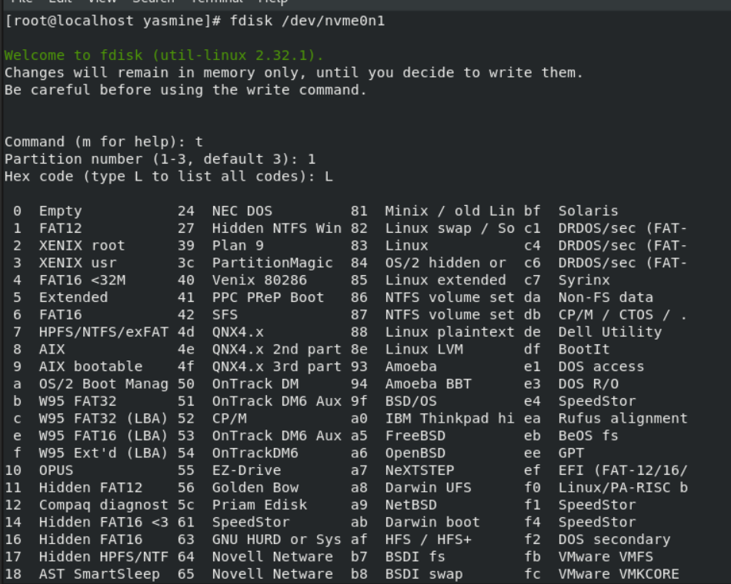
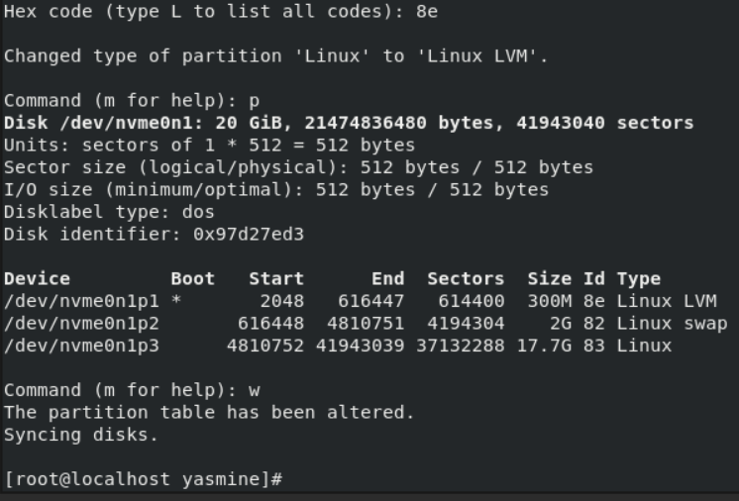
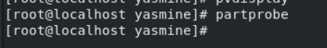

8- Initialize your Linux LVM partitions as physical volumes with the pvcreate command. You can use the pvdisplay command to verify that the partitions have been initialized as physical volumes.
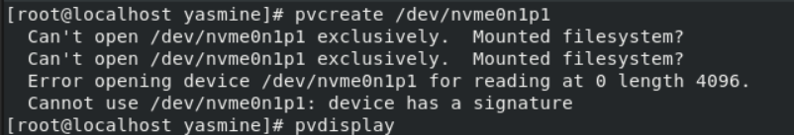
9- Using only one of your physical volumes, create a volume group called test0. Use the vgdisplay
command to verify that the volume group was created.
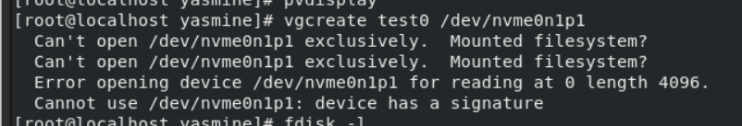
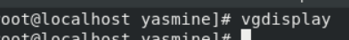

10- Create a small logical volume (LV) called data that uses about 30 percent of the available
space of the test0 volume group. Look for VG Size and Free PE/Size in the output of the
vgdisplay command to assist you with this. Use the lvdisplay command to verify your work.
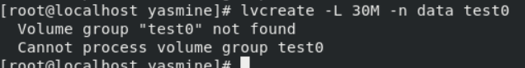
11- Create an ext2 filesystem on your new LV.
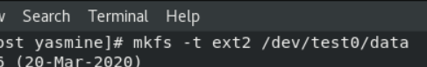

12- Make a new directory called /data and then mount the new LV under the /data directory.
Create a "large file" in this volume.
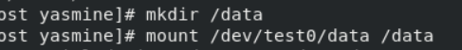

13- Enlarge the LV that you created in Sequence 1 (/dev/test0/data) by using approximately 25
percent of the remaining free space in the test0 volume group. Then, use the ext2online command
to enlarge the filesystem of the LV.
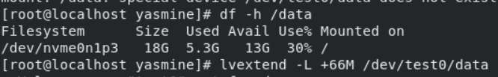

14- Verify that the file /data/bigfile still exists in the LV. Run the df command and check to
verify that more free disk space is now available on the LV.
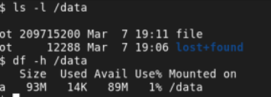

15- Use the remaining extents in the test0 volume group to create a second LV called docs.

16- Run the vgdisplay command to verify that there are no free extents left in the test0 volume group.

17- Create an ext2 filesystem on the new LV, make a mount point called /docs and mount the
docs LV using this mount point.
18- Add all of the remaining unused physical volumes that you created in Sequence 1 to the
test0 volume group.
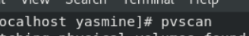

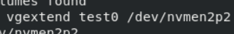

19- If you run vgdisplay again, there now should be free extents (provided by the new physical
volumes) in the test0 volume group. Extend the docs LV and underlying filesystem to make use of
all of the free extents of the test0 volume group. Verify your actions.
Before moving on to the RAID sequence, disassemble your LVM-managed volumes by
taking the following actions:
Remove any /etc/fstab entries you created.
umount /dev/test0/data
lvremove /dev/test0/data
umount /dev/test0/docs
lvremove /dev/test0/docs
vgchange -an test0 (this deactivates the volume group)
vgremove test0 (this deletes the volume group)
20- Run the fdisk command and convert the Linux LVM (0x8e) partitions that were created in
above into Linux raid auto (0xfd) partitions. Save your changes and run the partprobe command
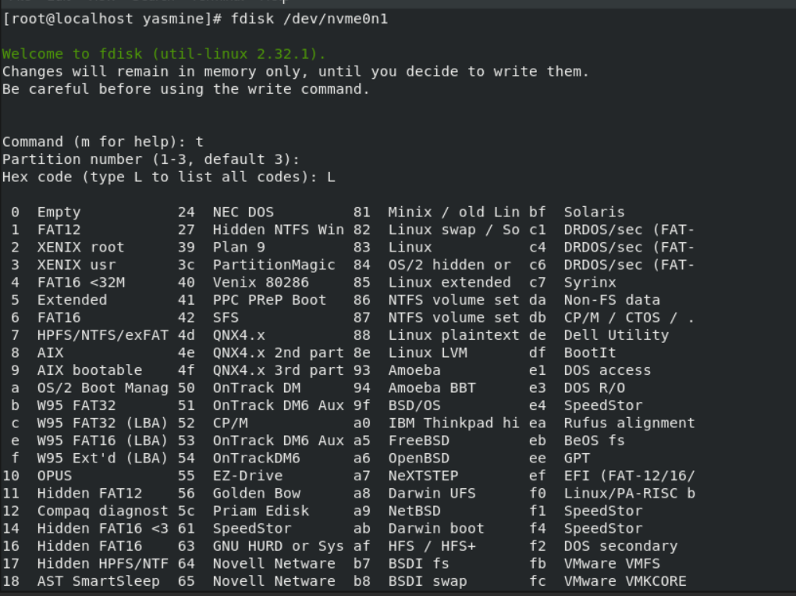
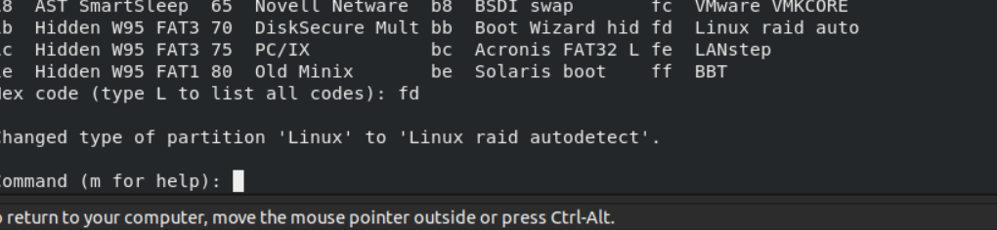

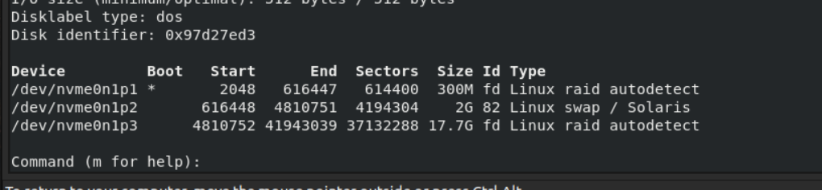
21- Initialize your RAID array (RAID 0)

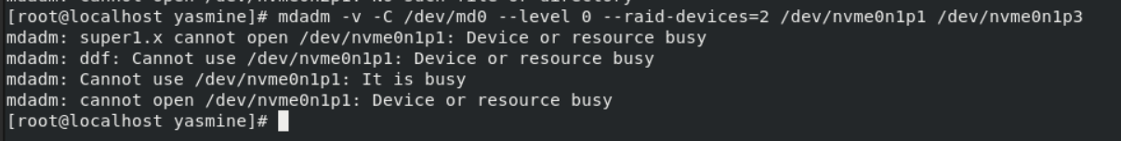
22- Format the RAID device with an ext3 filesystem

23- Use the /data directory as a mount point for the /dev/md0 RAID device. Use the df
command to check the size of the filesystem.

