1. Create a script that asks for user name then send a greeting to him.
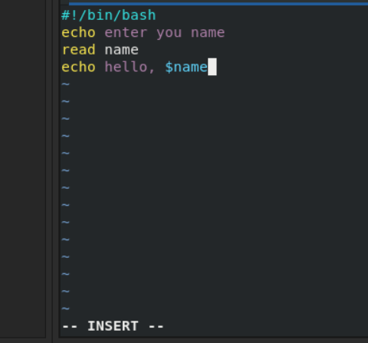

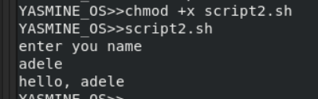

2. Create a script called s1 that calls another script s2 where:
a. In s1 there is a variable called x, it's value 5


b. Try to print the value of x in s2 by two different ways.
Way1:
Pass x as an arg from s1 and echo first arg at s2



way2:
export x in s1
way3 execute s2 as source(in the same shell of s1)

3. Create a script called mycp where:
a. It copies a file to another
b. It copies multiple files to a directory.

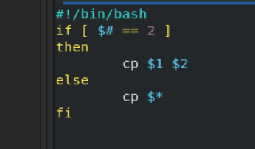

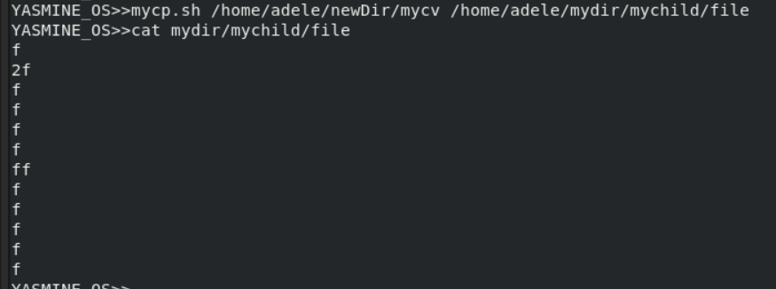
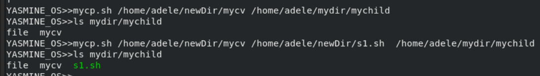

4. Create a script called mycd where:
a. It changed directory to the user home directory, if it is called without arguments.
b. Otherwise, it change directory to the given directory.
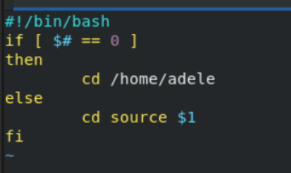

5. Create a script called myls where:
a. It lists the current directory, if it is called without arguments.
b. Otherwise, it lists the given directory.

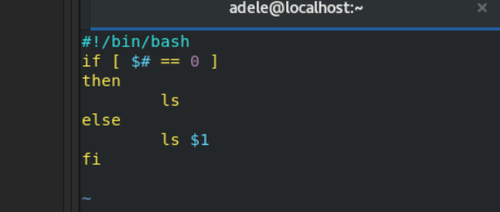
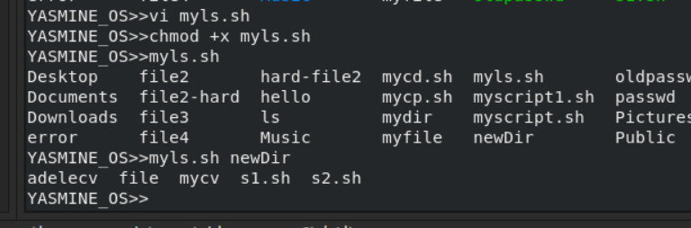

6. Enhance the above script to support the following options individually:
a. –l: list in long format
b. –a: list all entries including the hiding files.
c. –d: if an argument is a directory, list only its name
d. –i: print inode number
e. –R: recursively list subdirectories

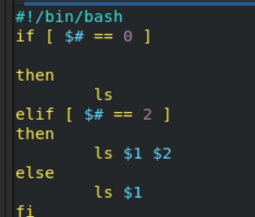

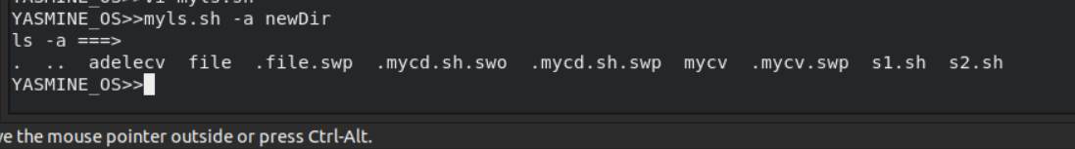
7. Create a script called mytest where:
a. It check the type of the given argument (file/directory)
b. It check the permissions of the given argument (read/write/execute)
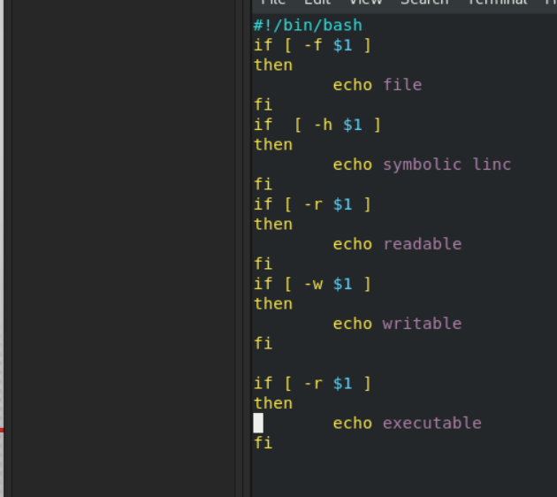

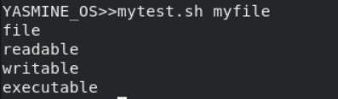

8. Create a script called myinfo where:
a. It asks the user about his/her logname.
b. It print full info about files and directories in his/her home directory
c. Copy his/her files and directories as much as you can in /tmp directory.
d. Gets his current processes status.
-v makes variable defined outside awk accessable in awk
