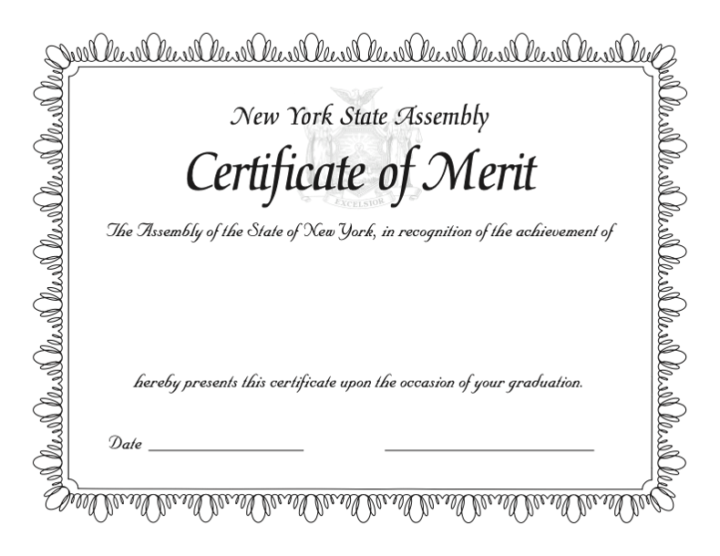

The Assembly of the State of New York, in recognition of the achievement of

First Last

upon being honored by

Myra S. Barnes Intermediate School 24

for having successfully completed the eighth grade,

hereby presents this certificate upon the occasion of your graduation

_____________ __________________

June 25rd 2020

Date