Name: Yasmine Hassan Tewfik Ali - ID 18012078

How to file :

Please don’t forget to open each folder separately as I sent a big folder (CalculatorAssignment) containing 2 folders and the how-to file :

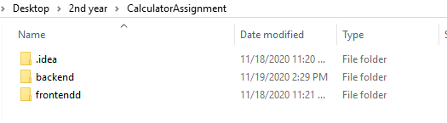

So please run the backend file in a window and the frontend file at another window like that:

(I included my GitHub account where I uploaded the project with a video of me using it as a hint )

<https://github.com/Yasminehassan26/calculater-oop-assignment>

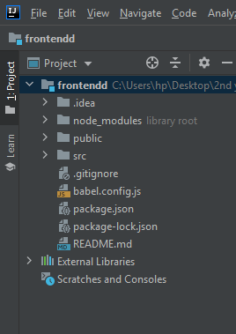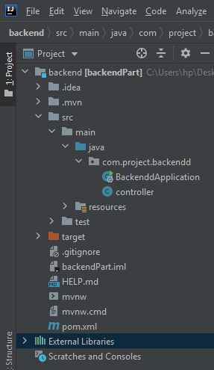

My variables

this.resultDown: is where I show my current number

this.resultUp: is where I show my previous expression

My calculator is the same as the usual windows calculator and if you didn’t try it here are its specifications:

**1-the loop of operating:**

When we enter the first number followed by the operator then w enter the second number we have **2 options**:

**A-** we click the result button then we will get the answer and we could reuse it by entering an operator or enter another input and start from the begin

**B**- we click on another operator then we get the result of the previous expression and evaluate it with the new input

**The loop gets stopped whenever an error is found!**

**2-Errors**:

(division by zero, the inverse of zero, the square root of a negative number2,...)

It shows the character E and stop completing any operations and clear all data and wait for the user to begin again by entering a valid number )

**3-Change sign:**

-zero will remain zero

-the only way to write a negative number is by entering the number then changing its sign

- **we need to click on the equal button so we could change the sign of the last result and use the result again otherwise the result of the previous operation its sign can’t be changed when we press the change button**

**4-percentage**

It divides the number by 100

**5-Hints:**

**A- 5+= is the same as (5+5=10)**

**B- 5+pow()= is the same as (5+25=30)**

**C- in a & b if instead of = we clicked another operator the same happens and we take the result s number one and wait for number 2**

**D-if 2 operators are entered then we last one entered**

