Result :
In this study, our aim was to review the effect of different factors on glucose levels and diabetes. We examined 800 female individuals for their BMI, skin thickness, number of pregnancies, insulin, blood pressure, age, and Diabetes Pedigree Function (DPF), along with the binary outcome of having diabetes or not.
To find the association between glucose levels and the mentioned variables, we applied a normality test for the variables using a QQ plot. Most of the variables did not have a normal distribution. In addition, all the variables contained outlier data, leading us to choose the Spearman test for checking associations.
The results showed a weak correlation for most variables, but at different stages. It is worth noting that biological relationships can be multi-factorial, and we should not expect statistical tests to always reveal all the strong relationships we may predict. The Spearman test indicated that age, blood pressure, and Age had the strongest correlation with glucose levels among the factors analyzed. These correlation differences can be found in Figure 1.
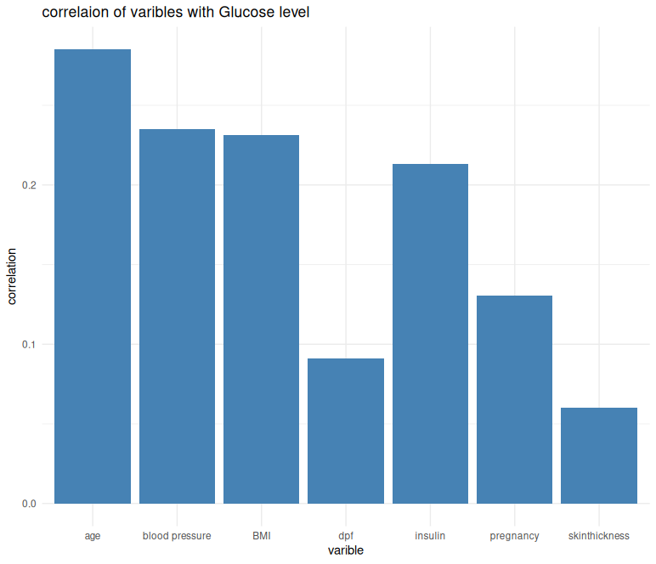

To examine the variables' effect on diabetes in a binary manner (diabetic patients = 1, non-diabetic patients = 0), we used logistic regression as our testing and training model.
The analysis indicated that BMI, age, and Diabetes Pedigree Function were the most significant predictors of diabetes (p-values < 0.01). For instance, BMI had a coefficient of 0.104, indicating that for each unit increase in BMI, the odds of having diabetes increased by 10%. For Diabetes Pedigree Function, with a coefficient of 0.94, the odds of having diabetes increased by 90%, which represents the highest coefficient and highlights the importance of genetic traits in diabetes compared to other factors.
The logistic regression model was successfully trained based on the most effective factors (BMI, age, pregnancies, insulin, and DPF). The model's fit was assessed using the Hosmer-Lemeshow test, which returned a p-value of 0.1456, indicating that the predicted probabilities aligned well with the observed data. Additionally, we tested the model's discriminative ability using the ROC curve, which showed an AUC of 0.85, suggesting a strong ability to distinguish between diabetic and non-diabetic patients.
The final results indicate that BMI and DPF have the most significant effects on diabetes. These findings suggest that managing BMI, with a focus on family health history (genetics), could help prevent diabetes at different stages.
Despite the significant factors identified in this study, the analysis may be limited by the dataset size and the potential for over fitting due to the available features. In-depth research into additional areas, such as diet and physical activities, could lead to more robust predictions.

