Department of Electronic and Telecommunication Engineering
University of Moratuwa

EN 1093 – Laboratory Practice I



Automated Solar Tracker and Battery Charger

Group – 6
180195A - Y.S.Ginige
180200M - K.A.C.N.W.Gunarathna
180205H - H.K.R.L.Gunasekara
180230E - K.Heethanjan

Abstract
Solar energy is fast becoming a very important means of renewable energy source. With solar tracking, it will become possible to generate more energy since the solar panel can maintain a perpendicular profile to the rays of the sun. The objective of this project is to build a solar tracking system which will use solar energy efficiently to charge a battery.
Here, ‘Atmeg32’ microcontroller is used in the controlling circuit and a servo motor is used to rotate the axis. Altium software is used to design the circuit layout while Solidworks software is used to design the enclosure. The microcontroller is programmed using Atmel Studio.

Content

- Introduction

- Method
  - Charging circuit
  - Controller circuit
  - Chassis
  - Approach
  - Logic

- Results

- Discussion

- Introduction
A solar power system is made up of multiple photovoltaic (pv) panels, a DC to AC power converter (called inverter), and a rack system that holds the pv panels in place.
Solar photovoltaic panels are generally fitted on the roof. They are fixed on a particular direction and angle to get maximum exposure but this is a problem as sun travel from east to west. So, we made this prototype to align our panel perpendicular to the sun.

- Method
Main parts of the system
- Charging circuit
- Controller circuit
- Chassis

  - Charging circuit
Here we use a LM317 regulator to regulate the DC voltage and a Zener diode to maintain a constant voltage. The charging circuit is designed considering following aspects
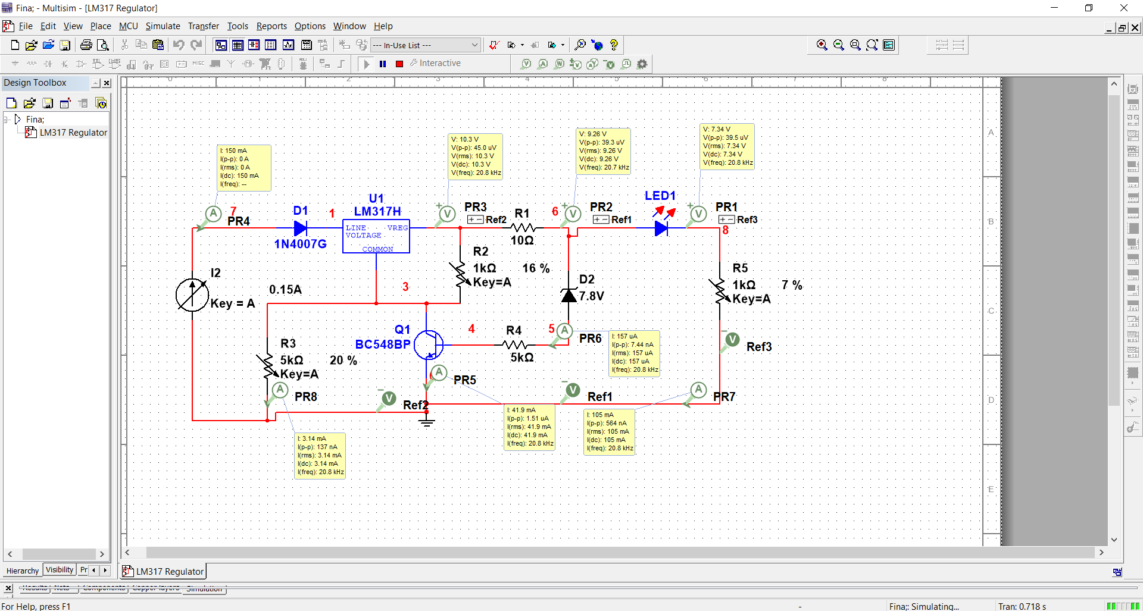
- Over current protection
We have used a BC548 power transistor to avoid the over current situation. This transistor will pass the extra current and avoid over current. The simulation done from the Multisim software is as follows.
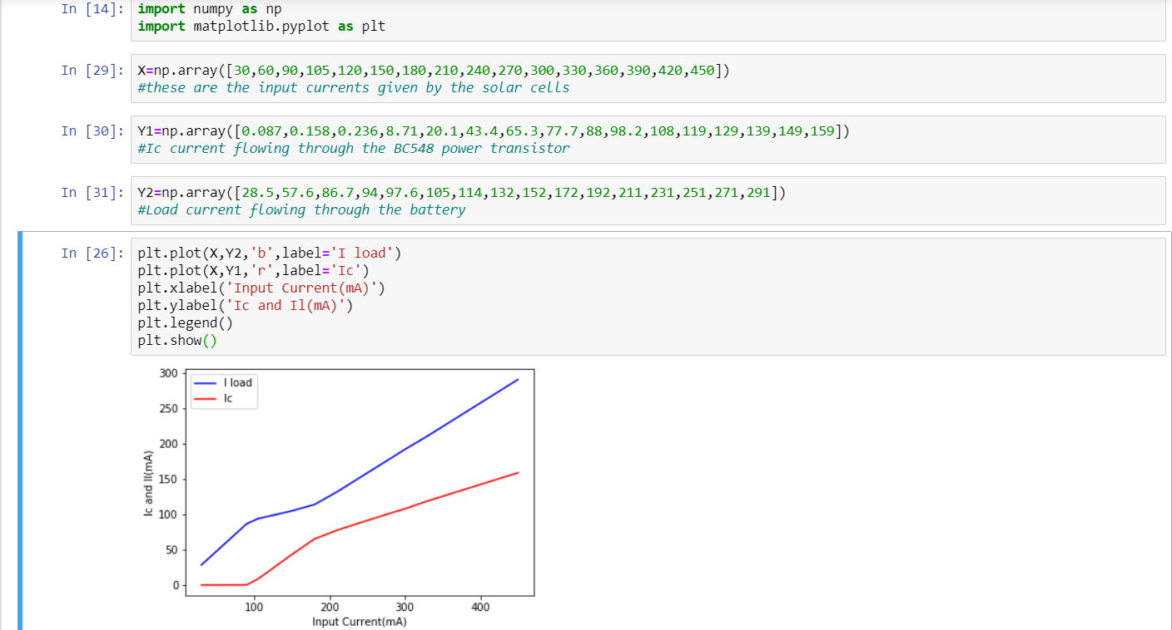
Here I load is the current through the load and the Ic the collector current of the transistor. So the circuit is protected even for a 500 mA input current.

- Back current protection
Back current is prevented by using a LED and diode(D2). So the battery will not gt discharge through the circuit when the input voltage is dropped. (specially in the night)
- Overcharge protection
We have used a zenner diode to get a constant voltage as the output. When the battery is charged up to that voltage, charging process will terminate.

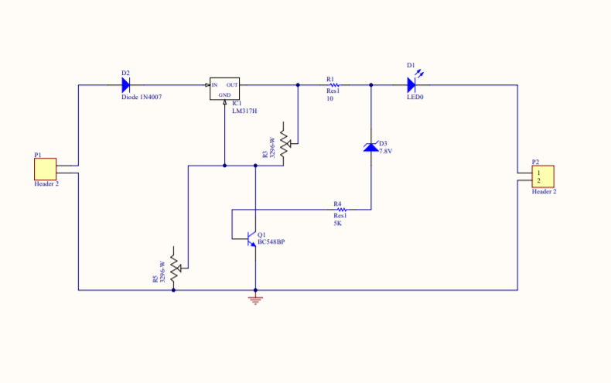

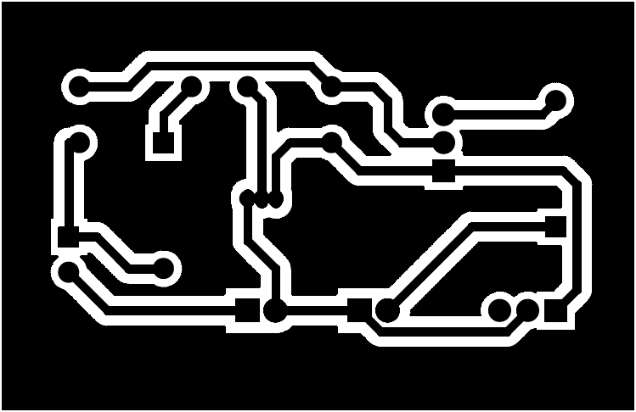

  - Controller circuit
This circuit is used to control the solar panel plane using the output from the 2 LDRs and PWM signal is used to rotate the servo motor.
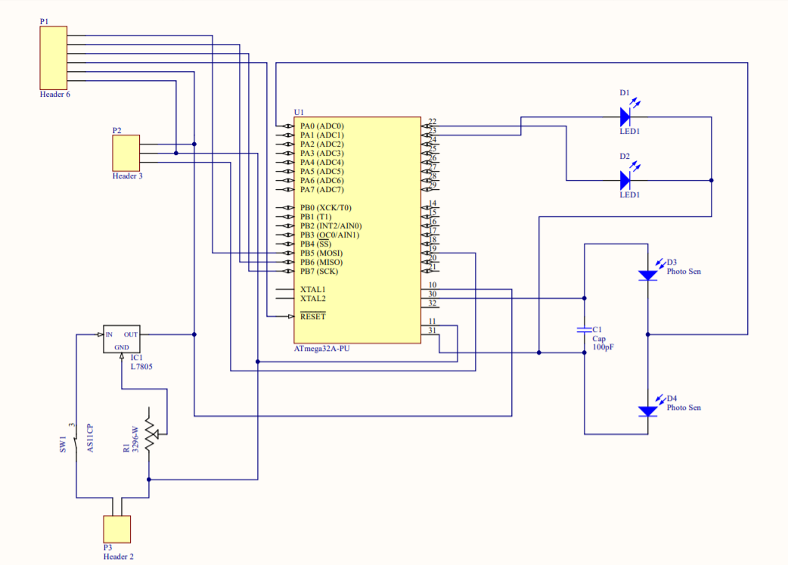

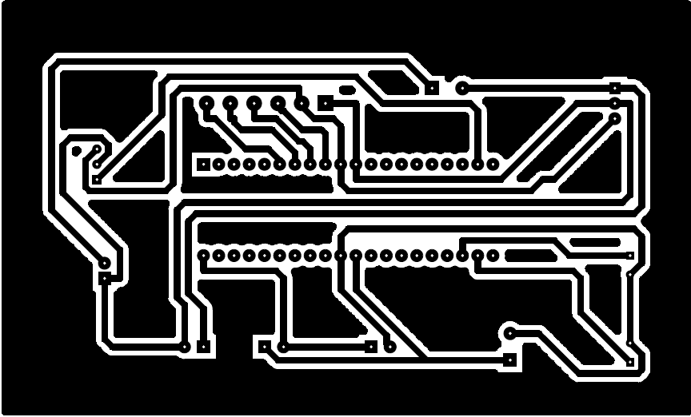

Code
#define F_CPU 12000000UL
#include <avr/io.h>
#include <util/delay.h>
#include <stdlib.h>
int ADC_Reader(char channel){
int Ain,Ainlow;
ADMUX=ADMUX|(channel & 0x0f); /* Set input channel to read */
ADCSRA |= (1<<ADSC); /* Start conversion */
while((ADCSRA&(1< Monitor end of conversion interrupt */
_delay_us(10);
AinLow = (int)ADCL; /* Read lower byte*/
Ain = (int)ADCH256; /* Read higher 2 bits and
Multiply with weight */
Ain = Ain + AinLow; return(Ain); / *Return digital value*/
int main(void)
{ int value;
DDRD|=0xFF;
TCCR1A|=1<<WGM11|1<<COM1A1|1<<COM1A0;
TCCR1B|=1<<WGM12|1<<WGM13|1<<CS10;
ICR1=19999;
DDRC= 0xFF; //makes port c as output
DDRA=0x0; // makes ADC port as input
ADCSRA = 0x87; //Enable ADC, fr 128
ADMUX = 0x40; //Vref:Avcc,ADC channel:0
TCCR1A|= 1<<WGM11|1<<COM1a1|1<<COM1a0;
TCCR1B|=1<<WGM12|1<<WGM13|1<<CS10;
ICR1=19999;
int i = 1500;
OCR1A=ICR1-i; //center position
_delay_ms(100);
while (1)
{value=ADC_Read(0);
PORTC=0x00;
//OCR1A=ICR1-i;
if (value>700 && i<2300){
PORTC=PORTC|(1<<1); //Turns On blue LED
i=i+50;
_delay_ms(10);
OCR1A=ICR-i;
}
else if (value<500 && i<2300){
PORTC=PORTC|(1<<1); //Turns On blue LED
i=i-50;
_delay_ms(10);
OCR1A=ICR-i;
}
else{}
}
}

  - Chassis
Chassis to mount the panels are designed using solidworks and made through laser cutting.

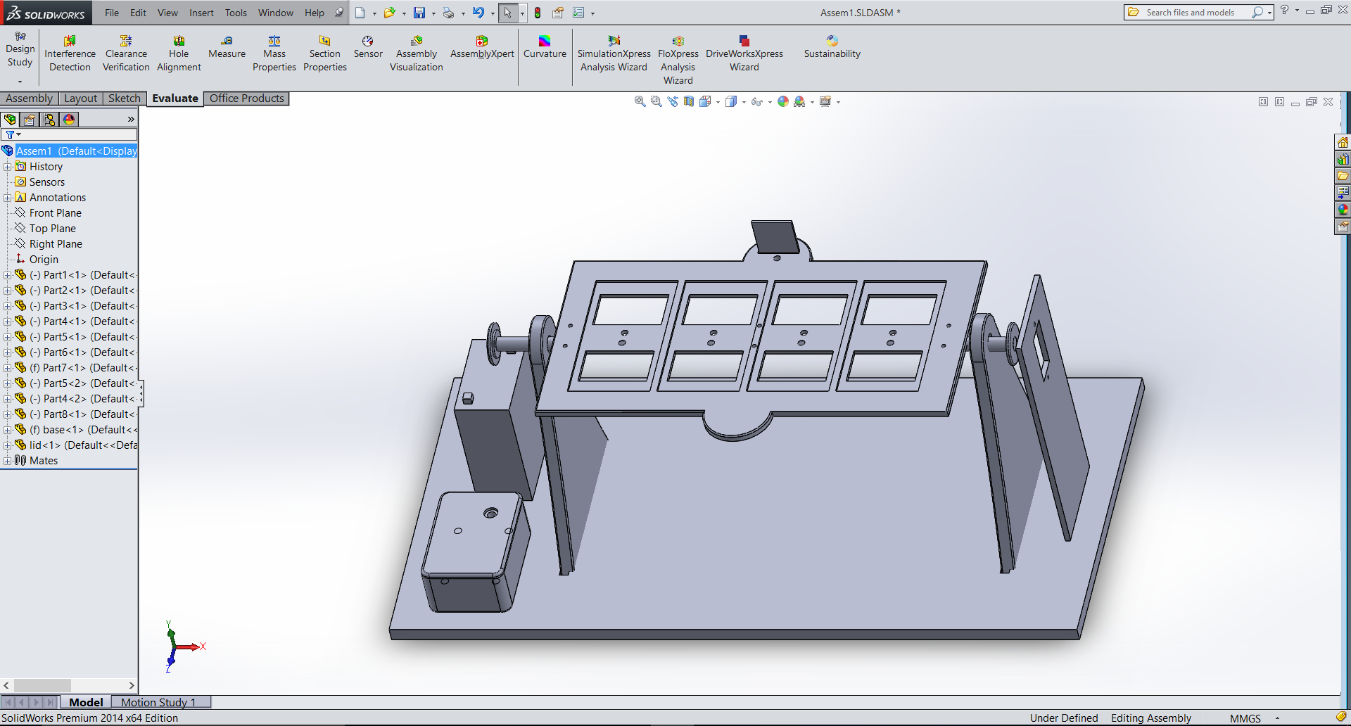

  - Approach

- First, we identified main components that will be needed for the charging circuit
    - Solar panel - two 6.8V/165 mA solar panels are connected in series and such 2 panels are connected in parallel to get a maximum current.

    - Sensors – 2 LDRs are used
This is because they are accurate, and sensitivity is high. We checked this by using an Arduino platform.
(https://www.youtube.com/watch?v=F_asCEInIGk)

    - Battery – lead acid accumulator
- Then the charging circuit was tested on a breadboard.
- Then we had to decide a method to measure the intensity or its change and give an output for the motor to rotate the solar panel.
- Then we decided the mechanism to rotate the panel and designed an efficient enclosure for the solar panel holder.

  - Logic

Start
Switch on?
No
Yes
Turn clockwise by 10 degrees

If V<2.5V and P<120
Yes
No
Turn anticlockwise by 10 degrees

If V>2.5V and P>-120
Yes
No
Stop

- Results

Solar panels successfully moved according to the direction of the light. And we obtained a voltage of 7.5V which we used to charge a lead acid accumulator as well as a mobile phone. The maximum current obtained from the circuit was 220uA.

- Discussion

Our main objective was to design a solar tracker and a battery charger. We had to face many problems while doing this project.
First, we have done brainstorm discussion and set up our sub goals. One thing was to come up with a light weighted enclosure because it is easy to rotate that. So we made a prototype with plywood and check the functionality of that. There were some errors like strength, appearance and the alignment of that prototype. Then we designed a full enclosure by using Solid works and checked the functionality. It was a success.
The second problem we faced was how to design a suitable charging circuit. We have selected 6.8v solar panels and increased the voltage up to 13V by connecting them parallel. Then we decided to select a Led Acid battery because it can be easily charged by using a constant voltage and a low current. Safety is also high. But Li-polymer batteries are flammable, so we didn’t use them. We wanted to have a fast charging circuit. But we couldn’t do that because the amperage was not enough for a fast charging circuit.
Atmega microcontrollers were something new to us. We had to learn from the beginning. But we managed to program the microcontroller correctly. We used Atmega because PIC microcontrollers burn very quickly.
Another problem that occurred was, solar tracker should turns back to its starting point in the morning and it will not happen if both the LDR’s are covered with a shadow of the panel stage. So we drilled a small hole and used Aluminum foil to increase the intensity.
Then we had to face some difficulties while soldering.
Anyhow we made our task possible.

For further details… https://www.youtube.com/watch?v=HLGuOH-ndo8

