EN1053 Introduction to Telecommunication

Yagi-Uda Antenna Assignment

Yasod Sandeepa Ginige

180195A

1.Radiation pattern with driven element, Directors and Reflector

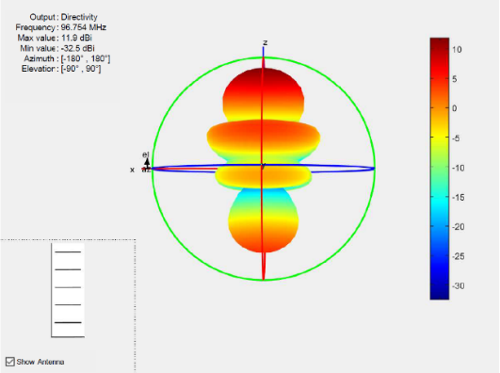

Vertical Pattern Horizontal pattern

Radiation pattern moves towards the directors because reflector pushes the radiation and directors grab those radiation.

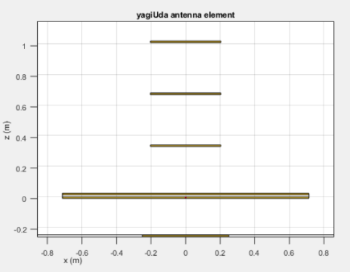2. Radiation pattern only with the Driven element.

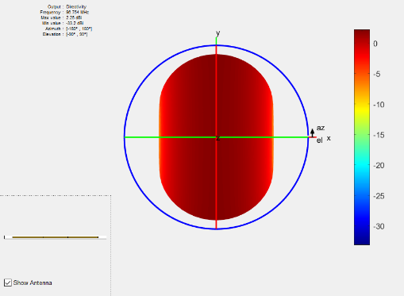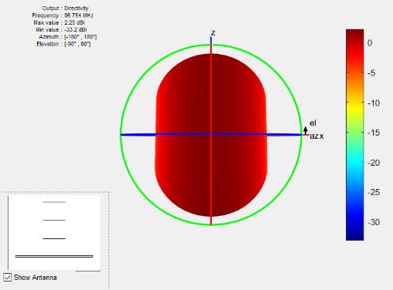

Vertical Pattern Horizontal Pattern

When there is no reflector and Directors, the radiation pattern gets a symmetrical shape.

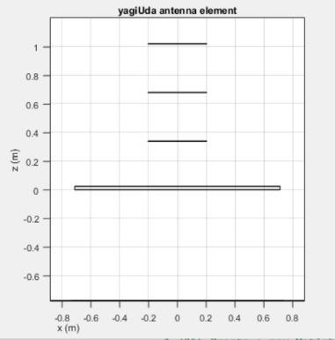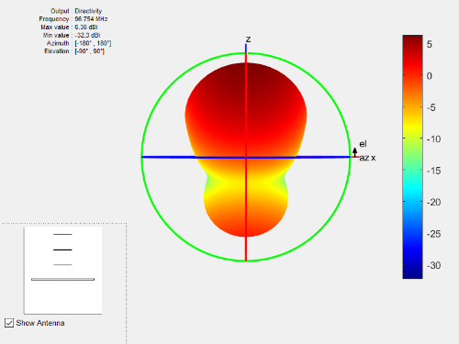3. Radiation Pattern with Driven element and the Reflector

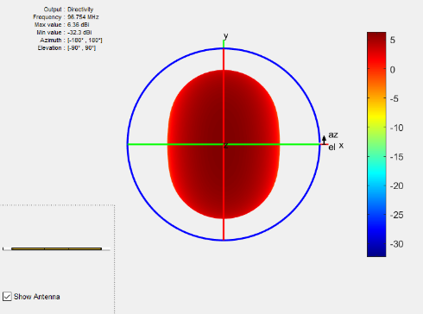 Vertical Pattern Horizontal Pattern

When a reflector is added to the antenna, the radiation moves to the other side from the driven element because it pushes the radiation.

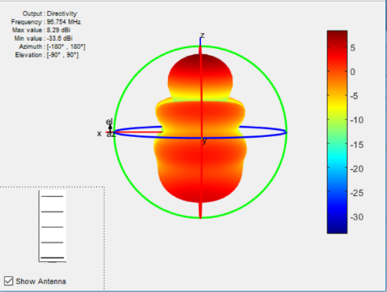4.Radiation Pattern with Driven element and Directors

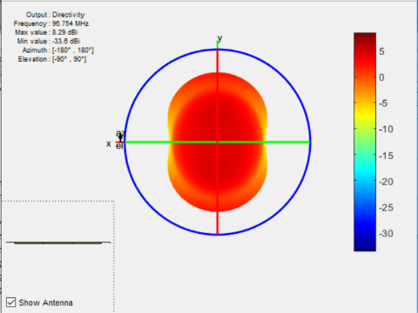

Vertical Pattern Horizontal Pattern

When we add directors, the radiation intensity of that area get increased.

**Effect by the Directors**

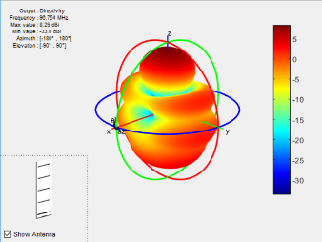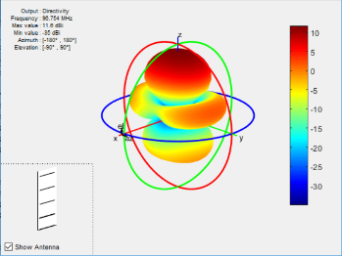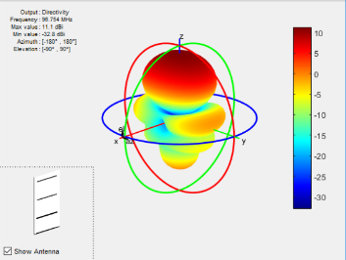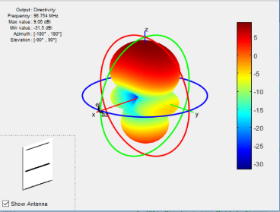

With 1 Director With 2 Directors With 3 Directors With 4 Directors

|  |  |  |
| --- | --- | --- |
| Num. of Directors | Min Val (dBi) | Max Val (dBi) |
| 4 | -32.5 | 11.9 |
| 3 | -35 | 11.6 |
| 2 | -32.8 | 11.1 |
| 1 | -31.5 | 9.06 |

When the number of directors increased, the radiation level gets high. We can see a radiation increasing at the reflector’s side when we do this.

Maximum and the minimum level of Output Directivity also varies as mentioned in the above graph.