Functional Requirement Specification
Sampath Access Portal (FAP)
Modernization Target — Node.js-Based Frontend Redesign
DRAFT / SAMPLE FOR REVIEW
Document No.: sampath_fap_frs_v04
Version: 0.4 (Sample)
Date: 01-Sep-2026

Document Control

Revision History
Version | Date | Author | Description
0.1 | 01-Sep-2026 | Claude (for Yasothar, N-able Agility) | Initial sample FRS generated from legacy source code review and the Reference Screenshots.docx walkthrough. For discussion — pending SME/BA input.
0.2 | 01-Sep-2026 | Claude (for Yasothar, N-able Agility) | Wireframes redesigned for a modern Node.js-based frontend (component/SPA UI, dashboard, cards, modern data grids) instead of mirroring the legacy JSP screen layouts. Added a proposed modern technology stack section. Functional scope, field lists and business rules are unchanged from v0.1 — only presentation/interaction design and the technology section were updated.
0.3 | 01-Sep-2026 | Claude (for Yasothar, N-able Agility) | Dashboard toned down after review: the illustrative KPI cards (Accounts Viewed, Reports Generated, Pending Authorisations) were removed from the wireframe because they cannot be populated from data the current system captures. Replaced with a welcome/context banner, Quick Actions and Profile — all derivable on day one from the existing login response. Added a new §4.2.1 explaining the data-sourcing/schema impact of each removed metric, and corresponding open items in §6.
0.4 | 01-Sep-2026 | Claude (for Yasothar, N-able Agility) | Corrected two factual errors found on a full re-check against the legacy source: (1) the Account History maximum date-range check is written in the legacy code but the call that enforces it is commented out, so no limit is actually applied today; (2) the legacy Txn Particulars/Txn Remarks fields are ordinary visible, editable text fields on the teller screen, not hidden — the "defaults to 099" fallback only fires if the parameter is absent from the request entirely, which the web form never does. Both are now described as current-state facts with the redesign decision framed honestly as a proposed change. See §4.4, §4.7 and the updated §6 items.

Sources Used
- Reference Screenshots.docx — 7 screenshots of an FAP application walkthrough (Account Details, Account History, Net Worth Inquiry, Reports, and a generated statement PDF).
- Legacy source code: finacle-access-portal-main (FAP / FAPEJB / UPMLatestEJB — IBM RAD/WebSphere EJB 2.x + JSP/Servlet project) provided in build_iterations/it02.
- Key files reviewed: JSPs under FAPWeb/WebContent/pages/**, action servlets under FAPWeb/JavaSource/sampath/fap/web/actions/**, and EJB data/session beans under FAPEJB/ejbModule/sampath/fap/ejb/**.

What Changed in v0.2
- The legacy JSP screens used a left side-menu-plus-postback-table pattern, unconditional-postback forms, and pop-up-window printing — these were carried over literally into the v0.1 wireframes. v0.2 replaces them with a modern, componentized web-app pattern intended for a Node.js-based frontend (e.g. React/Next.js) talking to a Node.js API layer.
- Every wireframe was redrawn: a persistent icon sidebar + top bar replaces the legacy plain-text menu; a new role-aware Dashboard (KPI cards + quick actions) replaces the plain "Home" welcome text; search screens use segmented controls and inline result grids instead of full-page postbacks; detail drill-downs (Account Balance, Transaction Detail) are framed as panels/cards rather than another full page reload; status values render as colour-coded badges; "Print" actions become "Export/Download PDF".
- The underlying functional requirements — fields, validations, business rules, and data objects documented in §4 and §5 — are unchanged from v0.1; they remain the authoritative source of "what the system must do". This revision only changes how that functionality is proposed to be presented and interacted with.

What Changed in v0.3
- The v0.2 Dashboard included four illustrative KPI cards (Accounts Viewed Today, Reports Generated, Pending Authorisations, Session Time Left). On review, three of these cannot actually be populated by the current system: the legacy application never logs read-only inquiries or report generations anywhere, and "Pending Authorisations" implied an asynchronous approval queue that does not exist — today's supervisor override happens synchronously within the same transaction request, not as a queued item picked up later.
- The Dashboard wireframe (§4.2) was toned down accordingly: the KPI row was removed and replaced with a welcome/context banner (name, branch, role, session countdown — all already returned by the login response), the same Quick Actions and Profile panels as before, and an explicit callout stating that activity metrics are a later-phase idea requiring new audit logging.
- A new §4.2.1 sets out, per metric, exactly what new logging/schema/process work each one would require if the business decides to pursue it later, and corresponding items were added to §6 Assumptions & Open Items.

What Changed in v0.4
- Account History date-range validation: earlier drafts described a maximum-days rule "same as legacy ParamValidator.validateDateRange" as an active constraint. Re-checking ACOptionsAction.getFullStmt() in the legacy source shows the validateDateRange() call is commented out — the configured STMT_PERIOD value is read but never actually enforced. §4.4 now describes this as the current (unenforced) state, with a new §6 item asking the business whether the new build should (re)introduce the limit.
- Txn Particulars / Txn Remarks fields: earlier drafts described the legacy Txn Particulars field as "currently... hidden" and defaulted server-side to "099". The legacy txnHome.jsp shows both fields as ordinary visible, editable text inputs — nothing is hidden today. The "099" fallback in TxnParamSetter only applies if the form parameter is missing from the request entirely, which a normal browser submission never does (an empty field still submits an empty string). §4.7 and §6 now describe the proposed single "Remarks" field as a genuine UX simplification being proposed for the new build, not a continuation of existing behaviour.
- These corrections do not change any wireframe image — the Node.js wireframes already showed a single, visible "Remarks" field, which turns out to match the proposed (not legacy) design intent once the text is corrected.

Important Note on This Draft
The functional content of this document was produced by reading the legacy JSP screens and the corresponding Java/EJB source code directly (field names, dropdown values, validation rules, and data objects were taken from the code, not guessed). The wireframes in this v0.4 are conceptual, modern re-imaginings of those same screens for a Node.js-based frontend — they are illustrative UI/UX proposals, not pixel-accurate designs, and should be validated with the business/UX team and refined in a proper design tool (Figma, etc.) before development. Sections marked "Assumption" or "To be confirmed" should be verified against the live Finacle-connected environment and the business team before this FRS is baselined.

Table of Contents

1. Introduction

1.1 Purpose
This Functional Requirement Specification (FRS) documents the observed functionality of the Sampath Access Portal (FAP) — a legacy internal banking application used to look up account information, statements and consolidated customer net worth, run transaction reports, and (for teller-class users) post simple over-the-counter transactions against accounts held in the Finacle core banking system. The purpose of this document is to give the modernization project a clear, code-verified baseline of "what the current system does" before any redesign or re-platforming decisions are made.

1.2 Scope
This draft covers the modules visible in the reference screenshots and confirmed in source: user authentication, the main navigation menu, Account Details (search + balance inquiry + signature retrieval), Account History (mini/full statement + printable statement), Net Worth Inquiry, Reports (transaction search + drill-down), and the Front Office Teller transaction screen. It does not yet cover PIN reset, help content, or any Finacle screens outside FAP itself — these exist as stubs or references in the code but were out of scope for this pass.

1.3 Intended Audience
Business analysts and SMEs validating current-state behaviour, the modernization delivery team (architects, developers, QA) designing the replacement system, and project stakeholders (N-able Agility / Sampath Bank) tracking scope.

1.4 References
Ref | Document / Artifact
R1 | Reference Screenshots.docx (application walkthrough, 7 screens)
R2 | finacle-access-portal-main source code — FAP (EAR), FAPWeb (WAR/JSP), FAPEJB (EJB 2.x), UPMLatestEJB (User Profile Management EJB)

2. System Overview

2.1 Architecture Summary
FAP is a classic J2EE application built on IBM WebSphere / Rational Application Developer: JSP + Servlet front end (FAPWeb) backed by stateless Session EJBs (FAPEJB) running under EJB 2.x. It does not hold banking data itself — every inquiry and transaction is relayed to the Finacle core banking system via a FinacleManager EJB, and to a separate internal staff-directory system ("UPM" — User Profile Management, via UPMLatestEJB) for login and officer/branch details. A single front-controller servlet (ActionController) dispatches every button/link action (encoded as an "Action.<Module>.<Operation>" request parameter, e.g. Action.ACOptions.GetACList) to one of five module action servlets.
Component | Responsibility
ActionController | Front controller — parses the posted "Action.*" parameter and routes to the matching module action servlet.
LoginAction | Authenticates against UPM (User Profile Management) by numeric User Id + Password; enforces a single active session per user; loads Security Class, branch (SOL) and officer name into session.
ACOptionsAction | Account Details search, Account Balance Inquiry, signature retrieval, Account History (statement) search and print.
CustOptionsAction | Net Worth Inquiry.
ReportsAction | Transaction Reports search, result list, and drill-down to transaction detail.
TxnAction | Front Office Teller transactions (cash deposit / cash withdrawal / account transfer) with supervisor override.
FinacleManagerBean (EJB) | Session bean that calls into Finacle core banking for account, balance, statement, net-worth and signature data.
FAPReportsManagerBean / FAPTransactionManagerBean (EJB) | Persist and query the local transaction/report and event log tables.
UPM (external EJB) | Bank-wide staff/officer directory — authenticates users and supplies Security Class, branch and designation.

2.2 Role-Based Navigation (Security Class)
The side menu is rendered conditionally in sideMenu.jspf based on the logged-in officer's Security Class (returned by UPM at login). The exact class-to-permission mapping should be confirmed with the business owner, but the code shows the following pattern:
Menu Item | Visible When
Home | Always (any authenticated user)
Account Details | Security Class = "20", OR numeric class ≥ 30
Account History | Always (any authenticated user) — currently unconditional in code
Transactions | Numeric class = 30 (teller role)
Net Worth Inquiry | Security Class = "20"
Reports | Security Class = "20", OR numeric class ≥ 30
Logout | Always

Assumption / To be confirmed: the meaning of each Security Class code (e.g. "20" vs "30") in business terms (Branch Officer vs Teller vs Supervisor, etc.) should be confirmed with Sampath Bank's user-access/BA team.

2.3 Session & Non-Functional Notes
- Session timeout: 15 minutes (web.xml session-config).
- Single active session per User Id — logging in again invalidates any other active session for that same user (LoginAction.setUserSession).
- Legacy character encoding: pages are served as ISO-8859-1.
- Printable outputs (Account Balance, Account History / Statement) are rendered as a separate pop-up window and produced as PDF for printing (uses iText 2.1.7).
- Tabular result sets (Account Details search, Account History, Reports) use the displaytag library — sortable, paginated HTML tables.
- Customer/account signature images on file in Finacle are retrieved as Base64-encoded PNG/TIFF and rendered client-side (including a TIFF-to-canvas conversion for non-IE browsers).

2.4 Proposed Modern Technology Stack (Node.js)
The wireframes in Section 4 assume the legacy JSP/Servlet/EJB front end is replaced with a Node.js-based stack. This is a starting proposal for discussion, not a locked architecture decision — it should be reviewed against Sampath Bank's platform standards, security policy, and existing Finacle integration options.
Layer | Proposed Technology | Notes
Frontend | React or Next.js (TypeScript) single-page application, component library (e.g. Tailwind CSS / MUI / Chakra UI) | Replaces the JSP pages. Client-side routing between Dashboard, Account Details, Account History, Net Worth, Reports, Transactions; component-based screens instead of monolithic JSPs; reusable components for the data grid, filter panel, and stat cards used throughout.
Backend-for-Frontend / API layer | Node.js with Express or NestJS, exposing versioned REST (or GraphQL) endpoints | Replaces ActionController and the module Action servlets. One resource-oriented endpoint per capability, e.g. GET /api/accounts?search=&type=, GET /api/accounts/:id/balance, GET /api/accounts/:id/history, GET /api/networth/:custId, GET /api/reports, POST /api/transactions.
Authentication & Session | JWT (or OAuth2/OIDC) issued after credential check; stateless API sessions; short-lived access token + refresh token; server-side session store (e.g. Redis) only if a single-active-session-per-user rule must be enforced centrally | Replaces UPM-driven HttpSession state. The existing UPM signOn/signOff call would sit behind the Node.js auth endpoint as the credential-verification step, preserving current authentication rules while modernizing session handling.
Core banking integration | A dedicated Node.js integration/adapter service (or reuse of the existing FinacleManager EJB behind an internal API) for Finacle calls; similarly for UPM | Keeps Finacle/UPM protocol details out of the new frontend-facing API; allows the legacy EJB tier to be strangled out incrementally rather than replaced in one step.
Data & caching | Redis or in-memory cache for short-lived reference data (dropdown lists, branch/SOL lists); the transaction/report log store (currently FAPTransactionManagerBean/EventLogManagerBean) migrated to a relational store (e.g. PostgreSQL) accessed via an ORM (Prisma/TypeORM) | Supports the Reports and Transactions modules' local persistence needs.
Cross-cutting | Centralized structured logging, input validation (e.g. Zod/Joi) mirroring ParamValidator's rules, role-based route guards replacing the Security-Class checks in sideMenu.jspf, automated tests (Jest/Playwright) | Preserves the existing validation rules (AC No./NIC/Customer Id formats, date-range limits) as shared, testable validation schemas instead of scattered JSP/servlet code.

Assumption / To be confirmed: whether the migration is a full rewrite of the EJB tier or a "strangler" approach that keeps FinacleManagerBean/UPM integration as-is behind a thin Node.js API gateway should be a joint architecture decision with Sampath Bank's core banking and infrastructure teams before implementation begins.

3. Functional Modules — Summary
The application exposes the following main functions, each reachable from the left-hand navigation menu:
# | Function | One-line Description
1 | Login | Authenticate via User Id + Password against UPM.
2 | Dashboard | Landing page after login; shows user/branch context, KPI summary and quick actions.
3 | Account Details | Search accounts by AC Number / Customer Id / NIC / Passport Number; drill into balance, limits, and signature.
4 | Account History | Statement of transactions for an account over a date range; printable.
5 | Net Worth Inquiry | Consolidated balance view (Lien / Reserved / Available) across all accounts of a customer.
6 | Reports | Multi-criteria transaction search across SOL, status, dates, users, accounts, amounts, currency; drill into transaction detail.
7 | Transactions | Front-office teller postings: Cash Deposit, Cash Withdrawal, Account Transfer, with supervisor authorisation for staff accounts / over-limit amounts.
8 | Logout | Ends the session and signs off from UPM.

4. Detailed Functional Requirements

4.1 Login
Authenticates a bank officer against the UPM (User Profile Management) directory before granting access to FAP. Presented as a centered, single-purpose sign-in card rather than a full legacy page.
Attribute | Value
Actors / Roles | All FAP users (branch officers, tellers, supervisors)
Entry Point | POST /api/auth/login (Node.js API) — SPA route "/login", presented before any other screen

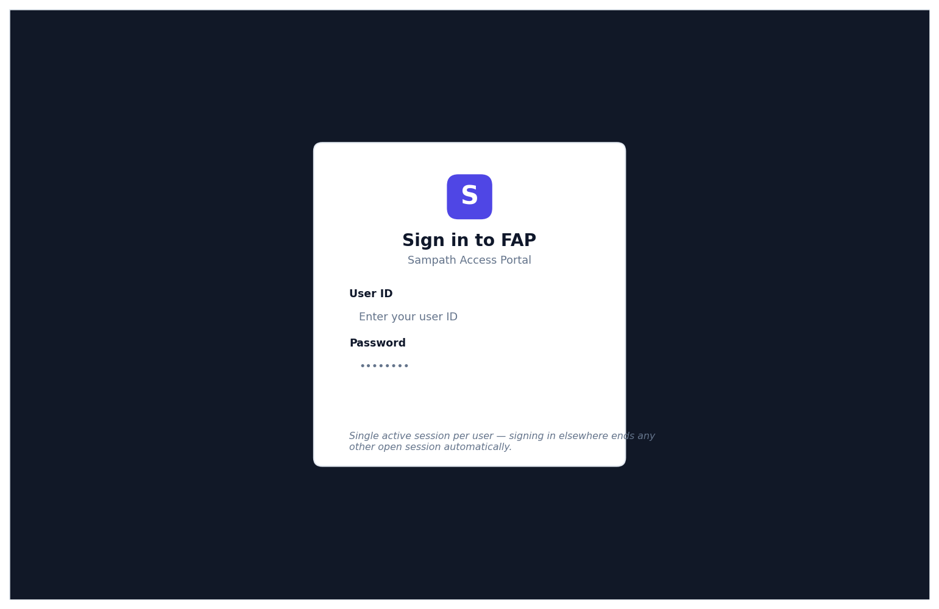
Figure 4.1: Login – wireframe

Input / Search Criteria
Field | Type / Format | Source (dropdown values / rules) | Mandatory
User Id | Numeric string | Required; must parse as a positive long integer | Yes
Password | Masked text | Passed as-is to the credential-verification step | Yes

Business Rules & Processing Logic
- On submit, the API first invalidates any stale session/token for the given user, then verifies credentials against UPM (User Profile Management) — the same UPM signOff()/signOn() sequence as today, called from the Node.js auth endpoint instead of directly from a servlet.
- A successful verification returns a signed JWT (access + refresh token) instead of a server-side HttpSession; the token carries the officer's role/permission claims used to drive the frontend's route guards and sidebar.
- On success, the officer's First Name, Last Name, Designation, SOL (branch) description + SOL Id, and role/permission set are returned to the SPA and used to render the Dashboard and sidebar.
- If the same User Id already has an active session elsewhere, that older session/token is invalidated (single-session-per-user policy is preserved).

Validation & Error Handling
- Non-numeric or empty User Id → inline field error "Invalid User Id" (client-side validation before submit, mirrored server-side).
- UPM sign-on failure (bad password, locked officer, etc.) → the specific UPM return-code message is shown as a toast/inline alert on the sign-in card.
- Any unexpected exception → generic "Login failed. Please try again." toast.

4.2 Dashboard (formerly "Home")
Landing page shown immediately after a successful login; establishes user/branch context and surfaces one-click quick actions into the other modules — replacing the legacy plain-text welcome page. Deliberately scoped to information the login response already provides, so it needs no new backend work to build as described here (see §4.2.1 for metrics considered and deferred).
Attribute | Value
Actors / Roles | All authenticated users
Entry Point | SPA route "/dashboard" — rendered entirely from the data already returned by POST /api/auth/login, no additional endpoint required

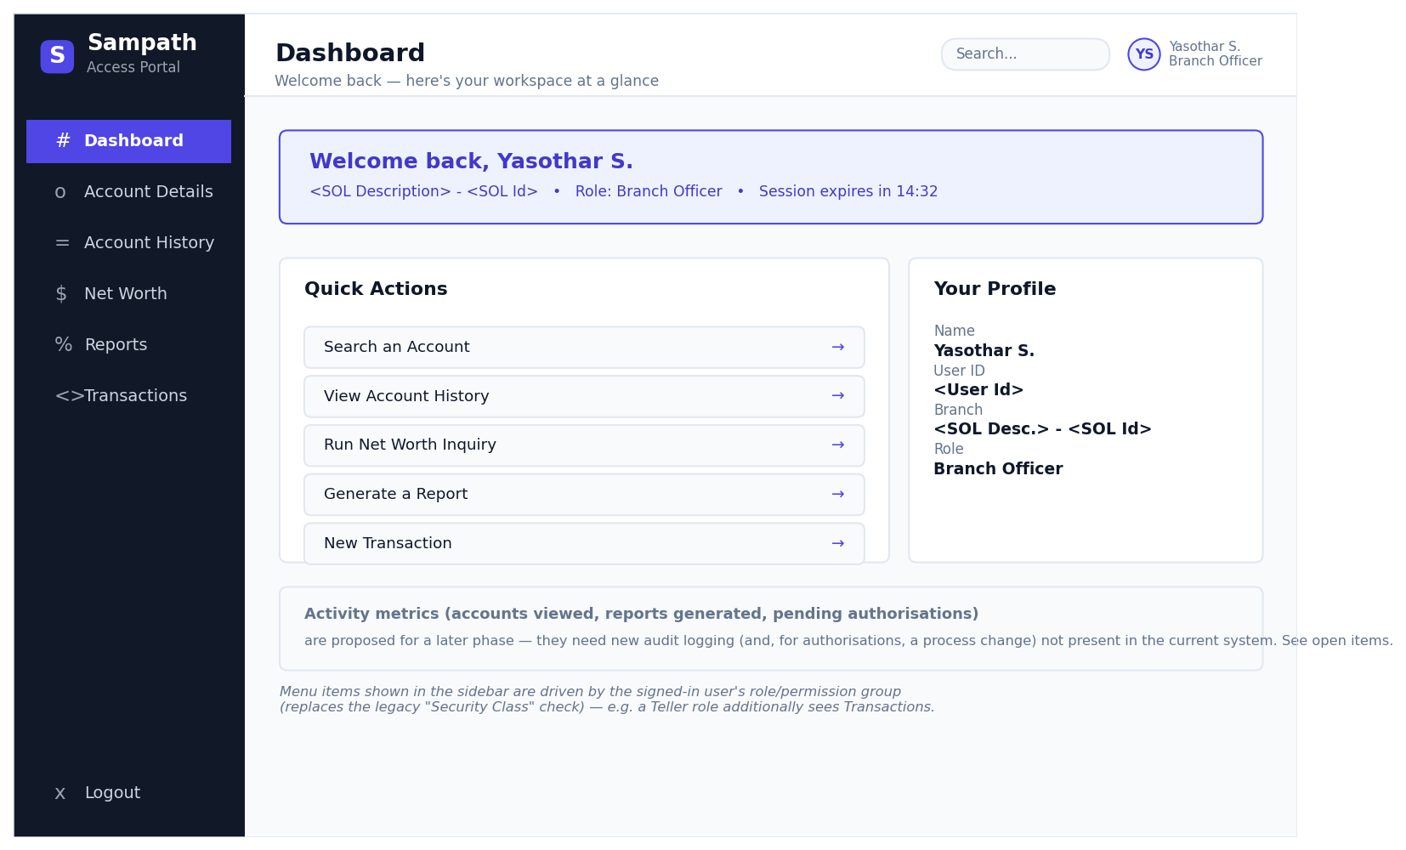
Figure 4.2: Dashboard (formerly "Home") – wireframe

Output / Data Displayed
Field | Description
User Name / User Id | Officer's name and id from UPM, shown in the top bar and welcome banner
Branch (SOL) | SOL description + SOL Id from UPM
Role / Permission Group | Drives which sidebar items are visible (see §2.2) — modern equivalent of Security Class
Session countdown | Derived client-side from the JWT/session expiry (same 15-minute timeout as today)
Quick Actions | One-click shortcuts into Account Details, Account History, Net Worth Inquiry, Reports and New Transaction

4.2.1 Activity Metrics — Considered and Deferred
An earlier draft of this Dashboard (v0.2) included KPI cards for "Accounts Viewed Today", "Reports Generated", and "Pending Authorisations", alongside the session countdown. On review against the legacy source code, three of the four turned out not to be backed by anything the current system captures. They are recorded here, with what each would actually require, so the decision to build them (or not) can be made deliberately rather than by default.
Metric | Available Today? | What It Would Require
Session Time Left | Yes — built into the v0.3 Dashboard | None — computed client-side from the existing session/JWT expiry. No backend or schema change.
Accounts Viewed Today | No | The legacy application does not log read-only inquiries anywhere (EventLogManagerBean is oriented around transactions, not views). Would need a new audit/activity-log table (user, account, screen, timestamp) and a new logging call added at every inquiry entry point (Account Details, Account History, Net Worth Inquiry), then an aggregation query per user/day.
Reports Generated | No | Same gap as above — the Reports screen never persists "a report was run" as an event today. Needs the same kind of new audit-log entry, written each time a report is generated, plus an aggregation query.
Pending Authorisations | No — and not just a logging gap | This one implies an asynchronous maker-checker queue that does not exist in the current process: today, a STAFF/LIMIT transaction is authorised by a supervisor synchronously, in the same request, before the teller moves on — there is no transaction sitting in a "pending" state for someone to act on later. Showing this metric honestly would require a business-process change (an async approval queue) and a new table (e.g. pending_transactions with a status column), not just a UI or logging addition.

Recommendation: ship the Dashboard as scoped in §4.2 (no new backend work) for the initial release. If the business wants the deferred metrics, raise them as separate, explicitly-scoped requirements — the first two as an audit-logging feature, the third as a maker-checker workflow change — each with its own schema design and sign-off, rather than folding them into this modernization pass unannounced.

4.3 Account Details
Lets a user look up one or more accounts by account number or by the owning customer's identifiers, then drill into a single account's balance/limit detail and, if available, the specimen signature held on file.
Attribute | Value
Actors / Roles | Users with Security Class = 20 or numeric class ≥ 30 (role name to be confirmed under the new permission model)
Menu Access | Sidebar → "Account Details"
Entry Point | GET /api/accounts?type=&value= — SPA route "/accounts"

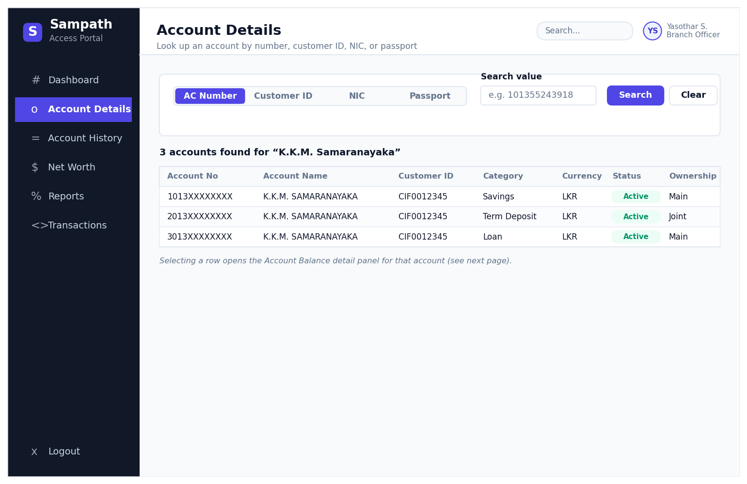
Figure 4.3: Account Details – wireframe

Input / Search Criteria
Field | Type / Format | Source (dropdown values / rules) | Mandatory
Search By (value) | Free text, max length 12 | Interpreted per the adjacent dropdown selection | Yes
Search Type (dropdown) | Single-select | AC Number (0) / Customer Id (1) / NIC (2) / Passport Number (3) | Yes

Business Rules & Processing Logic
- The API performs the search; results are shown in a modern data grid (client-side sortable columns, search-as-you-type on the value field, paginated) below the criteria — no full-page postback.
- AC Number search validates the value as numeric and exactly 12 digits (same rule as legacy ParamValidator.validateAC, enforced both client-side and server-side).
- Customer Id search validates the value as numeric and at least 9 digits (same rule as legacy ParamValidator.validateCustId).
- NIC search accepts either the old 10-character format (9 digits + "V"/"X") or the new 12-digit format (same rule as legacy ParamValidator.validateNIC).
- Passport Number is passed through without the numeric validations above.
- Selecting a result row opens the Account Balance detail view for that specific account (a dedicated panel/route rather than a full page reload).

Output / Data Displayed
Field | Description
Account Number / Account Name | From Finacle, via the account-search endpoint
Customer Id | Owning customer's CIF/customer id
AC Category (Scheme Type) | e.g. Savings, Current, Term Deposit (TDA), Loan (LAA)
Currency | Account currency code
Status | Account status returned by Finacle, shown as a colour-coded badge
Ownership | "Main" or "Joint", derived from the Finacle record type flag

Validation & Error Handling
- No matches / invalid search value → inline empty-state message in the results grid, plus a field-level or toast error describing why (e.g. "NIC format not recognised").

4.3.1 Account Details → Balance Inquiry (drill-down)
Detail view reached by selecting an account row in Account Details; shows balance, limit and (for term deposits) maturity/interest information for the selected account as a set of stat cards and an information panel, plus the option to view the Finacle specimen signature and download a statement PDF.
Attribute | Value
Entry Point | GET /api/accounts/:accountId/balance — SPA route "/accounts/:accountId"

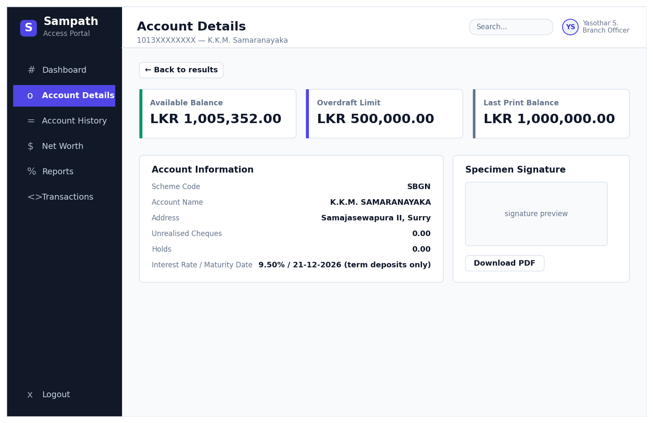
Figure 4.3.1: Account Details → Balance Inquiry (drill-down) – wireframe

Business Rules & Processing Logic
- The primary balance card label and the Overdraft/Loan-Amount label change depending on the account's Scheme Type: "Loan outstanding" + "Loan Amount" for Loans (LAA); "Cur Deposit Value" for Term Deposits (TDA); "Balance with Chq. Dep." otherwise.
- Interest Rate and Maturity Date rows are shown only for Term Deposit (TDA) accounts.
- Unrealised Cheques row is hidden for Loan and Term Deposit accounts.
- Holds row is hidden for Loan accounts.
- The signature panel fetches the Finacle specimen signature; if present it is rendered as an image (PNG/JPEG/TIFF handled server-side or via a modern image library, avoiding the legacy client-side TIFF-to-canvas conversion). If none is on file, an empty-state message is shown instead.
- "Download PDF" generates the same statement content as a downloadable file, replacing the legacy print pop-up window.

Output / Data Displayed
Field | Description
Account Number, Scheme Code, Account Name, Address | From DataAcDetails
Balance with Chq. Dep. / Loan Outstanding / Cur Deposit Value | Sum of Clear Balance + Unrealised Cheques (DataAcBal)
Overdraft Limit / Loan Amount | DataAcBal.odLimit
Interest Rate, Maturity Date (Term Deposits only) | DataAcDetails
Last Print Balance | DataAcBal.lastPrintBal
Unrealised Cheques, Holds | DataAcBal
Available Balance / Principal Amount Settled | DataAcBal.availBal
Specimen Signature | Base64 image retrieved from Finacle, if on file

4.4 Account History
Produces a statement of transactions for a single account over a chosen date range, with running balance and account/customer header details, summarised as stat cards, and a downloadable PDF version.
Attribute | Value
Actors / Roles | All authenticated users (unconditional in current menu code — to be confirmed as intentional)
Menu Access | Sidebar → "Account History"
Entry Point | GET /api/accounts/:accountId/history?from=&to= — SPA route "/accounts/:accountId/history"

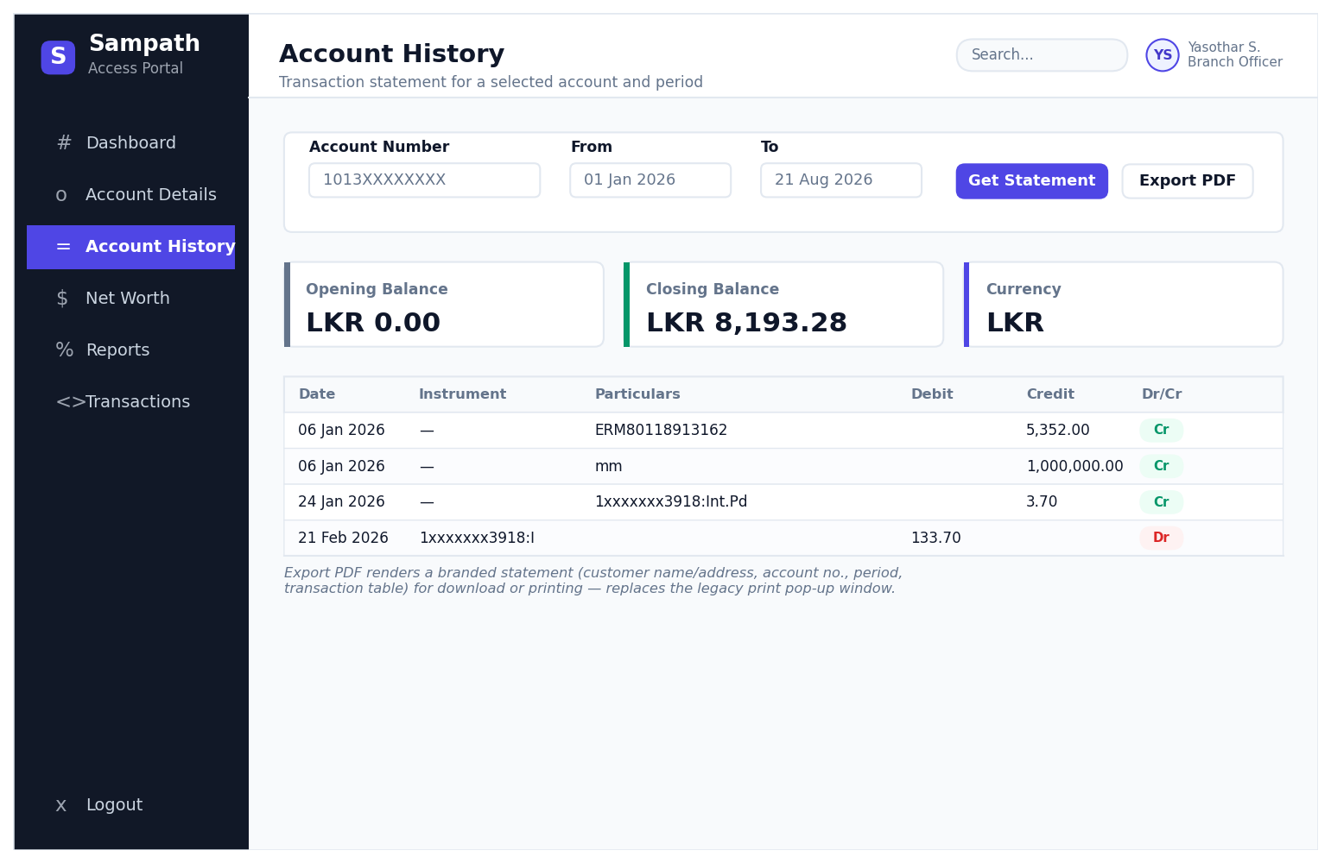
Figure 4.4: Account History – wireframe

Input / Search Criteria
Field | Type / Format | Source (dropdown values / rules) | Mandatory
Account Number | Numeric text, max length 12 | Required | Yes
From Date | Date picker | Required | Yes
To Date | Date picker | Required | Yes

Business Rules & Processing Logic
- The API retrieves the statement; an Opening Balance / Closing Balance / Currency summary (as stat cards) and a modern, sortable transaction data grid are then displayed.
- Each transaction row shows Date, Instrument No., Particulars, and the amount posted to either the Debit or Credit column (never both) based on the Dr/Cr flag, plus a colour-coded Dr/Cr badge and the running account Balance.
- "Export PDF" generates a branded statement (customer name/address block, account no., statement period, and the same transaction table) as a downloadable file — replacing the legacy print pop-up window.

Output / Data Displayed
Field | Description
Account Number, Account Name, Address | Account/customer detail service
Account Currency | Statement balance service
Opening Balance / Closing Balance | Statement balance service
Transaction list (Date, Instrument, Particulars, Debit, Credit, Dr/Cr, Running Balance) | One row per transaction

Validation & Error Handling
- Missing/invalid account or date range → inline field errors; no grid shown until corrected.
- No maximum date range is currently enforced: the legacy ACOptionsAction.getFullStmt() reads a configured STMT_PERIOD value, but the ParamValidator.validateDateRange() call that would reject an over-long range is commented out in the source, so any date range is accepted today (Finacle's own limits, if any, are a separate boundary outside this application). Whether the new build should (re)introduce a maximum-range check is an open item — see §6.

4.5 Net Worth Inquiry
Gives a consolidated, cross-account-type view of a customer's holdings with the bank — a headline Total Net Worth figure plus one card per account type showing Lien, Reserved and Available Balance amounts.
Attribute | Value
Actors / Roles | Users with Security Class = 20 (role name to be confirmed under the new permission model)
Menu Access | Sidebar → "Net Worth"
Entry Point | GET /api/networth?type=&value= — SPA route "/networth"

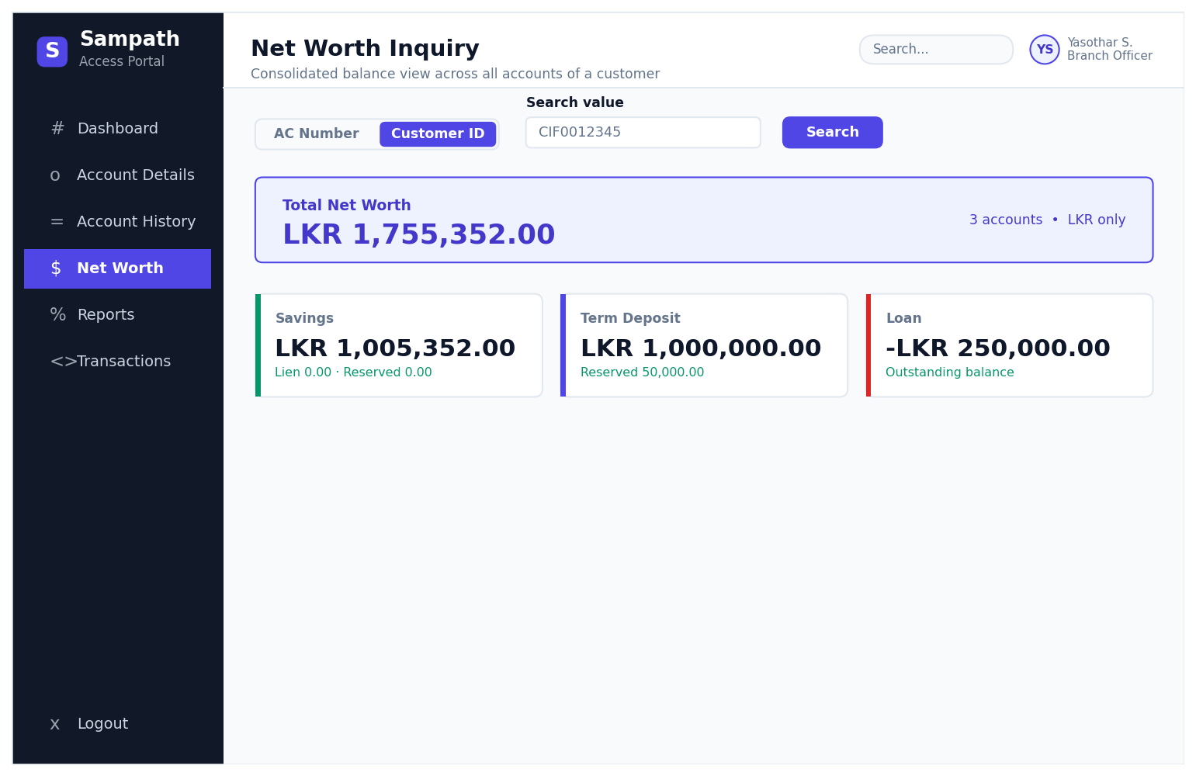
Figure 4.5: Net Worth Inquiry – wireframe

Input / Search Criteria
Field | Type / Format | Source (dropdown values / rules) | Mandatory
Search By (value) | Free text, max length 12 | Interpreted per the adjacent segmented control | Yes
Search Type (segmented control) | Single-select | AC Number / Customer Id — note: no NIC / Passport option here, unlike Account Details | Yes

Business Rules & Processing Logic
- The API performs the lookup and returns one entry per account/account-type held by the resolved customer, plus a computed grand total across all returned accounts (illustrative — the exact aggregation rule, e.g. whether Loan balances net off Savings/TD, should be confirmed with the business).
- Each account type renders as its own summary card (Savings, Term Deposit, Loan, etc.) rather than a plain HTML table row.

Output / Data Displayed
Field | Description
Total Net Worth | New, aggregated figure across all returned accounts — to be confirmed as an in-scope requirement
Account Type | e.g. Savings, Term Deposit, Loan
Lien | Amount placed on lien/hold against the account
Reserved | Reserved amount
Available Balance | Balance available after lien/reserve
Currency | Account currency code

Validation & Error Handling
- No matching customer/account or invalid search value → inline empty-state message; no cards rendered.

4.6 Reports
A generalized, multi-criteria transaction search across the FAP-recorded transaction log (as opposed to a single account's statement), intended for audit/reconciliation and investigation of specific postings.
Attribute | Value
Actors / Roles | Users with Security Class = 20 or numeric class ≥ 30 (role name to be confirmed under the new permission model)
Menu Access | Sidebar → "Reports"
Entry Point | GET /api/reports?… (query-string filters) — SPA route "/reports"

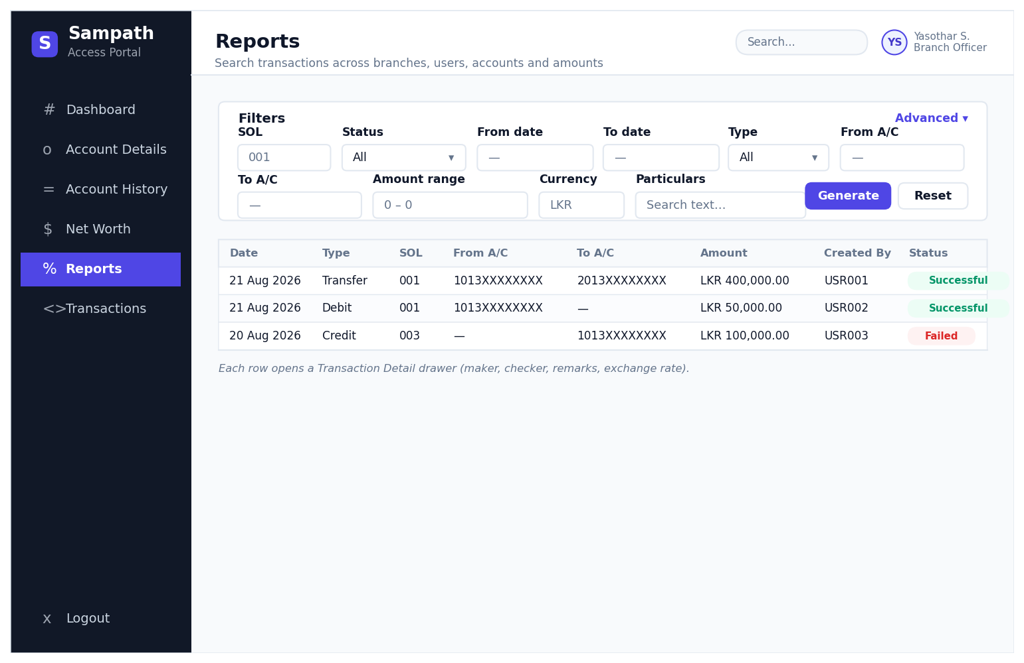
Figure 4.6: Reports – wireframe

Input / Search Criteria
Field | Type / Format | Source (dropdown values / rules) | Mandatory
Transaction SOL | Numeric text, max 3 chars | Branch/SOL code that processed the transaction | No
Transaction Status | Dropdown | All (.) / 000 Successful / 114 Invalid AC / 116 Insufficient Funds / 119 Transaction not permitted / 999 Response not received | No
Transaction Date (From / To) | Date picker, DD/MM/YYYY | Range filter | No
Entered User Id | Text, max 6 chars | Officer who keyed the transaction | No
Verified User Id | Text, max 6 chars | Officer who authorised/verified it | No
Transaction Type | Dropdown | All (.) / C / D / T (Credit / Debit / Transfer) | No
From A/C | Text, max 12 chars | Source account filter | No
To A/C | Text, max 12 chars | Destination account filter | No
Amount (From / To) | Text range, max 23 chars each | Filter on the base transaction amount | No
Currency | Text, max 3 chars | ISO-style currency code of Amount | No
Transaction Amount (From / To) | Text range, max 23 chars each | Filter on the transaction-currency amount | No
Transaction Currency | Text, max 3 chars | Currency code of Transaction Amount | No
Tran Particulars | Text, max 50 chars | Free-text match on transaction particulars | No
Tran Remarks | Text, max 20 chars | Free-text match on remarks | No
Exchange Rate | Text, max 10 chars | Filter on applied exchange rate | No

Business Rules & Processing Logic
- All fields are optional and combine as an AND filter; leaving Transaction Status / Type as "All" does not filter on that field. An "Advanced" disclosure separates the everyday filters (SOL, status, dates, type, accounts) from the less-used ones (currency, particulars, remarks, exchange rate) to keep the default view uncluttered.
- Results are shown in a sortable, paginated data grid with colour-coded status badges (e.g. Successful = green, Failed = red); an empty state is shown when the filter yields nothing.
- Selecting a result row opens a Transaction Detail drawer/panel carrying maker/checker, particulars, remarks, exchange rate, and status — without leaving the Reports page.

Output / Data Displayed
Field | Description
Txn Date, Txn Type, SOL | Transaction report record
Fr A/C, To A/C | Source / destination account
Amount, Currency | Transaction currency and amount
Created By, Status | User Id who entered the transaction, and its outcome status badge
(Detail view) Authorised By / Authorised Date / Txn Status / Exchange Rate / Particulars / Remarks | Shown after opening a row's detail panel

4.7 Transactions (Front Office Teller Options)
Lets a teller post simple over-the-counter transactions — cash deposit, cash withdrawal, or an account-to-account transfer — with a maker/checker style supervisor override for staff accounts or amounts exceeding the teller's authorisation limit.
Attribute | Value
Actors / Roles | Users with numeric Security Class = 30 (teller role)
Menu Access | Sidebar → "Transactions"
Entry Point | POST /api/transactions — SPA route "/transactions/new"

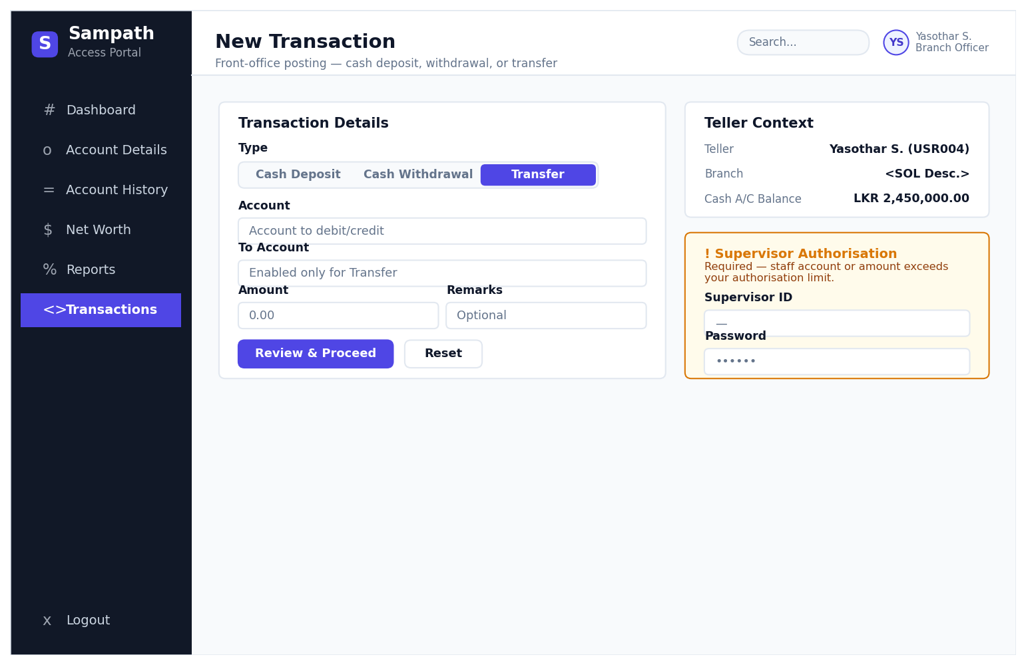
Figure 4.7: Transactions (Front Office Teller Options) – wireframe

Input / Search Criteria
Field | Type / Format | Source (dropdown values / rules) | Mandatory
Type | Segmented control | Cash Deposit / Cash Withdrawal / Transfer (replaces the legacy single-character C/D/T text field) | Yes
Account | Text, max 12 chars | Account to debit/credit | Yes
To Account | Text, max 12 chars | Enabled only when Type = Transfer | Conditional
Amount | Numeric, max 15 chars | Transaction amount | Yes
Remarks | Text, max 15 chars | Free text. Proposed consolidation of the legacy Txn Particulars and Txn Remarks fields into one optional field — both are ordinary visible, editable fields in the current UI (neither is hidden today); this simplification is a new design decision, to be confirmed with the business | No
Supervisor Id | Text, max 6 chars | Required only when the transaction is flagged STAFF or LIMIT | Conditional
Supervisor Password | Masked text | Required only when the transaction is flagged STAFF or LIMIT | Conditional

Business Rules & Processing Logic
- The "To Account" field is enabled only when Type = Transfer; for Cash Deposit/Withdrawal it is disabled/hidden.
- A "Teller Context" panel shows the logged-in teller's Name/User Id, Branch, and Teller Cash Account with its current balance, always visible alongside the form.
- If the resulting transaction status comes back as STAFF (posting to a staff account) or LIMIT (amount exceeds the teller's authorisation limit), a Supervisor Authorisation panel is revealed requiring a second officer's Id + Password before the transaction can proceed — a maker/checker control, unchanged from the legacy behaviour.
- On "Review & Proceed", the transaction is submitted via the API to Finacle (through the existing FinacleManager/FAPTransactionManager integration) and logged for later retrieval through Reports. A confirmation step/summary before final submission is recommended but should be confirmed with the business (the legacy flow submits directly on Proceed).

Validation & Error Handling
- Any validation or Finacle posting failure is shown as an inline error/toast tied to the relevant field where possible.
- Client-side validation prevents selecting an invalid Type or submitting incomplete required fields before the request is sent.

5. Consolidated Data Dictionary
The tables below consolidate the underlying data objects (EJB data beans) that back the screens above, for traceability into the eventual target data model.

5.1 DataAcDetails / DataAcBal (Account Details & Balance Inquiry)
Field | Type | Description
acName | String | Account name
custId | String | Owning customer id
currCode | String | Currency code
schmCode | String | Scheme code
addLine1 / addLine2 / addLine3 | String | Address lines
cityCode | String | City code
maturityDate | String | Term deposit maturity date
interestRate | String | Term deposit interest rate
balWithChqs | double | Balance including cheques
clearBal | double | Cleared balance
odLimit | double | Overdraft / loan limit
lastPrintBal | double | Last printed balance
unrlsChqs | double | Unrealised cheques
holdAmt | double | Held amount
availBal | double | Available balance

5.2 DataAcSearchList (Account Details search results)
Field | Type | Description
acNo / acid | String | Account number / internal account id
acName | String | Account name
custId | String | Customer id
currCode | String | Currency
schmType | String | Scheme/category (e.g. SB, TDA, LAA)
recType | String | M = Main, else Joint
acStatus | String | Account status

5.3 DataStmtBal / DataFullStmt / DataMiniStmt (Account History)
Field | Type | Description
legerBal / availableBal / floatBal / ffdBal / udBal / openingBal | double | Various balance components for the statement period
currCode | String | Account currency
txnDate / valueDate / txnPostedDate | String | Transaction, value, and posted dates
txnId / partTxnSrl / instNo | String | Transaction / instrument identifiers
txnType / txnSubType / drCr | String | Transaction type, sub-type, Dr/Cr flag
txnAmt / acBalance | double | Transaction amount and resulting running balance
txnPtcl | String | Transaction particulars

5.4 DataNwInquiry (Net Worth Inquiry)
Field | Type | Description
acType | String | Account type
lienAmt | double | Lien amount
reservedAmt | double | Reserved amount
availBal | double | Available balance
currCode | String | Currency

5.5 DataTxnReport (Reports)
Field | Type | Description
txnSerial / txnSolId | String | Transaction serial no. / SOL (branch) id
txnDate | String | Transaction date
txnType / txnStatus | String | Type (C/D/T) and status code
frAccount / toAccount | String | Source / destination accounts
amount / currCode | double / String | Base amount and currency
txnAmount / txnCurrCode | double / String | Transaction-currency amount and currency
txnPart / txnRemarks | String | Particulars / remarks
exRate | double | Exchange rate applied
createdBy / authorisedBy / authorisedDate | String | Maker / checker audit fields

5.6 TxnData / GeneralInqData (Transactions)
Field | Type | Description
txnId | String | Generated transaction id
account / toAccount | String | Source / destination account
amount / txnAmount | double | Posting amount / transaction-currency amount
option | String | C / D / T
txnDesc / txnRemarks | String | Particulars / remarks
tellerAcct | String | Teller's cash account
authLimit | double | Teller's authorisation limit
exRate | double | Exchange rate
txnStatus | String | e.g. STAFF / LIMIT / normal — drives the supervisor-override prompt
txnUser / authUser | String | Teller and supervisor user ids
accData / toAccData | GeneralInqData | Full account inquiry snapshot for the source/destination account (balances, customer name, scheme, mode of operation, joint holders, allowed flag, etc.)

6. Assumptions & Open Items
- This is a sample/first-pass FRS built from static code review and 7 reference screenshots; it has not been validated by walking the live application end-to-end or interviewing business users.
- Field-level business meaning for coded values (e.g. Scheme Type codes beyond SB/TDA/LAA, Transaction Status codes, Security Class numbers) should be confirmed with the business/BA team and Finacle documentation.
- The exact mapping of Security Class values to named business roles (e.g. "Branch Officer", "Teller", "Supervisor") is inferred from code conditions and should be confirmed.
- Account History's menu visibility appears unconditional in the current code (the security-class check is commented out) — confirm whether this is intentional or a defect to correct in the target system.
- PIN reset functionality exists as commented-out menu code but was not analysed in this pass; add if in scope.
- No screenshot was available for the Account Details / Net Worth Inquiry "No results" and validation-error states, or for the Reports transaction-detail drill-down screen — these were reconstructed from the JSP/action source only and should be visually verified.
- This document should be reviewed jointly with the actual end users (branch officers, tellers, supervisors) to confirm whether all described behaviour is still current or has since changed.
- The v0.2 wireframes are a conceptual modern redesign, not a signed-off UX design — they should be refined with a dedicated design tool (e.g. Figma), validated with end users, and checked against Sampath Bank's UI/branding standards before development starts.
- Net Worth Inquiry's "Total Net Worth" summary card (§4.5) is a new aggregation not present in the legacy screens — confirm whether a consolidated total is actually wanted, and if so, how Loan balances should be treated in that total (netted off vs. shown separately).
- The proposed Node.js technology stack (§2.4) is a starting point for discussion — the choice between a full EJB-tier rewrite and a "strangler" pattern that keeps Finacle/UPM integration behind a thin API gateway needs a joint decision with the architecture/infrastructure team.
- The legacy Txn Particulars and Txn Remarks fields are both visible and editable to tellers today (neither is hidden); the proposal to consolidate them into a single optional "Remarks" field is a new UX simplification, not a continuation of existing behaviour, and should be confirmed with the business before development.
- Whether the new build should (re)introduce a maximum date-range check for Account History is an open decision — the legacy code has the check written but disabled, so today there is no enforced limit (see §4.4).
- Decide, as a separate feature request, whether "Accounts Viewed Today" and "Reports Generated" activity metrics are wanted (§4.2.1) — if so, a new audit/activity-log table and logging calls at each inquiry/report entry point need to be designed and estimated.
- Decide, as a business-process question rather than a UI question, whether supervisor authorisation should move from today's synchronous in-request model to an asynchronous "pending queue" model before building any "Pending Authorisations" dashboard metric (§4.2.1) — this affects the Transactions workflow (§4.7), not just the Dashboard.

