- Introduction
  - Problem outline
The dataset contains 500 flight records, each one of them representing a single flight taken by a passenger, with fields for passenger ID, flight ID, origin, destination, departure time, and duration. The main objective of this project is to identify which passenger took the greatest number of flights. This is a counting problem similar to the ones discussed and implemented in labs, it is well suited for Mapreduce paradigm, as flights can be counted in parallel across subsets of the data and the partial counts aggregated in a final reduce step.
  - High level overview
The solution is implemented in python using only standard libraries as no third party packages were required. The framework is split across five files: mapreduce.py which contains the complete generic engine (data loading, splitting shuffling and the mapreduce class), while three job files in “jobs” folder each define a distinct analysis as interchangeable map_fn, combiner_fn and reduce_fn callables. The entry point main.py links these together via the command line. Key design choices include a semaphore bounded thread pool for parallel map execution, a combiner stage for local pre aggregation before the shuffling occurs, and positional column assignment to handle the datasets lack of a header row.

Figure 1: Project file structure
- Design and management
  - Solution flowchart
Figure 2: Mapreduce pipeline showing data flow from CSV input file through parallel map and combine, shuffle/sort, and reduce to the final output dictionary.
Figure 2 shows the complete pipeline. The input CSV is loaded and assigned column names positionally before being partitioned by split() into equal sized chuncks. Each chucnk is dispatched to a worker thread the dashed region represetnts the bounded thread pool where the semaphore ensures at most num_workers threads run concurrently. Within each thread, map_fn emits intermediate key value paris which are immendiatley passed to combiner_fn for local pre aggregation, reducing the volume of data entering the shuffle phase. Once all threads complete, shuffle_and_sort() groups all of the pairs by key in ascending order, and reduce_fn is applied then to each group to produce the final output dictionary.
  - Code Structure
The framework is deliberately made generic: MapReduce.run() accepts map_fn, reduce_fn and combiner_fn as parameters, meaning any analysis can be expressed without modifiying the framework itself. This is demonstrated by three completely different jobs which are passenger flight coutnign, route frequency and average duration all executing through the same engine. The split(), shuffle_and_sort(), and load_csv() functions are each single purpose and independently testable. The jobs package separates business logic from the infrastructure following python projects standards.
  - Code comments
Each function carries a docstring describing its purpose, paramets and return value. Inline comments mark the non obvious decisions for example, the (sum, count) tuple pattern in avg_duration.py’s combiner, which enables an excat mean to be calculated across distributed chuncks without retaining all raw values and the threading.Lock gurding the shared results list in the parallel map phase.
  - Version Control
Figure 3 : GitLab repository
- Implementaion details
  - splitting
Input data is partitioned into fixed size chuncks using python list slicing with a configurable stride. With the provided 500 record dataset and a chunck size of 50, ten equal chuncks are produced. Smaller chunk sizes increases the parallelism at the cost of more thread management overhead; larger chucnks reduce that overhead but may leave workers idle if the dataset does not divide evenly. The final chunck is permitted to be smaller than chunk_size which is expected behavior.
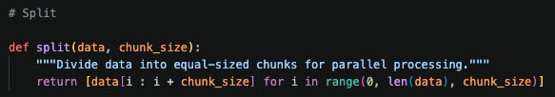
  - Map
Each chunck is then processed by a dedicated thread executing map_fn. For the primary job, map_fn iterates the chunk and emits one (PassengerId, 1) pair per record one emission per observed flight. A threading.Semaphore(num_workers) in the thread target function ensures no more than num_workers threads run concurrently, preventing resource exhaustion on larger datasets. A threading.Lock serialises writes to the shared results list, preventing data races between threads.

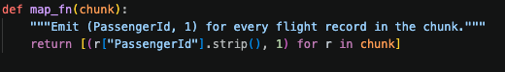
  - Shuffle/Sort
Then after all threads complete, their ouput pairs are flattened into a single list and passed to a shuffle_and_sort(). Defaultdict(list) groups all values sharing the same key, then dict(sorted(…)) imposes ascending key order before the grouped dict is returned. This mirrors Hadoop’s shuffle and sort behaviour: all values for a given key are co located and keys arrive at the reducer in a consistent order.
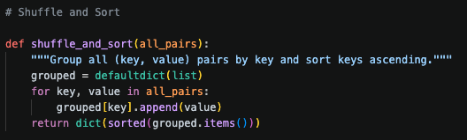
  - Reduce
The reduce phase goes through the sorted grouped dict and calls reduce_fn(key, values) for each key. For the primary job this simply sums the list of partial counts. The avg_duration job uses a more complex pattern which means that its combiner emits (partial_sum, count) tuples rather than raw values, and its reducer recombines these to compute and exact mean which demonstrates that the framework supports arbitrary aggregation logic beyind simple counting.
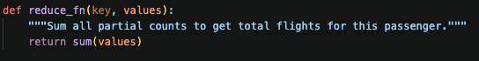
  - Advanced processes
Four extensions beyind the core Mapreduce requirements are implemented:
Multi-threaded execution. The map phase dispatches one thread per chunk via threading.Thread. A threading .Semaphore caps concurrent threads at num_workers (default 4), providing a lightweight thread pool mechanism without external dependencies. This allows the map phase to utilise multiple CPU cores on larger datasets.
Combiner. Each job provides a combiner_fn that performs local pre aggregation within a chucnk immediately after mapping, before the shuffle phase. For the passenger count job, the combiner reduces 500 raw (PassengerId, 1) pairs to 243 pre summed pairs a 51% reduction in shuffle volume. This directly mirrors Hadoop’s combiner optimiser and is particularly impactful on larger datasets where the network or memory transfer costs dominate.
Three reusable jobs. The generic Mapreduce.run() interface is exercised by three independent jobs. The busiest route job uses a tuple (FromAirport, ToAirport) as the key, demonstrating that the framework handles composite keys without modification. The average duration job uses a (sum, count) intermediate value, showing a non trivial combiner pattern. All three produce identical results regardless of chucnk size, confirming correctness across different parallelism configurations.
Fault Tolerant Data loading. The load_csv() function skips rows whose column count does not match the expected six fields, and strips whitespaces from string fields before use. Rows with blank PassengerId or FlightID are silently discarded. This prevents malformed data from crashing the pipeline.
- Results discussion and future work
  - Results

