1.

Question 1

In a *Multi-Class* classification scenario, your model can identify all the different items and people that are present in a given input image.

**1 / 1 point**



True



False

**Correct**

Correct! The above statement is true for a *Multi-Label* classification.

2.

Question 2

Which of the following statements correctly describes the difference between *object detection* and *object localization*?

**1 / 1 point**



*Object detection*is where you get a bounding box around the *main* subject of the image, while in *object localization* you get a bounding box around *all* of the objects within an image.



They both are the same.



*Object localization* is where you get a bounding box around the *main* subject of the image, while in *object detection* you get a bounding box around *all* of the objects within an image.



*Object detection* refers to detecting the object within an image, while *object localization* gives us the bounding box around that object.

**Correct**

Correct!

3.

Question 3

What is the method that locates an object(s) by *labelling the pixels*, where *each similar object(s) is assigned to the same class*? Type your response here (two words, all lower case).

**1 / 1 point**

semantic segmentation

**Correct**

Correct!

4.

Question 4

In the context of *Transfer Learning*, the initial training task where the model learns reusable patterns is called a *downstream task.*

**1 / 1 point**



True



False

**Correct**

Correct! The above statement is true for a *pre-training task*. The task for which the model is borrowed is called *downstream task*.

5.

Question 5

Check all the scenarios in which Transfer Learning could be beneficial.

**0.75 / 1 point**



When the task you want to perform is a sub-task of an already trained, larger, model.



To reduce computation and processing cost

**Correct**

Correct!



When you don’t have enough data for the task you want to perform, which resembles another same or similar, already trained task.

**Correct**

Correct!



To ensure better performance

You didn’t select all the correct answers

6.

Question 6

What is the name of the built-in TensorFlow layer-type which you can use to increase the dimensions of a 2D image ?

**1 / 1 point**



SampleIncrease



UpSampling



SampleUp2D



UpSampling2D

**Correct**

Correct!

7.

Question 7

You have an image of dimensions 48 x 48, and you want to upscale it to 240 x 240 using the built-in TensorFlow layer-type which is used to perform such a task (mentioned in Question 6). What will you pass in as *size=____*?

**0 / 1 point**

5

**Incorrect**

Hint: *size* is the ratio of the desired and the original dimensions.

8.

Question 8

Consider the following code:

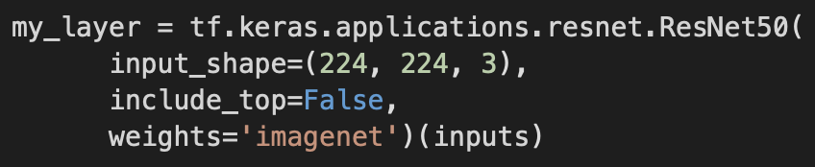

What does “include_top=False” mean ?

**1 / 1 point**



It discards the first layer of ResNet50 when initializing *my_layer* using it.



It discards the top most layers of ResNet50 when initializing *my_layer* using ResNet50.



It sets the top most layers as untrainable of ResNet50 when initializing *my_layer* using it.



It randomly sets up the weights, instead of using that of ImageNet, for the top most dense layers of ResNet50 when initializing *my_layer* using it.

**Correct**

Correct!

9.

Question 9

What is the name of the technique used in the output dense layer that is used to predict Bounding Boxes ? (Hint: It is a one word answer)

**1 / 1 point**

regression

**Correct**

Correct!

10.

Question 10

Check all the statements that are true regarding Intersection Over Union (IoU), with regards to Bounding Boxes.

**1 / 1 point**



The values of IoU range from 0 to *all* possible *positive* values.



IoU is the area of intersection of the two boxes (true and predicted) divided by the total union area of the two boxes.

**Correct**

Correct!



The closer the value of IoU is to 0 the poorer is the prediction of the bounding box.

**Correct**

Correct! The lesser the area of intersection the closer to 0 will be the value of IoU



The closer the value of IoU is to 0 the better is the prediction of the bounding box.