Some important links that can help you in completing your assignment,  
  
<https://iangilham.com/2016/03/22/Sns-trigger-lambda-via-cloudformation.html>  
<https://github.com/guardian/ses-send-email-lambda/blob/master/conf/cloudformation.yml>  
<https://github.com/nrdio/sns-lambda-dynamodb-cloudformation-example>

Please find details of assignment,  
  
  
•Add one more lambda in the Cloudformation  
stack  
•New lambda should use SES service to send  
an email  
•Call this lambda from existing lambda  
through SNS  
•Provide SNS permissions to existing  
Lambda  
•Call existing lambda, you should receive  
email  
•Create an architectural diagram for the  
above flow and share the CloudFormation  
script  
  
Note: You will need to explore AWS documentation for performing this assignment based on our discussion in the class. Deliverables of this assignment will be a working CloudFormation script

Sns->lambda1->lambda2->ses->email

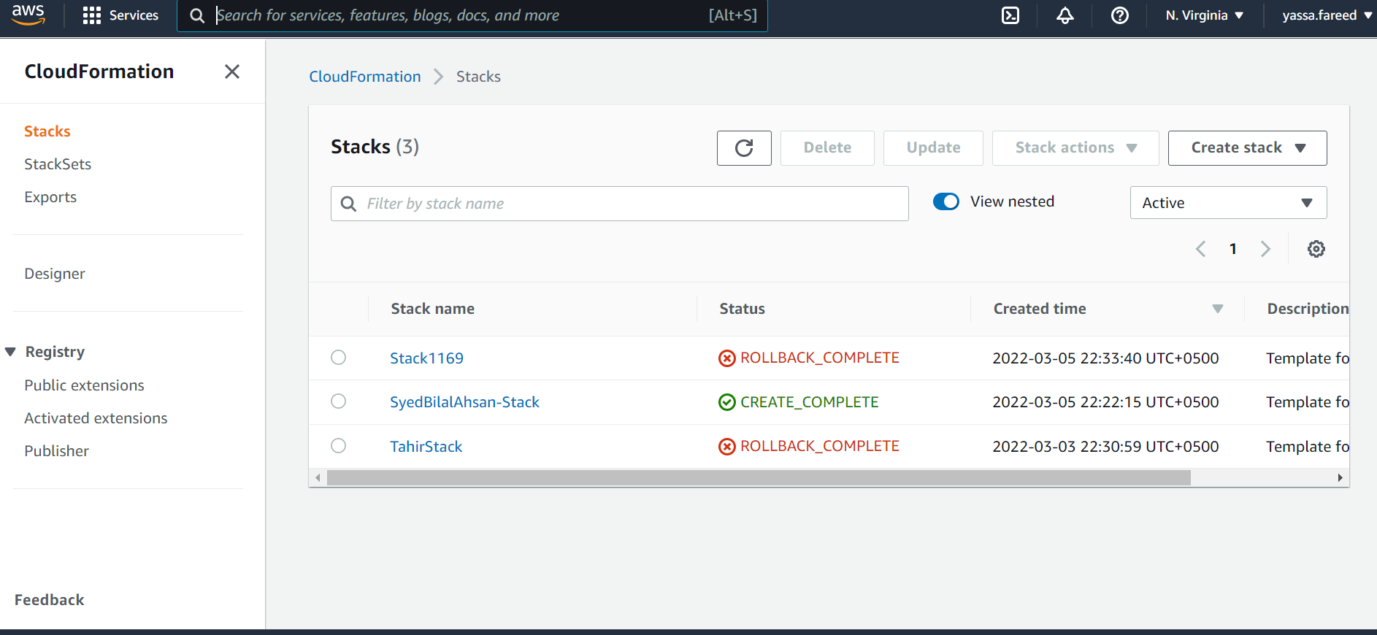

Create stack with new resource then:

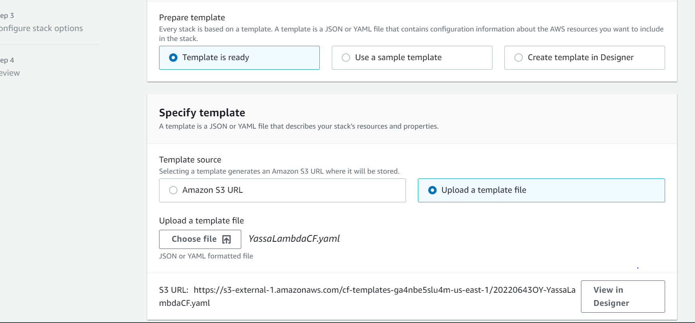

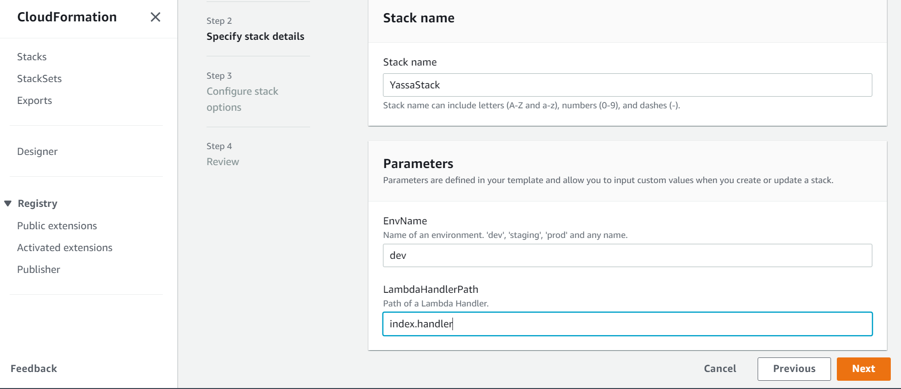

Do next and next and create stack

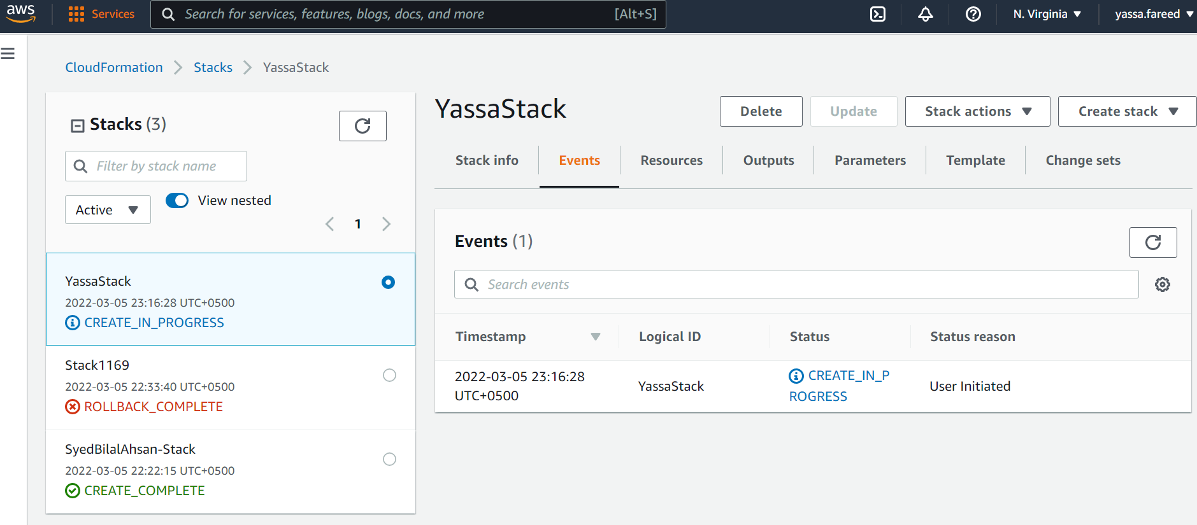

Wait until it is completed

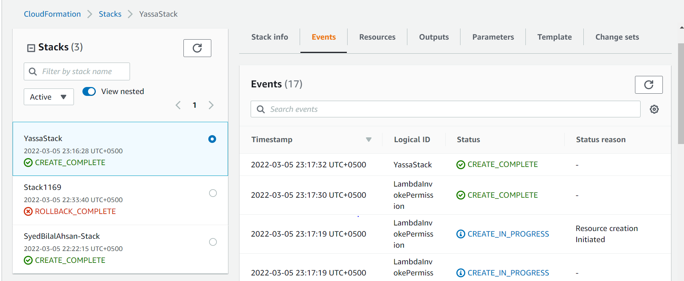

GO TO SNS to see if topic is created by script

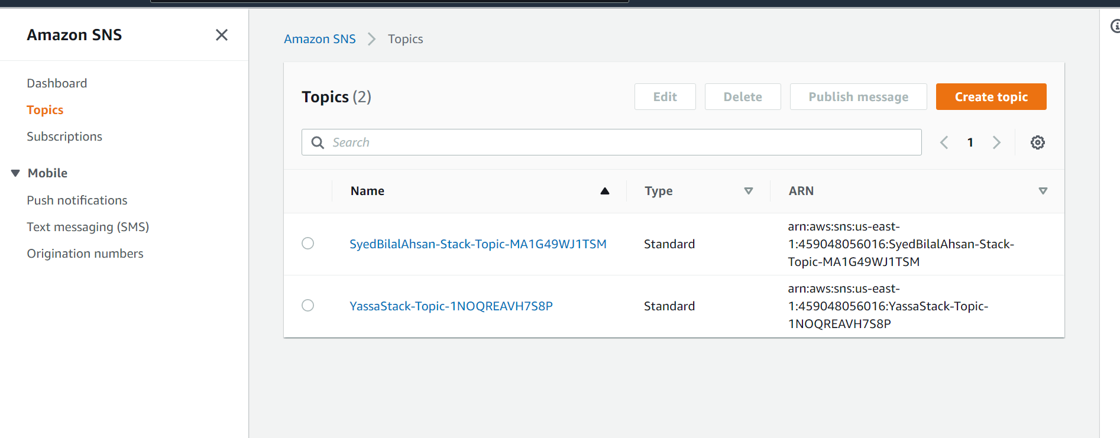

Click on your topic

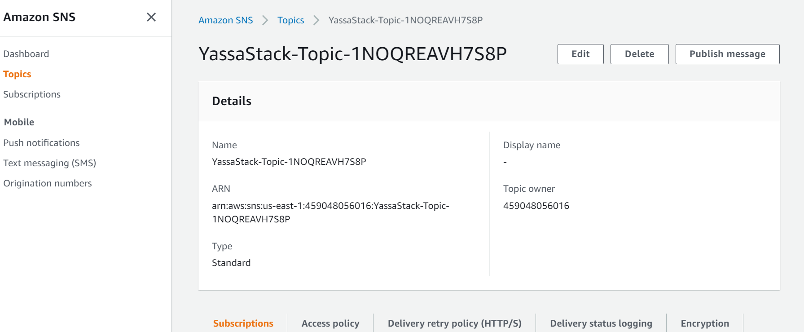

Then publish the message!

But First see that your email is verified in SES or not (if not verify it)

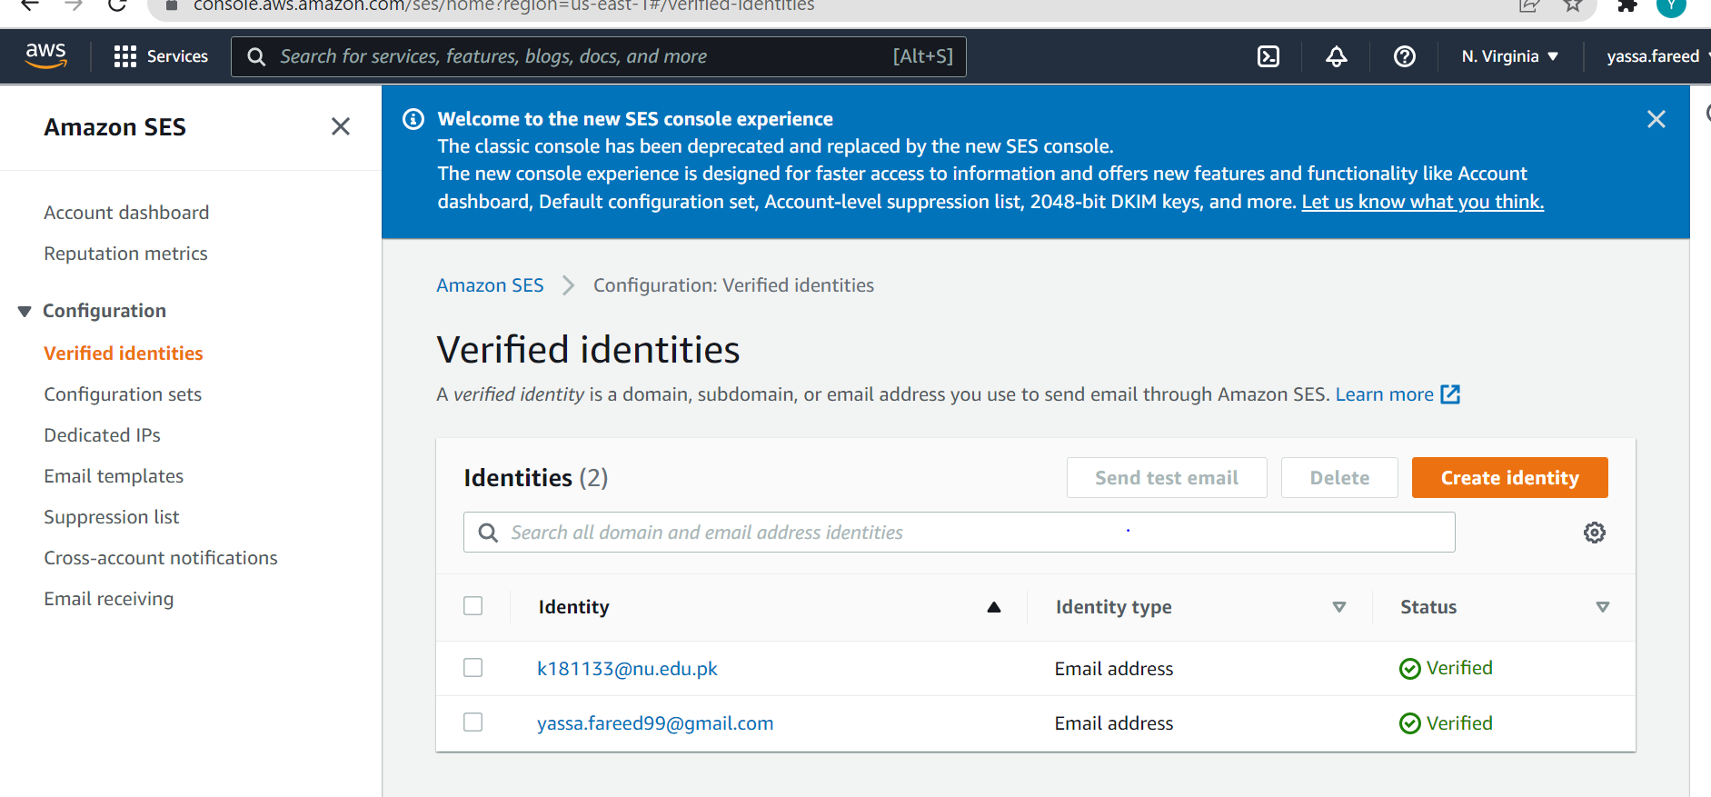

Come back to sns and publish message

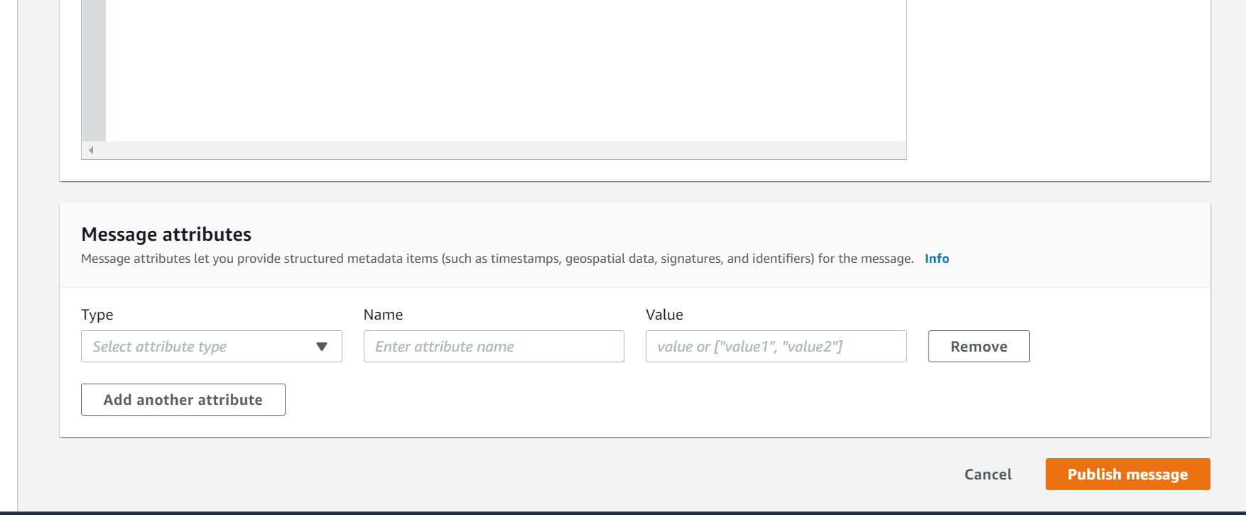

Check to see your email

You can check in designer under cloudformation how your stack is looking

