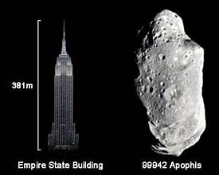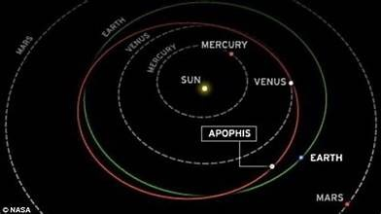 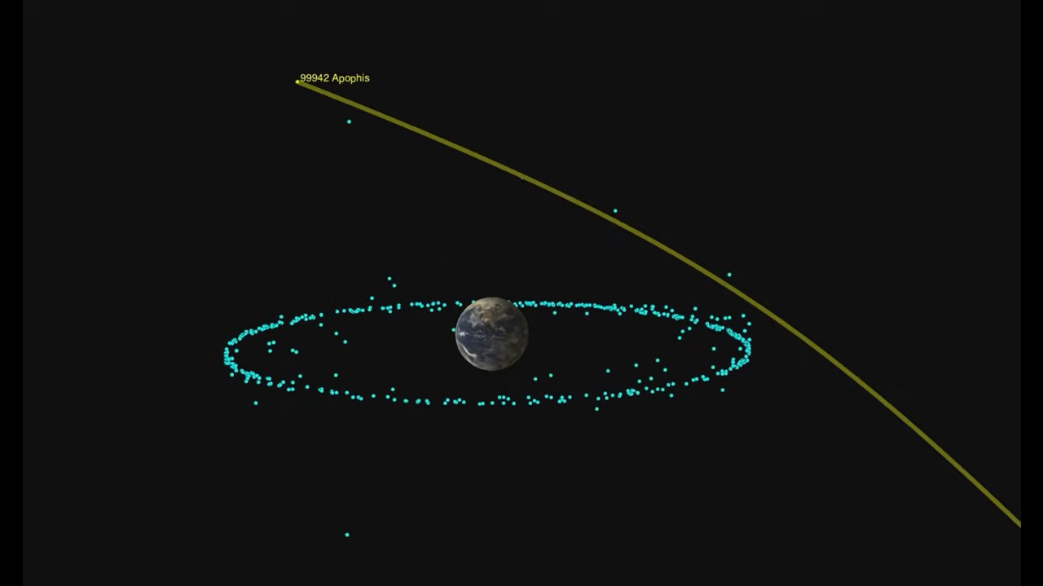



**NASA forecast of its path**

Name : 1. Apophis (99942 Apophis)

discoverd on 19 June 2004 at the kitt peak observatory in Arizona

diameter : 340m

distance from Earth : 2.1 AU (AU : about 150 million kilometers or 93 million miles).

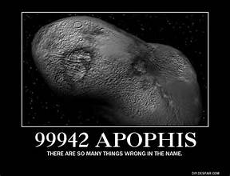current velocity : 29.98 km/sec

**more information**: Apophis (99942 Apophis) is a near-Earth asteroid that was discovered on June 19, 2004, at the Kitt Peak Observatory in Arizona. It has a diameter of approximately 340 meters, making it a significant object in terms of size. Apophis orbits the Sun at an average distance of 2.1 Astronomical Units (AU) from Earth, with 1 AU being about 150 million kilometers or 93 million miles. Currently, it travels at a velocity of 29.98 kilometers per second. Initially, Apophis drew attention because early calculations suggested it had a small chance of colliding with Earth in 2029, which raised concerns about its potential danger. If an asteroid of Apophis' size were to impact Earth, it could cause devastating regional damage. Although the 2029 collision risk has been ruled out, future close approaches still make it an object of scientific interest and monitoring for potential long-term risks.

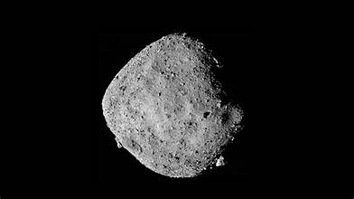Name : Bennu (101955 Bennu).  
Discovered : Sept. 11, 1999.  
Type : B-Type Asteroid.  
Diameter : About 1,614 feet (492 meters).  
Orbital Period : 1.2 Earth Years.  
Length of Day : 4.288 hours.  
Mass : 85.5 million tons (77.6 million metric tons).  
distance from the Earth : 93 million miles.

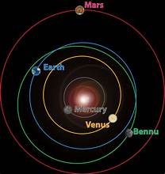**More information**: Bennu (101955 Bennu) is a B-type asteroid discovered on September 11, 1999, with a diameter of 492 meters and an orbital period of 1.2 Earth years. Bennu is part of the Apollo group of asteroids, meaning its orbit crosses Earth's path. It’s known for its rich carbon content, believed to contain organic molecules and water-bearing minerals, which makes it a prime target for understanding the early solar system. Bennu has a high probability of close encounters with Earth in the late 22nd century, specifically a 1-in-2,700 chance of impact in the year 2182. Its surface is covered in large boulders, with a highly porous structure, which suggests it could be a rubble pile asteroid, loosely held together by gravity.

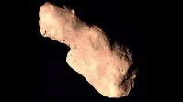Name: 4179 Toutatis  
Discovered: on January 4, 1989, by French astronomer Christian Pollas.  
size : 2.5 kilometers in length and 1.5 kilometers in width.  
Orbital Period: Takes about 3.98 years to complete one orbit around the Sun.

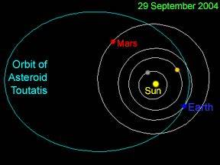More information: 4179 Toutatis is a near-Earth asteroid that was discovered on January 4, 1989, by French astronomer Christian Pollas. It measures 2.5 kilometers in length and 1.5 kilometers in width, making it significantly larger than most near-Earth asteroids. Toutatis takes approximately 3.98 years to complete one orbit around the Sun.

New information: Toutatis has a highly irregular, tumbling rotation, with two different periods of rotation—5.4 and 7.3 days. Its chaotic spin makes it an unusual object for study. The asteroid follows a complex, eccentric orbit that brings it close to Earth's orbit, making it a potentially hazardous asteroid (PHA). Toutatis has had several close approaches to Earth, with its closest recorded flyby in December 2004, when it passed at just over four times the distance from Earth to the Moon. Its irregular shape and chaotic rotation have provided unique challenges for radar observations, helping scientists understand the dynamics of asteroid movement better.

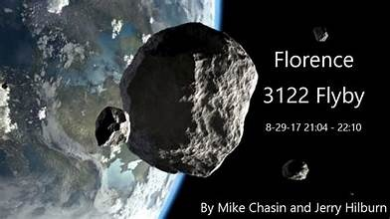 Name : Florence (3122 Florence)  
Discovery: Florence was discovered on March 2, 1981, by American astronomer Schelte "Bobby  
Size: Approximately 4.5 kilometers (2.8 miles) in diameter.  
Mass: Estimated to be in the range of 1.8 × 10¹⁴ to 3.6 × 10¹⁴ kilograms.

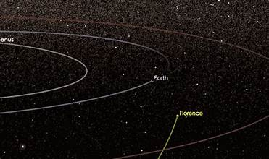More information: Florence (3122 Florence) is a large near-Earth asteroid discovered on March 2, 1981, by American astronomer Schelte "Bobby" Bus. It has a diameter of approximately 4.5 kilometers (2.8 miles) and an estimated mass between 1.8 × 10¹⁴ to 3.6 × 10¹⁴ kilograms.

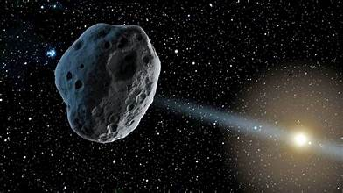New information: Florence is one of the largest near-Earth asteroids, and it made a notably close approach to Earth on September 1, 2017, passing at about 7 million kilometers (4.4 million miles) away. This flyby was its closest in over 400 years, and it won’t approach as near again until the year 2500. Florence is particularly interesting because radar imaging during its 2017 approach revealed that it has two small moons, making it a triple system. Studying asteroids like Florence helps scientists better understand asteroid dynamics and the potential threat such large objects could pose to Earth.

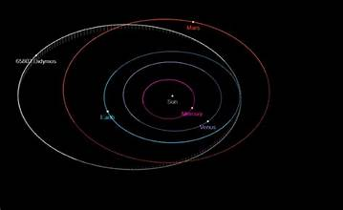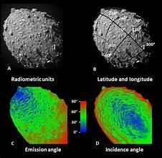

Name : 65803 Didymos

Discovered : on April 11, 1996, by the Near-Earth Asteroid Tracking (NEAT) program.

size: Approximately 780 meters (2,560 feet) in diameter.

mass: Estimated to be about 5 × 10^11 kg.

distance from the Earth : (7 million miles).

More information: Didymos (65803 Didymos) is a near-Earth asteroid discovered on April 11, 1996, by the Near-Earth Asteroid Tracking (NEAT) program. It has a diameter of approximately 780 meters (2,560 feet) and an estimated mass of around 5 × 10¹¹ kilograms. Its distance from Earth during its closest approach is about 7 million miles.

New information: Didymos is part of a binary asteroid system, meaning it has a smaller companion, or "moonlet," called Dimorphos, which is about 160 meters (525 feet) in diameter. This system has been a major focus for planetary defense research, particularly with NASA’s DART (Double Asteroid Redirection Test) mission, which successfully impacted Dimorphos in 2022 to test the ability to alter an asteroid's trajectory. This experiment has been a critical step in developing technologies to deflect potentially hazardous asteroids away from Earth.

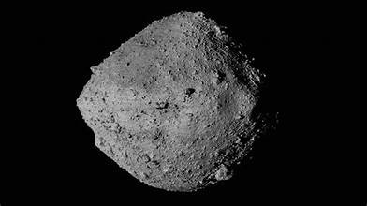

Name: 1989 JA

Discovery : 1989 JA: Discovered on May 6, 1989, by the Spacewatch program.

Size:300 meters (980 feet) in diameter.

Mass : 10^8 to 10^9 kg.

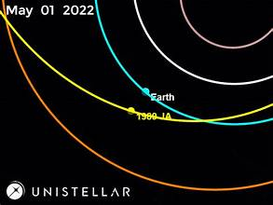Distance from Earth : 620,000 miles

More information: 1989 JA is a near-Earth asteroid discovered on May 6, 1989, by the Spacewatch program. It has a diameter of approximately 300 meters (980 feet) and an estimated mass ranging between 10⁸ to 10⁹ kilograms. During its closest approach, 1989 JA passed about 620,000 miles from Earth.

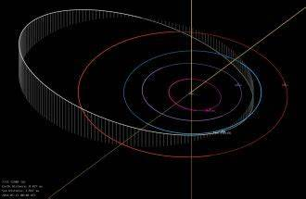New information: 1989 JA is classified as an Apollo-type asteroid, meaning its orbit crosses Earth's, making it a potentially hazardous asteroid (PHA). Despite its relatively small size compared to other near-Earth objects, its proximity during close approaches makes it an important object for monitoring. 1989 JA has a fast orbital velocity, making it a challenging target for observations and potential future deflection strategies. Its composition and spin characteristics remain subjects of study, as understanding such smaller, fast-moving asteroids is vital for planetary defense planning.

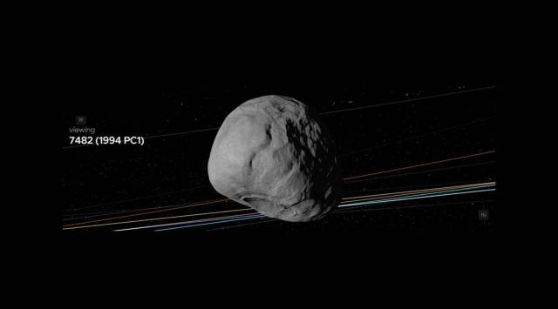

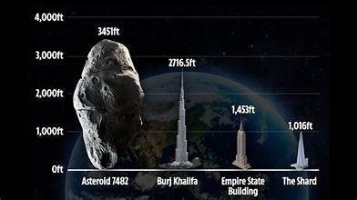

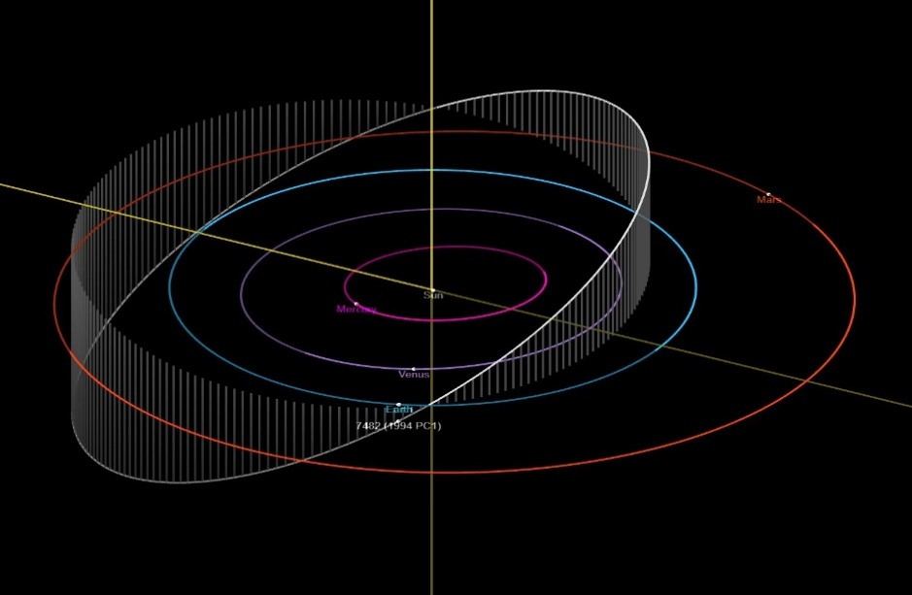**1994 PC1 (7482 PC1) (asteroid7482)**

* **Discovery**: 1994 PC1 was discovered on August 9, 1994, by astronomer Robert McNaught at the Siding Spring Observatory, Australia.
* **Size**: Approximately 1.1 kilometers (0.68 miles) in diameter.
* 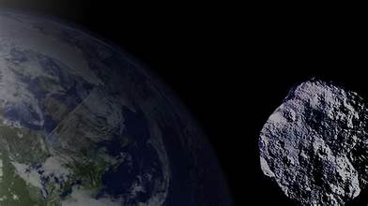**Orbital Period**: Takes about 1.57 years (572 days) to complete one orbit around the Sun.
* **Mass**: Estimated to be around **2.5 × 10¹¹ kilograms**.
* **More information**:

1994 PC1 (7482 PC1) is an Apollo-type asteroid, meaning its orbit intersects Earth's orbit, making it potentially hazardous. Discovered on August 9, 1994, by astronomer Robert McNaught, it measures approximately 1.1 kilometers (0.68 miles) in diameter and has a mass estimated at around 2.5 × 10¹¹ kilograms. The asteroid has an orbital period of about 1.57 years (572 days). Its most recent close approach occurred on January 18, 2022, when it passed Earth at a distance of about 1.2 million miles, nearly five times the distance between Earth and the Moon. Despite this safe distance, its size and proximity to Earth's orbit make it an object of interest for ongoing monitoring to assess any potential future collision risks.

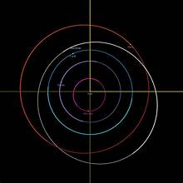

**Eros (433 Eros)**

* **Discovery**: Eros was discovered on August 13, 1898, by German astronomer Carl Gustav Witt.
* **Size**: Eros is one of the largest Near-Earth asteroids, measuring **about 34.4 kilometers (21.4 miles) in length**.
* 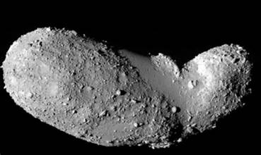**Orbital Period**: Takes approximately **1.76 years (643 days)** to complete one orbit around the Sun.
* **Mass**: Estimated to be around **6.69 × 10¹⁵ kilograms**.

**Why It Is Dangerous to Earth**

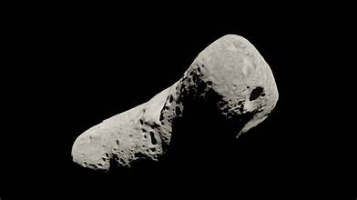Eros is classified as a potentially hazardous asteroid due to its large size and its orbit that brings it close to Earth's path. While it poses no immediate threat, its significant size means that an impact with Earth could cause massive regional or even global consequences.

more information: Eros, discovered on August 13, 1898, by Carl Gustav Witt, is one of the largest Near-Earth asteroids, measuring about 34.4 kilometers in length. It has an elliptical orbit around the Sun with a period of approximately 1.76 years and rotates every 5.27 hours. The asteroid's surface, studied by NASA’s NEAR Shoemaker mission, reveals a rocky composition with craters and boulders. While Eros poses no immediate threat, its proximity to Earth and size make it a significant object for monitoring and future exploration, as an impact could have severe consequences.

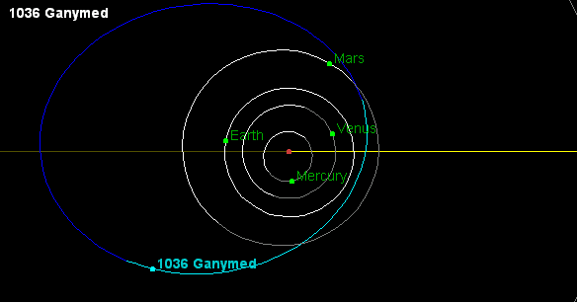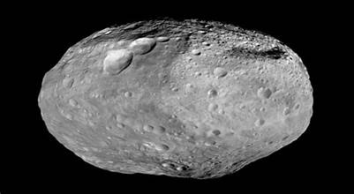

**Ganymed (1036 Ganymed)**

* **Discovery**: Ganymed was discovered on October 23, 1924, by German astronomer Walter Baade.
* **Size**: It is the largest Near-Earth asteroid, measuring approximately **35 kilometers (22 miles)** in diameter.
* **Orbital Period**: Takes about **4.33 years (1,581 days)** to complete one orbit around the Sun.
* **Mass**: Estimated to be around **7.5 × 10¹⁵ kilograms**.

**Why It Is Dangerous to Earth?**

Ganymed is classified as a potentially hazardous asteroid due to its large size and its orbit, which crosses Earth's path. While there is no immediate threat, its size means that an impact would cause catastrophic global consequences.