**Conclusion:**

There are many agricultural crops in Egypt that we cannot grow correctly and monitor their growth due to the farmers’ lack of experience and their inability to monitor large areas of agricultural land at one time, and also the farmers’ use of incorrect methods for irrigating plants, which wastes water, and also their incorrect use of pesticides. Which reduces the quality of production and the quantity of agricultural crops produced by Egypt, which affects the amount of food available in Egypt. Which humans feed on, and it mainly affects industry and the transformation of products, which affects the problem of unemployment and national income.

To solve this problem, we can use a low-cost solar-powered robot to preserve the environment, programmed via an Arduino chip, that can identify agricultural crops, spread grains in the ground, plant them, and also water them via a timer present in it. For example, we water the plants every 12 hours and it is connected via a Bluetooth chip so we can control it via phone. By knowing the number of areas that have been planted through ultrasound sensors and also through the camera, we can identify ripe and rotten fruits and carry out the sorting and separation process for them, as well as determine the type of plant and harvest them in the correct way without causing any harm. We can also make it move the fruits and carry them anywhere we want using the claw on the front of the robot that closes and opens using a servo motor. Insecticides can also be sprayed to protect the plant from insects and pests that could harm it, and this saves me a lot of effort and hardship. The farmer at a price less than (2600 pounds)

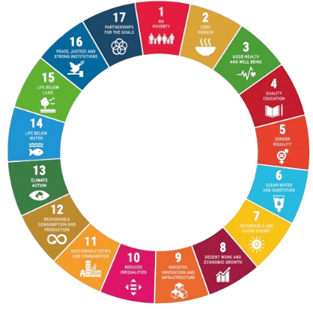After using this robot, it will work to increase the amount of agricultural production, reduce pollution, preserve the amount of Nile water, and solve many problems related to sustainable development goals, such as:

* Eliminating poverty
* Eliminate hunger
* Good health and wellness
* Clean water
* Use clean energy
* Decent work and economic growth
* Responsible consumption and production
* Climate action
* Life in the wild

**Recommendations:**

We know that everything on our planet is always progressing, developing, and constantly progressing, so there are many things that we can add to our robot, such as:

* Work with more than one robot and create a system between them to divide the tasks so that we can cover the largest area of agricultural land in the shortest possible time.
* Connecting the robot to greenhouses to create the appropriate environment for growing all crops at any time of the year.
* Creating a website for each farm that can display the agricultural crops it has produced automatically through robots to create a store for food crops.