**Results of our project after the experiment**

The robot was able to move in the clay soil with ease, but there were a few obstacles in the sandy soil, but after using a track instead of wheels, it began to walk easily.

The soil and its contents were analyzed, and the results of the soil and gas analysis were sent to the mobile phone application via the Bluetooth chip.

The area of agricultural land was irrigated using the drip irrigation method, which led to a large percentage of water savings, because regular irrigation per acre consumes 125 cubic liters, while drip irrigation consumes only two hundred thousand liters, which saved a very large amount of water.

The claw worked to cut and remove the fruits and did not encounter any difficulty

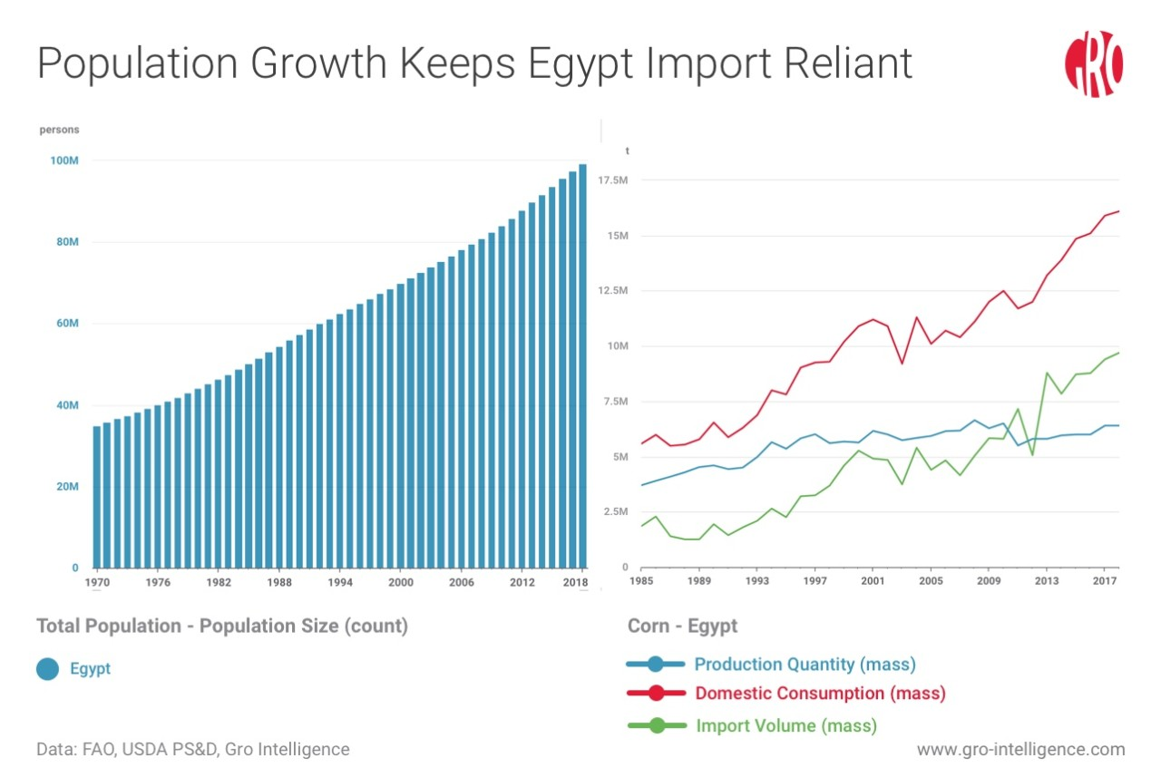Using the ESP32 camera, we were able to see the plants and distinguish between the ripe ones and the rotten ones. We are also working on linking it to artificial intelligence so that it works automatically.

In the event of expansion of the project, it will increase the productivity of the crop produced per acre and reduce the price of the food product, which will increase national income and satisfy the population’s hunger needs, and we can export the surplus abroad.

sults and Analysis (Cont.)

**Project-specific analyses**

**Scientific basis:**

Soil salinity has a specific number that, when it increases or decreases, affects the quality of the soil and its ability to be cultivated. There is a soil sensor that can measure the percentage of its salinity. In this way, we can know the quality of the soil and the type of plant that should be planted in it.

Drip irrigation saves water and is better than flood irrigation and saves more than 80% of water. In this way, we can calculate each plant and the amount of water it needs without wasting it.

Ripe fruits are saturated with color, while faded fruits are immature. We can use the camera to determine by color or by artificial intelligence to determine which plants should be picked and collected.

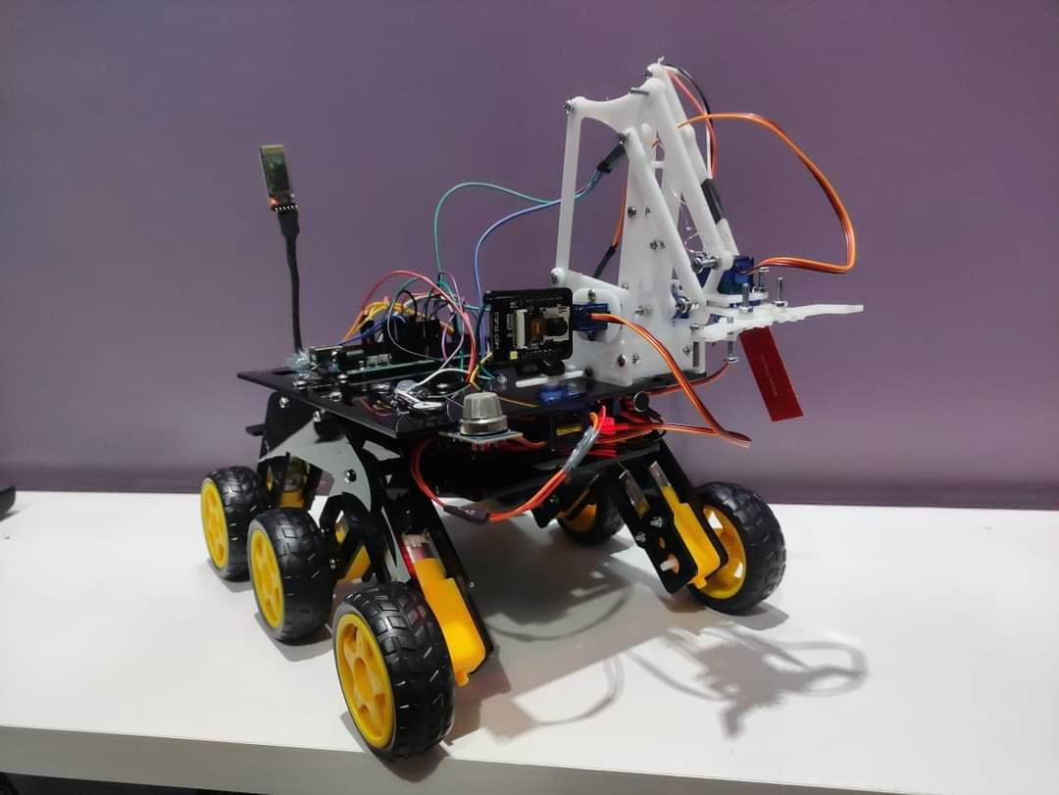**Positive results:**

After conducting all the experiments, we succeeded in measuring the soil salinity and the percentage of gases, determining the fruits and their quality, helping the farmer and irrigating the crops in a short time.

**Negative results:**

But we noticed that we must make many modifications and developments in the robot, for example that we must use batteries with a larger capacity so that it works for a longer time, and that we must increase its height slightly so that it does not collide with rocks.