

International Competition on Smart Innovation Technologies (IC-SIT’2024)

July 13 –14, 2023, Alexandria, Egypt



***Agrogaurd***

*By*

*Amr Mohamed Abdelrahman Samy*

*Mazen Nasser Yassen Ahmed*

*Yassin Hatem Hana Hamed*

*Yara Omar Judy Saeed*

*Supervised by*

*Dr/Randa Hosni*

*Qena STEM School*

*Qena Governorate*

*2024*

ACKNOWLEDGMENT

We want to express our sincere gratitude to the competition organizers for giving us the chance to participate and for believing in our abilities. Your trust and support have been crucial in our journey, allowing us to present our project and learn from others. We are truly thankful for the opportunity you've provided and for believing in our potential. Your encouragement motivates us to strive for excellence. Thank you for trusting us.

We also want to thank our teacher, Mr. Amr Abdulshafi, for his unwavering support and valuable guidance throughout our project. His dedication and expertise have greatly improved the quality of our work, and we deeply appreciate his encouragement.

Additionally, we extend our gratitude to Mr. Atef Osman, the principal of Qena STEM School, and Mr. Ahmed Abdel Rady, our IT teacher, for their constant support and encouragement in allowing us to participate in the competition. Their belief in our abilities and dedication to nurturing our talents have been essential to our journey. We are grateful for their guidance and inspiration.

Special thanks to Mr. Mahmoud Abdullah for his invaluable assistance, and to Dr. Randa Hosni for supervising us throughout the competition. Their unwavering support and guidance have been integral to our success.

Finally, we want to thank the farmer who trusted us and allowed us to implement our project on their land. Our experience in agriculture has been fruitful, thanks to your continuous support and encouragement. We appreciate your willingness to open doors for us to pursue our aspirations and develop our ideas. We look forward to continued collaboration and even greater achievements in the future. Thank you for your unwavering trust and support.

SUMMARY

The project endeavors to address prevalent challenges faced by farmers within the agricultural domain. This is pursued through the development of a robotic system designed to perpetually surveil agricultural lands, with a particular focus on the planted flora. The system is equipped to ascertain the condition of plants by quantifying soil moisture levels, thereby discerning between instances of desiccation or excessive irrigation. Additionally, it monitors the nutritional requirements of the plants, employs a camera for visual inspection, and incorporates memory storage for data retention. Furthermore, the system is programmed to eradicate deceased vegetation and oversee its state. An emergency buzzer feature serves as a deterrent against fauna threats that could jeopardize plant viability.

The pivotal capacity of the system lies in its ability to detect plant respiration, thereby augmenting crop yield by ensuring optimal water and nutrient provision. Furthermore, it enhances crop efficiency by furnishing precise data pertaining to soil moisture, nutrient content, and plant vitality. Energy provisioning is facilitated through solar panels supplemented by battery storage, ensuring sustained functionality even during periods of low solar exposure or in night.

The project delineates several salient features beneficial to agricultural practice. Foremost among these is the enhancement of crop management efficiency. The system aids farmers in managing their crops more effectively by furnishing real-time insights into soil moisture levels, nutrient status, and plant vigor. Moreover, it guarantees crop yield optimization by meticulously regulating water and nutrient administration. The integration of automation not only streamlines operations but also renders crop management more economically viable by minimizing reliance on manual intervention.

TABLE OF CONTENTS

# TABLE OF CONTENTS

ACKNOWLEDGMENT 2

SUMMARY 3

TABLE OF CONTENTS 4

TABLE OF CONTENTS 4

I. Introduction 5

II. Background 6

III. Proposed Work 7

Proposed Work (Cont.) 8

Proposed Work (Cont.) 9

Proposed Work (Cont.) 10

Proposed Work (Cont.) 11

Proposed Work (Cont.) 12

IV. Proposed Practical Work 13

Proposed Practical Work (Cont.) 14

V. Results and Analysis 15

Results and Analysis (Cont.) 16

VI. Conclusions and Recommendations 17

BIBLIOGRAPHY 18

APPENDIX I 19

Project Programs / Codes / Flowcharts 19

APPENDIX I (Cont.) 20

Project Programs / Codes / Flowcharts 20

APPENDIX II 21

Project Members Role 21

APPENDIX III 22

Project Schedule 22

1. Introduction

Millions of people in Egypt depend on agriculture as their primary source of income, and it contributes greatly to achieving food security. Egypt's economy, history, and culture are greatly influenced by agriculture. Egypt's rich agricultural history dates back thousands of years, and the fertile plains of the Nile River have supported civilization for thousands of years. Agriculture continues to play an important role in modern society, supporting rural livelihoods, employment and food security.

Egyptian agriculture has many advantages, but it also faces many difficulties, such as water shortages, land degradation, climate change, and unstable markets. Farmers often lack experience in modern agriculture and in using modern irrigation methods such as drip irrigation and also using fertilizers in sufficient quantities. Use insecticides only as needed

All of these problems that exist in agriculture cause the lack of use of areas that can be cultivated and the low quality of agricultural crops. Also, due to the use of chemicals to make the plant grow, we cause harm to the general health of people. We can conclude that efficiency and flexibility in the face of environmental constraints are hampered by reliance on traditional agricultural practices and restricted access to contemporary agricultural technologies.

The agricultural problems facing Egypt require a multi-pronged strategy that includes market development, regulatory reform, water management, soil protection, and technology adoption. We decided to use a low-cost, solar-powered robot to protect the environment and address many issues related to agriculture by encouraging innovation, promoting sustainable practices, and improving cooperation among stakeholders. The robot is programmed with an Arduino chip and can identify agricultural crops. It determines the percentage of salts and water in the soil, determines whether the plant needs water or fertilizer, and can also identify and report dead plants.

After employing this robot, it will solve many issues related to sustainable development goals, such as eliminating poverty and preserving the environment and climate, as well as increasing agricultural production, reducing pollution, protecting the amount of water in the Nile River, and will increase economic production due to the integration of agriculture and industry.

1. Background

In Egypt, boosting agricultural yields is vital to ensuring food security and economic stability. However, there are many challenges facing the progress of agriculture, such as water scarcity in some places, the inability of farmers to cultivate and care for large areas of land at the same time, and also the lack of experience of most farmers in using modern irrigation methods.

The use of traditional farming methods hinders agricultural progress. However, through innovations such as

With precision agriculture, biotechnology and the use of modern irrigation methods such as drip irrigation, Egypt aims to overcome these obstacles, paving the way for a more resilient and productive agricultural sector.

Therefore, there are many previous solutions to solve this problem, such as:

The first robot we will talk about is manufactured by Farm bot, and it is a robot capable of cultivating land with an area of 18 square meters. This robot can work completely autonomously, performing various tasks such as planting seeds, irrigation, eliminating harmful weeds, and controlling the appropriate amount of water for each plant.

But it has some disadvantages, such as the high cost, the maximum area it can cover is 18 metres, and it irrigate from the top of the plant, so it only grows ground plants and cannot plant trees or even water them.

The second robot is Avo, produced by Eco Robotics. One of the features of the robot is that it is self-driving, can be controlled by phone, charges itself using solar energy, and manages energy consumption independently. The best use of the robot is in agricultural lands of large areas, and its main ability lies in spraying pesticides with high efficiency to obtain healthy fruits that are less affected by chemicals. The robot runs on solar energy for 7 hours. The robot has the ability to survey 10 hectares of land within 24 hours. It weighs 750 kilograms.

But it also faces disadvantages, such as its very heavy weight and requires constant maintenance. It is also relatively slow and unable to send soil data and fruit quality. Rather, it only uses irrigation and sprays pesticides.

The third robot is Ropion, manufactured by Octinion. The robot has the ability to

Identify and pick fresh fruits. Its most important uses are in picking strawberries. The robot has the ability to distinguish images and take new photos of fruits. It can be controlled by a phone application and also distinguishes the quality of the plant using artificial intelligence.

It has defects, such as that it cannot determine the quality of the fruits of any plant except strawberries, and also that its harvesting method is not suitable for any plant except strawberries.

1. Proposed Work

Cultivation of agricultural lands faces many problems, such as that each plant has its own method of cultivation, that each plant needs a specific amount of water, and that most farmers perform flood irrigation, which causes a lot of loss in water resources. When farmers want to increase production instead of using machines Recently, they spray the plants with chemicals to make them grow faster, and they also spray them with pesticides in an exaggerated manner, which causes soil pollution without them knowing. During the picking stage, there are plants that they cannot pick in the correct way, such as hibiscus, which causes damage to most of the crop. To solve all these problems using a robot. There are several steps that we follow.

**problem are you trying to solve**

* Inefficient Crop Management: Traditional crop management techniques typically

depend on physical work and irregular checks, which results in ineffective use of

resources like fertilizer and water.

* Poor Soil and Plant Health Monitoring: Farmers find it challenging to make quick and well-informed decisions on fertilization, watering, and crop protection due to a lack of real-time data on soil moisture, nutrient levels, and plant health.
* Crop Damage from Wildlife and Insects: Farmers must make efforts to shield their crops from wildlife, insects, and birds that can harm them and reduce yields and profits.
* Ineffective Water and Nutrient Delivery: Crop growth and production might be inefficient when there is insufficient watering and nutrient delivery, which lowers total farm productivity.

**Design requirements**

In our robot, we made its length about 35 cm so that it can easily move between plants without getting stuck in them. We can also use wheels to walk on or use chains depending on the type of soil, sandy or clay, and the type of plant that we are tracking.

As for the body, we decided that it should be made of acrylic and plastic, and that the hook and corners should be made of iron, so that the robot is characterized by solidity, flexibility, and speed.

As for the sensors, they are installed at the bottom of the robot so that it is close to the plant and soil, and we can take readings in an accurate manner.

As for the camera, it is mounted on a servo motor so that we can move it left and right and see in clearer quality.

As for Bluetooth, it is at the top of the robot so that we can easily connect the phone to it

Proposed Work (Cont.)

**Software**

To program the robot, we use the C++ language on the Arduino program. We program each sensor individually, make sure that it works on the Serial Mentor, and transfer the camera code to the ESP 32 cam.

To program the mobile phone program, we use the Macintosh Institute application maker so that we can program it without writing codes through the puzzle. We connect it to Bluetooth and program it to transmit the readings of the sensors, camera, and LCD screen.

We program the website using HTML and CSS to teach people about the dangers of the environment and correct agricultural methods, and to teach children not to neglect agriculture and reduce urban sprawl.

**The benefits of the robot**

* A lightweight, easy-to-transport, fast-moving robot that can move within agricultural crops easily
* It runs on solar energy and is environmentally friendly and does not pollute it. It can work during the day and at night because it stores excess electricity in batteries.
* It can harvest agricultural crops quickly without causing any damage due to the use of more than one servo motor, so its movement is precise.
* We can connect it to the mobile phone via the HC-05 Bluetooth chip included in it
* Easy to maintain and cheap
* Using a camera programmed by artificial intelligence, he can identify ripe and spoiled fruits by their color, which makes it easier for the farmer and saves him a lot of time.

**User segment**

* There are many people who will benefit from this robot, such as:
* Farmers and their farms
* Companies that rely on food products such as ISIS tea
* People who have a garden in their home
* Public parks located in the streets
* Fruit and vegetable farms

Proposed Work (Cont.)

**The martials**

|  |  |  |  |  |  |
| --- | --- | --- | --- | --- | --- |
| **Items** | **Function** | **Price** | **Picture** | **No. of Items** | **Total Cost of Items** |
| Arduino mega | The main control board | 500 |  | 1 | 500 |
| LEDs | produce light up to 90% more efficiently than incandescent light bulbs | .75 |  | 6 | 5 |
| Buzzer | provide an audible alert or notification | 5 |  | 1 | 5 |
| Relay | allow low-power microcontrollers to handle circuits that uses much higher power than what the board can handle directly | 20 |  | 1 | 20 |
| Solar panels | convert sunlight into electrical energy | 150 |  | 1 | 150 |
| Soil moisture sensor | indicates whether the soil moisture level is within the limit | 50 |  | 1 | 50 |

Proposed Work (Cont.)

|  |  |  |  |  |  |
| --- | --- | --- | --- | --- | --- |
| Servo motors | turn to a specified position | 85 |  | 3 | 225 |
| Esp32cam | wireless video monitoring,Wi-Fi image upload, QR identification | 400 |  | 1 | 400 |
| MQ gas sensor | to detect a wide variety of gases like alcohol, smoke, methane, LPG, hydrogen, NH3, Benzene, Propane etc. | 50 |  | 1 | 50 |
| Water rate sensor | display the volume of water that has passed through the valve | 40 |  | 1 | 40 |
| Water pump | to turn the pump on and off, as well as to control the flow rate and direction of the water | 85 |  | 1 | 85 |
| Ultrasonic sensor | measure an object's distance and velocity | 45 | ‪Hc-SR04 Ultrasonic Sensor at Rs 65/piece | Ultrasonic Sensor Module in  Thane | ID: 18101779448‬‏ | 1 | 45 |

Proposed Work (Cont.)

|  |  |  |  |  |  |
| --- | --- | --- | --- | --- | --- |
| Bluetooth module HC 05 | to connect small devices like mobile phones using a short-range wireless connection to exchange files | 150 |  | 1 | 150 |
| DC motors | converts electrical energy into mechanical energy | 50 |  | 6 | 300 |
| Motor driver | amplifying electrical signals to power and control the motor | 90 |  | 1 | 90 |
| Total | | | | | 2560 |

**Partners**

At the present time, there are no partners, but we are trying to communicate with a business incubator or institution that will adopt this project to make it in a better way in terms of manufacturing components, modifying its system, testing it on more than one farm, and conducting a comprehensive feasibility study for its economic review.

Proposed Work (Cont.)

**scientific methodologies and theories were utilized in this study**

In the development of this robot, numerous scientific methods and theories were utilized, including 1- Engineering designing process (EDP), the project likely followed the EDP, from identifying the problem, searching for solutions that already exist, brainstorming solutions, designing a prototype, and testing it, to obtain the final product. 2- Sensor technology, the project involves the use of sensor technology in various parameters such as water level, fertilizer level, nutrient level, and plant health. 3- Image processing, the camera used in the robot included image processing techniques to analyze images taken and determine the health status of plants. 4- Renewable energy, the use of solar panels to power the robot, it must include the knowledge of renewable energy systems. These methodologies and theories would have been essential in the development of this robot.

**Expected results after using the project in the markets**

* Increasing the quality of agricultural products in general (plants, fruits and legumes)
* Increasing the area of used agricultural land
* Low prices of fruits and vegetables, which reduces poverty and famine rates
* Reducing climate change due to the reduced use of pesticides and chemicals
* Saving water resources due to the use of modern irrigation methods such as drip irrigation

1. Proposed Practical Work

We've observed a lack of experience among farmers in managing agricultural lands and modern irrigation. They struggle to attend to all crops simultaneously, from tilling the soil to transporting the produce. This leads to numerous errors that diminish both the quality and quantity of the harvest. To address these challenges, we've developed an agricultural robot.

Our robot comprises multiple components, each tasked with specific functions such as seed distribution, plant watering, and crop monitoring. Consequently, several steps were necessary in its creation:

**Firstly, we** **programmed** the codes using the Arduino program in the C++ language. We defined the inputs and outputs, identified the required libraries, and procured components for installation post-coding.

**Next, we** **installed solar panels to** provide the robot with clean electricity. Additionally, lithium batteries were installed to store electricity, enabling the robot to operate day and night when sunlight is unavailable.

**The frame** was constructed using lightweight materials such as plastic and acrylic to ensure agility and speed. Certain components, such as the hook, were made of iron for durability. A chain was also incorporated to enable safe traversal across soil and rocks.

**An Arduino Mega** was acquired to accommodate all project components. Its selection allowed for the integration of various sensors, LEDs, and motors into its pins, facilitating code transfer.

**LED** lights were installed to provide illumination, signaling the robot's presence to farmers and enhancing its aesthetic appeal.

**A buzzer** was incorporated to audibly signal task completion or the discovery of mature plants, alerting farmers.

**A relay** was installed to regulate electricity flow from solar energy to the Arduino chip and H-bridge, allowing for controlled operation.

**A soil moisture sensor was** integrated to measure soil quality and detect salt levels.

**servo motor** was employed to control the hook's opening and closing, facilitating the transportation of fruits and vegetables.

**Adding the ESP32cam** for plant and fruit identification, as well as viewing the agricultural area, enhances the robot's capabilities.

Proposed Practical Work (Cont.)

**Incorporating an MQ gas sensor** allows for monitoring oxygen and carbon dioxide levels,

providing insight into plant respiration and health.

**The water rate sensor** helps gauge soil moisture, ensuring plants receive adequate hydration.

**Integrating a water pump** enables precise watering of plants, with adjustable timing controlled via Arduino.

**Utilizing an ultrasonic sensor** aids in obstacle detection, safeguarding the robot and enabling accurate mapping of the land.

**The LCD** screen displays sensor data, soil quality, and plant health, contributing to both functionality and aesthetics.

**Incorporating an HC-05 Bluetooth chip** facilitates remote control of the robot via a mobile phone app. This enables farmers to monitor sensor readings, crop health, and quantity in real-time.

**A motor driver** manages electricity distribution to motors, enabling precise control of the robot's movements.

**The addition of a DC motor** enables omnidirectional movement, enhancing the robot's maneuverability.

**The mobile phone application**, developed using MIT App Inventor, communicates with the HC-05 Bluetooth chip. It displays sensor data, camera imagery, and offers controls for navigating the robot, activating lights, operating the hook, and picking up items.

**Programming the website** and uploading information about the robot and ways to protect and preserve the environment so that we can teach people about the dangers of environmental pollution and the use of industrial pesticides.

During testing in agricultural areas, the robot successfully performed tasks such as irrigation, soil moisture analysis, gas level monitoring, fruit handling, and camera operation. Sensor readings were accurately displayed on the LCD screen and we can control it remotely accessible via the mobile app.

In this way, we were able to help farmers plant and care for plants and grow agricultural products in the largest possible quantity in less time and less effort, saving a lot of money, ensuring higher health, preventing the harm of pesticides, and giving chemicals to the plant so that it grows more.

1. Results and Analysis

**Results of our project after the experiment**

The robot was able to move in the clay soil with ease, but there were a few obstacles in the sandy soil, but after using a track instead of wheels, it began to walk easily.

The soil and its contents were analyzed, and the results of the soil and gas analysis were sent to the mobile phone application via the Bluetooth chip.

The area of agricultural land was irrigated using the drip irrigation method, which led to a large percentage of water savings, because regular irrigation per acre consumes 125 cubic liters, while drip irrigation consumes only two hundred thousand liters, which saved a very large amount of water.

The claw worked to cut and remove the fruits and did not encounter any difficulty

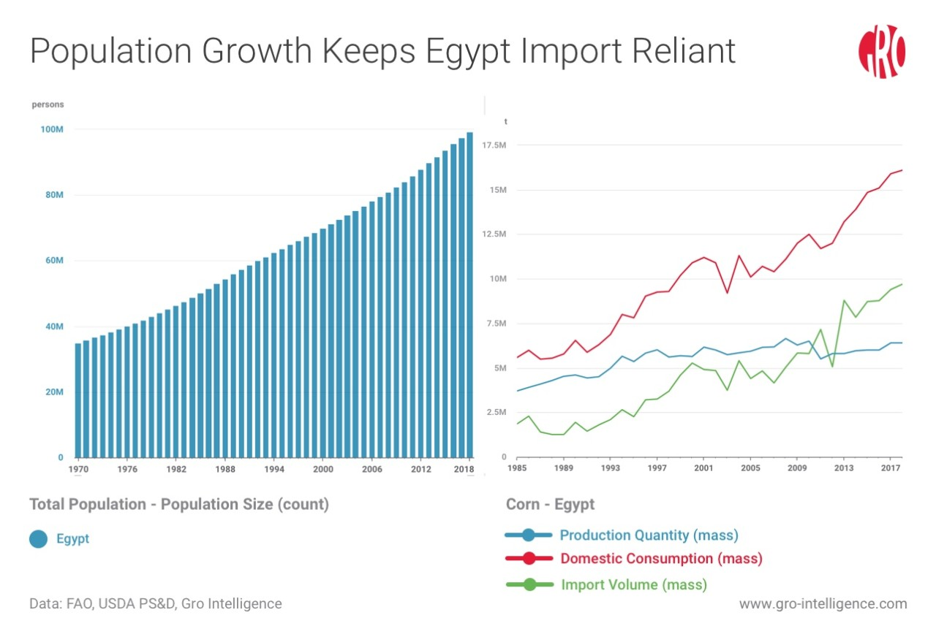Using the ESP32 camera, we were able to see the plants and distinguish between the ripe ones and the rotten ones. We are also working on linking it to artificial intelligence so that it works automatically.

In the event of expansion of the project, it will increase the productivity of the crop produced per acre and reduce the price of the food product, which will increase national income and satisfy the population’s hunger needs, and we can export the surplus abroad.

Results and Analysis (Cont.)

**Project-specific analyses**

**Scientific basis:**

Soil salinity has a specific number that, when it increases or decreases, affects the quality of the soil and its ability to be cultivated. There is a soil sensor that can measure the percentage of its salinity. In this way, we can know the quality of the soil and the type of plant that should be planted in it.

Drip irrigation saves water and is better than flood irrigation and saves more than 80% of water. In this way, we can calculate each plant and the amount of water it needs without wasting it.

Ripe fruits are saturated with color, while faded fruits are immature. We can use the camera to determine by color or by artificial intelligence to determine which plants should be picked and collected.

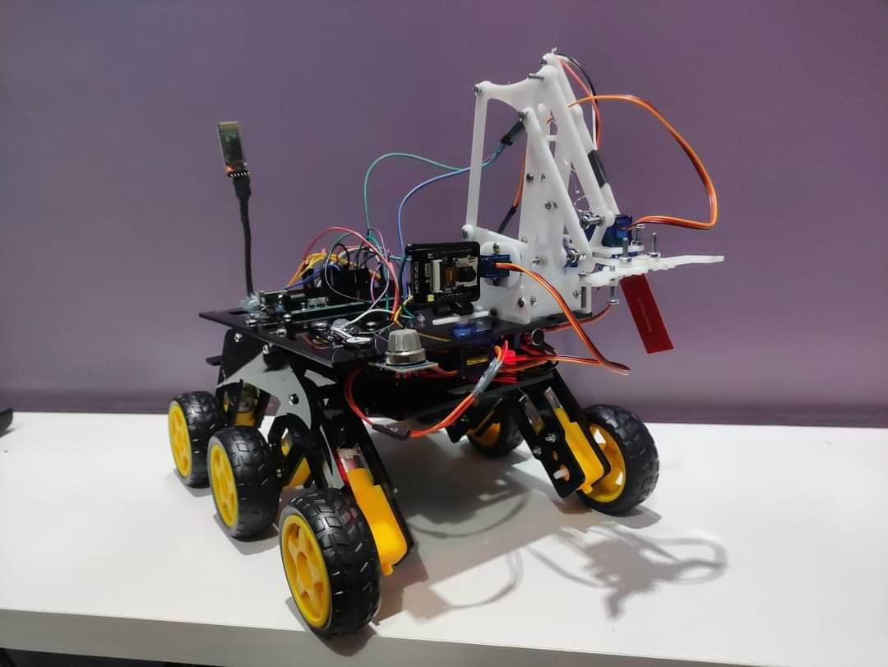**Positive results:**

After conducting all the experiments, we succeeded in measuring the soil salinity and the percentage of gases, determining the fruits and their quality, helping the farmer and irrigating the crops in a short time.

**Negative results:**

But we noticed that we must make many modifications and developments in the robot, for example that we must use batteries with a larger capacity so that it works for a longer time, and that we must increase its height slightly so that it does not collide with rocks.

1. Conclusions and Recommendations

**Conclusion:**

There are many agricultural crops in Egypt that we cannot grow correctly and monitor their growth due to the farmers’ lack of experience and their inability to monitor large areas of agricultural land at one time, and also the farmers’ use of incorrect methods for irrigating plants, which wastes water, and also their incorrect use of pesticides. Which reduces the quality of production and the quantity of agricultural crops produced by Egypt, which affects the amount of food available in Egypt. Which humans feed on, and it mainly affects industry and the transformation of products, which affects the problem of unemployment and national income.

To solve this problem, we can use a low-cost solar-powered robot to preserve the environment, programmed via an Arduino chip, that can identify agricultural crops, spread grains in the ground, plant them, and also water them via a timer present in it. For example, we water the plants every 12 hours and it is connected via a Bluetooth chip so we can control it via phone. By knowing the number of areas that have been planted through ultrasound sensors and also through the camera, we can identify ripe and rotten fruits and carry out the sorting and separation process for them, as well as determine the type of plant and harvest them in the correct way without causing any harm. We can also make it move the fruits and carry them anywhere we want using the claw on the front of the robot that closes and opens using a servo motor. Insecticides can also be sprayed to protect the plant from insects and pests that could harm it, and this saves me a lot of effort and hardship. The farmer at a price less than (2600 pounds)

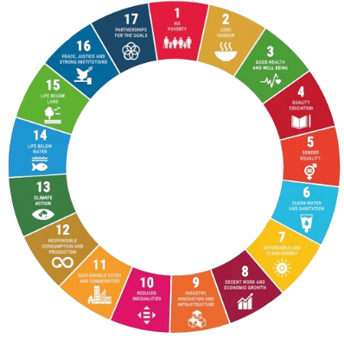After using this robot, it will work to increase the amount of agricultural production, reduce pollution, preserve the amount of Nile water, and solve many problems related to sustainable development goals, such as:

* Eliminating poverty
* Eliminate hunger
* Good health and wellness
* Clean water
* Use clean energy
* Decent work and economic growth
* Responsible consumption and production
* Climate action
* Life in the wild

**Recommendations:**

We know that everything on our planet is always progressing, developing, and constantly progressing, so there are many things that we can add to our robot, such as:

* Work with more than one robot and create a system between them to divide the tasks so that we can cover the largest area of agricultural land in the shortest possible time.
* Connecting the robot to greenhouses to create the appropriate environment for growing all crops at any time of the year.
* Creating a website for each farm that can display the agricultural crops it has produced automatically through robots to create a store for food crops.

BIBLIOGRAPHY

1) Billingsley, J. (Ed.). Robotics and Automation for Improving Agriculture. Burleigh Dodds Science Publishing, 2019, <https://doi.org/10.1201/9780429266737>.

2)Esco, S., et al. "Smart Agriculture and Digital Twins: Applications and Challenges in a Vision of Sustainability." European Journal of Agronomy, vol. 146, 2023, <https://doi.org/10.1016/j.eja.2023.126809>.

3) Katz, J. E., et al. (Eds.). Perceiving the Future through New Communication Technologies: Robots, AI and Everyday Life. Palgrave Macmillan, 2021, <https://doi.org/10.1007/978-3-030-84883-5>.

4) Kerr, T., & Barrett, S. F. Arduino IV: DIY Robots: 3D Printing, Instrumentation, and Control. Springer, 2022, <https://doi.org/10.1007/978-3-031-11209-6>.

5) Lago-Olveira, S., El-Areed, S. R. M., Moreira, M. T., & González‐García, S. (2023)Improving environmental sustainability of agriculture in Egypt through a life-cycle perspective. Science of the Total Environment, 890, 164335. <https://doi.org/10.1016/j.scitotenv.2023.164335>

6) Moury, M., ElFetyany, M., Meleha, A., & El-Bialy, M. A. (2023). Productivity and profitability of modern irrigation methods through the application of on-farm drip irrigation on some crops in the Northern Nile Delta of Egypt. Alexandria Engineering Journal /Alexandria Engineering Journal, 62, 349–356. <https://doi.org/10.1016/j.aej.2022.06.063>

7) Pandey, K., et al. (Eds.). Artificial Intelligence and Smart Agriculture: Technology and Applications. Springer, 2024, <https://doi.org/10.1007/978-981-97-0341-8>.

8) Paul, S., & Chang, J. (2024). Consequent pole flux modulated linear actuator under winding chang and field oriented control driving conditions for long track and multi-track agricultural robot. Computers and Electronics in Agriculture, 217, 108582. <https://doi.org/10.1016/j.compag.2023.108582>

9) Poojari, M., et al. "Computational Modelling for the Manufacturing of Solar-Powered Multifunctional Agricultural Robot." International Journal on Interactive Design and Manufacturing (IJIDeM), 2023, pp. 1–12, <https://doi.org/10.1007/s12008-023-01291-y>

APPENDIX I

Project Programs / Codes / Flowcharts

#include <Servo.h>

void processRobotCommand(char command) {

switch(command) {

case 'F':

moveForward();

break;

case 'B':

moveBackward();

break;

case 'L':

turnLeft();

break;

case 'R':

turnRight();

break;

case 'G':

moveForwardLeft();

break;

case 'I':

moveForwardRight();

break;

case 'H':

moveBackwardLeft();

break;

case 'J':

moveBackwardRight();

break;

case 'S':

stopRobot();

break;

case 'A':

Gassensor();

break;

case 'l':

Camleft();

break;

case 'r':

void loop() {

if (Serial.available() > 0) {

char receivedChar = Serial.read();

char command = bluetooth.read();

if (receivedChar == 'U' || receivedChar == 'D' || receivedChar == 'V' ||

receivedChar == 'W' || receivedChar == 'X' || receivedChar == 'Y') {

processArmCommand(receivedChar);

} else {

processRobotCommand(receivedChar);

}}}

void processArmCommand(char command) {

switch(command) {

case 'U':

moveShoulderUp();

break;

case 'D':

moveShoulderDown();

break;

case 'V':

moveElbowUp();

break;

case 'W':

moveElbowDown();

break;

case 'X':

openGrip();

break;

case 'Y':

closeGrip();

break;}}

#include <SoftwareSerial.h>

SoftwareSerial bluetooth(0, 1);

Servo shoulderServo;

Servo elbowServo;

Servo gripServo;

Servo camServo;

int gasSensorPin = A0;

int watersensor = A1;

int soilsensor = A2;

int armAngle ;

int speed = 150;

int speedsec;

#define in1 5

#define in2 6

#define in3 10

#define in4 11

#define LED 13

#define Buzzer 12

#define Airpump 9

int command;

int speedArm = 10;

void setup() {

Serial.begin(9600);

shoulderServo.attach(2);

elbowServo.attach(3);

gripServo.attach(7);

camServo.attach(4);

bluetooth.begin(9600);

pinMode(gasSensorPin, INPUT);

pinMode(soilsensor, INPUT);

pinMode(watersensor, INPUT);

pinMode(in1, OUTPUT);

pinMode(in2, OUTPUT);

pinMode(in3, OUTPUT);

pinMode(in4, OUTPUT);

pinMode(LED, OUTPUT);

pinMode(Buzzer, OUTPUT);

pinMode(Airpump, OUTPUT);}

APPENDIX I (Cont.)

Project Programs / Codes / Flowcharts

Camright();

break;

case 'w':

Watersensor();

break;

case 'h':

Soil();

break;

case 'M':

Ledon();

break;

case 'f':

Ledoff();

break;

case 'N':

BUZ();

break;

case 'a':

Air();

break;

case '0':

speed = 100;

break;

case '1':

speed = 60;

break;

case '2':

speed = 150;

break;

case '3':

speed = 165;

break;

case '4':

speed = 178;

break;

case '5':

speed = 191;

break;

void Ledon() {

digitalWrite(LED,1);}

void Ledoff() {

digitalWrite(LED,0);}

void BUZ() {

digitalWrite(Buzzer,1);

delay(500);

digitalWrite(Buzzer,0);}

void Air() {

digitalWrite(Airpump,255);}

void Soil(){

int soil = analogRead(soilsensor)

Serial.println(soil);

bluetooth.print(soil); bluetooth.println(soil);

Serial.print("");

Serial.println(soil);}

void Gassensor(){

int gasValue = analogRead(gasSensorPin);

Serial.println(gasValue);

bluetooth.print(gasValue);

bluetooth.println(gasValue);

Serial.print("");

Serial.println(gasValue);}

void Watersensor(){

int Water = analogRead(watersensor);

Serial.println(Water);

bluetooth.print(Water);

bluetooth.println(Water);

Serial.print("");

Serial.println(Water);}

void stopRobot() {

analogWrite(in1, 0);

analogWrite(in2, 0);

analogWrite(in3, 0);

analogWrite(in4, 0);}

void Camleft() {

armAngle = constrain(armAngle + speedArm, 0, 180);

camServo.write(armAngle);}

void Camright() {

armAngle = constrain(armAngle - speedArm, 0, 180);

camServo.write(armAngle);}

void moveShoulderUp() {

armAngle = constrain(armAngle + speedArm, 0, 180);

shoulderServo.write(armAngle);}

void moveShoulderDown() {

armAngle = constrain(armAngle - speedArm, 0, 180);

shoulderServo.write(armAngle);}

void moveElbowUp() {

armAngle = constrain(armAngle + speedArm, 0, 180);

elbowServo.write(armAngle);}

void moveElbowDown() {

armAngle = constrain(armAngle - speedArm, 0, 180);

elbowServo.write(armAngle);}

void openGrip() {

armAngle = constrain(armAngle + speedArm, 0, 180);

gripServo.write(armAngle);}

void closeGrip() {

armAngle = constrain(armAngle - speedArm, 0, 180);

gripServo.write(armAngle);}

case '6':

speed = 204;

break;

case '7':

speed = 216;

break;

case '8':

speed = 229;

break;

case '9':

speed = 242;

break;

case 'q':

speed = 255;

break;}}

void moveForward() {

analogWrite(in1, speed);

analogWrite(in3, speed);}

void moveBackward() {

analogWrite(in2, speed);

analogWrite(in4, speed);}

void turnLeft() {

analogWrite(in3, speed);

analogWrite(in2, speed);}

void turnRight() {

analogWrite(in4, speed);

analogWrite(in1, speed);}

void moveForwardLeft() {

analogWrite(in1, speedArm);

analogWrite(in3, speed);}

void moveForwardRight() {

analogWrite(in1, speed);

analogWrite(in3, speedArm);}

void moveBackwardRight() {

analogWrite(in2, speed);

analogWrite(in4, speedArm);}

void moveBackwardLeft() {

analogWrite(in2, speedArm);

analogWrite(in4, speed);}

APPENDIX II

Project Members Role

1. **Advisor Information:**

|  |  |  |  |
| --- | --- | --- | --- |
| **No.** | **Name** | **Email** | **Phone No.** |
| 1 | Dr/Randa Hosni Mohamed | [randahosni7@gmail.com](mailto:randahosni7@gmail.com) | 01001741800 |

1. **Team Member Roles:**

|  |  |  |  |  |
| --- | --- | --- | --- | --- |
| **No.** | **Name** | **Email** | **Phone No.** | **Project Role(s)** |
| 1 | Amr Elkhooly | [amr.2323032@stemqena.moe.edu.eg](mailto:amr.2323032@stemqena.moe.edu.eg) | 01001185869 | Software |
| 2 | Yassen Ahmed | [yassen.2323053@stemqena.moe.edu.eg](mailto:yassen.2323053@stemqena.moe.edu.eg) | 01278697377 | Software |
| 3 | Mazen Nasser | [mazen.2323038@stemqena.moe.edu.eg](mailto:mazen.2323038@stemqena.moe.edu.eg) | 01149618698 | Hardware |
| 4 | Abdelrahmn Samy | [AbdElRahman.2323018@stemqena.moe.edu.eg](mailto:AbdElRahman.2323018@stemqena.moe.edu.eg) | 01018784768 | Hardware |
| 5 | Yassin Hatem | [yassin.2323051@stemqena.moe.edu.eg](mailto:yassin.2323051@stemqena.moe.edu.eg) | 01096781551 | Hardware |
| 6 | Judy Saeed | [judy.2323513@stemqena.moe.edu.eg](mailto:judy.2323513@stemqena.moe.edu.eg) | 01143043839 | Researcher |
| 7 | Yara Omar | [yara.2323556@stemqena.moe.edu.eg](mailto:yara.2323556@stemqena.moe.edu.eg) | 01228009660 | Researcher |
| 8 | Hana Hamed | [hana.2323555@stemqena.moe.edu.eg](mailto:hana.2323555@stemqena.moe.edu.eg) | 01274039907 | Researcher |
| 9 |  |  |  |  |
| 10 |  |  |  |  |

APPENDIX III

Project Schedule

**Project Tasks Timeline:**

|  |  |  |
| --- | --- | --- |
| **Time Frame** | **Task To Be Completed** | **Status\*** |
| October 2023 | Get the idea | Done |
| November 2023 | Start research and do a background about the idea | Done |
| December 2023 | Start in our prototype | Done |
| January 2024 | Finish the prototype | Done |
| February 2024 | Do test plan for the first time | Done |
| March 2024 | Add modifications to the robot and create additions | In Progress |
| April 2024 | Try the prototype for the second time | Done |
| May 2024 | Collect data in trial one and trial two | In Progress |
| June 2024 | Get a response | Planning |

***\* Please write down one of these in the task status (Planning, In Progress, Done).***