**Precedence Diagramming Method**

| i | Task | Duration (days) | Dependencies |
| --- | --- | --- | --- |
| 1 | NEW TEAMS RECRUITMENT | 60 | 0 |
| 2 | Define Tasks and Responsibilities for the new team | 7 | 1 |
| 3 | Select Trainers from the Existing Team | 7 | 2 |
| 4 | Provide Theoretical Training | 14 | 3 |
| 5 | Implement On-the-Job Training | 30 | 4.14 |
| 6 | Monitor and Evaluate Performance | among the process | 3 |
| 7 | Tender CONTRACT Negotiation and Setting Terms: | 7 | 0 |
| 8 | Drafting the Contract | 4 | 7 |
| 9 | Legal Review | 3 | 8 |
| 10 | Signing and Documentation | 2 | 9 |
| 11 | Research and send RFPs to vendors. | 14 | 0 |
| 12 | SELECT VENDOR AND DEVOLOP CONTRACT | 14 | 11 |
| 13 | CONSTRUCTION PHASE | 60 | 12 |
| 14 | FINISHING THE BUILDING FACILITIES | 21 | 13 |
| 15 | Acceptance Inspection | 7 | 14 |
| 16 | Identify required equipment | 7 | 0 |
| 17 | Research Equipment Vendors | 14 | 16 |
| 18 | Purchase Equipment | 14 | 17 |
| 19 | Install Equipment | 16 | 18,14 |

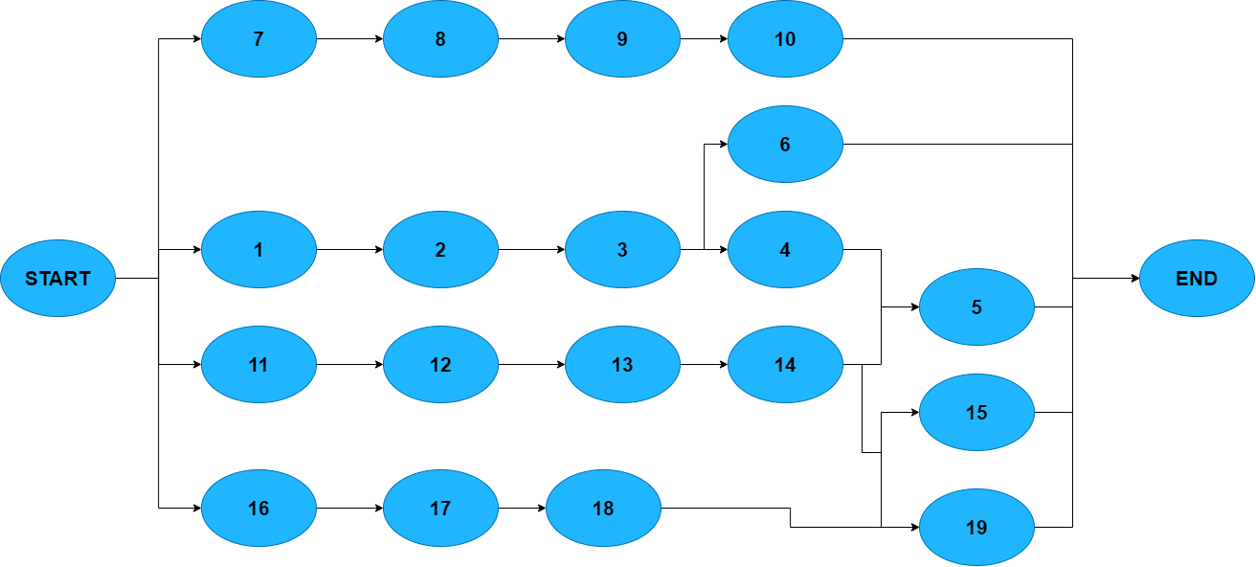

**Path 1:** START → 1 → 2 → 3 → 4 → 5 → END

**Path 2:** START → 7 → 8 → 9 → 10 → END

**Path 3:** START →11→12→13→14→5→END →→→→→→→ CRITICAL PATH

**Path 4:** START →11→12→13→14→15→END

**Path 5:** START →11→12→13→14→19→END

**Path 6:** START →16→17→18→19→END