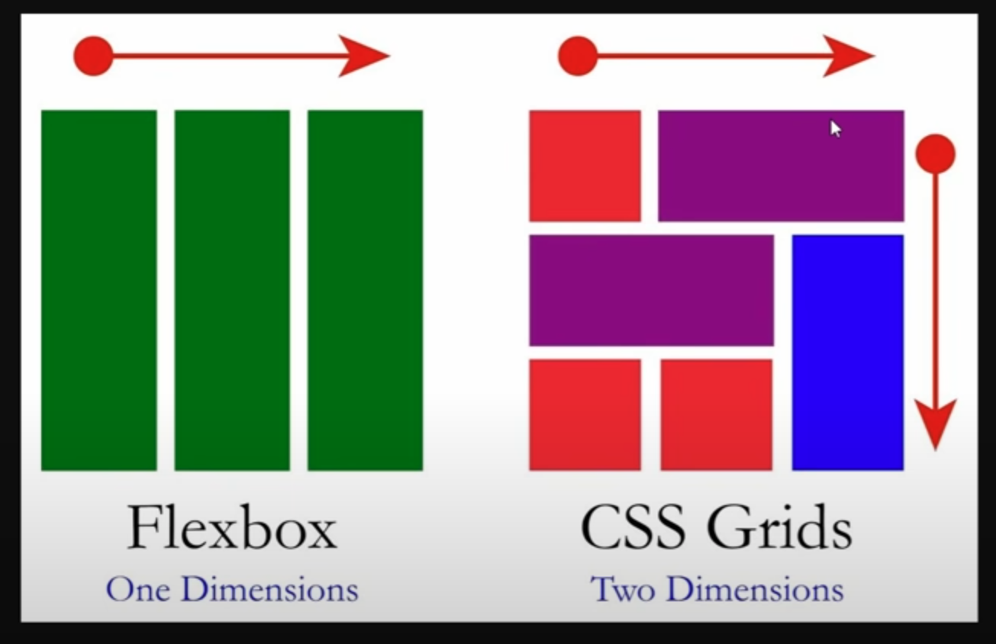https://www.figma.com/design/DzKEw6CANvnQkbzPEvNW6s/E-commerce-Website-Template--Freebie---Community-?node-id=0-1&p=f&t=UTXNVMKk4or7fUxO-0

(NAVBAR – BONUS, on both mobile and desktop)