AYAAM – Project Documentation

1. Introduction :

AYAAM is a Single Page Application (SPA) E-commerce platform designed to serve three main roles: Customer, Seller, and Admin.
It provides a smooth browsing and shopping experience using JavaScript modules, hash-based routing, and lazy-loaded pages.
The project is built with plain JavaScript, Bootstrap, CSS, and FontAwesome without external frameworks or APIs.
All data is handled using LocalStorage and SessionStorage for persistence.

GitHub Repository : Githup
Live Demo : AYAAM.com

2. Features :

2.1 Customer
Sign up and login
Browse products by category, brand, filters
Add products to cart
Checkout flow with order confirmation
View and manage profile information

2.2 Seller
Add, edit, and delete products
Manage product stock, discounts, and offers
View sales dashboard with performance insights

2.3 Admin
Manage users (customers & sellers)
Manage all products
Monitor system reports
Role-based access control

3. Technical Architecture

3.1 SPA and Routing
- Hash-based routing (#/home, #/catalog, #/product)
- Router module handles navigation and lazy loads the required page modules.
- Role-based protection:
  - Customer-only routes (checkout, profile, cart)
  - Seller-only routes (seller dashboard)
  - Admin-only routes (admin dashboard)
- Fallback to /404 page for unknown routes.

3.2 Data Management
- LocalStorage: Products, Users, Orders (seeded on first load)
- SessionStorage: User sessions, redirects, and temporary states
- No backend / API integration (mock data only)

3.3 Shared Components
- components/ → reusable UI building blocks
  - Cart
  - Landing
  - Dashboard elements
  - Layout
  - UI
- scripts/utils/ → helper functions
  - Loader utility
  - Navigation
  - Storage abstraction
  - Data seeding

3.4 Security & Role Management :
role-based access for Admin, Seller, Customer .

3.5 Technology Stack
Plain JS, Bootstrap, CSS, Font Awesome, LocalStorage/SessionStorage .

4. Project Structure :

E-COMMERCE-ITI
│── assets/ # CSS, images, JS assets
│── components/ # Reusable components (auth, cart, profile, etc.)
│── data/ # Local JSON/data & seeders
│── pages/ # SPA pages (Home, Catalog, Product, Cart, Admin, Seller, etc.)
│── scripts/ # Core scripts (router, utils, cartScripts)
│── theme-files/ # Extra theme/config files
│── index.html # Entry point
│── app.js # App initialization & routing
│── README.md

5. Data Model :
The project uses object-oriented modules (User, Product, Order) to structure and enforce data consistency. These classes wrap the raw JSON objects and add validation, formatting, and serialization (toJSON()) for safe storage in LocalStorage / SessionStorage.
4.1 User Model (User Class) :
Represents system users with role-based access control
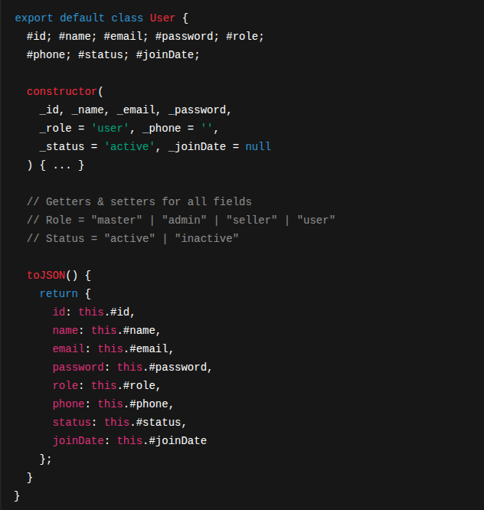
Notes
- Enforces roles (master, admin, seller, user).
- Defaults to "user" role.
- toJSON() makes the object serializable for LocalStorage.
- Plain-text passwords only for prototype/demo purposes.

4.2 Product Model (Product Class) :
Represents catalog products, including categories, variants, and inventory.
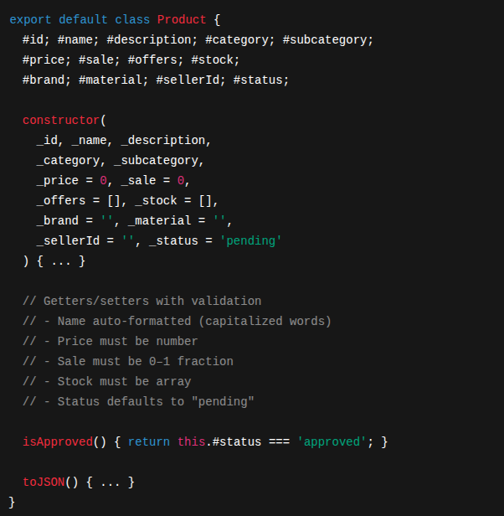
Notes
- Enforces strict validation on setters (e.g., Sale between 0 and 1).
- Normalizes capitalization for Name, Category, Subcategory, and Brand.
- Stock structure:

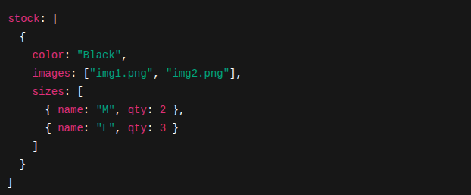
- isApproved() is used to filter products in the catalog.

4.3 Order Model (Order Class)
Encapsulates customer orders with private fields and auto-calculated totals.
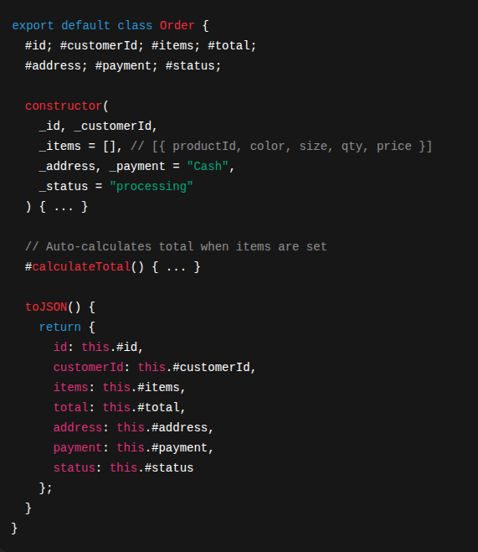
Notes
- Total is always consistent, recalculated automatically.
- Payment defaults to "Cash".
- Status workflow: "processing" → "shipped" → "completed" | "canceled".

4.4 Relationships
- User → Product
  - Sellers (role: seller) own multiple products via Product.SellerId.
- User → Order
  - Customers (role: user) create orders via Order.CustomerId.
- Product → Order
  - Orders reference products by productId inside Order.Items[].

6. Pages & Views (SPA Routes) :
AYAAM is built as a Single Page Application (SPA) using a custom Router that listens to hashchange and DOMContentLoaded events.
Each route corresponds to a page module dynamically imported (lazy-loaded) only when needed. This optimizes performance and reduces initial load size.

5.1 Public Routes
Route | View Module | Access | Description
/home | HomePage.js | Public | Landing page with featured products and categories.
/about | AboutPage.js | Public | Information about the project/brand.
/catalog | CatalogPage.js | Public | Displays product list with filters (brand, category, price, etc.).
/product | Product.js | Public | Single product details page with images, sizes, colors, and add-to-cart.
/info | SupportPage.js | Public | Customer support, FAQs, or static info page.
/404 | NotFound.js | Public | Fallback page for invalid routes.

5.2 Authentication Routes
Route | View Module | Access | Description
/login | LoginPage.js | Public | User login form, authenticates and stores session in SessionStorage.
/signup | SignupPage.js | Public | Registration form for new customers/sellers.

5.3 Customer Routes
Route | View Module | Access | Description
/cart | CartPage.js | Customer only | Shopping cart, manages items before checkout.
/checkout | CheckOutPage.js | Customer only | Checkout flow with address, payment, and confirmation.
/profile | Profile.js | Customer only | User profile: personal info, past orders, settings.

5.4 Seller Routes
Route | View Module | Access | Description
/seller | SellerDashboard.js | Seller only | Dashboard for sellers: add/edit/delete products, view sales.

5.5 Admin Routes
Route | View Module | Access | Description
/admin | AdminDashboard.js | Admin/Master | Manage users, approve/reject products, oversee reports.

5.6 Routing Logic
- Routes are matched via longest prefix match in Router.resolve().
- Restricted routes check the current user role before rendering.
  - If unauthorized → redirect to /404.
  - If unauthenticated → redirect to /login.
- Dynamic imports ensure lazy-loading:

7. User Flows
- Customer flow: Signup → Browse → Add to cart → Checkout → Profile
- Seller flow: Login → Add products → Manage stock/offers → View dashboard
- Admin flow: Login → Manage users → Manage products → Reports

8. Team Contributions
The development of AYAAM was a collaborative effort by a 5-member team. Each member was responsible for specific modules and features, ensuring clear ownership and efficiency.
Team Member | Contributions
Yasser | - Implemented Authentication & Authorization system.  - Built Login & Signup flows.  - Handled Role-Based Access Control (RBAC) across routes.  - Managed user session state using LocalStorage/SessionStorage.  - Developed Home Page UI and logic.
Ahmed beltagy | - Developed Product Catalog (Product List with filters, search).  - Implemented Product Card component and reusable catalog UI.  - Designed and coded Filter System (category, brand, size, color, price,  discount, offers).  - Built Single Product Page with images, details, and add-to-cart.
Azza | - Implemented Checkout Page (address, payment, confirmation).  - Developed Order saving mechanism.  - Added Order History view for customers.
Mariam | - Developed Seller Dashboard.  - Features: Add / Edit / Delete products, manage inventory (stock, price,  discount).  - Built Incoming Orders page for sellers.  - Added Sales History tracking.
Ahmed Osama | - Implemented Admin Dashboard.  - Built full User Management (CRUD) system.  - Developed Product Review & Approval workflow.  - Oversaw Reports & Control Panel for admins/master role.

9. Conclusion
AYAAM demonstrates a modular SPA architecture for an e-commerce platform using only Vanilla JS with Bootstrap styling.
It provides role-based features for customers, sellers, and admins, showcasing real-world flows in a simplified educational project.

