

Countries Coronavirus Worldometer
Process Design Document (PDD)

Raya Information Technology
Authored by: Yasser Salah Mohamed
Raya Information Technology
Authored by: Your Name



Process Design Document History

Date | Version | Role | Name | Organization | Function | Comment
09.09.2025 | 1.0 | Author | Mohamed Mesbah | N/A | SME | Creation v 1.0
10.09.2025 | 1.1 | Reviewer | Yasser Salah | Raya | BA | Approved v 1.0

Table of Contents
1. Objective 4
1.1 Business Objectives and Benefits 4
2. Current Process 4
2.1 Process Overview 4
2.2 Standard of Metrics 4
2.3 Volume of data 5
3. Business Rules 5
4. High Level Process Diagram 5
5. Detailed Process Steps – AS IS 6
6. In Scope for RPA 7
7. Out of Scope 7
8. Non-process requirements 7
8.1 Systems 7
8.2 Reporting 7
8.3 Archiving 7
8.4 Security & data retention 7
9. Exception Handling 8
9. Escalations 8

Objective
The objective of this process is to automate the retrieval of Coronavirus data by country from the Worldometer website. The bot will open a browser, access the website, extract the required data (such as cases, deaths, and recoveries), and insert the extracted information into a Notepad file for reporting and record-keeping purposes.

Business Objectives and Benefits

Objectives |  | Expected Benefits
Automate the retrieval of Coronavirus data by country from the Worldometer website and save it into Notepad. | - Saves time by eliminating manual data collection.  - Reduces human errors in copying data.  - Ensures consistent and up-to-date information.  - Provides quick access to structured data for reporting.

Current Process

Process Overview

The user opens a browser and navigates to the Worldometer website. After the page loads, the user manually extracts the Coronavirus data by country (cases, deaths, and recoveries). The user then opens Notepad, types or pastes the collected data, and saves it locally. With automation, these manual steps of browsing, data extraction, typing/pasting into Notepad, and file saving are replaced by an automated process that executes them without user intervention.

Standard of Metrics

General information about the process selected for RPA, prior to automation:

Process name | Countries Coronavirus Worldometer
Function | Extract Coronavirus data and save to Notepad.
Department | Data Reporting
Process short description | Automates extracting Coronavirus data from Worldometer and saving it into Notepad.
Process schedule | Daily
#of items process/month | ~30 (once per day)
Average cycle time | ~2 minutes
Average handling time | ~3 minutes (manual process)
Peak period(s) | N/A
# of FTE supporting this activity | 1 FTE
Input Data | Worldometer Coronavirus webpage
Output Data | Coronavirus data saved in Notepad file
Return on investment | Saves manual effort and time by replacing daily repetitive tasks with automation.

Volume of data

Activity | Time taken per month (hours) | Volume of data to be processed
Open browser and navigate to Worldometer | 1 | 30 (once daily)
Extract Coronavirus data by country | 2 | 30 (once daily)
Open Notepad and enter data | 1.5 | 30 (once daily)
Save Notepad file | 0.5 | 30 (once daily)
Total | 5 hours/month | ~30 records/month

Business Rules

BR# | Requirement | Additional Information
#BR001 | The bot must open the Worldometer Coronavirus webpage daily. | Website URL should be predefined and stable.
#BR002 | Extract country-level Coronavirus data (cases, deaths, recoveries). | Data should match the structure shown on the website.
#BR003 | Store extracted data into Notepad. | File should be saved with a clear name (e.g., CoronaData_ddMMyyyy.txt).
#BR004 | Save the Notepad file locally. | Default save path should be configurable.

High Level Process Diagram
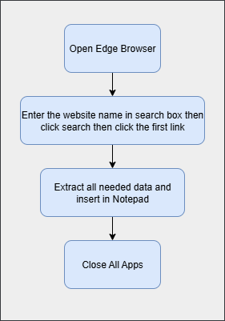

Detailed Process Steps – AS IS
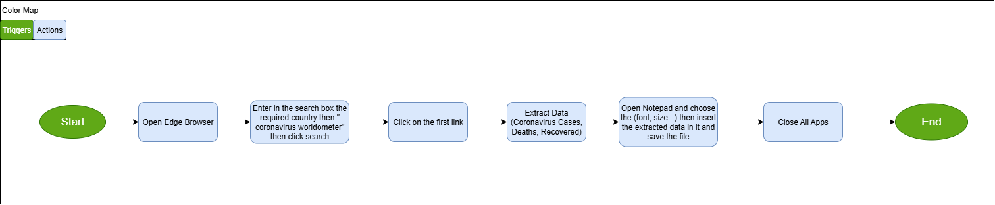

Steps | Description | Screenshots | Exception Handling
1 | Open Browser |  | #SE002
2 | Enter the required country then "Coronavirus Worldometer" in the search box then click search | 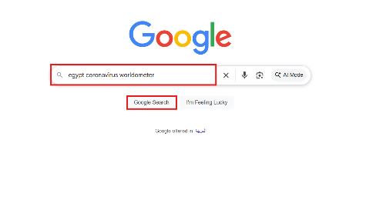
3 | Click the first link | 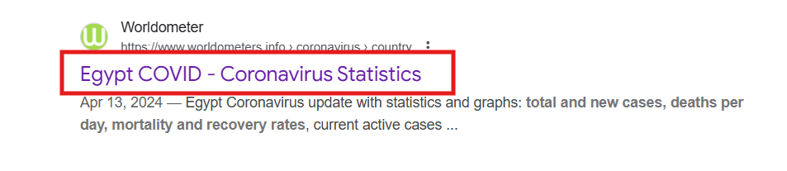 | #SE003
4 | Extract Data (Coronavirus Cases, Deaths, Recovered) | 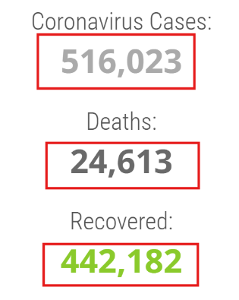 | #BE001 /  #BE002 /  #BE003
6 | Open Text File (Notepad)  To Extract data into | 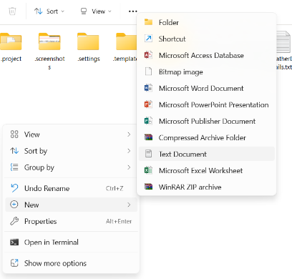 | #SE002
7 | Close All Apps

In Scope for RPA

The activities and exception in of scope for RPA, in this automation workflow /sequence are listed here:
-  Full Scope of the process for RPA - to be 100% automated

Out of Scope
- There are no activities out of scope for RPA …

Non-process requirements

Systems

System | Usage | Frequency
Edge Browser | To Open the required website | Daily
Notepad | To store the extracted data | Daily

Reporting

Report name | Source | Purpose
Daily Coronavirus Data Report | Worldometer Website | To provide updated statistics of Coronavirus cases, deaths, and recoveries by country

Archiving

Generated Coronavirus data files and process logs must be stored securely in designated folders for future reference and audit purposes, with retention based on organizational policies.

Security & data retention

Extracted Coronavirus data and process logs must be stored in secure local folders with restricted access. Data should be retained for a defined period (e.g., 12 months) in compliance with organizational policies, after which it should be archived or deleted securely.

Exception Handling

- Business Exception

#Business Exception no. | Business Exception | Description | Expected Action
#BE001 | Missing Data | Required fields (cases, deaths, recoveries) are not available on the Worldometer webpage. | Log the issue and notify the business user via email.
#BE002 | Incorrect Data Format | Extracted data does not follow the expected numeric format (e.g., text instead of numbers). | Skip invalid records, log the error, and continue with remaining data.
#BE003 | Incomplete Data | Only partial country data is extracted due to page load or structure issues. | Retry extraction; if still incomplete, log error and escalate to business support.

- System/Application Exception

# System Exception no. | Exception | Description | Expected Action
#SE001 | Network connectivity issues | Loss of internet prevents access to the website. | Retry connection; alert IT if persistent; pause automation until connection is restored.
#SE002 | Notepad Error | Notepad fails to open or save the file. | Retry saving; if unsuccessful, log error and notify business user.
#SE003 | low Page Load / Timeout | Website takes too long to load data. | Implement wait/retry mechanism; log timeout if limit exceeded.

Escalations

For immediate contacts for the process automation project, kindly contact the respective contact on the table below:

Email Address | Roles | Responsibilities
rpa-team@company.com | RPA Developer | Investigate and fix automation failures.
qa-lead@company.com | Business User | Validate extracted data and handle business-related issues.
support@company.com | IT Support | Resolve technical/system issues like browser or file errors.

