

Random Weather Generator
Process Design Document (PDD)

Raya Information Technology
Authored by: Yasser Salah Mohamed
Raya Information Technology
Authored by: Your Name



Process Design Document History

Date | Version | Role | Name | Organization | Function | Comment
08.09.2025 | 1.0 | Author | Mohamed Mesbah | N/A | SME | Creation v 1.0
09.09.2025 | 1.1 | Reviewer | Yasser Salah | Raya | BA | Approved v 1.0

Table of Contents
1. Objective 4
1.1 Business Objectives and Benefits 4
2. Current Process 4
2.1 Process Overview 4
2.2 Standard of Metrics 4
2.3 Volume of data 5
3. Business Rules 5
4. High Level Process Diagram 6
5. Detailed Process Steps – AS IS 6
6. In Scope for RPA 7
7. Out of Scope 7
8. Non-process requirements 8
8.1 Systems 8
8.2 Reporting 8
8.3 Archiving 8
8.4 Security & data retention 8
9. Exception Handling 9
10. Escalations 9

Objective
The objective of this process is to generate synthetic weather data by creating randomized yet realistic values for temperature, humidity, wind speed, precipitation, and weather conditions. This generated data can be used for testing, simulations, and demonstrations without depending on real-world weather APIs.
By introducing Robotic Process Automation (RPA), the process aims to:
- Eliminate the need for manual creation of test weather data, which is repetitive and time-consuming.
- Increase the speed and scalability of generating large volumes of synthetic weather records.
- Free up employees to focus on analysis, testing design, and higher-value tasks rather than routine data preparation.

Business Objectives and Benefits

Objectives | Expected Benefits
Automate the creation of artificial weather records such as temperature, humidity, wind, and precipitation. |  | Saves employees from repetitive and time-consuming manual data preparation.
Standardize how weather data is generated, stored, and distributed through automation. |  | Improves consistency and accuracy across all test datasets.
Enable large-scale generation of weather scenarios for different use cases. |  | Increases scalability and processing speed for handling high data volumes.

Current Process

Process Overview

The process begins when the user accesses the Random Weather Generator website. The user selects the required parameters (Climate, Season, or Supernatural Weather) and submits the request. The website generates random weather information including Description, temperature, wind, precipitation, and overall conditions. The results are displayed on the screen and can be copied for use in testing, simulations, or demonstrations.
With RPA, the bot automates this interaction by opening the website, entering the parameters, generating the weather data, extracting the results, and saving them in the required format. This removes manual effort and ensures fast, repeatable, and accurate data collection.

Standard of Metrics

General information about the process selected for RPA, prior to automation:

Process name | Random Weather Generator
Function | generate randomized weather data
Department | IT / Quality Assurance (Test Data Management)
Process short description | The process retrieves randomized weather data from the Random Weather Generator website by selecting parameters (climate, season, …). The results are extracted and stored for use in testing, simulations, or demonstrations.
Process schedule | On-demand or scheduled as needed (e.g., daily, weekly, or before specific testing/simulation activities).
#of items process/month | Approximately 200–500 weather records, depending on testing and simulation requirements.
Average cycle time | 2–3 minutes per run.
Average handling time | 1–2 minutes of manual effort per run before automation (reduced to near zero with RPA).
Peak period(s) | N/A
# of FTE supporting this activity | 1 FTE (part-time effort, primarily for data preparation and validation before automation).
Input Data | Parameters selected on the Random Weather Generator website (climate, season, supernatural weather).
Output Data | Weather Properties (Description, Temperature, …)
Return on investment | High ROI due to elimination of manual data preparation, faster generation of large datasets, reduced errors, and improved efficiency in testing and simulation processes.

Volume of data

Activity | Time taken per month (hours) | Volume of data to be processed
Accessing Random Weather Generator website | 3–4 hrs | ~200–500 records
Selecting parameters | 2 hrs | ~200–500 records
Generating weather data | 4–5 hrs | ~200–500 records
Extracting results | 6–7 hrs | ~200–500 records
Formatting and storing data | 8–10 hrs | ~200–500 records

Business Rules

BR# | Requirement | Additional Information
#BR001 | User (or bot) must access the Random Weather Generator website. | This is the starting point of the process.
#BR002 | Parameters (season, climate, and Supernatural Weather) must be selected before generation. | Ensures the weather data reflects the intended scenario.
#BR003 | The “Generate Weather” button must be clicked to produce results. | Triggers the creation of randomized weather data.
#BR004 | Weather output must be extracted from the website results. | Data is copied/downloaded for further use.

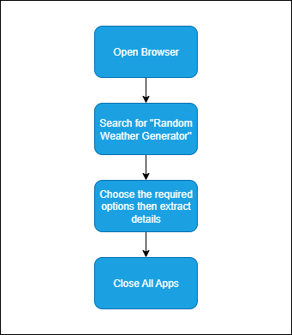
High Level Process Diagram

Detailed Process Steps – AS IS
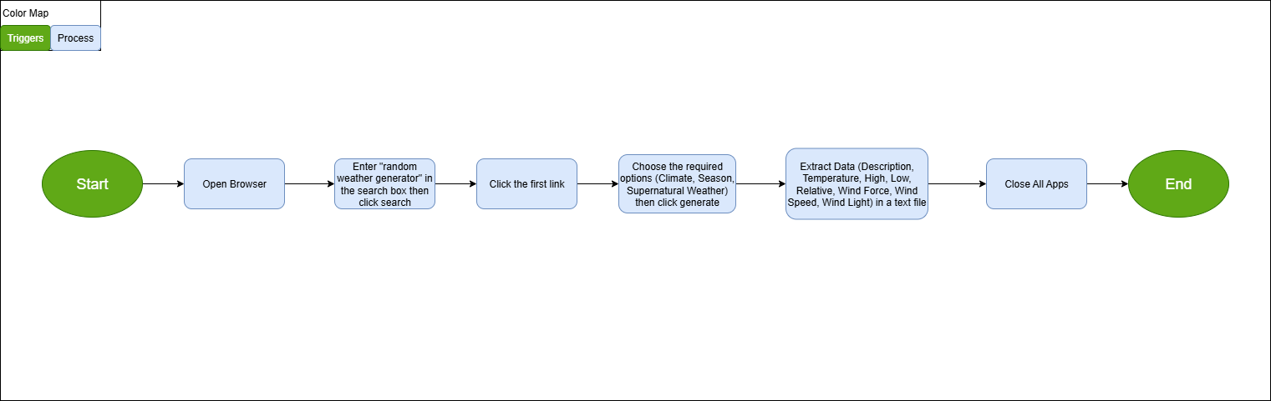

Steps | Description | Screenshots | Exception Handling
1 | Open Browser |  | #SE002
2 | Enter "random weather generator" in the search box then click search | 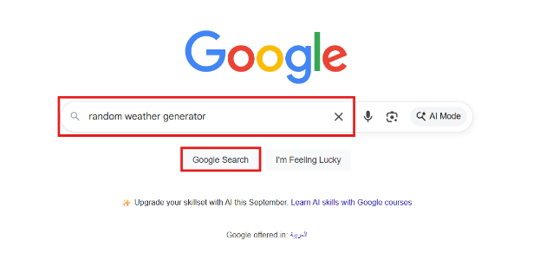
3 | Click the first link | 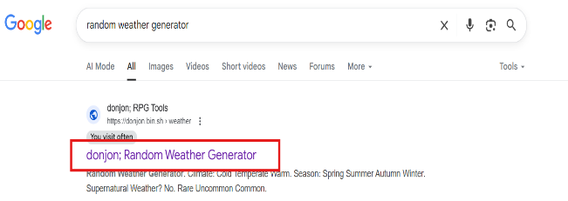 | #SE001
4 | Choose the required options (Climate, Season, Supernatural Weather) then click generate | 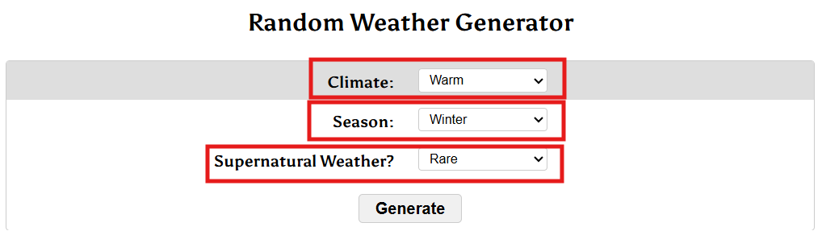
5 | Extract Data (Description, Temperature, High, Low, Relative, Wind Force, Wind Speed, Wind Light) | 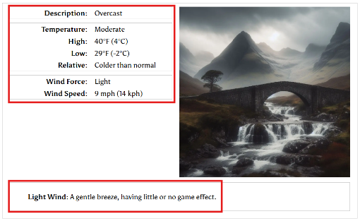 | #BE001
6 | Open Text File (Notepad)  To Extract data into | 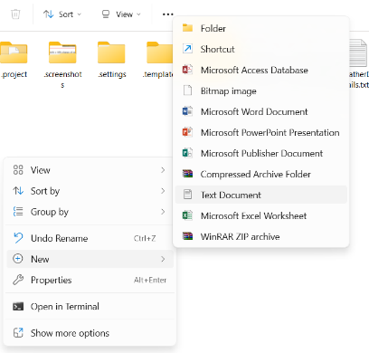
7 | Close All Apps | 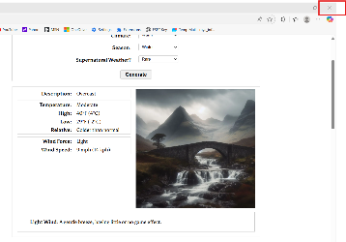

In Scope for RPA

The activities and exception in of scope for RPA, in this automation workflow /sequence are listed here:
-  Full Scope of the process for RPA - to be 100% automated

Out of Scope
- There are no activities out of scope for RPA …

Non-process requirements

Systems

System | Usage | Frequency
Edge Browser | To Open the required website | Daily (multiple times per day)
Notepad | To store the extracted data | Daily / As required per work item

Reporting

Report name | Source | Purpose
Weather Data Report | Random Weather Generator website output | Provides generated weather details for testing or simulations.
Process Execution Log | RPA tool (e.g., UiPath) | Tracks process runs, parameters used, and execution status for audit and monitoring.
Error/Exception Report | RPA tool and system logs | Highlights failures such as website unavailability or data extraction issues, enabling quick resolution.

Archiving

Generated weather data and process logs must be stored securely in designated folders or databases for future reference and audit purposes, with retention based on organizational policies.

Security & data retention

Access to the Random Weather Generator process and its outputs must be restricted to authorized users. All generated datasets and logs should be retained securely for a defined period (e.g., 12 months) in compliance with organizational policies and then archived or deleted as required.

Exception Handling

- Business Exception

#Business Exception no. | Business Exception | Description | Expected Action
#BE001 | Incorrect data format | Extracted results are not aligned with the expected format (e.g., missing columns, invalid values). | Raise exception for review.

- System/Application Exception

# System Exception no. | Exception | Description | Expected Action
#SE001 | System Downtime / Timeout Error | The website is offline or under maintenance. | Retry for 3 times. If still unavailable → raise System Exception.
#SE002 | Network connectivity issues | Loss of internet prevents access to the website. | Retry connection; alert IT if persistent; pause automation until connection is restored.

Escalations

For immediate contacts for the process automation project, kindly contact the respective contact on the table below:

Email Address | Roles | Responsibilities
rpa-team@company.com | RPA Developer | Handle bot failures, update automation logic, and maintain process continuity.
qa-lead@company.com | QA / Test Lead | Validate generated data, review exceptions, and ensure process meets testing requirements.
support@company.com | IT Support | Resolve website access, network, or system-related issues.

