

Verify Account Position
Process Design Document (PDD)

Raya Information Technology
Authored by: Yasser Salah Mohamed
Raya Information Technology
Authored by: Your Name



Process Design Document History

Date | Version | Role | Name | Organization | Function | Comment
28.08.2025 | 1.0 | Author | Mohamed Mesbah | ACME Systems Inc. | SME | Creation v 1.0
29.08.2025 | 1.1 | Reviewer | Yasser Salah | Raya | BA | Approved v 1.0

Table of Contents
1. Objective 4
1.1 Business Objectives and Benefits 4
2. Current Process 4
2.1 Process Overview 4
2.2 Standard of Metrics 5
2.3 Volume of data 6
3. Business Rules 6
4. High Level Process Diagram 7
5. Detailed Process Steps – AS IS 7
6. In Scope for RPA 9
7. Out of Scope 9
8. Non-process requirements 10
8.1 Systems 10
8.2 Reporting 10
8.3 Archiving 10
8.4 Security & data retention 10
9. Exception Handling 11
10. Escalations 12

Objective

The objective of this process is to verify client account positions by comparing data stored in ACME System 1 with information available in an external reference source. This verification ensures accuracy of financial records, supports compliance, and enables timely reconciliation.
By introducing Robotic Process Automation (RPA), the process aims to:
- Eliminate manual data entry and comparison efforts, which are repetitive and time-consuming.
- Reduce the risk of human error in financial reconciliation.
- Increase processing speed and consistency across large volumes of account data.
- Free up employees to focus on exception handling and higher-value tasks.

Business Objectives and Benefits

Objectives | Expected Benefits
Eliminate manual data entry and comparison | Saves employee time and effort by reducing repetitive work.
Reduce human error in reconciliation | Improves accuracy and reliability of financial records.
Increase processing speed and consistency | Allows large volumes of accounts to be processed faster and in a standardized way.
Free employees for exception handling and value-added tasks | Enhances productivity and employee engagement by shifting focus to higher-value activities.
Ensure auditability of processed transactions | Provides consistent logs and evidence for compliance and audit purposes.

Current Process

Process Overview

The Verify Account Positions process is responsible for validating that client financial data recorded in ACME System 1 matches information from an external reference source (e.g., account statements).
The process begins when a user logs into the ACME System and retrieves a list of client work items (type WI1). For each client, the user manually gathers account position data and cross-checks it against the reference source. Based on this comparison, the user determines whether the data is accurate or if discrepancies exist.
Finally, the outcome of the verification is updated back into ACME System 1 under the respective work item, marking it as Completed once processed.
This process is repetitive, rule-based, and high-volume, making it an ideal candidate for automation using RPA.

Standard of Metrics

General information about the process selected for RPA, prior to automation:

Process name | Verify Account Position
Function | Financial Data Validation / Reconciliation
Department | Finance / Accounting
Process short description | Verification of client account positions in ACME System 1 against external reference data to ensure accuracy and reconciliation.
Process schedule | Performed on a daily basis, depending on the availability of new WI1 work items in ACME System 1.
#of items process/month | Approximately 2,000 – 3,000 WI1 work items (volume may vary by business cycle).
Average cycle time | ~3–5 minutes per WI1 item (manual processing, including data retrieval, comparison, and update).
Average handling time | ~4 minutes per WI1 item
Peak period(s) | End of month, quarter, and fiscal year closings, when reconciliation volumes are significantly higher.
# of FTE supporting this activity | 2–3 full-time employees (depending on workload and reporting periods).
Input Data | Client account details from ACME System 1 (work item WI1) in the corresponding client financial data from the external reference source (e.g., statements or system reports).
Output Data | Updated WI1 work item in ACME System 1 with verification result (Rejected / Exception / Completed).
Return on investment | High – Automation reduces manual effort, lowers error rates, speeds up reconciliation, and frees 2–3 FTEs for higher-value tasks, delivering cost savings and improved accuracy.

Volume of data

Activity | Time taken per month (hours) | Volume of data to be processed
Logging into ACME System 1 | ~5 hours | N/A (single login per session)
Retrieving WI1 work items | ~15 hours | ~2,000–3,000 items / month
Accessing external data | ~25 hours | ~2,000–3,000 external records
Comparing account positions | ~150 hours | ~2,000–3,000 comparisons
Updating WI1 status | ~90 hours | ~2,000–3,000 status updates
Exception handling | ~20 hours | ~5–10% of total items (100–300)
Total | ~305 hours / month | ~2,000–3,000 WI1 items

On average, around 2,000–3,000 WI1 items are processed each month. This requires approximately 305 manual hours, with the majority of effort spent on comparing account positions and updating work item statuses. A smaller portion of time is allocated to exception handling (about 5–10% of total items).

Business Rules

BR# | Requirement | Additional Information
#BR001 | Each WI1 item must be retrieved from ACME System 1. | Items are listed under the Work Items dashboard and can be filtered by type WI1.
#BR002 | Client account details in ACME must be compared with data from the external reference source. | The external source may be financial statements, reports, or a secondary system.
#BR003 | If ACME data matches the external source, mark the WI1 item as Validated/Completed. | No further action is required for matched items.
#BR004 | If discrepancies are found, mark the WI1 item as Exception. | Exception handling may require escalation to Finance for further investigation.
#BR005 | All WI1 items must be processed within the same reporting cycle. | Typically daily, with higher volumes during month-end or quarter-end.
#BR006 | User must log in with valid credentials before accessing work items. | Credentials are managed by the organization’s IT/security policies.

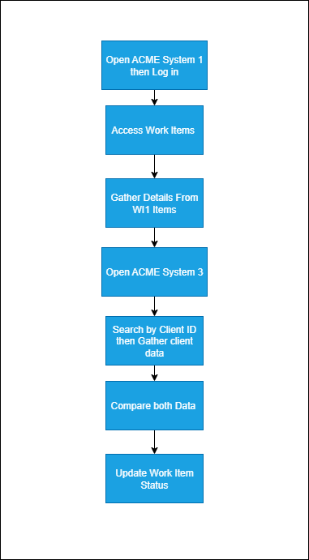
High Level Process Diagram

Detailed Process Steps – AS IS
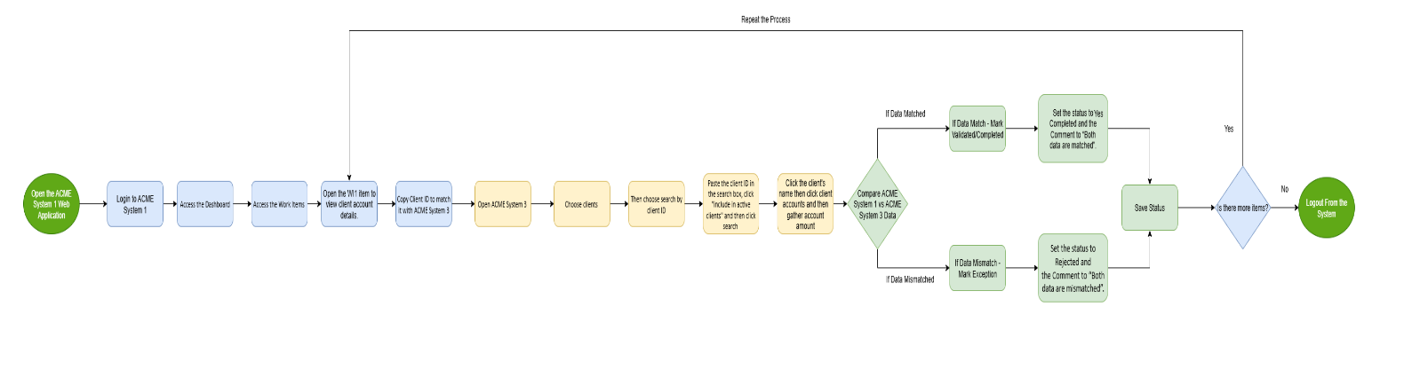

Steps | Description | Screenshots | Exception Handling
1 | Open the ACME System 1 Web Application |  | #SE002
2 | Log in to ACME System 1 using valid credentials. | 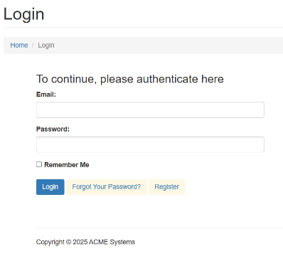 | #SE001
3 | Access the Dashboard, it’s the central location where the user can pick a specific menu item | 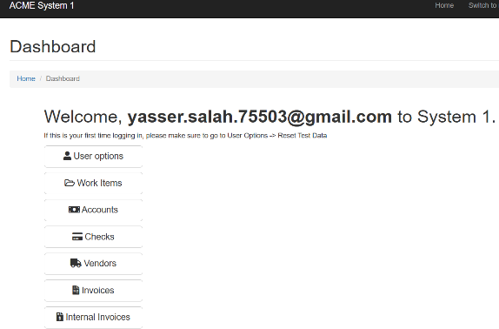
4 | Access the Work Items Listing to consult all the available tasks to perform (Output data: task) | 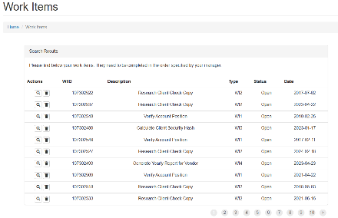
5 | Open WI1 item to view client account details. | 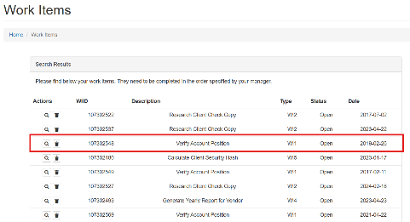
6 | For each activity of the type WI1 perform the following steps
6.1 | Copy Client ID to match it with ACME System 3 | 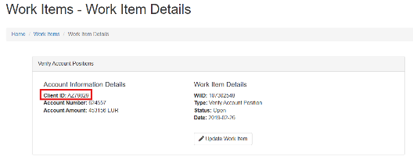 | #SE005
6.2 | Open ACME System 3 | 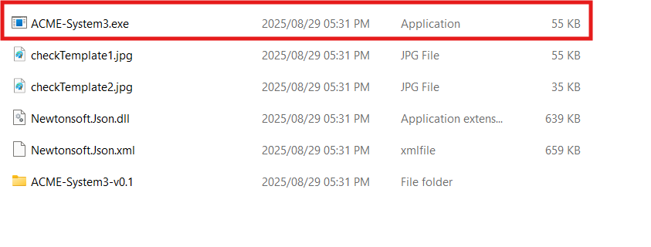
6.3 | Log in to ACME System 3 using the same credentials As ACME System 1 | 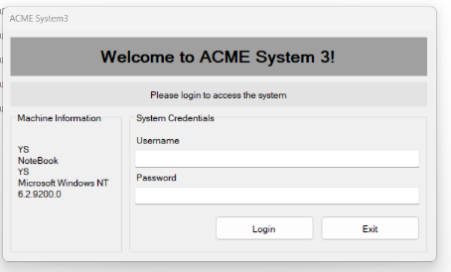 | #SE001
6.4 | Choose clients | 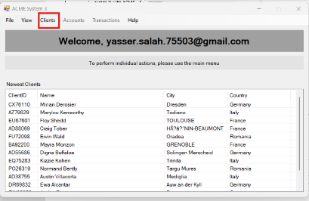
6.5 | Then choose search by client ID | 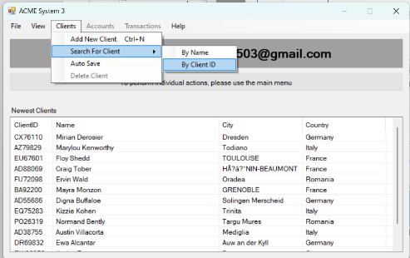
6.6 | Paste the client ID in the search box, click include inactive account and then click search | 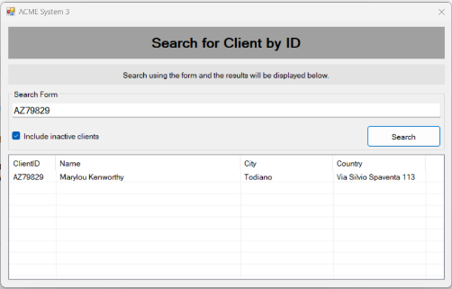 | #BE003 /  #BE005
6.7 | Click on Client ID | 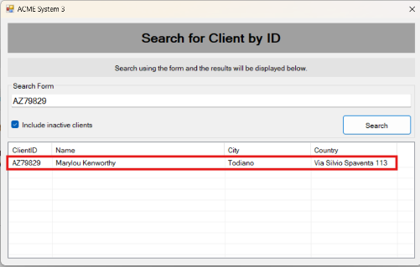
6.8 | Click on Client Accounts | 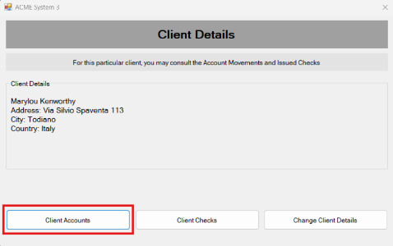
6.9 | Gather Account Amount | 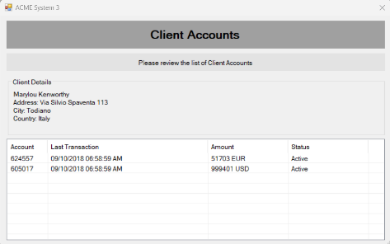 | #SE005
7.1_Yes | If both data are matched Go back to the Work Item Details and open the “Update Work Item” | 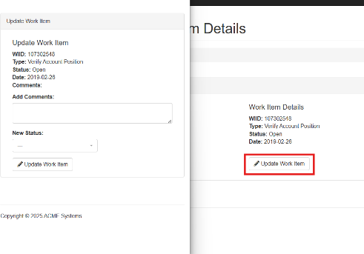
7.2_Yes | Set the status to Completed and the Comment to “Both data are matched”. | 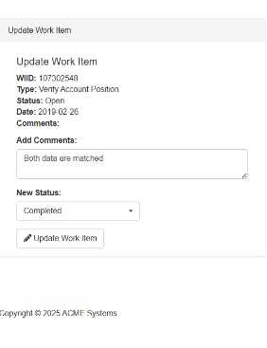
7.1_No | If both data are matched Go back to the Work Item Details and open the “Update Work Item” |  | #BE002
7.2_No | Set the status to Rejected and the Comment to “Both data are mismatched”. | 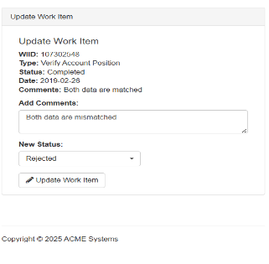
8.Yes | If there more Items Continue with the next WI1 Activity
8.No | Logout

In Scope for RPA

The activities and exception in of scope for RPA, in this automation workflow /sequence are listed here:
-  Full Scope of the process for RPA - to be 100% automated

Out of Scope
- There are no activities out of scope for RPA …

Non-process requirements

Systems

System | Usage | Frequency
ACME System 1 | Retrieve WI1 work items, view client account data, and update verification results. | Daily (multiple times per day)
External Reference Source (e.g., financial reports or statements) | Provide client account position data to compare with ACME System 1. | Daily / As required per work item

Reporting

Report name | Source | Purpose
Work Items Status Report | ACME System 1 | To track WI1 items processed, pending, validated, or flagged as exceptions.
Exception Report | ACME System 1 / Finance Team | To identify discrepancies found during account verification and escalate them for review.
Process Completion Report | ACME System 1 (Dashboard / Log) | To confirm the total number of WI1 items processed within a reporting period.
Reconciliation Summary Report | External Reference Source (e.g., financial system) | To provide client account balances for cross-verification with ACME System 1.

Archiving

All processed WI1 items, exception logs, and completion reports must be archived according to the company’s data retention policy. Records are stored either in ACME System 1 or the Finance shared repository, ensuring availability for audits and compliance purposes.

Security & data retention

Access to ACME System 1 and external reference data is restricted to authorized users only, with login credentials managed under the organization’s IT security policies. All client account data handled during the WI1 process must remain confidential and compliant with data protection standards. Processed records, exception logs, and reports are retained in line with company and regulatory requirements (typically 5–7 years) and are securely stored to ensure availability for audit and compliance purposes.

Exception Handling

- Business Exception

#Business Exception no. | Business Exception | Description | Expected Action
#BE001 | Invalid Data | Extracted Data is unclear or incomplete. | Request the finance team to review
#BE002 | Data Mismatch | Account balance or details in ACME do not match the reference source. | Mark WI1 as Business Exception → include mismatch details in logs.
#BE003 | Duplicate WI1 Items | The same client record appears more than once in the WI1 list. | Flag as duplicate → mark as Business Exception to avoid double-processing.
#BE004 | There is no work items | WI1 Items does not exist | Raise exception for review; request to update the list
#BE005 | Account Closed / Inactive | The client account has been closed but still appears in WI1 items. | Mark as Business Exception and report for clean-up.
#BE006 | Invalid Client | Client not found in master data. | Route to master data team or reject invoice.

- System/Application Exception

# System Exception no. | Exception | Description | Expected Action
#SE001 | Login Failure | ACME Test system not accessible due to wrong credentials or system error. | Retry login (max 3 attempts). If still failing → log as System Exception and notify support.
#SE002 | System Downtime / Unavailability | ACME Test website or reference source is offline or under maintenance. | Retry with defined interval. If still unavailable → raise System Exception.
#SE003 | Timeout Error | Page takes too long to load or data retrieval exceeds threshold time. | Retry the step. If repeated → log System Exception.
#SE004 | Unexpected Pop-Ups / Errors | ACME displays an error message, alert, or popup during processing. | Dismiss popup if possible, else raise System Exception.
#SE005 | Data Retrieval Failure | Unable to fetch client details or WI1 data due to broken link/API issue. | Retry the fetch; if still failing → mark as System Exception.
#SE006 | Application Crash | ACME or supporting reference system closes unexpectedly. | Restart the application and retry. If repeated → log System Exception.
#SE007 | Connectivity Issue | Internet/network issue prevents robot from reaching ACME or reference source. | Retry after short wait. If persistent → log System Exception.

Escalations

For immediate contacts for the process automation project, kindly contact the respective contact on the table below:

Email Address | Roles | Responsibilities
Support@company.com | System Support Team | Handle system/application exceptions (login failures, downtime, crashes). Provide technical fixes.
process.owner@company.com | Process Owner | Review business exceptions (data mismatches, missing data). Decide whether to reprocess or escalate.
operations.manager@company.com | Operations Manager | Oversee escalations, approve exception handling outside standard rules, and ensure process continuity.

