
Lebanese International University
School of Arts and Science

B+Tree Efficiency

By

Yasser Kaddoura

Instructor: Ms. Alia Ghaddar

Date: Monday December 26,2016

Table of Contents
Chapter 1STRUCTURE III
1.Database: III
2.Relation: IV
3.B+Tree: VI
Chapter 2ALGORITHM VII
1.Populating the data files: VII
2.B+tree creation: VIII
3.Linear search: VIII
4.B+Tree search: VIII
5.Natural join: IX
Chapter 3OPERATIONS COST IX

List of Figures
Fig. 1.1: Database ER-Diagram IV
Fig. 2.1: Records Format V
Fig. 3.1: B+Tree format VI

List of Tables
Table1-Operation/Cost(sec) IX

STRUCTURE

Database:

The database contains two relations(Authors and Books) with author_id and book_id as primary keys for each one respectively.

There’s a one-to-many relationship between the Authors and Books relations where the Author can have none to many books where the book can be written by one author only.

For more details refer to the ER-Diagram below(Fig. 1).

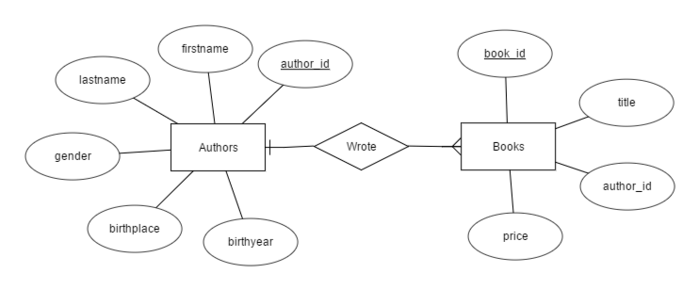
Fig. 1.1: Database ER-Diagram

Relation:

The records of each relation will be stored in plain text using JavaScript Object Notation(JSON) format.

For instance, the author relation attributes will be stored as shown in the following figure with author_id and birthyear as integers and birthplace, firstname, gender and lastname as strings.(Fig. 2).

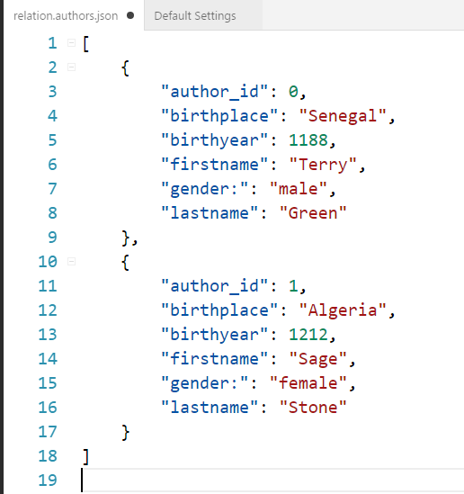
Fig. 2.1: Records Format

B+Tree:

The B+Tree will be stored as JSON format where each node will be stored as a dictionary that contains keys as integers or null, and pointers as another node until a leaf is reached and then the node would be storing a list (bucket) that refers to the actual data.

For more details refer to the figure below(Fig. 3).

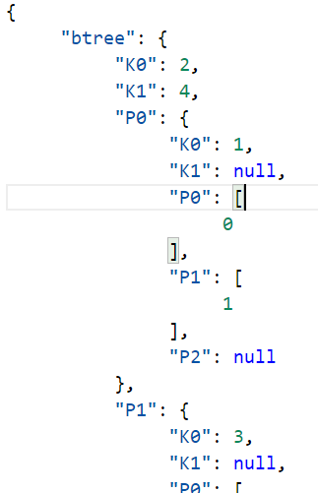
Fig. 3.1: B+Tree format

ALGORITHM

Populating the data files:

- Get the number of records from the user.
- Initialize an empty list.
- Create a dictionary with random details using a list of predetermined data.
- Repeat step 3 until the size of the list is the same as the inputted number.
- Open a file with write permission.
- Store the list in JSON format in the file then close it.

B+tree creation:

- Get the number of pointers and data stored in buckets from the user.
- Open the file that store the attribute records with read permission and store the records in a list.
- Get the path of the list(bucket) that the record should be inserted into.
- Insert the element in the list.
- If an overflow happens, split the list, and insert the new list inside a new pointer.
- If overflow happens in the leaf, split it and insert it to the parent node.
- Repeat step 6 until either an unoccupied pointer or the root of the B+tree are reached.
- If the root is reached split it and make a new root.
- Repeat step 3 through 8 with the total number of records.
- Open a file with write permission.
- Store the list in JSON format in the file then close it.

Linear search:

- Get the required key from the user.
- Open the file that stores the records with read permission.
- Check each record until either the required one or the end of the file are reached.

B+Tree search:

- Get the required key from the user.
- Open the file that stores the B+Tree with read permission.
- Reach the leaf that most likely contains the key.

Natural join:

- Open both files that we are going to make the natural join on.
- Get the first element of the attribute that we are going to make a join on from one file.
- Initialize a list to store the new records.
- Check every record in the second file if it contains the same attribute
- If the two elements are the same create a new record and store it in a list.
- Repeat step 2 through 4 until with every record in the first file.
- Store the list inside a file in JSON format.

OPERATIONS COST

To check on the efficiency for some operations, we populated the authors and books relations with 10,000 records each. We used our algorithm to generate a b+tree for each relation. We searched for a certain key using linear and B+tree search. We did a natural join between the given relations using the author_id attribute.

For further information, check the table given below(Fig. 4).

Operation |  | Time to Execute(sec)
Relation  Creation | Authors | 70.517
Relation  Creation | Books | 0.324
B+Tree  Creation | Authors | 0.288
B+Tree  Creation | Books | 0.224
Search | Linear | 0.036
Search | B+tree | 0.0
Natural join |  | 5.3
Table1-Operation/Cost(sec)

